Governing Board  President: Rebecca Fletcher  becky_fletcher@sbcglobal.net  President-Elect:  Robin Martinek  robinmartinek@yahoo.com  Immediate Past President:  Julie MacSwain  juliemacswain@gmail.com  Secretary: Jack R. Carlson  pspicata@gmail.com  Treasurer: Becky Ross  dirtlady71@gmail.com  Regional Vice-Presidents  EAST: Janet Perry  Janet.e.perry@gmail.com  WEST: Kristin Graham Chavez  phomenkoboris@gmail.com  SOUTH: John Mueller  john217@icloud.com  MIDWEST: Chris Tippie  cbstip@gmail.com  Advisory Board  Membership Chair:  Paul Benedict  soilwarden@verizon.net  Editor: Jerry Bernard  jbernard.nrcsret@gmail.com  Notes From the Potomac:  Craig Derickson,  craig.derickson@yahoo.com  SWCS Liaison:  Cheryl K. Simmons  cksoil@aol.com  Sr. Conservationist Chronicler: Ruth Montgomery  ruth58montgomery@gmail.com  Webmaster and Media Coordinator:  Julie MacSwain  juliemacswain@gmail.com  ARCSE  P.O. Box 3019  Galveston, TX 77551  . |  | NEWSLETTER  The Newsletter for Retired Conservation Service Employees  Vol. 54, No. 6 Nov/Dec 2026  The ARCSE Newsletter is published bi-monthly by the  Association of Retired Conservation Service Employees (ARCSE)  Website: www.arcse.org
From the President
As we reflect on another year with ARCSE, we are grateful for the continued dedication of our boards and members. Our work is rooted in preserving the legacy of SCS/NRCS, while keeping our conservation family connected and informed.
Again this year, NRCS experienced many challenges, including a major reorganization and significant staffing shortages. ARCSE also experienced a number of challenges, especially in recruiting and retaining members. Still, the year brought meaningful achievements and encouraging moments.
- A successful annual meeting in St. Louis.
- An active Facebook page and six excellent newsletters.
- A partnership with SWCS that connected emerging conservation professionals, helped fund a summer intern and provided a mentoring and leadership symposium for young conservation leaders.
- A Zelle account that simplifies electronic dues payments and donations.
- Continued growth of our Musicians Project.
- Recognition for members whose contributions exceed expectations.
- Three online meetings for state representatives and members.
- Continued efforts in our Mentoring and Training Program.
Our progress is possible because of our dedicated boards and members like you who care about ARCSE and choose to stand with us. Whether you paid dues, made a donation, volunteered, shared your story in the newsletter, reached out to a fellow retiree, or invited a friend to join, YOU ARE THE HEARTBEAT OF ARCSE!
Every contribution matters, and every connection helps keep our conservation family strong. Thank you for being part of ARCSE and helping us preserve the legacy and friendships built through years of conservation service.
On behalf of the Governing Board and Advisory Board, we wish you and your loved ones a peaceful, joyful holiday season and a healthy, hopeful New Year!
Training and Mentoring Team Update
The Mentoring and Training Project Team recently reconvened after our annual meeting in St. Louis and welcomed recent retiree Mark Bushman and the Regional Vice Presidents. Administrative changes in NRCS have continued to create challenges, with repeated starts and stops over the past two years. Still, we remain committed to the project and are preparing to help where we can.
We will maintain our collaboration with NRCS national training staff, NACD, and Women in Natural Resources. We are considering online sessions called “Meet a Subject Matter Expert,” “Coffee with a Senior Conservationist,” or both.
We ask state ARCSE representatives to continue contacting new retirees in their states to invite them to join ARCSE and explore their interests in serving as trainers or mentors. Training opportunities include conservation planning certification, cultural resources, and soil health. We also ask state representatives to strengthen relationships with their state conservationists and state office staffs and discuss training and mentoring needs.
Watch for updates as the team moves forward. For more information, contact Craig Derickson (craig.derickson@yahoo.com) or your Regional Vice President.

 | Association of Retired Conservation Service Employees

NOTES FROM THE POTOMAC
October 25, 2026
Update on USDA Reorganization
A recent headline reads: “Judge extends temporary pause in USDA relocations as he considers indefinite freeze.” The news article from Government Executive magazine goes on to say: ”A federal judge in San Francisco said it was ‘significant’ that Congress included a provision in a fiscal 2026 spending package that blocked the Agriculture Department from reorganizing without approval from the House and Senate appropriations committees.”* Most of the content of this article is taken from a September 30, 2026, article in the Government Executive organization. See citation at the end of the article.
Once USDA began implementation of the reorganization plans it announced mid-year of 2025, opponents argued that the proposed relocations are really just a veiled attempt for USDA to further shrink its workforce. USDA has already cut its workforce by about 20,000 employees, largely through voluntary separation incentives last year–which is nearly 20 percent of its total workforce.
A coalition of federal employee labor unions, nonprofits and local governments filed suit a few months ago after USDA announced plans to begin implementation of the forced moves. A federal judge in San Francisco has been weighing whether or not to block the USDA from carrying out its reorganization plans. In the late September hearing, U.S. District Court Judge Vince Chhabria told USDA and lawsuit plaintiffs to draft proposed language for a potential legal injunction by October 7. The judge also extended an administrative stay on USDA plans until October 13, which will continue to put a temporary hold on deadlines for all “management-directed reassignment” letters USDA has issued so far.
The plaintiffs argue that USDA is trying to circumvent guardrails on USDA reorganization established by Congress. Lawmakers included a provision in the fiscal 2026 appropriations bill for USDA that blocked officials from reorganizing or relocating offices or employees without approval from the House and Senate appropriations committees.
It is important to note that Congress controls funding for federal agencies and the funds they have available to carry out operations, including the cost of the USDA Reorganization. Judge Chhabria said the specific mechanism lawmakers included in the FY 2026 spending package was “obviously unconstitutional,” and that “Congress must have known that it was unconstitutional.” The judge went on to say: “If Congress knows full well that the committee permission provision is unconstitutional, then is there an argument for just treating it as if it never happened? As if Congress did nothing to ratchet up the restriction on agency action?” he said.
Judge Chhabria commented: “Congress did not want USDA to be spending money on these kinds of reorganization activities, unless it got permission from the committees,” he said in the late September hearing. He added, “If you take away the committee-approval provision, then what you're left with is that Congress doesn't want the USDA to be engaging in spending this money on these kinds of reorganization activities, unless it goes and gets legislation passed to create an exception to the prohibition.”
Corrine Johnson, an attorney for plaintiffs, argued that USDA’s moving around funds to carry out its reorganization is exactly what Congress sought to block. She said: “They are reprogramming available funds to use them for a different purpose than which they were allocated for. So it falls under the definition of reprogramming,” Johnson said.
Judge Chhabria questioned whether USDA has adequately prepared for attrition in cases where employees quit rather than opt for relocation — and whether that level of attrition could make it harder for USDA component agencies to carry out their work and their intended purpose. Chhabria commented: “Even if it's with an eye towards having a better organization — you know, a more modern, less bloated organizational structure or whatever – if, when you're making that transition, you're going to lose a bunch of key personnel who provide support to the people in Tahoe National Forest to protect against fires and things like that, that might interfere with the ability of the agency to perform its functions,” he said.
Department of Justice (DOJ) attorneys representing USDA told the court in August that USDA hadn’t conducted any attrition analysis yet, but was planning do so, "in conjunction with hiring and facilities planning at relocation sites as it finalizes relocation plans on an agency-by-agency basis.” Johnson added that “high attrition of people being relocated was likely” with USDA’s current relocation plans, “given the previous experience with the relocations to Kansas City.” This was in reference to the fact that the vast majority of employees at the Economic Research Service and the National Institute of Food and Agriculture quit rather than relocate to Kansas City in 2019.
Some USDA employees say they went ahead and accepted relocation notices because it's the only way they can proceed with a request for a hardship or medical exemption. Others say they have nominally agreed to relocate, but are still applying for other jobs. If that plan doesn’t work out, they may quit rather than move.
An additional part of this story is that USDA officials told the court on July 24 that USDA is planning to hire nearly 16,000 employees this year. But according to updated staffing plans, the department expects that a “majority” of its hiring initiatives will “result in no net gain,” and will instead “offset expected attrition.” For more from Government Executive on the USDA Reorganization see:
https://www.govexec.com/management/2026/09/judge-extends-temporary-pause-usda-relocations-he-considers-indefinite-freeze.
USDA Court Statement Issued on October 13, 2026
On October 13, 2026, U.S. District Judge Vince Chhabria of the U.S. District Court for the Northern District of California issued a preliminary injunction and stay order, halting major parts of the U.S. Department of Agriculture’s (USDA) sweeping reorganization plan. For more from the National Federation of Federal Employees, see:
https://www.nffe.org/press-release/court-orders-stop-to-usda-reorganization-in-lawsuit-filed-by-unions-nonprofits-cities-and-counties/.
In a reply to all USDA employees, the formal announcement stated: “This message is for USDA employees within the Agricultural Research Service; United States Forest Service; Food and Nutrition Administration; Research, Education, and Economics mission area; Foreign Agricultural Service; Rural Development mission area; Farm Production and Conservation mission area (which includes NRCS, FSA and RMA); Office of the General Counsel; and Office of the Assistant Secretary for Civil Rights.”
Language from the federal court hearing on October 13, 2026, and published in the court findings, include the following: In American Federation of Government Employees, AFL-CIO, et al. v. United States Department of Agriculture, Case No. 26-cv-09976-VC (N.D. Calif.) (* see citation at the end of the article), the Court ordered the following:
In light of the foregoing [litigation], and pursuant to this Court’s authority to “issue all necessary and appropriate process to postpone the effective date of an agency action or to preserve status or rights, 5 U.S.C. § 705, it is hereby ordered that:
“Defendants USDA and USDA Secretary Rollins and their officers, agents, servants, employees, and attorneys, and all persons are enjoined and stayed from (a) closing or eliminating offices or (b) relocating or reassigning employees or their positions or functions to different and/or new locations outside the local commuting area, including by issuing or enforcing MDR letters or any other notice or directive of reassignment or relocation in whole or in part, including any deadlines in those letters at the: Food and Nutrition Administration; Research, Education, and Economics mission area; Foreign Agricultural Service; Rural Development mission area; Farm Production and Conservation mission area; Office of the General Counsel; and Office of the Assistant Secretary for Civil Rights.”
“Notwithstanding the foregoing, this order does not enjoin the defendants from:
relocating or reassigning USDA employees currently located within the National Capital Region to other local offices or locations also located within the National Capital Region, or closing offices, programs, or facilities in the National Capital Region from which all employees have been relocated or reassigned to other local offices or locations within the National Capital Region; reassigning a covered employee who applies or applied to a job announcement on USAJobs or other internal agency merit-hiring application processes, is selected for the position, and accepts the position, provided that the reassignment is unrelated to the reorganization activities stayed by paragraphs 1 through 3.”
For purposes of this order, “local commuting area” means “the geographic area that usually constitutes one area for employment purposes. It includes any population center (or two or more neighboring ones) and the surrounding localities in which people live and can reasonably be expected to travel back and forth daily to their usual employment.” 5 C.F.R. § 351.203.
For purposes of this order, “offices” does not include physical locations that were empty of staff as of the date of the congressional notification letter for the relevant USDA component (which are either in April or June 2026).
This order does not require the defendants to return employees who were relocated pursuant to the reorganization activities stayed by paragraphs 1 through 3 and began work at their new duty station prior to this Court’s first administrative stay order on September 14, 2026, to their original duty station or enjoin the defendants from issuing any associated relocation incentive or payment entitlements to those employees.
By October 22, 2026, the defendants shall file a declaration verifying that they have complied with this order and setting forth the steps they have taken to do so. The court order stipulated that USDA must notify all affected employees within two business days. However, the judge noted the stay may in fact be temporary, as the underlying congressional spending restrictions are tied to a Continuing Resolution (CR) expiring on December 11, 2026. The judge also noted the federal government has the option to appeal the decision to the 9th U.S. Circuit Court of Appeals. Impacted USDA employees will be notified of any changes in the litigation. For more information from the Courts ruling see:
https://democracyforward.org/wp-content/uploads/2026/10/26-cv-09976-VC-Stay.pdf.
Top Priorities for Congress to Address Before End of CR on Dec. 11, 2026
Although both the House of Representatives and the Senate won't resume duties until after the November 3, 2026 mid-term elections, there are several priority actions Congress must address before the December 11, 2026 deadline. At the top of list of priorities is the need to pass full-year fiscal year 2027 appropriations bills or another stopgap spending extension to prevent a government shutdown. Readers will recall that Congress extended federal funding at current fiscal year 2026 levels with the passage of the Continuing Appropriations and Extensions Act, 2027 (H.R. 6500), but this short-term legislation leaves lawmakers with a compressed legislative schedule during a post-election lame-duck session.
The Holland and Knight organization reported: “The lame-duck session will also require action – or at minimum another temporary extension – on surface transportation programs, portions of the Farm Bill, several healthcare programs, and other expiring authorities. At the same time, congressional leaders will work to complete the fiscal year (FY) 2027 National Defense Authorization Act (NDAA), Water Resources Development Act (WRDA), permitting legislation and potentially a year-end tax package.” For more from Holland and Knight see:
https://www.hklaw.com/en/insights/publications/2026/10/beyond-the-midterms-congress-faces-converging-year-end-deadlines
Critical fiscal and budget priorities:
FY 2027 Appropriations — According to the National Association of County Officials (NACO), Congress must attempt to negotiate and pass the 12 annual full-year appropriations bills. If final agreements are not reached, leaders must decide whether to pass another short-term continuing resolution (CR) or an all-encompassing "omnibus" package. Democratic House Minority Leader, Hakeem Jeffries, has stated that he prefers to address the appropriation bills during the lame duck session. For more information from NACO on fiscal year 2027 appropriations see: https://www.naco.org/news/congress-passes-short-term-funding-bill-keeping-federal-government-funded-through-dec-11-and
Blocking the OMB Uniform Guidance Overhaul —The stopgap spending bill temporarily halted a controversial Office of Management and Budget (OMB) proposed rule, "Regulation for Federal Financial Assistance," which would alter federal grant-making. The proposal is actually much more than a routine technical update from OMB. It would fundamentally alter the legal and operational framework for federal grants, cooperative agreements, and other forms of federal financial assistance.
One of the most consequential changes would convert the Uniform Guidance into what OMB calls the “Uniform Grants Regulation.” Under the current framework, OMB issues government-wide guidance that federal agencies generally implement through their own regulations. Under the proposal, OMB’s requirements would operate as a binding government-wide regulation with a common effective date, without requiring separate agency rule-making to implement each future revision. The prohibition expires on December 11, forcing lawmakers to decide whether to permanently block it. See more from the BDO Alliance at:
https://www.bdo.com/insights/industries/nonprofit-education/what-the-continuing-resolution-means-for-ombs-proposed-uniform-guidance-rewrite.
Expiring Federal Authorizations:
The Farm Bill — Lawmakers face a critical deadline to renew or extend vital agricultural policies and nutrition program authorizations that expire alongside the CR on December 11. The House passed the Farm, Food, and National Security Act of 2026 (H.R. 8646) in April, 2026, which outlines baseline support and cuts certain discretionary rural and nutrition funds.
The Senate Committee on Agriculture advanced Chair John Boozman’s Agricultural Act of 2026 (S. 5526, or Farm Bill 2.0) in September, 2026, though significant partisan disagreements exist—particularly over the Supplemental Nutrition Assistance Program (SNAP) provisions—have stalled a final floor vote. The CR (P.L. 119-103) funds USDA operations and the current Farm Bill through December 11, 2026, but does not provide a broad farm bill reauthorization for FY 2027 and beyond.
Major farm bill safety net programs — including Agriculture Risk Coverage (ARC), Price Loss Coverage (PLC), Dairy Margin Coverage (DMC), crop insurance, and core working lands conservation programs (EQIP, CSP)—were previously extended through 2031 under the 2025 budget reconciliation legislation, but are at risk without additional legislation. Several smaller farm bill programs ("orphan programs") lost authorization and funding as of October 1, 2026, including the Local Agriculture Market Program, Specialty Crop Block Grants, and the Senior Farmers' Market Nutrition Program.
Existing CRP contracts will remain active, but USDA cannot write new contracts without formal program and funding reauthorization. If Congress does not act, decades-old 1938 and 1949 "permanent law" commodity policies could begin triggering market impacts, starting with dairy in early 2027. For more see the Congressional site at:
https://www.congress.gov/crs-product/R49343.
Surface Transportation Authorization — Federal programs governing highways, transit, and broader surface transportation infrastructure require reauthorization or temporary extensions to prevent a lapse.
Healthcare Extenders — Critical authorizations for several healthcare initiatives, including certain Veterans Affairs healthcare extenders, expire on December 11 and require renewal.
Defense and National Security — Completing the annual defense authorization act remains a must-pass objective. Republican congressional leaders are also weighing potential additional funding requests tied to the conflict involving Iran.
Stalled Legislation — Lawmakers will evaluate which bipartisan packages caught in legislative limbo can find a vehicle to advance before the 119th Congress adjourns, including energy permitting reform, cryptocurrency regulation, children’s online safety, and prescription drug costs.
According to the Holland and Knight (H&K) group, “The central strategic question is whether Congress assembles a broad year-end package or defers the most politically difficult decisions to 2027. If the current majority retains control, leadership has a strong incentive to enact full-year appropriations and selected policy packages before adjournment. Likewise, U.S. House of Representatives Minority Leader Hakeem Jeffries (D-N.Y.) has publicly stated that he favors doing the appropriations bills during the lame-duck period.”
H&K also suggest that the most likely year-end legislative architecture is one of the following: “A major omnibus or series of minibuses combining appropriations, healthcare extenders, tax provisions and selected authorizations, or a shorter-term CR, potentially into January or March 2027. They also suggest that this would be accompanied by narrowly-tailored extensions, or a hybrid package that provides full-year funding for some agencies while temporarily extending the remaining appropriations bills and expiring programs.
A final dismal reality remains that a partial government shutdown is possible if the parties cannot resolve disputes over spending levels, policy riders, defense funding, healthcare, and Trump Administration authorities before December 11, 2026. For more see:
https://www.hklaw.com/en/insights/publications/2026/10/beyond-the-midterms-congress-faces-converging-year-end-deadlines .
Record ARC and PLC Payments Expected by Month’s End: What Farmers Could Receive Per Acre
Farmers will receive a record $13.8 billion in gross Agriculture Risk Coverage (ARC) and Price Loss Coverage (PLC) safety net payments for the 2025 crop year, with funds beginning to hit bank accounts by late October 2026.
Estimated Payments Per Acre (2025 Crop Year)
Projected averages per base acre vary by crop and region according to university and extension estimates:
Corn: ~$51 per acre (with total corn payouts estimated between $4.5 and $5 billion)
Soybeans: ~$29 per acre (with total soybean payouts around $1.5 billion)
Wheat: ~$47 per acre (with total wheat payouts under $3 billion)
Cotton: ~$119 per acre (with total cotton payouts around $1.5 billion)

Key Program Details and Timelines
Payout Structure: Payments generally factor at roughly 85% of base acre levels, and actual amounts depend heavily on individual county or farm data.
Payment Limits: Individual checks may be trimmed or capped by statutory payment limits, though recent updates under the Working Families Tax Cuts Act (WFTCA) raised the ARC and PLC payment limit from $125,000 to $155,000 starting with the 2025 crop year.
Deadline: County Farm Service Agency (FSA) offices have a deadline of October 30, 2026, to certify and sign 2025 payments in the National Payment Service, with direct deposits arriving shortly after verification.
2026 Enrollment: Enrollment and election for the 2026 crop year are currently open through December 11, 2026, according to USDA. For more information see the Ag Web site at: https://www.agweb.com/news/policy/politics/record-arc-and-plc-payments-expected-months-end-what-farmers-could-receive-a.
Is Social Security running out?
USAFacts is a non-partisan, not-for-profit civic initiative that collects and visualizes official U.S. government data. The organization has published information about the future sustainability of the Social Security program. The following information comes directly from the USA Facts website on the Social Security program.
Social Security trust funds have run at a deficit every year since 2021, a reversal after decades of surpluses. The Social Security Administration (SSA) projects that, absent congressional intervention, the combined trust fund reserves could be depleted by 2034. At that point, revenue coming into the fund could cover about 83% of scheduled benefits.
The Old-Age and Survivors Insurance and Disability Insurance trust funds, which were worth a combined $2.56 trillion at the end of 2025, fund Social Security. Workers pay into Social Security trust funds through payroll taxes. Employers match these contributions.
Social Security covered 70.5 million people in December 2025, up 174% from 1970. The SSA paid retirees and dependents an average monthly benefit of $2,017 last December. Disabled workers and dependents received an average of $1,492. Survivors of deceased family members who had paid Social Security taxes received an average of $1,621.
The trust funds ran a surplus every year from 1982 to 2020. Since then, they’ve declined 11.9%, or $347.0 billion, as benefit costs outgrew income money coming in. Last year, they took in $1.45 trillion and paid out $1.61 trillion.
One reason for the potential depletion? Shifting age demographics. The Social Security system is designed, among other purposes, to support retirees. The model needs a balance between workers contributing to the trust funds and beneficiaries receiving them. These days, more people are reaching retirement age and living longer in retirement, while relatively fewer people are entering the workforce.
How many people work for the government?
The federal government has a lot of employees. Like, a lot: just under 2.69 million as of June 2026. It’s the single largest employer in the country, responsible for one in every 60 jobs. That number includes nurses, air traffic controllers – and, yes, a lot of people in office buildings in the DC metro area. Here’s what the civilian federal workforce looks like.

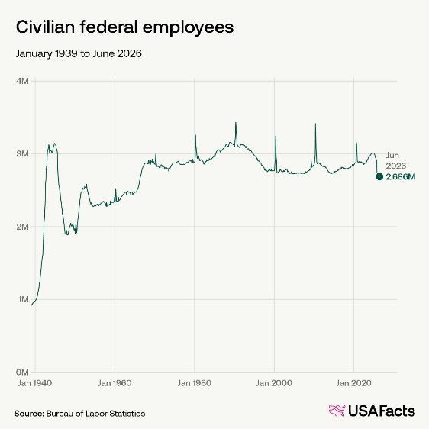
In June, federal employment accounted for 1.7% of non-farm jobs nationwide, a share that has been declining. The highest rate on record was in November 1944 at 7.5%, or about one in 13 jobs.
Most civilian federal jobs are in the executive branch, which employed 2.03 million as of May 2026. The Defense Department employed the most (684,900), followed by the Department of Veterans Affairs (445,700) and the Department of Homeland Security (225,600).
As of June, 5% of workers in Hawaii were employed by the federal government, the highest proportion of any state. This was followed by Maryland (4.8%), Virginia (4.0%), and Alaska (4.0%). Wisconsin has the lowest share at 0.95%.
Perhaps unsurprisingly, the US government employed a higher share — 22.8% of all workers in Washington, DC.
These figures account for non-farm jobs, meaning they exclude agricultural workers. Farm jobs are excluded because they change a lot with the seasons, and sharp ups and downs can hide the true health of the job market. These also exclude military personnel.
For more information from USAFacts on the Social Security program see: https://usafacts.org/articles/how-much-does-the-us-spend-on-social-security-is-it-sustainable/.
MEMBERSHIP REPORT
Paul Benedict, Membership Chair
New Members
Kristina Hare – Pleasant Garden, North Carolina (Joined last May, name accidently omitted from July/August 2026 newsletter)
Susan Samson-Liebig – Bismarck, North Dakota
James Harder – Lincoln, Nebraska
Laureen Eipp – Syracuse, New York
Harrison D Philbrick – Cassville, Missouri
New Affiliate Member
Mark Kopecky – Fellsmere, Florida

2027 ARCSE MEMBERSHIP DUES and HARD COPY NEWSLETTER FEES are due Jan. 1st, 2027.
Please see the 2027 Dues Notice that accompanies this newsletter. For your convenience ARCSE annual dues and hard copy fees can be paid by credit card online: https://arcsecommunications.wordpress.com/renew/
Or you can pay by check. Make the check payable to ARCSE and mail to: ARCSE, P.O. Box 3019, Galveston, TX 77551.
The annual membership dues are $25/year, and hard copy fees are $15/year. If you are a Life Member or are an Honorary Member (Member with 5 or more years of paid membership who turned 91, or will turn 91 in 2026 or earlier), you do not owe annual dues. Life and Honorary members receiving the printed newsletter in the mail must still pay $15 for that service. If you have questions about your membership or newsletter status do not hesitate to contact me at soilwarden@verizon.net.
Donations to ARCSE are always appreciated. Donations can be mailed to the address above (please mark contribution on your check), or they can be made online at
https://arcsecommunications.wordpress.com/give/
Members receiving the newsletter by printed hardcopy: A green insert dues notice is included with the hard copy newsletter. Please follow the instructions on the notice concerning the address label information to determine if your dues are due.
Members receiving the electronic newsletter: Members receiving the electronic newsletter whose dues are due will receive a separate attachment from ARCSE with dues notice attached (WATCH FOR IT). Life Members, honorary members, and members who have already paid their 2027 dues will receive an email assuring you that your membership dues are paid.
Have you moved, have a new phone number, or changed your email address? If so, send us your updated contact information now, before you forget.
ARCSE MEMBERSHIP DUES
Due by Jan. 1st
Member $25 per year
Affiliate $25 per year
Life Member (One-time payment)
Age 64 or younger $325
Age 65 thru 74 $275
Age 75 or older $175
NOTE: Dues payment includes receipt of the bimonthly electronic newsletter. All members (both life members and those who pay annual dues) who desire a hard copy of the newsletter must pay an additional fee of $15.00 per year to cover costs of printing and mailing.

Please submit Dues to ARCSE at P.O. Box 3019, Galveston, TX 77551

ACES Note
The Agriculture Conservation Experienced Services (ACES) Program
From Julie MacSwain: “Working with the ACES program has been a very positive experience. I currently support Ohio NRCS remotely as a Public Affairs Specialist, allowing me to continue contributing my skills and experience to the conservation mission I’ve enjoyed throughout my career.” For more information and jobs listings, see:
https://newsolutions.org/programs/aces-program-nrcs/
ALABAMA
Earl Norton, ARCSE Representative
Email: earl.norton@charter.net
From John Mueller: We are saddened by the recent deaths of Charles Love and Earl Norton. Mr. Love had served as Soil Survey Regional Director (Auburn) as well as State Soil Scientist prior to his retirement. Mr. Norton had served as State Resource Conservationist for Alabama for a number of years prior to his retirement. Additionally, we thank him for his service as ARCSE State Representative.
For additional information, please see their obituaries later in the newsletter.
ARIZONA
Wade Biddix, ARCSE Representative
Email: rwbiddix@aol.com
The Arizona SWCS Chapter has received the University of Arizona College of Agriculture, Life & Environmental Sciences 2026 Organization Lifetime Achievement Award. They were recognized at an awards banquet Friday, September 18th, 2026, at the Arizona Sands Club (Football Stadium). An excerpt from the award letter is shown below:
"Congratulations on being selected as recipient of the College of Agriculture, Life and Environmental Sciences 2026 Organization Lifetime Achievement Award.
This award recognizes organizations who have significantly supported the College and/or Arizona Agriculture in a superior and sustained manner over a thirty-year period through activities reflected in the mission of the College, emphasizing activities directly affecting agriculture sciences, renewable resources, the marketplace, or families and consumers. I am delighted to honor your contributions and achievements on this special occasion."
–Thanks, Wade Biddix
Steve Black spent two weeks at his farm in Illinois harvesting corn and soybeans. Due to the more than adequate rainfall and the rains coming at just the right times during the growing season, the yields were excellent. The corn yield was the highest ever for the farm and the soybeans were the second highest on record. The new corn and soybean varieties with their modified traits have made a big difference in yields over the past five to ten years. Corn yield in the last five years has increased by 30% over the average for the fifteen years prior to that. In the area of the farm planted to 3,500 hardwood trees back in 1986, the Emerald Ash Borer finally arrived and killed about 900 White Ash trees. However, the Walnut and Red Oak trees survived. There are lots of perfect-sized firewood available from the dead Ash trees.
From August 25th to September 14th, 2026, Wade Biddix and his wife, Joanne, took a Viking River Cruise from Amsterdam to Budapest. They arrived a few days early in Amsterdam and toured the Ann Frank House in Amsterdam and the Corrie Ten Booth home in Haarlem. These women were truly inspirational during World War II. Ann Frank wrote her famous dairy during the early war years, was later captured, and died in a concentration camp. Corrie Ten Booth saved about 800 Jews during the Holocaust Period. After being captured, and later released, she toured the world and told her story. She wrote many books including “The Hiding Place” and “Tramp for the Lord.” Two amazing women for sure.
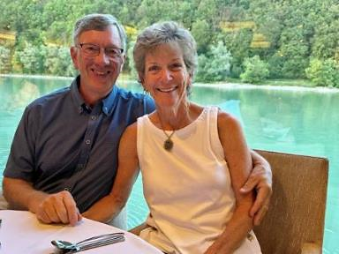
Wade and Joanne Biddix celebrating their 41st wedding anniversary, September 1st, 2026.
Even though Europe experienced record droughts in 2026, and the Rhine River and Danube River were at historic low water levels, the river cruise was amazing. There were incredible castles, churches, and small towns along the rivers as well as many beautiful vineyards and wineries. In addition to the castles along the rivers, the highlights of the cruise were touring the windmills in Kinderdijk, which pump about 4,000 gallons per minute into the Rhine River; the cathedral and the Kolsch Beer Pub Crawl in Cologne; the palace in Wurzburg, Hitler’s Zipper drill fields and Jewish Museum in Nuremburg, “stumbling stones” in front of buildings that designated Jewish people who were taken from their homes and disappeared, an E-Bike tour from Passau, Germany to Austria and back, the beautiful buildings in Vienna, and the evening river cruise in Budapest. In addition, Wade and Joanne celebrated their 41st wedding anniversary on September 1st. It was truly a wonderful experience and one highly recommended.
ARKANSAS
Ralph Mashburn, ARCSE Representative
Email: ralphmashburg@gmail.com
Bob Price organized and led annual Arkansas ARCSE luncheon on Thursday, September 10th at the Whole Hog Café, 2516 Cantrell Rd in Little Rock. Tammy Blenden of Blue Cross Blue Shield provided attendees with valuable materials and shared insights on new and changing health care cost and benefits. Bob was again elected president by unanimous applause. Those attending are shown below.
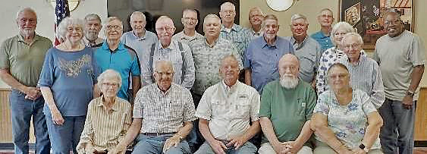
Bottom Row: Nancy Mashburn, Ralph Mashburn, Bob Price, Rick Miller, Glenda Miller
Middle Row: Judy Mayfield, Lewis Mayfield, Bill Garner, Edgar Mersiovsky, Rick Fielder, Lori & Dick Babeu, Anderson Neal
Top Row: Ken Ziegler, Ralph Harris, Randy Ferguson, David Heffington, Stanley Mathis, Tony Stevenson, Neal Sparks, Charles Fultz
Ralph and Nancy Mashburn celebrated their 70th wedding anniversary in September, 2026.
Ralph and Nancy began dating during their junior year at the University of Arkansas and married just before starting their senior year. They borrowed his parents’ car for a two-day honeymoon on the way back to college. They have three children, seven grandchildren, and four great-grandchildren. Below is part of a poem Ralph composed for Nancy to commemorate their wonderful 70 years together and their lifelong habit of holding hands. In the poem he recalled the many SCS friends they made in various places. Four friends they keep in touch with are Dick and Lori Babeu, who live nearby, and Bob and Elaine Caldwell, who live in Sequim, Washington. Bob and Ralph recently exchanged encouraging letters about how much their friendship has meant to both of them since it began in 1965 on a River Basin staff in East Aurora, New York, and continued years later on the NTC staff in Portland, Oregon.
 | 
1956, Leaving the church. | 2026, Hand in Hand
"Hand in Hand”
70th Anniversary Poem, From Ralph to Nancy
September 2, 2026

Over 70 wonderful years we have held our hands
Remember, the 1955 night when it all began
You tapped on a window of the library room
You said a campus movie was starting soon

In the movie darkness I reached your hand to woo
Your gentle squeeze said that you liked me too
Hand in hand walking on a snowy Fayetteville night.
And in the college student union, everything felt right

Nancy Brickell, you captured my soul,
With you, I felt wonderfully whole
Soon we agreed that our campus love was real
So, we planned the summer our wedding to seal

Then, In Little Rock, 1956 our marriage began,
September second holding each other’s hand
With every shared year, you made me whole.
A beautiful partner, heart and soul.

Seventy years, a great milestone no doubt,
Many places we’ve lived, SCS friends throughout.
And hand in hand, we've weathered each storm,
With faith in the Lord, our hearts stayed warm.

With laughter and kindness, we've shared our way,
A testament of love that grows day by day.
So - here's to the blessings bestowed from above,
For seventy years - of hand holding love.
Twenty Second year of the Little Rock Touchdown Club – a reputation as the best such Football Club anywhere.
SCS/NRCS Retirees and Club Members: Dick and Lori Babeu, Ralph, Nancy, and their son, Drew Mashburn and their group of friends are excited to begin another Fall season of participating in Little Rock Touchdown Club luncheons. These luncheons feature football-related speakers from across the nation. The normal attendance is between 300 and 1,000. This year’s October 12th luncheon featured both former President Bill Clinton and Dallas Cowboys owner Jerry Jones. The event drew an attendance of over 3,000 in an arena. Past years have always included the current Razorback coach and many Hall of Fame speakers such as Peyton Manning, Bret Farve, Tony Dorsett, Emmitt Smith and Terry Bradshaw. The charismatic and efficient organizer and MC is the former Razorback linebacker, David Bazell
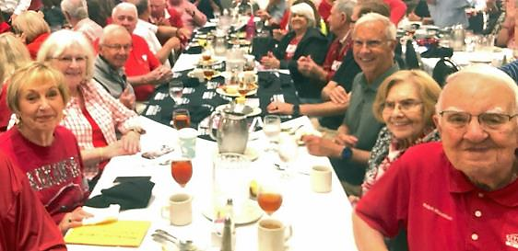
CALIFORNIA
Bill Ward, ARCSE Representative
Email: bluegrassbillward@gmail.com
Hello to all my fellow retirees all across the country from California! California Retirees continue to enjoy connecting on our monthly retiree Zoom meeting I host the first Wednesday of every Month.
The folks shown below enjoyed taking part in our recent September 2nd Zoom Meeting. These meetings are a great opportunity to reminisce about past experiences working together, and to see old friends and familiar faces.
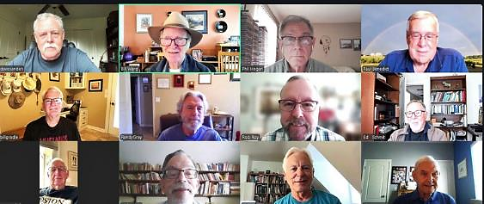
Top: Dave Sanden, Bill Ward, Phil Hogan, Paul Benedict
Middle: Bill Gradle, Randy Gray, Rob Roy, Ed Schmit
Bottom: Tom Wehri, Walt Sykes, Bob Snieckus, Chester Bush
Attention all SCS/NRCS Musicians. This is a reminder that our SCS/NRCS Musicians Project team is still looking for more Musicians who worked for our agency (SCS/NRCS) to work with on writing your own personal biographies that will be shared on the ARCSE Musicians Project Website. Following is a link to the ARCSE Musicians Project Website: https://arcse.org/musicians/
The ARCSE Musicians Project website contains all existing Biographies, currently about 20. Take a look at the existing biographies.
Biography Content: Generally, biography content includes the individual's life experiences as a musician, as well as their professional experience working for SCS/NRCS and other professional experience working outside SCS/NRCS.
How to apply to have your biography developed and shared on the ARCSE Musicians Project website:
Complete the Musicians Biography Information form: This is a fillable PDF Form providing needed information for each biography. Following is a link to this Fillable Form:
form-musician-bio-info_25feb2025.pdf
Douglas Toews, our Musicians Project Editor, will work with each SCS/NRCS musician to put the biography in final format to be shared on the website.
If you have questions regarding how to apply to join this unique group of musicians, and have your own biography shared on the ARCSE website, please let me know.
–Sincerely, Bill Ward PE, ARCSE CA State Rep
COLORADO
Jack Carlson, ARCSE Representative
Email: pspicata@gmail.com
In early September, Wendall Oaks and Jack Carlson participated in the family and friends memorial gathering at a lodge and the hillside family plot near Frost, West Virginia for Senior Conservationist and former National Plant Materials Specialist Curtis Sharp, who passed away this past spring. Curtis was instrumental in ensuring conservation plant supplies supporting Conservation Reserve and other programs as they got off the ground and flourished.
Meanwhile, retirees Eric Hesketh, Frank Geter, and Jack Carlson with colleagues at the One Water Solutions Institute at Colorado State University have used AI coding assistants to transform the old WinPST (Pesticide Screening Tool) desktop application to a tool run in a web browser integrated with NRCS soils and pesticide data tables – an effort taking a few days, currently in review and testing.
And please note the In Memoriam obituary for Bernie Shafer, who had a profound impact on the direction and progress of automated systems conceived and deployed in the 1980s and 1990s, setting the stage for the systems used today, including some still operating that Bernie and his group deployed many years ago.
CONNECTICUT, RHODE ISLAND, NEW HAMPSHIRE
Carl DuPoldt, ARCSE Representative
Email: cdupoldt@gmail.com
CT
Connecticut has several natural resource conservation events scheduled for November and December 2026, ranging from state-wide resiliency initiatives to local wildlife tracking and habitat restoration.
Mermaid Beach Cleanup, Date: Saturday, November 7, 2026
Venue: Bluff Point State Park, Groton, CT
Description: Estuary and beach clean-up campaign. Learn more on the Connecticut National Estuarine Research Reserve Events Page.
Volunteer Day: Habitat Improvement
Date & Time: Saturday, November 7, 2026 at 10:30 AM
Venue: Woodcock Nature Center, 56 Deer Run Road, Wilton, CT
Description: Hands-on invasive plant removal (such as burning bush) and planting of native replacements.
Cost: Free, registration required via the Woodcock Nature Center.
Date & Time: Saturday, November 14, 2026 at 8:30 AM
Venue: Deer Lake Outdoor Center, 101 Paper Mill Road, Killingworth, CT
Description: Trail maintenance, brush clearing, and woodland upkeep.
Cost: Free, lunch provided.
WBDC Virtual Orientation: Farming & Agricultural Business
Date & Time: Thursday, November 19, 2026 from 12:00 PM – 1:00 PM
Venue: Virtual Webinar
Description: Joint session focusing on the conservation and business resources available to Connecticut’s agricultural community.
Cost: Free; register on the Connecticut Resource Conservation & Development (CT RC&D) Events Calendar.
Connecticut Butterfly Atlas Project v2.0
Meet Your Greens: Conservation Mixer
Date & Time: Thursday, December 10, 2026 from 5:00 PM – 7:00 PM
Venue: Litchfield Distillery, 569 Bantam Road, Litchfield, CT
Description: An informal public gathering hosted by local conservation organizations for networking and community building among those who care about protecting Connecticut's land and waters.
Cost: Free; full details available via the Connecticut Land Conservation Council Events.
Northwest Connecticut Land Conservancy

The Forgotten Rail Walk
Date: Saturday, December 12, 2026
Venue: Midway Yard / Haley Farm area, Groton, CT
Description: Guided history and coastal ecology hike hosted by the Connecticut National Estuarine Research Reserve.
Connecticut National Estuarine Research Reserve
Sustainable CT Monthly Coffee Hour
Date & Time: Thursday, December 17, 2026 from 10:00 AM – 11:00 AM
Venue: Virtual
Description: Informal network-wide discussion regarding community resilience, environmental resources, and program updates.
Cost: Free; access links via Sustainable CT.
SOS Trees Community Meeting
Date & Time: Saturday, December 19, 2026 at 10:30 AM
Venue: Acton Public Library, 60 Old Boston Post Road, Old Saybrook, CT
Description: A community-led gathering focused on local canopy preservation, urban shade, and forestry conservation efforts.
Cost: Free.
--------------------------------------
NH
New Hampshire has several major natural resource conservation events, agency meetings, and educational workshops scheduled for November and December 2026.
November 7, 2026: 56th NHACC Annual Meeting & Conference
The premier statewide gathering for municipal conservation commission members, offering dozens of workshops on wildlife habitat protection, wetlands identification, climate change, and land management. The keynote addresses forest and water evolution at Hubbard Brook. Register via the NHACC Annual Meeting Portal.
November 10, 2026: The Merrimack: River at Risk Movie Night
An environmental educational screening detailing conservation efforts for one of America's endangered rivers, co-hosted by the Forest Society and the NHTOA. Event information can be found via the NHTOA Calendar.
December 2026 Events
December 10, 2026: Climate Resilience Grant Informational Session
A virtual briefing held by NH's 10 County Conservation Districts covering funding opportunities for farm-level climate adaptation, soil health upgrades, and resource mitigation. Join through the Rockingham County Conservation District Events.
--------------------------
RI
Several natural resource conservation organizations and agencies in Rhode Island host educational events, guided field walks, and board meetings during November and December 2026.
Natural History Walks at Napatree Point: Hosted by The Watch Hill Conservancy, these natural history walks explore the coastal ecosystem of the Napatree Point Conservation Area alongside expert naturalists.
Dates: Saturday, November 7, 2026, and Saturday, December 12, 2026
Time: 9:00 AM
The Watch Hill Conservancy
Geological History Tour: Explore the shoreline topography during the "Uncovering Napatree: A Geological Journey" event.
Date: Saturday, November 14, 2026, at 9:00 AM

The Watch Hill Conservancy
ERICD Monthly Board of Directors Meeting: Hosted by the Eastern Rhode Island Conservation District (ERICD), this public meeting addresses local agricultural programs, soil health, and watershed initiatives.
Date: Monday, November 23, 2026
Time: 5:30 PM–7:00 PM (In-person at Greenvale Vineyards in Portsmouth or via Zoom)
--------------------------------
VT
Here is the schedule of Natural Resources and Conservation events in Vermont for November and December 2026.
• November 4, 2026 (4:00 PM – 6:00 PM): Conservation Reading Circle: Birding to Change the World
An in-person community and conservation book discussion hosted by the Vermont Land Trust.
• November 7, 2026 (12:00 PM): Fall Forest Bathing (Shinrin-yoku)
A sensory, guided nature-connection walk led by a certified therapy guide under the late-autumn canopy. Hosted at the Shelburne Farms Inn.
• November 17, 2026 (6:00 PM – 7:00 PM): Winter Preview: How and Where to Recreate This Winter
An online webinar offering sustainable winter recreation tips and land stewardship guidance, hosted by the Vermont Land Trust.
• November 18, 2026 (5:00 PM – 8:00 PM): Vermont Fish & Wildlife Board Meeting
An in-person public meeting addressing local wildlife conservation and hunting/fishing regulations. Held at the National Life Dewey Building Conference Room in Montpelier. Virtual links and agendas are provided on the Vermont Fish & Wildlife Event Page.
• November 28, 2026 (8:00 AM): November Bird Monitoring Walk
A citizen-science volunteering walk to track and record local bird populations across forest, meadow, and trail habitats. Organized by the Birds of Vermont Museum.
• December 13, 2026 (1:00 PM): Decorative Swag Making at King Farm
A seasonal gathering using sustainably foraged evergreens and natural elements. Hosted by the Vermont Land Trust.
• December 21, 2026 (4:30 PM): Solstice Social
A community nature gathering celebrating the winter solstice, hosted by the Vermont Land Trust.
Nature's Comeback: Regenerating Soil After Wildfire
https://www.youtube.com/watch?v=QyceWoYS3fc
INDIANA
Jane Hardesty, ARCSE Representative
Email: dirtlady52@aol.com
A small group of retirees and employees welcomed Becky Ross back to Indiana in October when she and her wife Julie traveled to the Hoosier State on vacation.
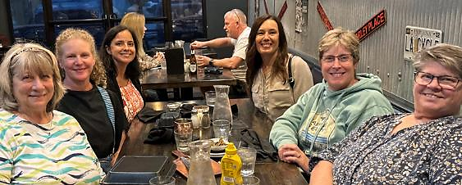
Seated L–R: Becky Fletcher, Jill Reinhart, Amie Lester, Beth Clarizia, Becky Ross and Susan Meadows
The Indiana retirees lunch group never tires of getting together for Mexican food! Everyone is welcome! Here's our September crew.
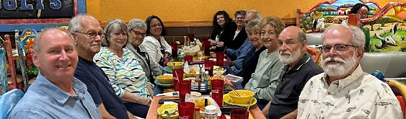
Indiana retirees’ lunch crew, L–R: William Elliott, Henry Wallis, Becky Fletcher, Jane Hardisty, Damarys Mortenson, Deb Montgomery, Susan Meadows, Tom Mulligan, Paula Mulligan, Cathy Deal, Mike Wiggington, and Chris Torp.
IOWA
Mark Jensen, ARCSE Representative
Email: amjens1@gmail.com
Retirees from northeast Iowa got together for breakfast on September 29th. They met at Johnson’s Restaurant in Elkader.

On August 29th a social gathering was held at the Oakland Community Center for NRCS and DSC retirees. The event was open for everyone, including current employees, but was primarily intended for folks who had worked in Area 4 or southwest Iowa. Approximately 50 people attended. The picture shows 33 of the attendees. It was a lot of fun reminiscing with everyone and enjoying a good pulled pork lunch. Thank you to Bonnie Allely and Jeff Godwin for organizing this get-together.

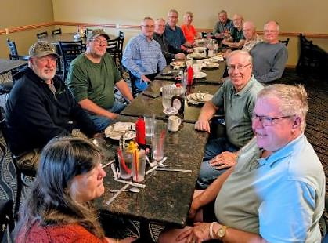
Northeast Iowa Breakfast Attendees: (Clockwise from the left) Todd Duncan, Roger Ericson, Jerry Muff, Rick Cordes, Norman Friedrich, Agnes Kenney, Jim Ranum, Bob Vobora, Ed Andrews, Kurt Hoeft, Dave Mellick, Tom Duvel and his wife Cindy. Shawn Dettmann took the picture.

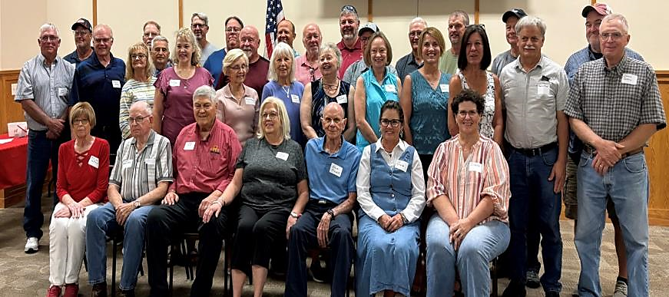
Area 4 Social Gathering: (L–R) Front Row seated: Billie Jo Hurford, Norm Koester, Ernie Aust, Bonnie Allely, Steve Stover, Lori Altheide, Sindra Lensch; Middle Row: (L–R) Steve Fluckey, Mark Jensen, Ronda McIntosh, Jim McIntosh, Kristi York, Linda Seipold, Bonnie Pierce, Becky Lockwood, Ruth Holan, Traci Blocker, Lois Crawford, Marvin Freed, Dennis Perkins; Back Row: (L–R) Brian Holmes, Tom Hurford, Kevin Kuhn, Jeff Godwin, Jim Gillespie, Dave Carter, Greg Mathis, Dave York, Terry Gleaves, Rick Sprague, Dale DuVal, Bill Hammitt, and Kevin McCall
On October 6th, Norm Koester and 4 other people from the class of '56 met at Bob's Bar in Martinsburg (NE) for burgers and French fries. The purpose was to observe 70 years out of high school. The day before this event, Norm told me the following: “We have been instructed that only true stories will be allowed, so there will not be a lot of conversation. There is one girl left, so we are relying on her to do the talking. Being a woman, she said she could handle it.
Four door prizes were awarded: 1. The person with the most natural teeth remaining; 2. The person with the best Medicare story; 3. The person who still remembers how to get home; and 4. The person who can twirl his cane without dropping it. We anticipate having a good time and if I remember, I'll let you know how it went.” So far, I haven’t heard back from him. Norm, I’ll catch up with you later to find out if you won a door prize!
Mike Sucik reports that RAGBRAI (the Des Moines “Register’s Annual Great Bike Ride Across Iowa”) was full of NRCS employees and retirees. He said “I saw retirees Lori Altheide and Darrell Geib at the Conservation tent, as well as Weston Dittmer. I also spent time with Dan Paulsen and was made aware that Christian Osborn also was on the ride.”
Linda Seipold retired from her Soil Conservation Technician position in the Malvern Field Office in December 2009. In addition to being a SCT, she began serving on the Malvern Volunteer Rescue Unit in 1981. After retirement from NRCS, she continued serving as an EMT. This past summer, Linda retired from her work with the Malvern Volunteer Rescue Unit after serving with them for 45 years. In 2023, Linda was inducted into the Iowa Emergency Medical Services Association’s Hall of Fame.

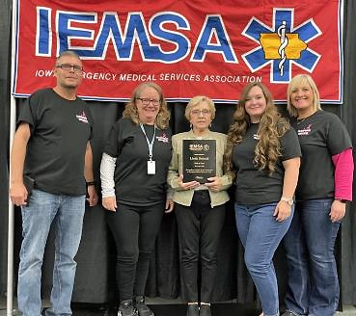
On October 4th, Jaia Fischer began serving as Iowa’s 12th State Conservationist. Jaia grew up on a farm in central Iowa. She and her family continue to live on the farm. They grow row crops and have a cow/calf operation. Jaia served in several different positions with NRCS in Iowa before being named the STC. I’m sure she will be a strong advocate for NRCS and agriculture in Iowa.
Since the Soil Conservation Service was established, Iowa has had 12 state conservationists. Following are the names and tenures of our state conservationists: Frank Mendell (1937-1965); Wilson Moon (1965-1975); William Brune (1975-1984); Michael Nethery (1984-1990); Jeff Vonk (1990-1994); Leroy Brown (1994-2004); Richard VanKlaveren (2004-2007); Rich Sims (2008-2012); Jay Mar (2012-2015); Kurt Simon (2015-2020); Jon Hubbert (2020-2026); Jaia Fischer (2026-Present). Lee White is one of the few – or probably the only – person who has worked under all 12 STCs. Lee started as a student trainee under Frank Mendell. He then worked as an engineer in the field and later as the State Construction Engineer, until his retirement in 2013. He then began working on a contract doing various jobs in the dam safety area, O&M, training, etc. He continues to work in that capacity. I’m fairly sure there aren’t very many retirees who have worked for that many STCs, or all of the STCs in a given state.
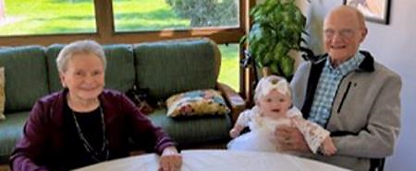
Jeannie and Eldon Weber with their great granddaughter Alanna
Eldon Weber told me that he and Jeannie were thankful that they were able to see their great granddaughter, Alanna, baptized. Eldon said there is “only a 90-year difference in their ages”!
In August we were saddened by the passing of John Chenoweth. John was the Hydraulic Engineer on the Planning Staff in Des Moines for many years.
MAINE
Mary Thompson, ARCS Representative
Email: mpthom@roadrunner.com
A chill is in the air here in Maine. The last games and meets of the high school sports seasons are wrapping up, firewood piles are getting stacked, and the last of the garden bounties are getting harvested. Beets are waiting to be pickled and carrots pulled for storage for me.
Soil Scientists and Conservationists, take notice. Here in Maine new license plates have been issued in the last year. As I travel the roads and follow behind those going the speed limit or below, I find myself gazing at the last three letters of the license plate number to see if it might be a soil unit symbol. I have found LrB, but no others that I know. Of course, here in Maine the last letter needs to be an A to E. My mother used to look when we had all numbers on the plates to see if it was a good cribbage hand.
I have not been able to attend any of the breakfasts for 2 or 3 months as we have been at our camp on First Roach Pond, which is on the east side of Moosehead. It is a camp, which I define as having no electricity, just propane gas and an outhouse, which was dubbed the “Music Room” by my father.
We are a small group that meets on the second Tuesday of each month at 9am at the Dysart’s Truck stop in Hermon, just south of Bangor and off Interstate 95. If you are in the area, please stop by! My email is skidthompson60@gmail.com if you have questions or want to catch up. Skid was my nickname when I attended Forestry School at the University of Maine at Orono.
–Yours in Conservation, Mary E. Thompson
MICHIGAN
William Fude, ARCSE Representative
William Fude passed away on October 15th. He worked in Iowa, Vermont, and Michigan for 31 years as an Administrative Officer with the NRCS. See the In Memoriam section for more details.
MIDATLANTIC STATES
Terry D’Addio, ARCSE Representative
Email: tmdaddio@aol.com
John Stierna passed away on September 27th. Wilson Scaling passed away on September 19th. See the In Memoriam section for more details.
John Moore reported: “I was in Aviemore, Scotland for two weeks. Did some technical rock climbing and bike riding with my friend and guide, Adele Pennington with whom I have climbed in the past in the English Lake District and Ben Nevis, Scotland.”
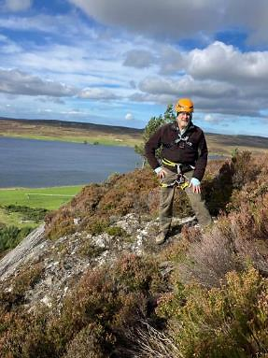
Janet Perry reported: “When we retired, we decided to take a big trip every year (that wasn't a family-related one). This year we went to Mount Rushmore and Crazy Horse, and worked our way to Yellowstone, where we spent 4 days, then to Grand Tetons at Jackson Lake. Our next stops were Craters of the Moon and the Experimental Breeder Reactor Atomic Museum, several dinosaur museums, and the Potato Museum. We ended our trip in Twin Falls, Idaho and spent some time at the Shoshone Falls Park. A good time was had my all. Our world sure is beautiful!”

Mount Rushmore
From SWCS: The National Capital Chapter is getting started on planning for the next SWCS International Annual Conference in the Washington, D.C., area. Please save the date for the event on July 25–28, 2027 in National Harbor, Maryland!
We're currently recruiting volunteers for the Local Coordinating Committee to help shape the conference experience by sharing local knowledge, recommending speakers and activities, and supporting efforts such as tours and a silent auction.
Please check out the initial interest form. Interested volunteers should complete the form by Friday, November 13, to be included in our first planning meeting.
MISSOURI
Gail Sallee, ARCSE Representative
Email: moarcse@gmail.com
The Annual MOARSCE Luncheon was held September 10, 2026 at the Golden Corral in Columbia. It was a rainy morning, and the road construction getting to Columbia provided some challenges for the out-of-towners. It was a small crowd of 17, but Bob Herschbach shared good news on Randy Freeland’s recovery, and we prayed his right thumb will heal quickly!
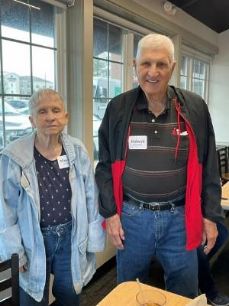
Mayree and Robert Crowder
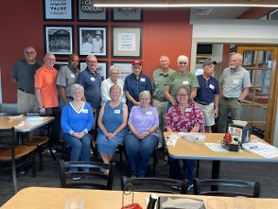
Back (L–R): Dennis Hoffman, Roger Hansen, Odie Swanegan, Larry Pollard, Bonnie Pollard, Jerry Edwards, Curt Rockhold, Bob Herschbach, Jack Cronhardt, Dwaine Gelnar. Front (L–R): Gail Sallee, Darlene Johnson, Jean Herman, Marilyn Gann. Not pictured was photographer, Rosie Herschbach
Jim Sturm: Been quite a while since the Great Jimbo did an article for the MOARCSE newsletter. So here it goes. Spent 2½ months in the nursing home last fall recuperating from foot surgery. This year, a couple of 9-day hitches at nursing home recuperating from cataract surgery. Sold a gas powered lawn mower this spring and now use an EGO 4204 42” battery power rider and amp; a 21” battery self-propelled unit that can travel 0.9 to 3.1 MPH, and a push mower. Both mowers have LED front lights too. It takes about 2–3 hours with the self-propelled unit, changing out two batteries. Great exercise. Added an 18ft X 28ft open carport to my house this spring. Redesigned some 108 feet of my 1990 spindle rail deck system this spring. Still working on the underground stormwater drain system under the carport and hauling “X” tons of gravel before the weather gets below 50 degrees this fall. Heard that the persimmon seed shape for north central MO was a spoon. Guess I shall be like an old bear and get ready for ‘bout 3 months of winter hibernation, what do ya all think?
Mike Blaine: This is a short update from Blaine Hill. I love the fall weather. It is great to be outdoors on the farm enjoying God’s creation. I am replacing a half mile of fence right now. Taking down a lot of very old barbed wire. I was hoping to have it done by deer season, but I don’t think that will happen! As I write this on October 20th I am 80 years old. My goodness, where did the years go? God has given me a good life! Happy Thanksgiving to all!
Paula Price: In 2024–2025 I had the pleasure of presiding over the Andrew County Rotary Chapter. The president, I was told, needed a project. So, I suggested a stage in Duncan Park for bands to use during concerts and for other events, too. Well, the stage grew into a Pavilion and to my pleasure our chapter toured the “ALMOST” completed project two weeks ago with donors and members. I must say it is amazing! The members took hold of the idea and ran with it. To finish means a large Andrew County rock will be dug up as soon as the soybeans are out of the field it is in. Its use will be a donor list where the public can see those who helped us. If you are ever in Savannah, I invite you to find Duncan Park (out by the High School and Performing Arts buildings) and take a look at what only a few people can do when they put their minds and skill to use. It is exciting that it has already been reserved for a wedding. In July the community rallied with an evening of music, food trucks, and a fireworks show at dusk. It was estimated over 1,000 people attended. Who would have known?
NEBRASKA
Jim Culver and Norm Kempf, ARCSE Representatives
Emails: j4culver@aol.com; nkempf@neb.rr.com
First Friday of the Month NRCS/SCS Retirees Breakfast Club
Participating during the September 4th 2026 First Friday of the Month Retirees breakfast were Ed Chmelka, Jim Harder, Mike Kucera, Jim Culver, Steve Chick, Harold Klaege, Craig Derickson, Steve Scheinost, Dennis Schroeder, Bob Sullivan and Dave Griffith.
Steve Chick continues to do an outstanding job of adding some great photos and reviews of past NRCS field activities to the Nebraska NRCS Facebook Group page. Current/past NRCS employees with ties to Nebraska can join by searching for Nebraska NRCS on Facebook and requesting to join.
Participating during the October 2nd 2026 First Friday of the Month Retirees breakfast were Ed Chmelka, Jim Harder, Steve Scheinost, Jim Culver, Dennis Schroeder, Ken Noonan, and Harold Klaege.
Craig Derickson recently had knee surgery and reported he is doing well. Recent rains slowed down the beginning of fall harvest of corn and soybeans. However, Dennis Schroeder said combines would be in full swing by the first of the week. He was correct as combines, trucks, and other farm equipment associated with fall harvest were quickly in action. So driving on rural roads one has to be careful as the large size farm equipment often takes up most of the highway.
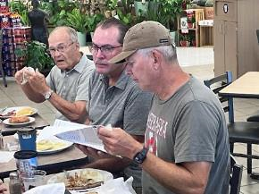
Right to left – Mike Kucera, Bob Sullivan, and Jim Harder. Mike is reviewing the past issue of the ARCSE newsletter.
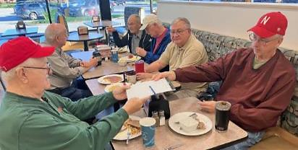
Left to right – Harold Klaege, Ken Noonan, Jim Harder, Ed Chmelka, Steve Scheniost, and Dennis Schroeder. Dennis is passing the signup sheet to Harold for our monthly attendance records.
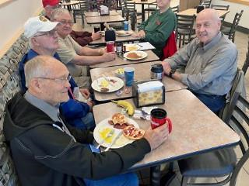
Jim Harder – Left end is enjoying breakfast. Jim does an excellent job of sending out notices to reminder us of our upcoming monthly breakfast meeting.
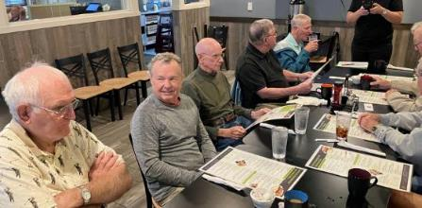
Our September meeting. Left to right – Craig Derickson and Norm Kempf visiting about Craig’s upcoming knee surgery.

Donna Dornbusch and Norm Helzer talking about Nebraska volleyball excellent start this year, Norm and his wife – Linda are very strong Nebraska volleyball fans!!
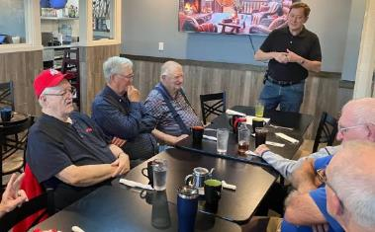
Doug Christian, our chairperson – standing- is cheerfully getting our meeting off to a good start. He is emphasizing it is now time to start discussing the opportunity to become an officer to lead our NRCS Retirees Breakfast Club for the upcoming year!
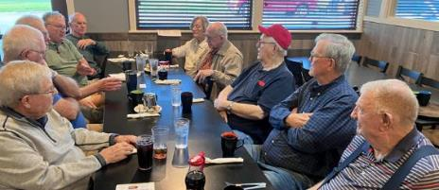
Our Wednesday morning breakfast group having some good discussion about some of the great Nebraska weather we are having, along with the ups and downs of some of the more significant sports – like football and volleyball – before getting our food orders placed.
Paul Allen Bartlett, 95, of Lincoln, Neb. passed away on October 7, 2026. Born on March 17, 1931, north of Max, Nebraska to George and Ocie (McClure).
NRCS/SCS RETIREES MINUTES
September 16, 2026
The meeting was called to order by Acting Chairperson Craig Derickson. Attending were Brown, Larry; Culver, Jim; Derickson, Craig; Dornbusch, Donna, Gus; Helzer, Norm; Kempf, Norm; Muckel, Gary; Reinsch, Thomas; Scheinost, Steve; Snyder, Dana; and Stover, Steve.
October 21, 2026
The meeting was called to order by Chairperson Doug. Christensen. Attending were Brown, Larry; Culver, Jim; Dornbusch, Donna, Dornbusch, Gus; Helzer, Norm; Kempf, Norm; Muckel, Gary; Scheinost, Steve; Snyder, Dana; and Stover, Steve, Klaege Harold.
Craig commented that it is interesting to think about how dynamic the weather is in Nebraska and around the globe. After months and years of drought conditions, we now have lots of rain. We seem to bounce back and forth between too hot, too cold, too dry, and then too wet.
Steve Stover reported that he was invited to attend a get-together of retired employees from his former Area Office staff in Council Bluffs, Iowa. Steve said the event was well attended by as many as 50 people, and he really enjoyed catching up with people and seeing everyone. Steve also recalled that many years ago he and his wife flew their small plane to Iowa to check out conservation activities while he was considering accepting the position of Area Conservationist. Steve was impressed with the operations in Iowa and accepted the position. That experience leaves him with many fond memories of all the SCS/NRCS activities, employees, and operations.
Norm Kempf reported that he had a surprise phone call from an old who had plans to come to Lincoln to see a family member play in the girls’ volleyball tournament. The friend came to Lincoln and brought 9 other family members with him. Norm and Sylvia were able to accommodate three people to stay at their house, and the others stayed in local hotels. Norm was happy to get tickets to the volleyball matches for three games.
Norm Helzer reported that the newly remodeled Bob Devaney Sports Complex turned out very well, and many people complimented the comfortable sets and the renovations.
Steve Schienost reported that he and his wife celebrated their 54th wedding anniversary recently. The group congratulated Steve and wished him and his wife many more happy years to come. Norman Kempf celebrated his 86th birthday in October.
Jim Culver reported that the recent SWCS Foundation golf tournament was a big success, with 40 or so participating. Many others who did not play offered to make donations to the Foundation. Jim commented that he and others were working on a letter to ARCSE and SWCS members to request donations for 2026 to support the Foundation’s efforts to provide scholarships to students in natural resources and the sciences.
Notes by Craig Derickson and attendance by Tom Reinsch. Submitted by Norman Kempf and Jim Culver
NEW JERSEY
Nancy Paolini, ARCSE Representative
Email: npaolini@comcast.net
Richard K. Shaw, Retired NJ State Soil Scientist, reported:
Since I retired at the end of 2019, I’ve kept busy with teaching and consulting work. Initially I taught Soil Classification for a few years at Delaware Valley University before they hired a full-time faculty member. As a result, I had to really learn Soil Taxonomy to keep ahead of the students. Since I always enjoyed doing fieldwork, describing and interpreting soil profiles, I did some onsite investigations on Preserved Farmland for the New Jersey Department of Agriculture for several years. Lately I’ve been teaching the intro soils class and coaching the soil judging team at Brooklyn College.
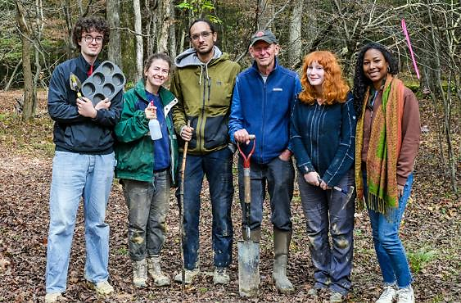
Brooklyn College Soil Judging Team, Fall 2025, University of Pittsburgh, Johnstown. Coach Richard K Shaw, third from right
Although it’s a somewhat lengthy trip for me by train and subway to the school from my home in New Jersey, the students’ enthusiasm keeps me returning each year. It’s always rewarding to see a diverse mix of students from the urban environment with interest in our science, and to gain confidence in their knowledge and field skills. As I worked on the soil survey in NYC, I also believe I have something to offer on the properties and distribution of the local soils
Barb Tibbetts passed away in May after a long illness. She was the wife of retired NJ State Engineer, Jack Tibbetts. A Celebration of Life was held at Barb’s favorite ocean point in Kennebunk, Maine, and was a nice gathering of family and friends. Rest in Peace Barb!
Dave Lamm, retired NJ State Engineer, with Jack Tibbetts | 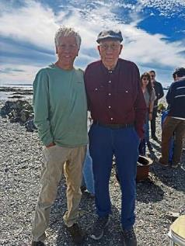
NORTH CAROLINA
James Canterberry, ARCSE Representative
Email: jhcanter@bellsouth.net
Retirees from the Raleigh area met at the NC Farmers Market Restaurant for breakfast on September 23rd. Several people were unable to attend due to health conditions. Attending the breakfast were Jim Canterberry, Frank Evans, John Kelly, Cecil Settle and Phil Tant.
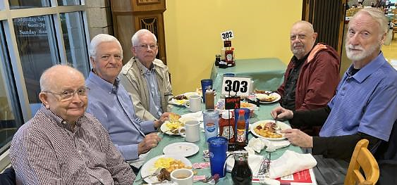
North Carolina Retirees’ breakfast
OHIO
Mike Monnin, ARCSE Representative
Email: mike.monnin427@gmail.com
With regret, I inform you that Norman Mull has passed away. I first met Norm when he was an SCS technician in Preble County, and remember him as a very dedicated conservationist with much to teach others. See the In Memoriam section for more details.
OREGON
Denise Troxell, ARCSE Representative
Email: nisetrox.gmail.com
Fall is in full swing here in the Pacific Northwest! Leaves are falling, and we’re planting our winter gardens and cover crops. Although the rain hasn’t started in earnest, it certainly will be soon, and the trick or treaters will likely be making their rounds in the rain.  The Oregon fall luncheon will be held next Wednesday, October 28th at the Stir Crazy Kitchen in Aloha, Oregon, and hoping to see some new faces. There have been numerous retirements in the last couple of years, and I’ve reached out to many recent retirees and grown the mailing list! | 


Steve (Sven) Fedje is doing well and recently enjoyed taking his boat up to Puget Sound.
Don Greiner is looking forward to an upcoming elk hunt. Ginny Cairo is planning an upcoming trip to Depoe Bay to celebrate her cousin’s 50th birthday at the Oregon Coast Aquarium that will include an octopus encounter (!).
Kathy Pendergrass shared that she is busy pruning a lot of her landscape for winter and moving plants around.
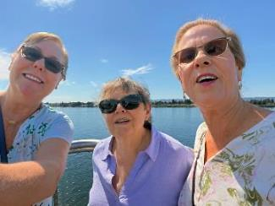
Anne Derting, Marybeth Smith, and Denise Troxell had a day outing to explore the new waterfront in Vancouver WA.
Mitch Cummings has spent his summer salmon fishing, building a shed, and hanging out with my family. Jeanne C George just enjoyed her 89th birthday celebrating with family and friends.
On a more somber note, there were two passings shared within the last couple of months:
Rita Ramos, Oregon NRCS IT Specialist and Webmaster passed on September 6, 2026, in Farmington, Utah. We also lost Bruce Franssen on August 31st, 2026.
This is the most difficult part of the job as the state lead for the retiree group, but it is so important to remember our colleagues; their contributions, and the indelible effects they had on our lives.
PENNSYLVANIA
Tim Murphy, editor (Excerpts from The PA Bugle)
Ed Brzostek says: “Due to my wife's recent fall and neck vertebrae operation, I had to cancel our trip to this year's PA retirees meeting. However, the day after the meeting I received a very touching and thoughtful gift of Amish Shoe-Fly Pie from a fellow co-worker. It was delivered by Wayne Bogovich who attended the reunion and has a house near ours.
Well once I found out who sent me this unique treat, I called them, thanked them and asked them, how in the world did you know that I love Shoe-Fly Pie. They said that the PA Grassland Specialist that did a detail about 15 years ago at the National Office (NHQ) left a message at the PA State Office that if anyone is going to NRCS headquarters bring Ed a Shoe-Fly Pie.
When that specialist was on detail at NHQ, we talked about PA things and I asked her if they sold Shoe-Fly Pie where she lived. She said they did and I said if she could bring one, I would gladly reimburse her. Sure enough the next Monday I had some wonderful Shoe-Fly Pie that I hadn't had in years. I never knew that she left a message at the State Office about me loving Shoe-Fly Pie.
And now 15 years later a State Office retiree somehow remembered this tidbit out about me and brought in Shoe-Fly Pie for me. This still blows my mind. Thank you again to that person for their thoughtfulness. NRCS retirees rock!”
Alan and Judy Wood recently traveled to Spain and Portugal. They walked portions of the Pilgrims’ Trail, visited the Guggenheim Museum in Bilbao, and toured the Douro Valley, of course sampling their port wines!
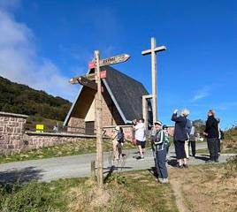
Judy on the Camino de Santiago
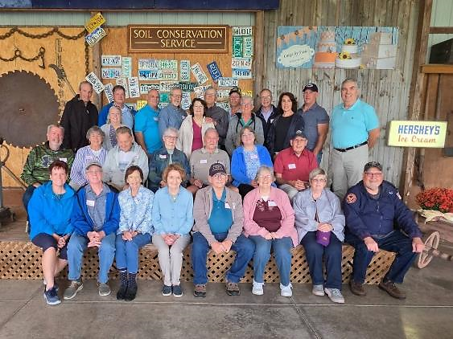
PA Retirees and Spouses, left to right, top row: Barry Frantz, Jackie and Wayne Bogovich, Bill Stidfole, Tim Murphy, Glenna and Hosea Latshaw, Ed and Susie Sanders, Gary Smith, Melinda and Scott Heckman, John Metrick. Middle row: Martin and Mary Smith, Norm Wolfrom, Leanne and Tom Calvert, Wendy Zwally, Nevin Ulery. Front row: Barb and Pete Vanderstappen, Rosie Updegraff, Gina Murphy, Chuck and Debby Shrump, Judy Ulery, Tim Hann. Not pictured: Russ and Darlene Kiefer, Dale and Gwen Kriner, Lori Stidfole, Rose Wolfrom.

The Guggenheim Museum in Bilbao, Spain
Rosie Updegraff writes: “I was in Chincoteague, Virginia in September with my daughter Tracy and her husband Rick. It was the week of the Plein Air Arts Festival. Artists paint on the island all week, then display their work for sale. It's very popular and is held every September. Rick also took us on the OSV (Over Sand Vehicle). He takes 1/2 of the air out of the tires to do it. It's a very bumpy ride but we love it and we can go far out on the sand.”
Hosea Latshaw reports: “Back in June, I had the opportunity to ride the Amtrak Pennsylvanian train from Elizabethtown, Lancaster County to Greensburg, Westmoreland County. I traveled with my 13-year-old grandson, who is crazy about anything trains. We stayed overnight in Greensburg and returned the next day and note that our trip was about 2 weeks before the Big Boy journey on the same rails.
I had never really ridden on an Amtrak train, and I had never taken a ride on a train across Pennsylvania, where I had worked for 43 years with SCS/NRCS. Here are some of my observations.
We traveled for miles following the Juniata River and later for miles following the Conemaugh River and in the middle crossed the mountains at Cresson. I have visited and stood next to the tracks at the Horseshoe Curve many times, but the Horseshoe Curve appears to have a much sharper radius when you are riding the curve and sitting inside the train coach!
From the train window, I saw pipe outlet storage terraces installed in the fields of the Blairsville State Hospital. The majority of the trip was through Pennsylvania forests, interspersed with small amounts of nice farmland. Along the tracks, there is significant, old industrial infrastructure; noticeably much older than the buildings you see along our highways; of course, the highways are much newer and have been built since the 1960’s.
Who remembers the Twin Ponds RC&D project, the retiree tour at the Lemon House, the Johnstown Flood, the broken dam at the Sportsman’s Club on the Southfork of the Conemaugh River, Spruce Creek where a past U.S. President came to fly fish, Spruce Creek home of the old EWP contractors (Earth Movers), the old paper mill in Tyrone, Lewistown (home Bill and Don Bowers), the local “Statue of Liberty” on the Susquehanna River, Rockville Bridge the longest stone arch railroad bridge, the former State Office locations near HACC, along Cameron Street, and at the old Federal Building near the Harrisburg Train Station, the new Federal Courthouse in Harrisburg. These were all adjacent to or near the route.
The Elizabethtown Railroad station is a beautifully refurbished old train station building, with oak woodwork, limestone structure, copper metalwork, and ADA handicap access! Most of the other stations that we passed were in fair to poor condition. The Tyrone station was only a moveable 10’ x 10’ woodshed built on skids located in the woods and out of sight of the town of Tyrone.
The railroad tracks are owned by Norfolk Southern Corporation and Amtrak rents the use of the tracks for their passenger service. Guess who has the right-of-way, passenger service or the freight trains? Several times our passenger train had to stop to let a freight train pass by as the freight train had the right-of-way.
Our trip by train took over 5 hours, and by car the trip would take only 3 hours. We enjoyed our travel by train, and I would recommend others consider giving this a try. Starting in November, Amtrak will be running a second daily train between Harrisburg and Pittsburgh.
Shirley Lindsey shares: “I recently visited my family in New Brunswick, Canada. My son Bruce Lindsey and his wife, Doris went along with me.
Since Don died last November 24, it will soon be a year. Some days I do okay and some days I just still miss him so much. It does help greatly to hear from or have visits from friends. I had a strange experience recently when I started getting emails from “Mr. Vance” – I assumed it was a scam. When I realized it was an AI voice message. I realized it was from old friends of ours (Lee and Jean Bentz). So, I might be 94, but did figure out that AI doesn’t know everything! Ha! If anyone is in the Hanover, PA area, I find calls and visits a real joy!”
Tim and Gina Murphy enjoyed a tour of Nova Scotia, Prince Edward Island and New Brunswick in September. We experienced some wild wind and rain on Cape Breton Island, including power outages and road closures. Lots of agriculture and aquaculture on PEI. The 50-foot tides on the Bay of Fundy were most impressive.

Peggy's Cove, Nova Scotia
The scenery and food were great, and the Canadian people were even better.
TEXAS
Michael Bogard, ARCSE Representative
Email: mbogard41@gmailo.com
David Buland reported: Dwain Daniels, former NRCS GIS specialist, is still doing GIS work, and church mission work in Rwanda. Here is a link to the mission work.
https://storymaps.arcgis.com/stories/594651ed44924778b4321d7c8017ba00
The Fort Worth NRCS Alumni Club met on Tuesday, September 8th at the Prima Pizza and Pasta.
In attendance were David Buland, Clyde Goodman, Rafael Guerrero, John Haberer, Maxine and Burnie Owen, Jim Rickman, Carol and Jim Robinson, Douglas Seibel, and Ken Twitty.
The next meeting is scheduled for December 8th, 2026 at noon at the Prima Pizza and Pasta located at 6108 S Hulen St, Fort Worth, TX 76133. Please forward this message to others I may have missed. Hope to see you there!
–Douglas Seibel
Michael Bogard wrote:
In this photo my wife Mary Beth and I are standing in four states. This is the exact spot where four states join. Those states are Utah, Colorado, Arizona, and New Mexico.  This photo was taken during our recent trip to mostly northern New Mexico, southwestern Colorado, southeastern Utah, and northeastern Arizona. Our trip began on Labor Day | 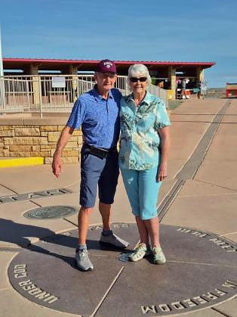

Ronald Hillard wrote:
“Edith and I just returned from a South African safari that began in Cape Town South Africa and ended in Johannesburg 12 days later. A wonderful trip beginning with Table Mountain in Cape Town, touring the countryside, wildlife sanctuaries, ostrich farms, vineyards, beautiful caves. The national park system is very well preserved and protected along the Indian Ocean route we took. Local foods were an added bonus on the safari, which consisted of chicken dishes, lamb, and ostrich prepared many ways. And a delicious. highlight of the safari was the 250,000-hectare Kruger National Park, where we spent two days in safari vehicles driving across the massive park to see and witness and photograph many African animal species roaming freely in their native habitat. We saw lions, elephants, hippos, giraffes, crocodiles, impalas, cheetahs on the hunt, wart hogs, and many more. A wonderful trip of history, and animal habits and habitats. Edith and I completed our travel to all seven continents with this African trip and have been to all five Oceans.
We are blessed to have been able to travel and experience so much. This trip is one everyone would enjoy, just a long 28-hr flight from Dallas to London to Cape Town, South Africa.
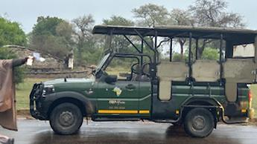





On our return we travelled to Houston to assist with the Ranching and Wildlife Archery Competition on October 9–11 which drew over 640 competitors from FFA and 4H chapters across the state.”
Arnold and Willeen King spent the week of October 5–11 on the island of Oahu to celebrate their 60th wedding anniversary. Because of the hurricane, they had to alter their trip and spend the entire week exploring that island. They stayed on Waikiki beach each night and spent the days visiting the sights. Highlights included the nightlife on Waikiki beach, the Pearl Harbor memorials, the Polynesian Culture Center, and the Dole Pineapple Farm.
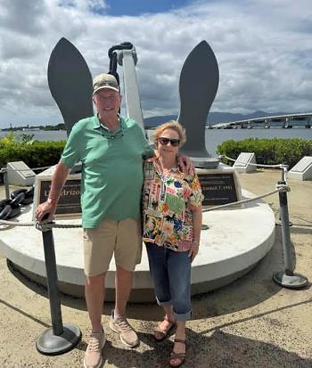
Arnold and Willeen King at Pearl Harbor. This is the actual anchor of the battleship Arizona.

Willeen and Arnold King on Waikīkī beach at sunset. “It’s a great place to be if you enjoy great food and tropical drinks.”
WEST VIRGINIA
Peg Reese, ARCSE Representative
Email: pegreesewv@gmail.com
West Virginia lost two of our own recently. Deborah Dorsey died on June 5th. She began her career as an aide in the Gassaway office. In the next phase of her career she was an Administrative Office Assistant in the Beckley Area Office. When she retired, she was functioning as a Farm Bill Contractor in the Morgantown State Office.
Dr. John Sencindiver died on October 21st. In the early 70s, John was a soil scientist in the Morgantown Soil Survey Office working under Dale Childs. He soon left SCS to become a professor at WVU and the coach of the WVU Soil Judging Team. His stellar career earned him a place in the WV Agriculture and Forestry Hall of Fame.
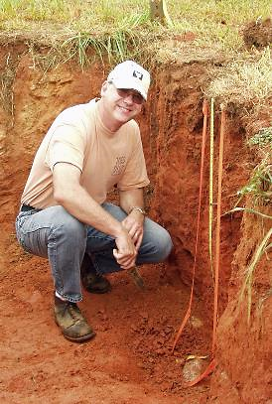
John Sencindiver in his natural environment.
You can learn more about the lives of Debbie and John in the In Memoriam section of this newsletter.
The WVDA Winter Blues Market is returning to Mylan Park in Morgantown on December 12th and the Charleston Coliseum and Convention Center on February 3rd. Mark your calendars if you want to pick up locally grown meat and produce.
WVU Soil Judging Coach James Thompson provided an overview of the team’s latest adventure:
The WVU Soils Team was in Athens, Georgia, last week (October 5–8) to compete in the 2026 Southeast Regional Collegiate Soils Contest. The nine students from the Davis College of Agriculture and Natural Resources were among 74 students representing 12 different schools. The history of intensive agriculture – and extensive erosion – is recorded in the soils and across the landscapes of the southern Piedmont. While conservation efforts restored forests across millions of acres, upland soils still show evidence of the previous soil loss, while valley bottoms have accumulated up to 5 feet of agricultural sediment.
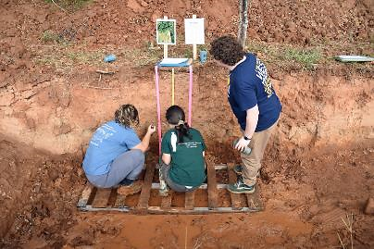
The contest was hosted by the University of Georgia. Other schools that participated were Auburn University, Clemson University, the University of Florida, the University of Kentucky, North Carolina State University, the University of Puerto Rico-Mayagüez, the University of Tennessee-Knoxville, the University of Tennessee-Martin, Tuskegee University, Virginia Tech, and Western Kentucky University. The students that traveled with the Team were Aubrie Benavidez (senior, Environmental Soil and Water Sciences), Kendall Gebhard (senior, Environmental Soil and Water Sciences), August Mallow (freshman, Environmental Soil and Water Sciences), Emma Quint (junior, Environmental Soil and Water Sciences), Brynn Sisk (senior, Environmental Soil and Water Sciences), Raleigh Sterling (sophomore, Environmental Soil and Water Sciences), Daisy Stemple (senior, Environmental Soil and Water Sciences), Joley Stemple (junior, Wildlife and Fisheries Resources), and Doreen Winter (sophomore, Biochemistry).
The team began their week with three days of practice, which involved describing, sampling, and evaluating a variety of soils representing both uplands and valley bottoms. After calibrating themselves on these unfamiliar soils, the students were ready to apply their soil judging skills to the contest pits. I am pleased to report that, once again, the team performed well. When the results were announced, four WVU students placed in the top 25, with Doreen Winter finishing 7th, Emma Quint 20th, Brynn Sisk 24th, and Daisy Stemple 25th. These individual results propelled WVU to a fifth place finish in the team competition. The WVU Soils Team will now begin to prepare for the 2027 National Collegiate Soils Contest, which will be held in April and will be hosted by Colorado State University. The other schools who finished in the top six and will represent the Southeast Region in the national contest are Auburn (first), Virginia Tech (second), Kentucky (third), North Carolina State (fourth), and Tennessee-Knoxville (sixth).
As always, I am extremely proud of the accomplishments of all these students, and I hope that you will join me in congratulating them if you have them in any of your courses or if you interact with them in other ways. These students continue to build upon the past success of the WVU Soils Team, and students and faculty from other schools recognize these students’ achievements. I believe this speaks to the quality of the training that these students receive from the School of Natural Resources and the Environment. It also reflects the overall strength of the academic programs across the Davis College. Thank you for your support of these students, particularly when they are away from campus for extended periods at critical times during the semester.
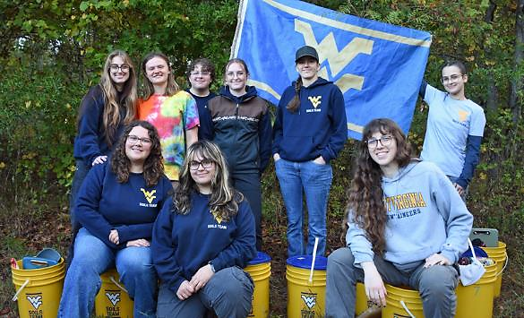
The WVU Soils Judging Team
WISCONSIN
Deb Legear, ARCSE Representative
Email: deb.legear@gmail.com
Submitted by Deb LeGear:
A gathering of retirees for a luncheon was held at the Pizza Ranch on September 17, 2026 in Verona, Wisconsin.
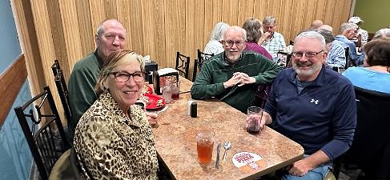
(L-R) Pattie Haack, Bob Weihrouch, Tom Thrall, John Pingry.
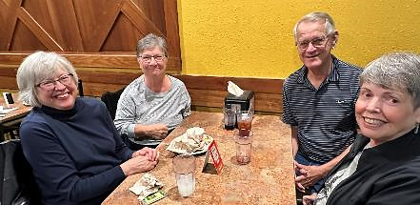
(L-R) Joanne Lubich, Sue Gundlach, Jim Enlow, Lynette Enlow.
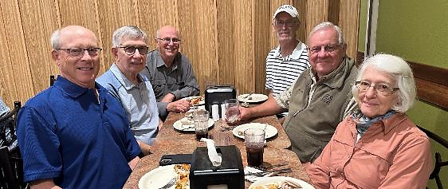
(L-R) Phil Meyer, Jim Kaap, Greg Igl, Roger Allan, Gene Nimmer, Annemarie Nimmer.
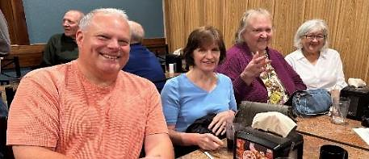
(L-R) Mark Roloff, Shawn Nameth, Judy Derricks, Susan Skubal.
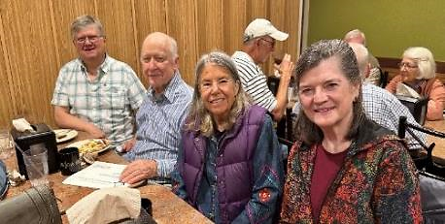
(B-F) Mike Sundquist, Phil Leavenworth, Pat Leavenworth, Renae Anderson.
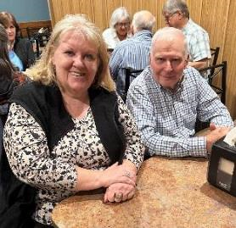
(L-R) Deb LeGear, Ted Manning.
Submitted by Joe Waukechon:
A smaller gathering was held at Shawano’s Café in Shawano, Wisconsin on October 8, 2026.
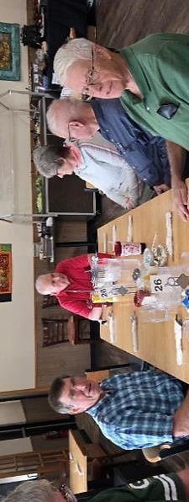
(L-R) Cutting the cake is John Campbell, Greg Rebman, Ted Manning, Linda Lindgren, Pete Lindgren, Gary Stanke. Not pictured, Joe Waukechon.

SENIOR CONSERVATIONISTS – Ruth Montgomery. Senior Conservationists have reached the minimum age of 83 years and have completed the Senior Conservationist Questionnaire (download at https://arcsecommunications.wordpress.com/senior-conservationists/). See IN-MEMORIAM for the Senior Conservationists who have left us since the last Newsletter. Please help us identify retirees who should be named Senior Conservationists. Please provide their contact information to your ARCSE Representative or Regional Vice-President.

OBITUARY INFORMATION  Paul Benedict, Membership Chair | When you receive word of someone passing, with little other information provided to you, obituaries can often be found by doing an advanced search using Google, using the full name of the deceased. If you do not have access to the internet, Paul Benedict will be glad to do the search. Please send death notices and obituary information directly to Paul Benedict at soilwarden@verizon.net. Always include the position or the spouse’s position with SCS/NRCS.

Surname | Year | In-Memoriam (Note: These are recent notices. For a complete list, please see www.arcse.org)
Bartlett | 2026 | Paul Allen Bartlett (95) of Lincoln, Nebraska, passed away on October 7, 2026. Paul was born on March 17, 1931, north of Max, Nebraska to George and Ocie (McClure) Bartlett. He enlisted in the U.S. Army in March 1952 and served in the Korean War as a Browning Automatic Rifleman, then as an Army squad leader. He graduated from the University of Nebraska Lincoln in agronomy and soil science in 1958. Paul went on to marry Betty Jean Sittner in 1956. He worked for 30 years as a soil scientist in several Nebraska counties and retired as an assistant state soil scientist in Honolulu, Hawaii. He eventually moved to Grand Junction, Colo., and later to Lincoln where he worked for Cambell’s Nursery for several years. He was a member of Good Shepherd Presbyterian Church, loved the outdoors, gardening, fishing, hunting, and serving as a deacon in his church. Survivors include his wife, Betty (Sittner) Bartlett; daughter, Susan (Todd) Kuwitzky; son, Wade (Susan) Bartlett; granddaughters, Kelly Kuwitzky, Kristen (Kuwitzky) Critchfield, Evelyn (Lee) Todd, and Eleanor Bartlett; great-grandson, Theodore Critchfield; and many special nephews and nieces.
Black | 2026 | Life Member Jacob W. “Jake” Black, Jr. (86) of Laurens, South Carolina, passed away July 9, 2026, at Prisma Health Laurens. Jake was born on May 10, 1940, in Swansea, South Carolina, to the late Jacob W. Black, Sr. and Clara Dantzler Black. He graduated from Clemson University in 1963, where he earned a football scholarship and played under the legendary Coach Frank Howard. He remained an avid Clemson Tiger fan for his entire life. Jake retired in 2000 from the USDA-Natural Resources Conservation Service in Laurens as the District Conservationist. During his 40-year career, he worked in Pickens, Edgefield, and Laurens counties. He was instrumental in the work to build the Lake Rabon dam and also assisted in the work to build the park in downtown Laurens and to help control the flooding issues in town. He also served as the President of the LD55 High School Booster Club from 1984-1988. Jake was of the Methodist faith, was a Captain in the United States Army where he served in the Dominican Republic, and loved being outdoors, especially hunting and working in the garden before his health declined. Jake is survived by his wife of 32 years Diane Lollis Black. Other survivors include a daughter, Angela Black Drake (Lucas) of Charleston, South Carolina, and a son, Todd C. Black (Olga) of Woodstock, Georgia; two stepchildren, Scott Barker (Caroline) of Laurens and Mary Beth Campbell (Tim) of Laurens; and three step-grandchildren, Alexandra Barker, Hampton Barker, and Christian Campbell, all of Laurens.
Bone | 2026 | Carl Wayland Bone (88) of McKinney, Texas, passed away on October 12, 2026. Carl was born December 2, 1937, in Coryell County to the late Blaine and Irene Bales Bone. He graduated from Gatesville High School in 1956 and attended Tarleton State College. He worked for the USDA-Soil Conservation Service as a Civil Engineering Technician, first in Waco, Texas and then in Temple, Texas on the State Office Design Team. After retirement, he lived in Tyler, Texas and Georgetown, Texas, before moving to McKinney to be closer to family. He was a member of Prestonwood Baptist Church in Plano, Texas. Carl is survived by his wife, Bonnie Berry Bone; daughters, Lezlie Smith (Randall) of Flower Mound, Texas and Lori Myers (Bob) of McKinney; grandchildren, Sarah Smith Walsh (Brandon) of Flower Mound, Rob Myers (Chasidy) of Prosper, Texas, Karen Smith Ambriati (Chris) of Flower Mound; and eight great-grandchildren, Riley Walsh, Camden Walsh, Hutton Walsh, Graham Myers, Declan Myers, Bree Myers, Caden Ambriati, and Adelyn Ambriati.
Bumgarner | 2025 | Bobby Jack “'Bob” Bumgarner (87) of Duncan, Oklahoma, passed on June 17, 2025. Bob was born September 29, 1937, in Graham Township, Oklahoma to John Stanford and Sue Elizabeth (Digby) Bumgarner - the youngest of seven children. He married Anita Ruth Gibson on September 15, 1961. He completed a 25-year career as a Registered Land Surveyor with the USDA-Soil Conservation Service (SCS) for the Davis, Lindsay and Marlow Oklahoma Field Offices) and then he worked 10 years as a Personnel Relations Specialist at Fort Sill, Oklahoma. Bob also served in both the United States Army Reserves and Air Force Reserves. Bob was a charter member of the Oklahoma Society of Land Surveyors. Few know that he was recruited by the local SCS Field Office after their inquiry with Davis Schools for students who excelled in math. After observing his performance as a Land Surveyor, his superiors encouraged him to transfer to the state office in Stillwater so he could attend college and major in Engineering. Though he declined that opportunity, his superiors assigned their interns to work with him to gain practical experience as part of their Surveying and Engineering development program. After losing his father at the young age of five, he began helping support his mother during his early teens by working for local cattlemen in the Davis area. Through this work, he developed a deep and lasting passion for livestock, horses, and pasture management - knowledge that would somewhat shape the course of his life. Alongside his brother Tom, he built and maintained a successful livestock operation for nearly 20 years. Following Tom's passing in 1988, he continued the work they had started together, carrying on the operation for another two decades. Acknowledging his civic responsibilities, Bob served on the Arbuckle Memorial Hospital Board, City of Davis Planning Board, as Deacon at the Vinita Ave Church of Christ in Sulphur, Oklahoma, and the Food Closet at the Chisholm Trail Church of Christ in Duncan. Survivors include his wife of 63 years, Anita; son John Bumgarner (Monica) of Duncan; grandson Joshua of Edmond, Oklahoma; and granddaughter Marissa also of Edmond.
Chenoweth | 2026 | Senior Conservationist and Honorary Member John Wilson Chenoweth (95) of Pella, Iowa, passed away August 23, 2026. He was born on January 20, 1931, to Wilson and Helen Joyce (Furry) Chenoweth in the Daviess County Hospital in Washington, Indiana. John's 4-H Club activities included potatoes, beef calf, gardens and corn. Beef projects were financially profitable (somewhat due to his father's generosity) to the extent that John paid his way through Purdue University. He graduated from Purdue in 1953 with a bachelor's degree in agricultural engineering. He continued his interest in raising beef cattle until 1987. After 10 weeks in hydraulic development at John Deere Tractor Works in Waterloo, Iowa, the military draft called John into the U.S. Army on August 26, 1953. He completed basic infantry training, field wire school and communications chief school at Fort Knox, Kentucky. Then, it was off to Europe where John was assigned to the 843rd Engineering Aviation Battalion at Toul Rosieres Air Force Base between Nancy and Metz, France. His primary duty was as chief construction surveyor on NATO airfields in France and Germany. While in the service, he visited 14 countries by using three-day passes and accumulated vacation time. After leaving the army, John farmed at Shoals for a while. His major career was with the USDA-Soil Conservation Service, beginning in 1961. After serving in field positions in Washington, Indiana, and North Vernon, Indiana, he specialized in hydrology and hydraulic engineering for 29 years, working in project planning offices in Indianapolis, Indiana and Des Moines, Iowa. He retired in 1995 and enjoyed part-time consulting on matters related to his professional experiences. John was a member of the Soil and Water Conservation Society for 53 years. He held lifetime memberships in the American Society of Agricultural Engineers and the Purdue Alumni Association and was a licensed Professional Civil Engineer for 44 years. John married his sweetheart, Carolyn Sue Pinkston, in her hometown of Farmersburg, Indiana, in 1960. John was involved in activities of the Methodist church early in life and remained active in congregations throughout his life. He is survived by his wife of 66 years, Carolyn; three sons, Gregory John, Paul Wilson, and Andrew Joseph; 10 grandchildren and 5 great-grandchildren.
Crane | 2026 | Cara Diane Crane (49) of Stillwater, Oklahoma, passed away on September 12, 2026, in Stillwater. She was born on October 25, 1976, in Stillwater, Oklahoma to Gene and Sherry Crane. Cara earned her bachelor’s degree in business management from Oklahoma State University (OSU) in 2000. She worked for several years as a management analyst for the USDA-Natural Resources Conservation Service and the Federal Aviation Administration. She also gave generously of her time and leadership in service as President/Treasurer of the Tri Delta Sorority Housing Corporation. She will be remembered as a fun, loving, kind, and generous person whose presence brought warmth to those around her. Cara enjoyed fishing, reading, restoring antiques, and anything related to OSU athletics. She especially loved fishing with her family and was always proud to say she had caught the biggest fish, a memory that will continue to bring smiles to those who knew and loved her. Cara is survived by her parents, Gene and Sherry (Russell) Crane; her brother Derek Crane and his wife, April, of Magnolia, Texas; and her nieces, Sydney Crane and Reena Crane, both of Magnolia, Texas. She is also survived by her uncles and aunts, Mike and Reta Crane, Billie and Doug LeForce, Carol Allen, John and Pam Russell, Denise Hunt, Becky and Virgil Beckner, LeAnn Jones, Bill and Sue Russell, and Phillip and Mary Russell; and numerous cousins. She was preceded in death by four uncles, Jim Allen, Bill Vassar, Lynn Hunt, and Wayne Jones.
Dorsey | 2026 | Deborah “Debbie” Lynn Dorsey (70) of Mount Nebo, West Virginia, passed away June 5, 2026, following a brief illness. Debbie was born October 9, 1955, at Naval Air Station North Island in Coronado, California, the daughter of Paul and Mazie Clemens of Canvas, West Virginia, who survive her. Debbie married her high school sweetheart, Leon Dorsey, on July 6, 1973. Together, they built a life centered on faith, love, and family and shared nearly 53 years of marriage. Debbie retired from the USDA-Natural Resources Conservation Service after more than 20 years of dedicated service, rising to the position of GS-13. She was a Special Projects Officer with the Soil and Plant Division working remotely from Beckley, WV when she retired. She found great joy in arts and crafts, spending time with her family, and supporting her grandchildren in their many activities. Her kindness and generosity touched the lives of many. Debbie was a faithful member of Mountain View Church in Canvas. Even during her final illness, her confidence in Christ remained strong. In addition to her parents, Debbie is survived by her beloved husband, Leon Dorsey; three children, Lisa Randolph (Brian), Chris Dorsey (Trish), and Andrea Torres (Scott); and ten grandchildren, Andrew, Matthew, and Tyler Randolph; Caleb, Taylor, and Colton Dorsey; and Boston, Bryce, Bailey, and Brooks Torres.
Elkins | 2026 | Robert “Bobby” Jones Elkins (85) of Richmond, Kentucky, passed away peacefully on October 17, 2026. He was born on April 12, 1941, in Hodgenville, Kentucky, the son of the late Lorene and Joe Elkins. Bobby began working with the USDA-Soil Conservation Service as an engineering technician in 1962 and retired in 1994. He then returned to the Madison County Conservation District, under its new name, the Natural Resources Conservation Service, and continued working there until 2009. In total, he dedicated 49 years and 6 months of service to the organization. In addition, he served S as a pond consultant for the entire state of Kentucky. Bobby found joy in spending time with his best buddies on their annual hunting trips, fishing, enjoying the outdoors, reloading hundreds of shells, watching the University of Kentucky Wildcats, and watching every Western rerun over and over. Bobby was of the Baptist Faith. Survivors include children, Robin Elkins and Scott Elkins along with their mother: Maxine Bowen; his grandchildren, Jessica McVey, Reagan Read, Reanna Lobb (Jonathan Lobb), and Jared Elkins (Ashley Elkins); his great-grandchildren, Kindal Read, Haylee Hunt, Lane Elkins, Kyleigh Read, Conner McVey, Wyatt Elkins, Colt Elkins, Emery McVey, and Laira Lobb; one great-great-granddaughter Jazmyne Myers; and his sister, Jorene Garrison (Kenny Garrison). He was preceded in death by his wife, Frances Elkins in 2009.
Ely | 2026 | Gary Robert Ely (70) of Fairmont, West Virginia, peacefully passed away surrounded by his family on September 3, 2026. He was born on August 16, 1956, a son of the late Robert Henry and Katherine Elizabeth Welch Ely. Gary retired as a Soil Conservation Technician for the USDA-National Resources Conservation Service (NRCS) in 2011, a job he thoroughly enjoyed. Early in his career his duties included flood response, work that left him with many memories of the 1985-86 floods in West Virginia, and construction on watershed dams in the counties surrounding Marion. In retirement, Gary was happiest outdoors and at home with his hands busy. He enjoyed hobby farming on his property, and he spent many hours building hiking trails through the woods, often with his grandchildren beside him. Gary is survived by his loving wife of 47 years, Cindy Jane Henderson Ely; his children, Clint Ely (April) of Ohiopyle, Pennsylvania, Aaron Ely (Katherine) of Mt. Harmony, West Virginia, Jason Ely (Jessica) of Mt. Harmony, Megan Ely of Mt. Harmony, Sara Spicer (Logan) of Levels Community, West Virginia and Kimi Ely of Mt. Harmony. Gary is also survived by his grandchildren, Logan Garner, Levi Garner, Lucas Garner, Asher Ely, Graham Ely, Maddox Ely, Reid Ely, Caroline Ely, Kairi Jarrett, Brantley Spicer, Isla Ely, and Aliyah Spicer, one great-grandchild, Tobiah Garner.
Franssen | 2026 | Bruce Allen Franssen (75) of McMinnville, Oregon, passed away peacefully, at home on August 31, 2026. He was born in Sacramento, California, on January 23, 1951, to Roy Alex Franssen and Ethel Norma (Hanson) Franssen. He studied Rangeland Resources at Oregon State University. He married Nancy on Dec. 4, 1983. Bruce worked for the USDA-Natural Resources Conservation Service for over 30 years, passionately working as a Range Conservationist alongside Oregon's farmers and ranchers to implement sustainable land practices. Bruce was a dedicated husband, father, brother, grandfather, uncle, cousin and a friend to many. He was loyal, honest, and a lover of the natural world. He could often be found among a mountain of library books, curiously exploring different countries and cultures, reeling in trout at the local lakes, or cheering on the mighty Oregon State Beavers proudly wearing orange and black. Bruce is survived by his wife, Nancy; son, Steven (Courtney); daughter, Melody (Dan); brother, Brian; sister, Karen; three grandchildren, Calla, Royce and Reed; and many cousins, nieces and nephews.
Fude | 2026 | Member and ARCSE Michigan State Representative William John Fude, Jr., (80) of Grand Ledge, Michigan, passed away on October 15, 2026. Bill, as he was best known, was born on November 25, 1945, in Estherville, Iowa, the son of William Sr. and Marie (Haag) Fude. He was drafted into the United States Army and served during the Vietnam War. On November 23, 1974, Bill married Theresa “Terry” at St. Francis Xavier Catholic Church in Winooski, Vermont. Following his military service, he graduated from Parsons College in Iowa. He later worked in Iowa, Vermont, and Michigan for 31 years with the USDA Soil Conservation Service/Natural Resources Conservation Service. He was the Michigan State Administrative Officer when he retired in 2008. In retirement, Bill continued his commitment to public service by serving as president of the National Active and Retired Federal Employees Association (NARFE). Bill enjoyed genealogy, traveling to Florida, and a good whiskey. He also enjoyed spending time with his dog, Aspen. Bill was preceded in death by his wife, Terry in 2009. Survivors include his daughter, Andrea (Kevin), and grandchildren, Chase William and Reese Marie, all of Grand Ledge.
Graves | 2026 | John E. Graves (97), formerly of Vega, Texas, passed away on January 14, 2026. John was born June 21, 1928, in Garrison, Texas. He graduated from Texas A&M University in 1952 with a bachelor’s degree in Forest Management, was a Corps Cadet member, earning his military rank as Second Lieutenant in the United States Marine Corps. Upon his honorable discharge from the service to return to the farm in Garrison to care for his widowed mother. He married Zella Mae Carpenter on February 27, 1953, in Nacogdoches, Texas. His employment with the USD-Soil Conversation Service transferred him to various West Texas cities before moving to Vega, Texas in August 1967. During this time he worked as a District Conservationist and Range Conservationist. John & Zella retired in 1996, moved briefly to Amarillo in 1997 before moving to Conroe, Texas in 1998. After Zella’s untimely death from cancer in September 2002, John continued to live in Conroe. When his youngest daughter Sharon moved to Frankston, Texas in the spring of 2017, John followed shortly after that. John loved working outside in the yard, even helping Mike and Sharon at the farm. At the time of his death, John was residing at Garden Estates Retirement Center in Tyler, Texas. John was preceded in death by his wife of 49 ½ years, Zella M. Graves. Survivors include his children, Debbie Wilson (Brad) of Amarillo, Texas; Rick Graves (Chella) of Waco, Texas; and Sharon Spinhirne (Mike) of Frankston, Texas; grandchildren and great grandchildren: Shaye Pingel Segovia of Vega and her daughter Abreigh; John Wayne Pingel (Tara) of Humble, Texas and children, Wyatt, Tate and Walker; Dustin Spinhirne (Jin) of Frankston, and children, Logan and Evan; Joshua Spinhirne (Christina) of Flint, Texas, and children Jared and Jacob; Seth Spinhirne (Emily) of Frankston, and children Cole and Anna; Jason Graves Megan) of Arlington, Texas, and children Elijah, Ezra and Emerson; Jeffrey Graves (Jenny) of LaVernia, Texas, and children, Lyla, Layton and Linc; and Johnathon Graves of Lubbock, Texas.
Hart | 2026 | Jimmy Joe Hart (89) of Tulsa, Oklahoma, passed away on February 4, 2026. He was born on September 24, 1936, in Enid, Oklahoma, to John and Helen Hart. He attended Oklahoma State University from 1955 to 1956. On September 28, 1956, he married his high school sweetheart, Joyce Marie Hancock, at First Baptist Church in Enid. Jimmy enjoyed a successful 30-year career with the USDA-Soil Conservation Service (SCS). In 1962, he accepted a position as a Civil Engineering Technician with the Kansas State Office in Salina, Kansas. From 1974 to 1977, he continued his career in the Michigan State Office in East Lansing, serving first as a Contract Specialist and later as a Personnel Management Specialist. In 1978, Jimmy returned closer to family and continued his career with the Oklahoma State Office in Stillwater, where he served as Personnel Management Specialist, Personnel Officer and later as State Administrative Officer until his retirement from federal civil service in 1994. After retiring, Jimmy and Joyce moved to Tulsa, Oklahoma, in 1995 to be closer to family. Never one to be still, Jimmy became an active member of the Tulsa Elks Lodge. In 2019, the Elks Lodge honored Jimmy and his wife, Joyce, by renaming the Lodge's lounge the Hart Lounge, in recognition of their many years of dedicated service to the Lodge and the community. Jimmy enjoyed camping and hunting in his earlier years, later transitioning to golfing and traveling. However, his greatest joy was always found in spending time with his family. He had a gift for working with his hands, and no project was ever too great a challenge. Whether remodeling a bathroom, installing wood floors, or building furniture, Jimmy approached each task with skill and craftmanship. Jimmy is survived by his loving wife, Joyce Hart; his sons, Ron (Christy), and Doug (Susan); his grandchildren, Olivia Hughes (Nathan), Ann-Marie, and Megan.
Henney | 2026 | Scott Shafter Henney (62) of Elizabethtown, Indiana, passed away peacefully at home surrounded by his dearly loved ones on September 25, 2026. Scott was born August 17, 1964, to Jean S. Henney and Geraldine (Sheets) Henney. Scott suffered a spinal injury that changed his life forever. If someone told Scott he couldn't do something, he was determined to prove them wrong. His strength, determination, spirit, and wit were hallmarks. Scott married the love of his life, Lorie Ann (Brinkley) Henney. He worked as a Computer Specialist for the USDA-Natural Resources Conservation Service until his retirement. He enjoyed working on cars, listening to jazz, drinking Mountain Dew, following motorsports, and driving his Corvette. He looked forward to trips to the Indy 500. Scott loved his family. Some of his happiest memories came from family trips to Mardi Gras and theme parks. He is survived by his wife, Lorie Henney; son, Zachary (Sherrianna) Henney; goddaughter, Laci Green; stepson, Adam Smith; stepdaughter, Amanda Smith; grandchildren, Theodore Henney, Charlotte Henney, Lexi Green, Jasmine Smith, Nicholas Smith, and Zoey Smith.
King | 2026 | Lynn Turner King (71) of Cerulean, Kentucky, passed away October 3, 2026. Lynn was the wife of retired Soil Conservation Technician Gaylon Wayne King. She was born on November 11, 1954, in Cadiz, Kentucky, to William Bill Turner and Louise Jacob Turner. She retired from the Kentucky Department of Unemployment as an Unemployment Insurance Specialist after 27 years of service. She was a member of the Cerulean Baptist Church. Lynn was a farmer alongside her husband, Gaylon. The joy of her life was spending time with her family and grandchildren. In addition to her husband Gaylon, Lynn is survived by her son Dusty King (Andrea), of Cerulean; daughter Laura Gayle Stith (Kevin), Brandenburg, Kentucky; eight grandchildren Laura Michelle King (fiancé Tyler Frost), Garrett King, Logan King, Emma Grace King, Mary Brooke Stith, Andrew Stith, Joellen Hanson (Carrington), and Jamison Reynolds; and two great-grandchildren.
Krebs | 2026 | Life Member Donna Rae Krebs (87) of Centre Hall, Pennsylvania passed away at Mount Nittany Medical Center on October 10, 2026, surrounded by her family. She was born in Centre Hall on March 10, 1939, to parents Emory F. Floray Sr. and Alice I. (Weber) Floray. Donna was in the first class to graduate from the new Penns Valley High School in 1957 where she played the trombone in the marching band and was the high school’s first drum major. After high school, she worked at Pennsylvania State University in correspondence and later at HRB Systems-Singer in State College, Pennsylvania. Donna married Gerald L. Krebs in 1960 after meeting him at the Spring Mills Carnival, and four years later decided to stay at home and raise her growing family. Eventually, she worked in Bellefonte, Pennsylvania for the Centre County government and later for the USDA-Natural Resources Conservation Service (NRCS) in State College. Donna was best known as the Area Clerk in the Area 5 office on State College, and she served as a Program Assistant and held other roles in NRCS after that office closed until her retirement in 2003. She was a 55-year member and past matron of Centre Chapter 207, Order of the Eastern Star in Centre Hall; a charter member of the Centre Cedarettes in State College; and a longtime member of Trinity United Church of Christ in Centre Hall where she was the church secretary for 43 years. Her husband Gerald passed away in 2018. Survivors include three daughters, Jeanette Krebs of Harrisburg, Pennsylvania, Jessica Krebs (Mark West) of Lancaster, Pennsylvania, and Janda Hankinson (Ray) of Centre Hall; grandchildren Nick Jimenez (partner Sarah Kula) of Philadelphia, Pennsylvania, Sophia Fox (fiancé Brendan Balco) of Philadelphia, Andy Hankinson (fiancé Natascha Santaella) of Mill Hall, Pennsylvania, Lydia Hankinson of Centre Hall, Anya Fox of Harrisburg, Pennsylvania, and Olivia Jimenez (partner Larry Bourland) of Bozeman, Montana.
Lamirand | 2026 | Thomas Jackson Lamirand (79) of Perry, Oklahoma, passed away October 9th, 2026, at Stillwater Hospital in Stillwater, Oklahoma. Tom was born on February 5th, 1947, in Shawnee, Oklahoma, the son of T J and Deloris (Patterson) Lamirand. Tom studied at Oklahoma State University where he received a Master of Science degree in Civil Engineering. He went to work for the USDA-Natural Resources Conservation Service where he was a well-respected engineer. After retirement he worked for M & E Consultants for 11 years. His Christian faith was an important part of his life. Tom is survived by his sons Nathan Lamirand of Tecumseh, Oklahoma and Vince Lamirand of Oklahoma City, Oklahoma, his brothers, Gerald Lamirand of Louisiana, and Charles (Mike) Lamirand of Edmond, Oklahoma; his grandson Trevin Lamirand of Englewood, Colorado and two great granddaughters. Tom was preceded in death by his his oldest son Troy Lamirand of Vermont. Tom was also preceded in death by his good friend Donna Brorsen.
Lavway | 2026 | David R. Lavway (79) of Glenburn, Maine, passed away peacefully September 22, 2026, at the Aroostook House of Comfort in Presque Isle, Maine, after a two-year battle with cancer. David was born on October 18, 1946, in Presque Isle, Maine, the son of Clair and Christina (Churchill) Lavway. Dave attended the University of Maine at Orono, earning a Bachelor of Science degree in agricultural business and economics. He married his sweetheart, Joanne, in July 1969. Dave began his career in 1969 with the USDA-Soil Conservation Service. Along the way, his commitment to service also led him into Christian education, where for 14 years he taught and coached at Bangor Christian Schools and later New Testament Christian School in Massachusetts. After returning to Maine, Dave resumed his career in agriculture and held a number of positions of increasing responsibility, including district director of the Central Aroostook Soil and Water Conservation District, executive director of the Maine Potato Board, government relations director for the National Potato Council, administrative officer for the USDA Agricultural Research Service, state executive director of the USDA Farm Service Agency, and deputy commissioner for the Maine Department of Agriculture, Conservation and Forestry and the Maine Department of Administrative and Financial Services. Dave was a founding member of the Agriculture Council of Maine and was appointed to serve two terms on the Agricultural Technical Advisory Committee for Trade in Fruits and Vegetables. He also served as a member and chairman of the USDA Potato Industry Advisory Committee for Research and Extension. Throughout his career, Dave was a respected advocate for Maine agriculture, supporting the state's agricultural community and the people whose livelihoods depend upon it. Dave is survived by his beloved wife of 57 years, Joanne (Brown) Lavway and their daughter, Marci (Stephen) Wilcox; son-in-law, Kris Milo; grandchildren, Christopher (Brooke) Wilcox, Andrew Wilcox, Morgan (Chris) Amero, and Felix Milo; great-grandchildren, Mason and Aubree Wilcox, and Grady and Brecken Amero. Dave was predeceased by his daughter, Amie Milo.
Love | 2026 | Life Member Charles Lee Love (72) of Auburn, Alabama, passed away on October 2, 2026, at his home. Charles was born February 24, 1954, in Madison County, Tennessee. On October 16, 1993, Charles Love and Alice Shackelford-Love united in holy matrimony in Chatman, Illinois. At Tennessee State University he graduated with a Bachelor of Science degree in Agronomy and Soil of Science. He worked as a Soil Scientist for the USDA-Natural Resources Conservation Service (NRCS) for forty years throughout the midwestern and southern states. In 2017, he closed his career as the “First African American” Regional Director for Region-7 headquarters in Auburn, Alabama. He received many awards as an employee with the NRCS. Upon relocating to Auburn, Alabama, Charles became an active member of Mt. Vernon Missionary Baptist Church. Survivors include his devoted wife of thirty-two years, Alice Shackelford-Love; a loving daughter, Princess Mildred Love; four brothers, Terry Love, Jerry Love, Thomas Love, and DeRoy Ellison; one sister, Glenda Rogers; a host of nieces, nephews, other relatives and friends.
Menkin | 2025 | Frank R. Menkin (85) of Plymouth, Maine, passed away on December 6, 2025. Frank was born September 2, 1940, in Elmhurst, New York, the son of Arthur H. and Goldye (Wagner) Menkin. He majored in music, specializing in voice at Cornell University, graduating in 1962. In 1966, Frank married Frances M. Merrihew. They spent nearly 60 blessed years together. Most of Frank's working years were in computer technology, the last 12 years with the Maine State office of the USDA-Natural Resources Conservation Service in Bangor, Maine, until he retired in 2015. The memory of Frank's beautiful voice, lifted in song to the Lord will remain in the minds and hearts of all who heard him. Frank was a communicant of St. Paul the Apostle Parish in Bangor, Maine, (St. John's Church) for 26 years, where he enjoyed the privilege of serving as an extraordinary minister of Holy Communion. Survivors include his devoted wife, Fran; their three children, Franklin R. Menkin Jr., Joshua C. Menkin (Joyce), and Sarah M. Menkin; 13 grandchildren: Elyshia Menkin, Ryan Menkin (Rebecca), Jennifer (Menkin) Glick (Matthew), Audrey (Menkin) Prowant (Joshua), Jordan Menkin (Laura), Zachary Menkin, Jared Menkin, Alyssa Menkin, Cherry Menkin, Melody Menkin, Spencer Menkin, Spring Menkin and Caroline Menkin, and 7 great-grandchildren: Emily, Bethel and Eleanor Glick; Woodland, Betsy and Madelyn Prowant and Ethan Menkin.
Mull | 2026 | Life and Honorary Member Norman Taylor Mull (93), formerly of New Paris, Ohio, passed away peacefully on September 30, 2026. He was born December 26, 1932, to Charles and Ruth Mull. Norman proudly served his country in the United States Army from 1953 to 1955 with the 298th Transportation Company (Light Truck). He earned the rank of Private First Class in 1954 and received the National Defense Service Medal. In 1956, Norman met the love of his life, Carolyn Joyce Bright, when he famously “fell over her desk at work.” Six months later, they married at her parents’ home. Norman “No-Till” Mull began farming at 14 and continued into his 70s. A dedicated conservationist, he embraced no-till farming and sought ways to care for the land while improving his farm. He worked for the USDA-Soil Conservation Service in Preble County, retiring in 1988. He later spent several years as a contractor for the Wayne County Soil Conservation Service Extension Office. Alongside Carolyn, he created Running Springs mini-bike farm and campground, where families, friends, and church groups gathered and made lasting memories. As founder of the Ambassador 4-H Motorcycle Club, he encouraged young people to develop riding skills, responsibility, character, and sportsmanship. He and Carolyn were longtime faithful members of St. Paul United Methodist Church in New Paris, where they worshiped and served together. Following Carolyn’s passing, Norman found a new church home at New Hope Church. He was also a member of The Gideons for nearly 30 years. In 1994, Norman and Carolyn opened the Pathway Rec Center at St. Paul United Methodist Church. For the next 15 years, they provided a Christian environment where young people could enjoy games, friendship, and fellowship. Norman and Carolyn also spent more than 20 years supporting the National Trail cross-country team and were honored with induction into the National Trail Hall of Fame. Norman is survived by his sons, Daniel (Angela), Jim, and Rick (Shelly); his 12 grandchildren, Nigel (Jadwiga), Amanda (Marc), Alex (Tyler), Kristin (Matt), Ben, Roger (Katie), Leah (Vinny), Keaton, Victoria (Chris), Bethany, Krista (Stephen), and Keith; nine great-grandchildren; and one great-great-grandchild. He is also lovingly remembered by his bonus son, Steve (Sharon) Vanzant, and the Tabi family of Kumasi, Ghana, whose special friendship with Norman and Carolyn spanned many years. Norman was preceded in death by his beloved wife of 65 years, Carolyn, and his son, David.
Norton | 2026 | Senior Resource Conservationist, Life Member and ARCSE Alabama State Representative Earl Norton (88) of Auburn, Alabama, passed away on October 3, 2026. Earl was born in Gadsden, Alabama on November 13, 1937, to Earl Wood and Fannie Lee Norton. Earl went on to Auburn University (AU) where he played trumpet in the AU Marching Band, participated in Naval ROTC, and earned a Bachelor of Science degree in Agricultural Science in 1960 and a Master of Science degree in Agronomy and Soils in 1964. Upon graduation Earl served on active duty with the United States Navy before beginning his career with the USDA-Soil Conservation Service (now the Natural Resources Conservation Service). Earl retired in 1994 with 37 years of federal service and immediately began his second career as a natural resources consultant for erosion and sediment control planning in the private and public sectors of the construction industry. He taught a conservation course at Auburn University, coordinated a state-wide erosion and sediment control program in construction stormwater for the Alabama Soil and Water Conservation Committee, and worked as a specialist in the program. Earl believed strongly in professional development and obtained certifications as a Professional Agronomist, Professional in Erosion and Sediment Control, Crop Advisor, and Prescribed Burn Manager. He was a long-time member of the Soil and Water Conservation Society (SWCS), the International Erosion Control Association (IECA), the American Society of Agronomy, the Soil Science Society of America, and several state-level organizations. He received numerous recognitions and honors for his contributions to the field. He was inducted into the Hall of Honor by the Auburn University Agricultural Alumni Club and honored as a Fellow of the SWCS, a Sustained Contributor of the International Erosion Control Association, and the Soil Conservationist of the Year and Water Conservationist of the Year by the Alabama Wildlife Association. In addition to his career pursuits, Earl was an active member of Auburn United Methodist Church where he sang in the choir for 50 years. Earl is survived by his wife of 59 years, Julia Norton; son, Tony (Lisa) Norton of Auburn; son, Daniel (Susan) Norton of Auburn; grandchildren, Brad Norton (Sean Flowers) of Rochester, New York, Ashley (Levi) Sexton of Cartersville, Georgia, Payne Norton of Birmingham, Alabama, and Camille Norton of Auburn. Contributions for the Memorial Scholarship Fund may be made by check, payable to the Alabama Chapter of SWCS with “Earl L. Norton Memorial Scholarship Fund” included in the memo line, and mailed to: Alabama Chapter of SWCS, PO Box 116, Auburn, AL 36831-0116.
O’Bryan | 2026 | Robert Claude O’Bryan (78) of Eucha, Oklahoma, passed away September 12, 2026. He was born on March 11, 1948, in Tulsa, Oklahoma to his parents, Grayson O’Bryan and Alma Christine “Jackie” O’Bryan. Robert was a long time Soil Conservation Technician for the USDA-Natural Resources Conservation Service in the Jay, Oklahoma, field office. Robert’s life was lived making sure his family was well taken care of. He was a blessing, his memory a treasure. He is loved beyond words and missed beyond measure. Robert was preceded in death by his grandson, Levi Aaron Sanders. Robert is survived by his wife of 52 years, Sandra O’Bryan of the home; Daughter, Lisa Sanders (Pat); Son’s, Michael Prather (Kelly), and Patrick O’Bryan (Amy); Grandchildren, Jared and Derek Sanders, Hayden (Hannah), and Parker Prather; Great-Grandchildren, Jolene Sanders; numerous extended family and friends.
O’Connor | 2018 | Life Member John Douglas O'Connor (79) of Mt. Pleasant, Texas, passed away surrounded by family on September 17, 2018, after a brief illness at Christus Mother Frances Hospital in Tyler, Texas. He was born in Petty, Texas on August 7, 1939. John graduated from Texas A & M University in 1961 with a Bachelor of Science in Agronomy. He served in the 2nd Infantry Division, United States Army, for two years. John retired in 1994 after 32 years of service with the USDA-Soil Conservation Service (SCS). While with the SCS, he worked in Texas, Kansas, and Louisiana, finishing his career as the Deputy State Conservationist of Louisiana. He then worked in Mt. Pleasant, Texas for 13 years as a Regional Manager for the Texas State Soil & Water Conservation Board. John was an active member of Tennison Memorial United Methodist Church in Mt. Pleasant. He was a Texas Master Gardener and enjoyed working with plants in his yard. John was a 33rd Degree Mason and a member of the Temple Lodge in Mt. Pleasant, TX. Survivors include his wife of 56 years, Deloris; daughter Susan Moore (Stan) of Broken Bow, Oklahoma; daughter Pamela Kane (Chris) of Rockwall, Texas; and grandchildren Sarah Connor Moore, Jackson John Kane, and Cooper James Kaney.
Phillips | 2026 | Gene Tunney Phillips (96) of Elkhorn, Nebraska, passed away on August 10, 2026. He was born on a farm in Thurston County, Nebraska on April 24, 1930, to Lester and Blanche (Beaudette) Phillips. He was named after world heavyweight boxing champion Gene Tunney. He farmed for 3 years after high school with his brother Duane before entering military service, where he proudly served in the United States Air Force during the Korean War. After returning from Germany, where he was stationed, he married Elsa Piper on August 7, 1956. He graduated from the University of Nebraska in 1959. He devoted his professional life to caring for the land and helping others through his career with the USDA-Soil Conservation Service, where he worked as a Liaison District Conservationist with the Lower Elkhorn Natural Resources District, an Area Resource Conservationist and then a State Office Resource Conservationist. He also served on the Stanton Community Schools school board, United Methodist church board, Stanton Health Center board of directors, and was instrumental in the design and development of the Stanton Golf Course and Maskenthine Lake. He was preceded in death by his wife, Elsa (Piper) Phillips in 2024. Survivors include his children: Reva (Dana) Altman, Joni Brower, Bret (Jean) Phillips, Lesa Verplank, and Steve (Jane) Phillips; grandchildren: Jordan, Chase (Rachel), Spencer, Audra (Danny), Grant, Jared (Rachel), Beau (Liz), Elise (Troy), Brittany (Stephan), Luke (Maggie), Colton, Tara, Dirk (Melissa), Kirsten (Tim), Ryan (Megan), and Brooke; great-grandchildren: Jade, Carter, Ray, baby girl Poppen, Nora, Maddox, Rhea, Eleanor, Oliver, Kael, Knox, Nash, Timmy, Nolan, Collins, Bella, Gabby, Emma, and Rosalie.
Prescott | 2026 | Timothy McGuire Prescott (67) of Champaign, Illinois, passed away at home on September 17, 2026. Tim was born in Chicago, Illinois, to James and Doris (McGuire) Prescott as the third of four children. Shortly after graduating high school, Tim moved with his family to Wisconsin and enrolled at the University of Wisconsin-Baraboo, where he played on the basketball team and earned an associate of science in 1980. Tim went on to complete a Bachelor of Science in landscape architecture in 1987 at the University of Wisconsin-Madison, which led to a 33-year career in the USDA-Natural Resources Conservation Service (NRCS) as a cartographer/GIS specialist in Wisconsin, Nebraska, West Virginia, and Illinois. He worked in the Regional Soil Survey Office and was the National Resources Inventory Coordinator for West Virginia from 1997 through 2015. He retired from the NRCS in 2021. Tiim enjoyed basketball, softball, swimming, cycling, tennis, golf, and cross-country skiing. He met his future wife on a volleyball court. He passed his love of the outdoors on to his son via hiking, camping, and sledding adventures. Tim is survived by his beloved wife of 28 years, Linda Wessels, and son, Cole. Also survived by siblings Sandi Prescott (Dave Gray), Tom Prescott (JoAnne), and Ted Prescott, a niece and two nephews, five great-nieces and -nephews, and many cousins
Ramos | 2026 | Rita Marie Conley Ramos (65) passed away on September 6, 2026, in Farmington, Utah. She was born in Honolulu, Hawaii, to parents Thomas Conley and Tomiko Ebihara. After finishing school, Rita joined the United States Army, spending time in Germany as a drill sergeant. After an honorable discharge, Rita channeled her technical talents into a successful career with the USDA-Natural Resources Conservation. She worked in information technology and became the state webmaster. While there, she met the love of her life, Fred Ramos. They shared many years together happily married, living in Oregon and Colorado. In retirement, Rita's tireless drive to serve others found a home at the Department of Corrections, where she volunteered with young people. Her nonjudgmental warmth and ability to make others laugh earned her the deep affection of staff and youth alike, several of whom called her simply "Mom". Rita's greatest joys in life were her family, her two labradoodles (Sally and Zoey), a passion for photography, her Japanese heritage, and taking long road trips to see friends. Rita is preceded in death by her beloved husband, Fred Ramos. She is survived by her son and family in Utah.
Reed | 2026 | Sally J. Reed (89) of Dixon, California (formerly of Woodland, California), passed away on October 7, 2026. She was born December 19, 1936, in an Indiana farmhouse to Arnold and Sadie Luebcke. After high school she started to work for Calumet Title Insurance Company and worked her way up to being assistant supervisor in the Preliminary Department. In 1967 she went to work for USDA-Soil Conservation Service in Berkeley, California. She enrolled in Laney College in Oakland and got an associate degree in business administration. Sally married Howard Reed on September 28, 1968. Her office was moved to Davis, California in 1973 and she and Howard moved to Woodland. There Sally was reassigned to the Contracting staff where she worked on putting out bids for building concrete, rock riprap channels, and dams. When there were floods, fires or earthquakes, she worked on EWP (Emergency Watershed Project). She retired in December 1995. She was preceded in death by her husband Howard in 2007. Survivors include stepson James Reed and daughter-in-law Michelle Reed; two granddaughters Amy Reed and Jenny Pulliam, grandson Jared Reed; three great-grandsons Jacob VerPlanck, Christopher Pulliam and Alexander Reed and two great-granddaughters Zoey Pulliam and Natalia Reed.
Salinas | 2026 | Enedina R. Salinas 78 of Troy, Texas, passed away October 3, 2026, in a Round Rock Hospice Home. She was born August 24, 1948, in Caldwell, Texas, the daughter of Esteban and Ysabel (Garcia) Ramirez. She married Daniel Salinas June 25, 1969, in Belton, Texas. She was a graduate of Temple College and worked for 37 years as a Secretary for the Natural Resources Conservation Service in the Temple State Office. She retired in 2012. She was a member of Christ the King Catholic Church in Belton. Survivors include her husband Daniel Salinas Sr., two sons, including Daniel Salinas Jr; and one daughter Veronica Yost; four grandchildren and four great-grandchildren.
Scaling | 2026 | Life Member George Wilson Scaling II (88) of Henrietta, Texas, passed away on September 19, 2026. He was born July 14, 1938, to Harry W. and Marjorie Bevering Scaling. He grew up in the ranch home he lived in for the rest of his life. He received his Bachelor of Science degree in Animal Husbandry from Texas Tech University. He was a member of Phi Delta Theta fraternity and kept up many of those relationships all his life. When he graduated, he returned home, the place he treasured most. His love of Clay County branded everything he did. His heart for the land, people, and conservation of natural resources was rooted deeply, just as his family’s history was. That history began in Clay County in 1891, when his great-grandfather Samuel Scaling purchased land here, and his Lazy B brand still marks Wilson’s Hereford cattle. Wilson’s humble, hard-working, and kind-hearted nature fueled everything he did, whether he was serving as Parade Marshall for Clay County Pioneer Reunion or as Chief of the USDA-Soil Conservation Service in Washington, DC, under Presidents Reagan and George H.W. Bush. He didn’t just serve, he led in county, state, and national organizations. He was precinct 3 County Commissioner from 1993 to 2008. He served as a director of the Texas and Southwestern Cattle Raiser’s Association, director and Vice-President of the Red River Authority, President of Clay County Pioneer Reunion and Rodeo, Chairman of the Nine-Man Board during each of his two terms, and he served on the Kirk Edwards Foundation. He was a Governor-appointed member of the Conservation Advisory Council in Austin, Texas, and was instrumental in many conservation societies from the Little Wichita Soil and Water Conservation District to the Region B Water Planning Commission. Wilson’s slogan in all his conservation efforts was “take care of what takes care of you.” But he took care of more than that. He loved young people and was a big supporter of FFA, 4-H, Boy Scouts and others. He helped secure scholarships for graduating seniors. As a widower, Wilson “added to his family” on November 7, 2009, with a late-in-life marriage to a dear, lifelong friend, Ann Adams. Together they carried on Wilson’s enthusiastic support of Clay County. One of Wilson’s favorite leadership positions was with the North Texas Rehabilitation Center (NTRC) in Wichita Falls where he began serving in l975. He was Trail Boss for many years over its Livestock and Merchandise Auction. He and Ann both served on its board, and he was a lifetime director of both the Rehab Center Operating Board and its Foundation Board. Ranches who compete in the NTRC’s main fundraiser, the Texas Ranch Roundup, voted to give Wilson the coveted Trailblazer Award. In addition, he was recognized as Individual of the Year by the Clay County Chamber of Commerce. “Giving back” motivated Wilson, whether serving in his church (Trinity Episcopal) or in the United States Army Reserve from 1961 to 69. He continued to support the military through his involvement in the “Dove Salute” for enlisted men and women at Sheppard Air Force Base. He appreciated and supported all who worked to help others, including area volunteer fire fighters. He is survived by his wife, Ann, and her son, Duncan Arnhold of Florida; his sister, Sally Scaling Gray of Wichita Falls; Scott Schroeder of Scaling Ranch in Clay County; and many beloved cousins, relatives and friends.
Sencindiver | 2026 | DB NM Dr. John Coe Sencindiver (78) of French Creek, West Virginia, passed away with family on October 21, 2026, at his home. He was born on August 21, 1948, in Martinsburg, West Virginia, the son of the late John Lee and Mary Lee Hollida Sencindiver. On November 3, 2001, he was united in marriage to Sharon Ann Trainer, who survives. John was in ROTC in his college years & transitioned to the Army Reserves and was a proud veteran. He received an Associate of Arts degree from Potomac State College and a Bachelor of Science degree from West Virginia University (WVU) in Soil Science. Working with Richard M. Smith, John received his PhD and was a pioneer in mine soil classification. After a short stint with the USDA-Soil Conservation Service, he was hired at WVU where he taught a variety of classes including soil development, soil survey, soil physics, and land reclamation, and he earned several outstanding teaching awards. He trained the WVU soil judging team for annual collegiate competitions and advised the Plant & Soil Science Club. He was also active in numerous professional societies and often served in leadership positions in the American Society of Reclamation and the Soil and Water Conservation Society. He was a founding member of the Mine Drainage Task Force and worked closely with the National Cooperative Soil Survey. John received many awards including induction to the WV Agricultural and Forestry Hall of Fame, the Lifetime Achievement Award from the American Society of Reclamation, Fellow of the Soil and Water Conservation Society, and the Silver Spade Award. In addition to his wife Sharon, survivors include two daughters: Susan Shelton (Craig) of Flemington, West Virginia, and Amy Rhodes (Matt) of St. Albans, West Virginia; son Matt Sencindiver (Jacie) of Fairmont, West Virginia; stepdaughter Alexis Sabo of Marshall, NC; two stepsons: Jeremy McGill (Elaine) of Buckhannon, West Virginia and Ian Sabo (Alex) of Hot Springs, North Carolina; twelve grandchildren and two great grandchildren.
Shafer | 2026 | Bernard “Bernie” Shafer (78) of Fort Collins, Colorado, passed away after a brief illness, with his wife, Connie, by his side, on August 24, 2026, at Poudre Valley Hospital in Fort Collins. He was born on December 25, 1947, in San Francisco, California to Glenn “Tine” Shafer and Rose Shafer. In 1969, he graduated from Montana State University (MSU) in Bozeman, earning a Bachelor of Science Degree in Physical Geography, then went on to get his Master of Science in Meteorology/Hydrology in 1971. While there he met and married Connie, the love of his life, on December 30, 1970. They celebrated 56 years of marriage this past December. He began his career with the USDA-Soil Conservation Service in snow surveys in Montana, working in the mountains he loved. He helped install snow measuring sites in Colorado, New Mexico, and Wyoming, responsible for water supply forecasting for the Western United States. He was a regional, then national hydrologist before launching the Information Technology Center in Fort Collins. He and then Chief Information Officer Tom Christiansen led the development of Future Directions, which guided NRCS into mainstream architectures leading to NASIS, PLANTS, Web Soil Survey, Customer Service Toolkit, Protracts, and many other automated tools, still in use or precursors to those used today supporting agency program delivery. Throughout his career, Bernie was widely respected by his colleagues for his technical expertise, leadership, and dedication to public service. His first retirement was in 1999 from what was now the Natural Resources Conservation Service. He then worked in the private sector until his second retirement in 2003, and finally retiring for good from private consulting in 2006. Bernie was known for his love of the great outdoors – hiking, hunting and above all – fly fishing in Montana and the streams and lakes of Colorado. He was never more at peace than when he was drifting down a river or standing in the middle of a stream with his waders on and a fly rod in his hand. In addition to his wife Connie, he is survived by two children, Codi (Todd) Kaji, and Josh (Julie) Shafer, and his four treasured grandsons, Benjamin and William Kaji and Oliver and Arlo Shafer.
Short | 2026 | James Wayne Short (75) of Littleton, North Carolina, passed away on August 30, 2026. He was born April 30, 1951, to James and Alma Short. Wayne married Alice Mustian in 1972 and together they built a life and raised three children. Wayne was a longtime well-respected District Conservationist in the Halifax Field Office for the USDA-Natural Resources Conservation Service. He was strong technically and knew how to put conservation on the ground. He took great pride in his family and found particular joy in being a granddad. Wayne is survived by his wife, Alice; his children, Jim Short (Brandi), Brian Short (Jennifer), and Susan Buenaventura (Patrich); and his cherished grandchildren, Bella Short, Tristan Short, and McKenna Buenaventura.
Smith | 2020 | Member Harry Lee Smith (82) of Early, Texas, passed away October 19, 2020. Harry was born October 8, 1938, in Post, Texas to Arvil and Eula Bee Smith. He received a bachelor’s degree from Texas Tech University. He married Nelda Joy Townsend on August 15, 1964, and they began a life together that blessed them with two children. Harry worked for the USDA-Natural Resources Conservation Service as a planning engineer, retiring in 2006. Harry loved working with kids and taught 2nd grade and Jr. High Sunday school classes. He was frequently seen walking around the church singing children’s Bible songs. Harry gave much of his spare time to the church. Long hours of mowing grass, fixing sprinkler heads and filling in where needed. Harry served as a Deacon at the Coggin Avenue Baptist Church in Brownwood. Harry is survived by his beloved wife, Nelda Joy Smith of Early; sons, Ryan Lyle (Alicia Smith) of Rockwall, Texas, and Reed Evan (Midge Smith) of Conroe, Texas; grandkids, Ashley Smith of Alexandria, Virginia, Amanda Smith of Cheyenne, Wyoming, Andy Smith of Ft. Collins, Colorado and Garrett Smith of Rockwall.
Stierna | 2026 | Life Member John H Stierna (83) of Santa Rosa, California (formerly of Hidden Valley Lake, California), passed away peacefully on September 27, 2026. John was born April 27, 1943. He attended Finlandia University in Hancock, Michigan from 1961 to 1963, and then went on to earn a Bachelor of Science degree and a Master of Science degree in Agricultural Economics at Michigan State University. He worked as an Economist for the Midwest Research Institute from 1967 to 1970 and the National Water Commission in Washington, DC where he provided analysis and policy recommendations for the Commission's report to the President and the Congress. He then went to work for the Bureau of Economic Analysis Under the Department of Commerce from 1972 to 1975. From 1975 to 2004 he worked for the USDA-Natural Resources Conservation Service (NRCS) as a Senior Economist where he worked on economic and policy analysis for conservation issues affecting agricultural and rural lands. After retiring from NRCS in 2004 he went to work for the American Farmland Trust working on policy for the Conservation Title of Farm Bill and related work. John served 16 years on the Board of Trustees for Finlandia University and served as Chair of the Board for over five years. Survivors include his wife Ruth and children. A memorial service will be held November 28, 2026 at Galilee Lutheran Church in Kelseyville, California. Donations in memory of John can be made to the Lake County Land Trust may www.lakecountylandtrust.org.
Thomas | 2026 | Life Member Edward (Ed) Earl Thomas (94) of Bryan, Texas, passed away peacefully on June 30, 2026. Ed was born on January 14, 1932, in Runningwater, Hale County, Texas, to Findley Hubert Thomas and Inez Hill Thomas. In September 1949, Ed entered Texas A&M College. Because of the large number of World War II veterans enrolled at the college, his freshman class was housed at the A&M Annex (now the RELLIS Campus). During his college years he worked as a waiter in Duncan Dining Hall and eventually became Doorman his senior year. He played the clarinet in the Fightin' Texas Aggie Band and earned a varsity letter as a high jumper on the Southwest Conference Championship Track Team in 1953. His lifelong devotion to Texas A&M began during those years and remained one of the defining passions of his life. After receiving his Bachelor of Science degree in Agricultural Education, Ed accepted a commission as a Second Lieutenant in the United States Army while beginning his career with the USDA-Soil Conservation Service (SCS). Entering active duty in June 1954, he trained at Fort Eustis, Virginia, served sixteen months in Pusan, Korea, and completed his service at Camp Leroy Johnson in New Orleans before receiving an honorable discharge as a 1st Lieutenant in June 1956. On June 16, 1956, Ed married Mary Esther Farlow, the love of his life in Fort Worth, Texas. Following military service, Ed resumed his career with SCS, beginning in Wellington and Wheeler, Texas, before serving as District Conservationist in Jayton and Morton, Texas. His leadership abilities soon led to appointments as Area Conservationist in Pecos, Texas and Harlingen, Texas, Assistant State Conservationist in Temple, Texas, Deputy State Conservationist in Nashville, Tennessee, and in 1972, State Conservationist of Texas. In 1975 he was appointed Assistant Administrator at SCS National Headquarters in Washington, D.C., where he later served as Assistant Chief responsible for the Southern States, Puerto Rico, and the U.S. Virgin Islands. During his distinguished federal career, he also accepted temporary international assignments with the Food and Agriculture Organization and other conservation programs in Rome, Peru, Egypt, South Africa, and Lesotho. Ed attended Harvard University's Kennedy School of Government in 1976, graduated from the Federal Executive Institute in Charlottesville, Virginia, in 1977, and in 1979 became a Charter Member of the Federal Government's Senior Executive Service. During his final year with the Soil Conservation Service, he served as Deputy Chief of Technology before retiring in 1987 after more than three decades of distinguished public service. Retirement brought Ed and Mary back home to Texas and they chose to live in Bryan near the university they loved so dearly! Retirement gave him more opportunities to serve others. A dedicated Christian, Ed was a member of the A&M United Methodist Church but for 37 years was a devoted member of First United Methodist Church of Bryan and held numerous church leadership positions. He volunteered for many years as an official at Texas A&M track meets, audited university courses—including turfgrass management—and remained an enthusiastic supporter of Aggie athletics, faithfully attending football, baseball, and basketball games with Mary for more than twenty-five years. One of Ed's greatest joys was restoring antique horse-drawn farm equipment. What began as a hobby became a backyard miniature museum where he carefully restored mule-drawn implements and proudly shared them with visitors, preserving an important part of America's agricultural heritage. He is survived by his devoted wife, Mary Esther Thomas; his sons Edward Earl Thomas (Penelope Sue "Penny") of College Station; James W. “Bill” Thomas (Donna) of Corpus Christi, Texas, and Lee Merrill, surviving spouse of Ed’s predeceased daughter, Susan Elizabeth; grandchildren Julia (Clint) Bell, Sarah (Bryan) Jody, Laura Thomas, Brice (Ashleigh) Thomas, Kyle Thomas, Ryan Thomas, Karen (John) Griffin, Bryan (Chandler) Merrill and Ellen (Stephen) Reynolds; and eleven great-grandchildren.
Thomas | 2024 | Life Member Jimmy Denton Thomas (88) of Okmulgee, Oklahoma, passed away at his home on January 24, 2024. Jim was born on April 22, 1935, in Paris, Arkansas alongside his twin brother, Benny, to Robert Fay and Norma Pansy (Cooper) Thomas. Jim's life was marked by a deep sense of duty, and he proudly served our country in the United States National Guard at Fort Chaffee, Arkansas. Jim found love with his wife of over 40 years, Lillian F. Thomas, whom he married on February 12, 1982. Jim's career started with the USDA-Forest Service and continued as a surveyor for the USDA-Soil Conservation Service where he retired after 30 years. He then went to work for the State of Oklahoma Conservation Commission Abandoned Mine Land Reclamation (AML) Program as a field inspector until he again retired. An avid lover of all-things sports, Jim can be remembered as having coached his son's little league baseball teams, refereeing the high school basketball games, running the chains during the high school football games, as well as playing softball well into his 50s. Additionally, Jimmy was a proud lifetime member of the Okmulgee Elks Lodge. In his retirement, through his wife Lillian, he became involved in various activities and organizations within the Muscogee (Creek) Nation including volunteering to work at the Senior Citizens Gift Shop, driving the van for the Elder Services field trips, volunteering at several Education Services challenge bowls, and participating with his wife in the walking program. Jim was preceded in death by his twin brother, Benny Lenton Thomas, and his eldest son, Dean Keith ("Deke") Thomas. Survivors include his wife Lillian Thomas, son Michael Thomas (Teresa), daughter Renae Raburn (Perry), daughter Shelley Aary (Doug), daughter Roberta Lynn "Robbie" Thomas, stepdaughter Natalie Garrett, stepdaughter Lila Garrett, grandchildren Jeremy Thomas, Chris Thomas, Eden Pettus (Dustin), Jesse Bear, Sean Raburn, Haley Raburn, J.T. Binning, Elliott Garrett, and a host of great-grandchildren and other loving relatives.
Wadleigh | 2026 | Member Ralph Stuart Wadleigh (91) of Aloha, Oregon passed away on February 12, 2026. An official obituary was not published; however, his Celebration of Life service was posted on YouTube: www.youtube.com/watch?v=Z5RCZrm7YLk&t=2545s. Ralph was born January 17, 1935. He worked for the USDA-Soil Conservation Service as a Hydraulic Engineer, retiring in 1990. From the video we know that Ralph married Janet Ruth Tripp on August 24, 1957. She preceded him in death. Ralph received his engineering degree from the University of New Hampshire.
Webb | 2026 | Carolyn Gladys Webb (86) of Bristow, Oklahoma, passed away September 20, 2026. She was born October 23,1939 to Stacy L. and Gertrude Ann Masters in Bristow. She married her high school sweetheart Bob Webb on Valentine’s Day, February 14,1958. She worked as a Secretary for the USDA-Soil Conservation Service and Creek County Conservation District. When she traveled, she always had a pocket full of $20s to give to any military service person she would see and made sure to chat with them and tell them how proud and grateful she was for their service. She volunteered at the hospital and was a substitute teacher at the Bristow schools helping young people with their reading. She quietly paid for school photos, gym clothes, and beautiful prom dresses for those who could not afford them. She wanted everyone to participate. She was an active member of the first Church of God for many years, helping with bean dinners, funeral dinners, she helped with Sunday school classes and many other activities too. She organized the Red Cross blood drives in Bristow for years and for the last many years, she absolutely loved volunteering at the Bristow Historical Society and Museum at the Train Depot. Survivors include her husband, Bob Webb; son, Robert Webb, and his family June Kwark, Tyler Webb, Bryan Webb, and Aden Webb; favorite daughter, Sue Ann Coberg and her family Thom and Natalie Scout; favorite youngest son, Stacy Webb, and his family Michael Hodge.
Wright | 2026 | Juanita Huff Wright (101) of Winona, Mississippi, passed away on June 22, 2026. She was the wife of late Wilson Kermit Wright, former Conservation Technician for the USDA-Soil Conservation Service. Juanita was born in Lowndes County, Mississippi, on February 2, 1925, to Grady and Mary Landin Huff. She was a graduate of Caledonia High School in Caledonia, Mississippi and Draughn’s College in Jackson, Mississippi. Her husband Wilson passed away in 1999. Juanita is survived by her two sons, Frank Wright (Carla) and Grady Wright (Regina); five grandchildren, Mitchell Wright of Brooklyn, New York, Brae Wright of Freeport, Florida, Lezlee Wright of Greenville, North Carolina, Brantley Wright of Albemarle, North Carolina and Chandler Witherington of Raleigh, North Carolina; nine great-grandchildren, Baylor and Parker Wright of Cumming, Georgia, Brady Wright of Freeport, Florida, Alexandra Wright of Garner, North Carolina, Brooklyn and Easton Marks of Sneads Ferry, North Carolina.


arcse.org
Deadline for January/February 2027 Newsletter Contributions is December 25th, 2026.



