Governing Board  President:  Arnold D. King  1900 Canaveral Ct.  Granbury, TX 76048-4370  (817) 578-8177  arnolddking@hotmail.com  President-Elect:  Julie MacSwain  1024 E Cascade Ave.  River Falls WI 54022  (651) 472-2453  juliemacswain@gmail.com  Immediate Past President:  Cheryl K. Simmons  1055 Hazeltine Rd  Moscow, ID 83843  (817) 542-2725  cksoil@aol.com  Secretary: Jack R. Carlson  2937 Garrett Drive  Fort Collins, CO 80526-6222  (970) 980-7443  pspicata@gmail.com  Treasurer: Donna Beggs  P.O. Box 8965, Moscow, ID  83843  (518) 524-8907  arcse.treas@gmail.com  Regional Vice-Presidents  EAST: Melvin Womack  10307 Scots Landing  Mechanicsville, VA 23116  (804) 803-8940  mwpocket2@comcast.net  WEST: Bill Ward  3029 Nikol Street  Sacramento, CA 95826  (916) 769-0280  bluegrassbillward@gmail.com  SOUTH: William Kuenstler  79 Gulf Winds Way  Santa Rosa Beach, FL 32459  (817) 845-65158  bkuenstler@gmail.com  MIDWEST: Rebecca Fletcher  15 Danridge Drive  Danville, IN 46122-1342  (317) 371-6944  becky_fletcher@sbcglobal.net  Support Members  Membership Chair:  Paul Benedict  190 Nittany South Way  Stephens City, VA 22655  (202)-578-8226  soilwarden@verizon.net  Historian: Vacant  Editor: Jerry Bernard  15 Apple Blossom Ct.,  Stafford, VA 22554  (540) 720-5644  jbernard.nrcsret@gmail.com  Webmaster: Vacant  Notes From the Potomac:  Vacant  Sr. Conservationist Chronicler:  Marc Safley  11975 William and Mary Circle, Woodbridge, VA 22192  (703) 494-8074  Jsafley1@verizon.net | 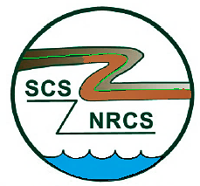 | NEWSLETTER  The Newsletter for Retired Conservation Service Employees  Vol. 49, No. 4 July/August 2022  The ARCSE Newsletter is published bi-monthly by the Association of Retired Conservation Service Employees, 1900 Canaveral Court, Granbury, TX 76048-4370  Website: www.arcse.org
FROM THE PRESIDENT
Arnold King
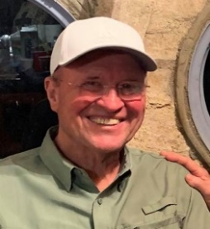
The ARCSE Board of Directors has been meeting monthly via Zoom to firm up plans for our annual board meeting in Denver, Colorado. As tradition dictates, we are meeting concurrently with the Soil and Water Conservation Society (SWCS), as they conduct their more elaborate annual membership meeting/convention. We are beginning to form a closer working relationship with SWCS. Both organizations agree that we have similar goals and objectives that can be accomplished more efficiently by working together. For instance, SWCS has given us a valuable booth location in the commercial exhibits area, where we can advertise, inform, and solicit new members. Conversely, our bi-monthly newsletter can be useful to SWCS when they have membership information/announcements to share via that outlet. So, we are looking for ways to work together and disseminate information through both organizations.
We have discovered that many newly retired employees do not even know our association (ARCSE) exists. Because of legislation like the privacy of information act, agency staff are reluctant to publicize lists of employees planning to retire. If and when we somehow break through that barrier, we can make retirees more aware of ARCSE, and membership should grow.
We are excited about the luncheon planned on Monday, August 1st. at the John Elway Steakhouse located in the Ritz-Carlton Hotel, about three blocks from the headquarters Hilton City Center Hotel in downtown Denver. We are pleased to let you know that both State Conservationist, Clint Evans, and NRCS Chief, Terry Cosby, will attend the luncheon and make presentations to the group. So, please plan to head toward Denver for a vacation and opportunity to meet with us for a great meal, program, and social event. Click on the hotlink below to bring up the registration form. Please fill it out and send it in ASAP, if you plan to attend.
https://arcsecommunications.wordpress.com/annual-meeting/.
ARCSE Recruitment, by Julie MacSwain, ARCSE President-Elect
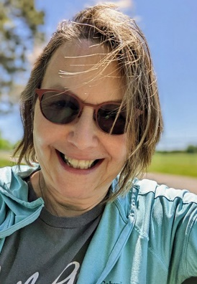
It’s hard to believe that it’s been over a year since I retired from USDA-NRCS in Portland, OR. Looking back on this, I am very thankful that Dana Dukes York, Retired Associate Chief for NRCS, reminded me about the Association of Retired Conservation Service Employees (ARCSE). She told me that this would be a good organization to join after retiring from NRCS. Ms. York was absolutely right!
Since joining, I became the ARCSE President-Elect and have found other ways to get involved with ARCSE; for example, serving as the Administrator for ARCSE’s Facebook site; writing articles for the newsletter, and serving as a member on the Recruitment, Hiring, and Strategy for NRCS.
If you know of someone who’s retiring in the near future, think about reaching out. New members bring new ideas, and it’s a way for us retirees to connect with like-minded conservationists. Thank you! –Julie
New SWCS Intern sponsored by ARCSE
Kailey Thompson joined the SWCS staff virtually as the Student Leader Project Intern. Her focus during the internship will be developing a student session and assisting in the operations and logistics of the 77th SWCS International Annual Conference, as well as assisting ARCSE, the intern sponsor, on website and communication development. Kailey is a senior at the University of Kentucky studying Agricultural Education and Agricultural Economics, with an emphasis in animal science. She has been involved in non-profit, youth, and professional organization work in multiple facets, including interning for the Kentucky Department of Agriculture and the National Cattlemen's Beef Association.
ASSOCIATION OF RETIRED CONSERVATION SERVICE EMPLOYEES

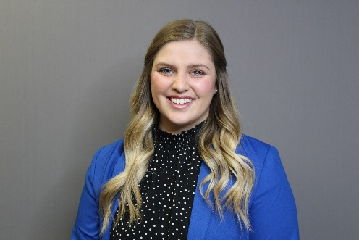

Tentative Agenda
Association of Retired Conservation Service Employees (ARCSE) Luncheon
Elway’s at the Ritz-Carlton Hotel, Denver
August 1st, 2022
Invocation Earl Norton
Opening Comments/ Arnold King
Board/Guest Recognition
In Memorium Paul Benedict
Membership Report Paul Benedict
ARCSE Awards Presentation Julie McSwain
Remarks from the SWCS CEO Clare Lindahl
Conservation In Colorado Clint Evans, STC, Colorado
NRCS National Perspective Terry Cosby, Chief NRCS
Closing Arnold King

Notes from the Potomac (by way of the Rocky Mountains) – Jack Carlson, ARCSE Secretary, Fort Collins, Colorado
We are still looking for someone to volunteer to author the Notes from the Potomac column in our ARCSE newsletter. If you are interested, please contact Arnold King or one of the Board members to take on this rewarding opportunity. In the meantime, here are some items catching the eye from gleaning agency news releases and news aggregators.
In June, the House Appropriations Committee approved a $27.2 billion spending bill for USDA and FDA that includes new funding for conservation technical assistance (CTA), rural broadband, and food safety. The committee vote was 31-26 along party lines, and the overall funding level is expected to be cut significantly during negotiations with the Senate. Currently, House spending for CTA for NRCS increases to $883.7 million from $759.8 million.
https://appropriations.house.gov/news/press-releases/appropriations-subcommittee-approves-fiscal-year-2023-agriculture-rural
The new Security and Exchange Commission (SEC) rule requiring publicly traded corporations to report greenhouse gas emissions in their supply chains has prompted calls by numerous farm groups to exempt agriculture from this obligation, saying it would unduly burden small and mid-sized farmers, lead to further consolidation, and blunt progress already underway to meeting a pledge to be carbon neutral by 2050. An example of these concerns from the National Council of Farmer Cooperatives (NCFC) is here:
http://ncfc.org/letter/enhancement-standardization-climate-related-disclosures-investors-sec-comments/
A perspective on the other side of the issue is here:
https://www.americanprogress.org/article/the-secs-proposed-scope-3-emissions-disclosure-will-not-affect-farms-and-ranches/
The second funding pool through the Partnerships for Climate Smart Commodities received over 600 applications in June from 400 groups. The first funding pool received 450 proposals in May from 350 groups, bringing the overall total interest to more than $18 billion. The USDA funding opportunity will provide up to $1 billion for pilot projects that create market opportunities for commodities using climate-smart practices. The May proposals ranged from $5 million to $100 million each, whereas the June proposals emphasizing small and/or underserved producers and minority-serving institutions, ranged from $0.25 million to $5 million each.
https://www.nrcs.usda.gov/wps/portal/nrcs/detail/national/newsroom/releases/?cid=NRCSEPRD1938227
In May, FSA announced Conservation Reserve Program (CRP) participants in their final year of their contract would have flexibility to request voluntary termination without having to repay rental payments, in order to respond to mitigating global food supply challenges.
https://www.nrcs.usda.gov/wps/portal/nrcs/detail/national/newsroom/releases/?cid=NRCSEPRD1929823
In early June, NRCS Chief Terry Cosby and USFS Chief Randy Moore announced a request for proposals for the Joint Chiefs’ Landscape Restoration Partnership to improve forest health on public and private lands. Proposals for fiscal year 2023 are due August 5th, 2022. Proposal evaluation and selection will emphasize reduction in wildfire risk in a municipal watershed or wildland-urban interface.
https://www.nrcs.usda.gov/wps/portal/nrcs/detail/national/newsroom/releases/?cid=NRCSEPRD1932627
Also in early June, the Biden-Harris Administration released the Drought Resilience Interagency Working Group Summary Report, outlining actions taken by USDA, Defense, EPA, Interior, Health and Human Services, and US Army Corps of Engineers during the past year, through financial and technical assistance, to address the effects on communities of intense drought. You can download the report from here:
https://www.fsa.usda.gov/news-room/news-releases/2022/biden-harris-administration-drought-resilience-interagency-working-group-releases-summary-report-marks-one-year-since-interagency-coordination
Finally, inflation is a hot topic nowadays. USDA-ERS produces a Food Price Outlook and many other useful publications and data products. Here is their June 2022 forecast for food prices:
https://www.ers.usda.gov/data-products/food-price-outlook/summary-findings/
For those who knew him, Carlos Crovetto was a farmer in Chile who died June 17th, 2022. He was a pioneer in direct seed/no-till and worked tirelessly to develop the technology and promote it throughout the Americas. He visited the U.S. several times in the 80s and 90s, working with Dr. David Schertz, Dr. Jerry Lemunyon, Mike Hubbs, and many others to promote the adoption of no-till.
Here is a link to the AAPRESID (the national no-till organization in Argentina) FB page.
https://www.facebook.com/aapresidargentina
See more details in the In Memoriam section.

ARCSE MEMBERSHIP DUES
Due by January 1st, 2022
Member $18 per year
Affiliate $18 per year
Life (One–time payment)
Age 64 or younger $250
Age 65 thru 74 $200
Age 75 or older $125
NOTE: Dues payment includes receipt of the bimonthly electronic newsletter only. All members (both life members and those who pay annual dues) who desire a hard copy of the newsletter must pay an additional fee of $12.00 per year.
Please submit Dues to ARCSE at P.O. Box 8965 Moscow, ID 83843
MEMBERSHIP REPORT
Paul Benedict, Membership Chair
New Life Member
Michael Kolman, York, Pennsylvania
New Members
Edward Schwille – Groesbeck, Texas
John Mueller – New Braunfels, Texas
Henry Bogusch – Cleburne, Texas
Charles Melton – Temple, Texas
Marvin Daniel – Fredericksburg, Texas
Bailey Mayo – Lubbock, Texas
Tim Holland – Meridian, Texas
Norman Friedrich – West Union, Iowa
James Dean – Athens, Georgia
Mary D. Shaffer – Salina, Kansas

Deadline for Sept./Oct. 2022 Newsletter Contributions is August 25th, 2022.
ALABAMA
Earl Norton, ARCSE Representative
Email: earl.norton@charter.net
The retirees in the Auburn area have met for breakfast each month this year. Attendance has been relatively low.
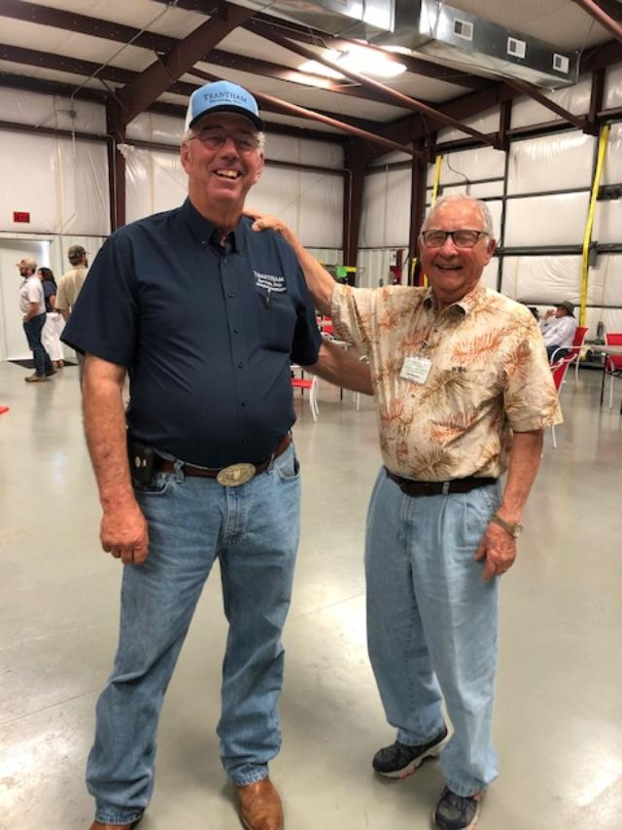
Retirees Perry Oakes, Steve Musser and Earl Norton attended the 2022 meeting of the SWCS AL Chapter recently and heard the former district conservationist Louie McDonald mentioned so many times by a local successful farmer/businessman that we want to share information about Louie. “We at the Alabama State Office always considered Louie McDonald one of the best district conservationists of all time. He was exceptionally strong technically and such an excellent communicator and leader that land users believed him and became some of the best conservation farmers in Alabama.”
Calhoun County SWCD Supervisor told the SWCS meeting, “SCS DC Louie McDonald told me in the early 1980s, ‘Try conservation tillage. We can make it work.’ The rest of the story: it worked, and with this success and the help of his son, the farm operation has become very successful with 1,000 acres of no-till crops, a cow-calf operation, a commercial feed component, a hay and wheat straw component, and trucking. Grantham praised Louie McDonald for helping him realize that he could be a success at farming.
Louie began his SCS career in 1962 after serving two years in the U.S. Army. He worked 3 years as a technician and then spent four years at Auburn University as a married student with a working wife and three young boys and earned a B.S. in Agricultural Administration. After one year as a soil conservationist, he served field offices in Chambers, Cullman and Calhoun SWCDs and left significant marks on the landscape at each location. Especially noteworthy accomplishments included no-till demonstrations that led to farmers adopting no-till and as result of successes and early adopters, most cotton, soybeans, and corn in each of these SWCDs are now grown in no-till system. In his last two locations, Louie was instrumental in getting important work done in PL-566 watersheds from 1977 – 1992. After retirement in 1999, Louie provided maintenance on PL-566 watershed dams to willing sponsors over Alabama through an innovative program with the Coosa Valley RC&D Council. In 1999 Louie moved back to the property where he was raised and has been a pillar in the community assisting with erosion control at the local middle school, developing a walking trail for the community, constructing wheelchair ramps, and serving on the local industrial development board.
CALIFORNIA
Bill Ward, ARCSE Representative
Email: bluegrassbillward@gmail.com
Greetings to Retirees across the Nation from California! June 17th, 2022. California Retirees continue to have and enjoy a monthly Zoom meeting for all who wish to participate and stay connected. We had nine shown below join us for our most recent June 1st meeting.
It is always nice to see our fellow retirees to share news with each other. In my last California report I had shared that NRCS retiree Ron Harben had joined us for his first Zoom Session and had shared with us about his passion for his hobby of sailing.
Ron is a USN Vietnam veteran, but his passion for sailing actually began when he was introduced to sailing as a Boy Scout in the 50s. From his Navy days of the 60s to the present time, he has actively pursued his passion for sailing, with formal training and taking advantage of a multitude of opportunities he had to participate as a crew member on a very wide range of sailing adventures.
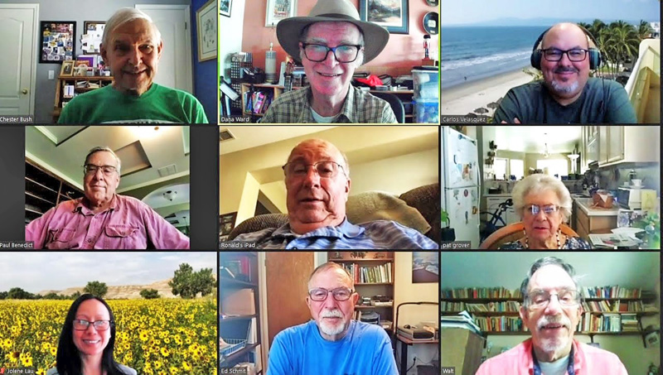
CA June 1st Retirees’ Zoom Meeting: (Top) Chester Bush, Bill Ward Carlos Velasquez. (Middle) Paul Benedict, Ron Schultz, Pat Grover. (Bottom) Jolene Lau, Ed Schmidt, Walt Sykes.
Ron Harben just completed a very significant sailing adventure as part of a three-man crew that sailed the "TransPac 49, Havili from Reeds Bay at Hilo Hawaii to Bahia Marina in Oxnard, CA.” Here is a photo at the successful end of their voyage.
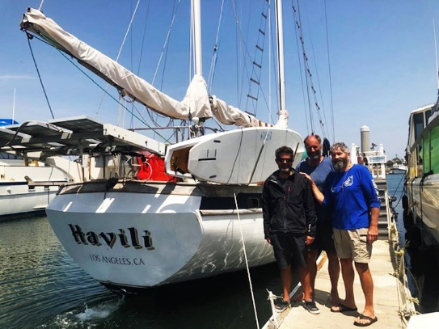
Ron Harben and his tired crew mates at the end of their successful voyage.
As Ron began sharing with me his photos and videos he took while on his voyage, it became obvious this would be a great “story” to share with our California retirees and to include in our National Newsletter for retirees across the nation to enjoy. So here you go folks, a link to photos and video I put together to share Ron’s most recent sailing adventure from Hilo, Hawaii to Oxnard, CA. Enjoy!
https://youtu.be/3hWKTfXahW0
As Ron and I discussed how to best share this story, as well as how his passion and sailing skills grew over the years, Ron shared with me a “Sailing Resume” he had put together for himself. What an impressive document it was chronicling his training and details of his many varied sailing adventures, going all the back to his Navy days in the 60s!
Ron enjoyed a long and productive conservation career with 30+ years with NRCS (includes Navy time) plus another 14 years work for local RCDs or CARCD. Ron’s technical area of expertise was Rangeland Conservation. Ron retired from it all in 2014.
From Bill Ward – Health challenges tend to be personal, and sometimes men especially keep them quiet and to themselves. I am going to share about one of my health challenges here now because I believe it could be helpful to men in our age group. I never expected I might get prostate cancer, but that is what happened when I was diagnosed with it earlier this year. After a crash course in learning about prostate cancer and its treatment options, I have learned several things I believe may be good for men in our group to know.
Among other things I have learned is that prostate cancer is not at all unusual for men to get in their 60s and 70s. If your PSA reaches “4,” you should be concerned. Talk to your doctor about it and discuss having a biopsy done at that time.
Early detection is very important and greatly increases the treatment options available and improves chance of success in eradication of the cancer. In its early stages, it is generally confined to the prostate and both surgery and radiation treatment have good chances for success. Delays in detecting or treating prostate cancer increase its chances spreading to other body parts, which reduce your treatment options and chances of success in eradicating the cancer.
I remember late in 2021 seeing a PSA test number of 4.1 with a capital “H” next to it, meaning “High.” I paid no real attention to it, as my primary care doctor did not seem real concerned about it. It jumped up to about ”6” a few months later, and I was referred to a urologist who recommended a biopsy be done.
With that biopsy done, I was diagnosed with prostate cancer, “Intermediate Favorable” designation. I was shocked to hear the words that I had “prostate cancer”. My outlook is good because it was found early and appears confined to my prostate. I had the choice of radiation or surgery and have chosen the surgery option, which is now scheduled for August 10th.
Here are a few comments and recommendations I have for my fellow male retirees, based on my experience and what I have learned about prostate cancer since my diagnosis.
- Have regular checkups with blood work done with your primary care physician on at least an annual basis. Always get a PSA test and keep a close eye on that test number. Your PSA number is the primary red flag number that indicates the potential for prostate cancer. A PSA number of “4” is the current accepted number that indicates the potential for prostate cancer and when a biopsy may be appropriate. Knowing what I know now, I would begin watching my PSA closely when it got above “3” and request a biopsy when it reached “4.”
- Spend some time learning about prostate cancer and its treatment options, depending on the stage of the cancer. This kind of knowledge will provide you incentive to keep up with needed checkups and to be proactive in pursuing treatment. I hope this information may be helpful to some folks out there. If anybody would like to follow up further with me personally feel free to send me an email.
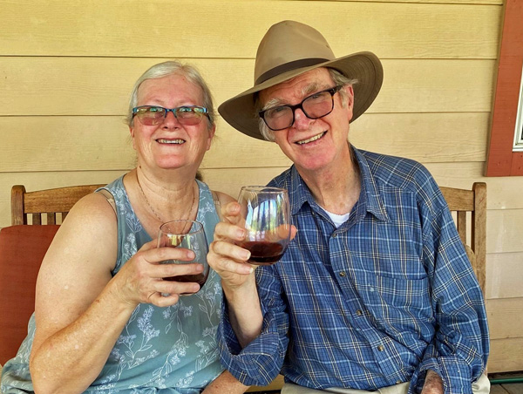
Bill and Dana, Father’s Day 2022
Father’s Day is certainly one of my favorite days of the year. My wife Dana and I have been blessed with three wonderful kids and four grandkids. All of our family gathered at our house Saturday. I would like to share all my family pictures from this day but will limit my sharing to these two photos.
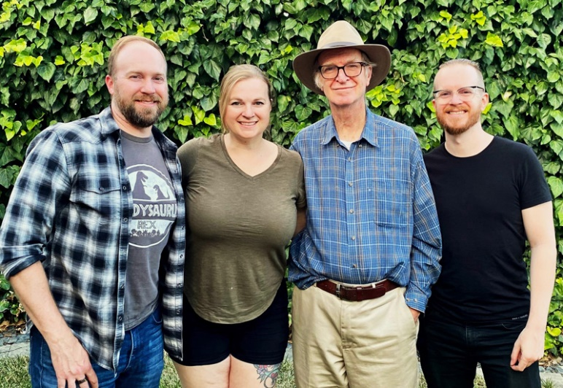
Bill with his three children: Jimmy, Jennifer, and Steven
Well, that is all from California this time around folks. Best Wishes to all, Bill Ward, CA.
COLORADO
Jack Carlson, ARCSE Representative
Email: pspicata@gmail.com
Five Fort Collins retirees gathered for First Tuesday breakfast club in May and eight in June. Discussion topics included toasting Ken Carpenter, garden Jalapeno scovil unit decline, SWCS-Denver, wind and fire, upcoming trips, and summer plans. Many former co-workers and spouses attended Ken Carpenter’s celebration of life (see In Memoriam) including Scott and Kathy Snover, Jennifer and Tom Schukar, Stu Keil, Terry Buettgenbach, Ed Seely, Luis Gamboa, Phil Smith, Wendall and Barbara Oaks, Dave and Sandy Butler, and Jack Carlson.
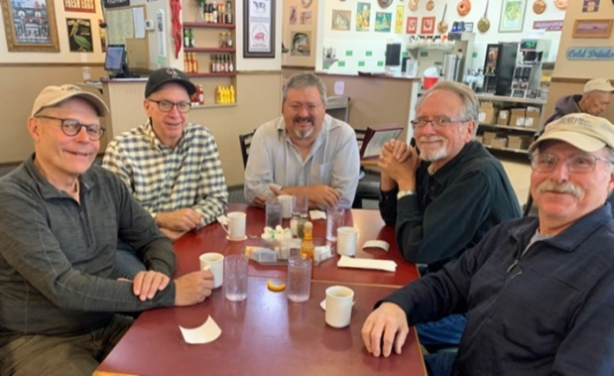
From left: Steve Ekblad, Jack Carlson, Ken Rojas, Terry Buettgenbach, Chuck Hart
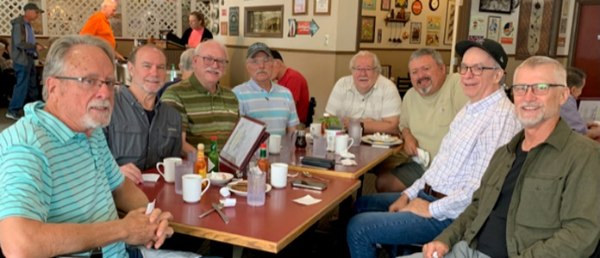
From left: Terry Buettgenbach, Ken Harward, Stu Keil, Chuck Hart, Wendall Oaks, Ken Rojas, Jack Carlson, and Frank Geter.
IOWA
Mark Jensen, ARCSE Representative
Email: amjens1@gmail.com
After living in Red Oak for the past 36 years, Tom Burkhiser and his wife Barb have moved to Johnston. Tom was the DC in Red Oak for many years. Their oldest son, Kyle, and his wife, Melissa, live in Clive. Their other son, Wade, lives in Austin, TX. Wade travels a lot, so the Des Moines airport has become a convenient location for visits!
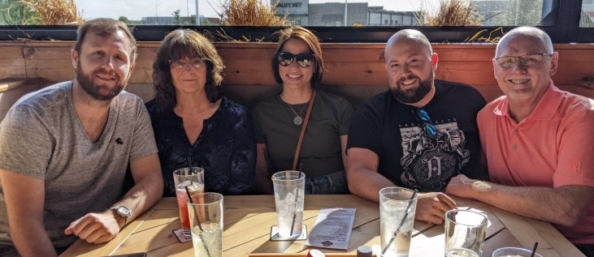
Wade, Barb, Melissa, Kyle, and Tom Burkhiser
On April 27th, a luncheon was held at Buzzard Billy’s in Des Moines to honor Norman Friedrich and Curt Fopma on their retirement. Norman is a Civil Engineer specializing in CADD, engineering computer programs, GPS. and almost all other NRCS technology tools. Curt is a Civil Engineering Technician who also specializes in all types of engineering technology, including CADD, GPS, surveying, pipe camera inspection – and the list goes on. NRCS will definitely miss these guys. The following group of folks attended the luncheon: Norman Friedrich and Curt Fopma; retirees Don Peterson, Kevin Holcombe, Kathy Woida, Jim Phillips, Ron Carper, and Mark Jensen; and current employees Christian Osborn, Mark McCurdy, Sarah Anderson, Tim Mensing, and Wade Klooster.
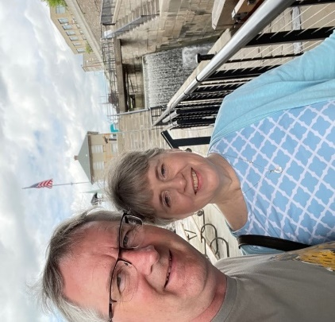 | 
Norman and Susan Friedrich at the Flight of Five Locks | Flight of Five Locks on the Erie Canal
After retiring on April 30th, Norman and Susan visited their daughter Ellen in Burlington, VT. Ellen is in grad school there. As part of her studies, she is working on an NRCS Conservation Innovation Grant. On the way to Vermont, Norman and Susan stopped by Niagara Falls where they enjoyed the fireworks and light display. From there they stopped by the Flight of Five Locks in the Erie Canal in Lockport, NY. These locks deal with about 60 feet of elevation on the Niagara Escarpment. From there, they visited the Old Erie Canal Heritage Park at Port Byron, NY. Norman said that, with these stops, he was able to get in his “engineering fix” for the trip! On the way home, they stopped in Mt. Vernon, OH, to visit Ellen’s sister. Norman has decided to go back to work part time. He will be working with the National Office through the ACES program.
Curt Fopma started a phased retirement at the beginning of the year and will officially retire on July 2nd. He just became a first time Grandpa, so I’m pretty sure we can guess what will be taking up a lot of his time after retirement!
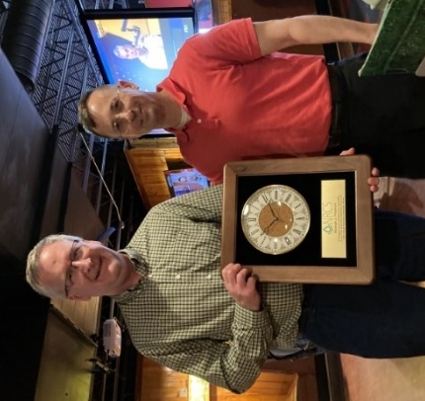 | 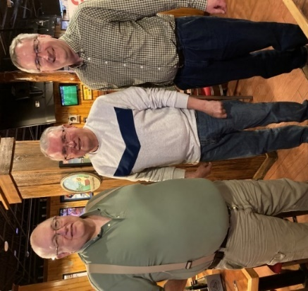
Christian Osborn presenting a Clock Norman Friedrich at retirement party. | Curt Fopma, Ron Carper, and Norman Friedrich
After a couple of years off due to the COVID virus, the Iowa RC&D get together was held on June 13th and 14th at the Shirley Stout/Warren Johnson farm in southern Iowa. Various travels, farm accidents, positive COVID tests, and jury duty reduced the size of the crowd, but did not affect the story-telling and sharing of memories. A few fish were caught and a couple or so beverages were raised to toast former board members and friends. In general, a good time was had by all. Plans for next year’s event will be spontaneous as usual, but will be based on traveling to former projects somewhere in Iowa.
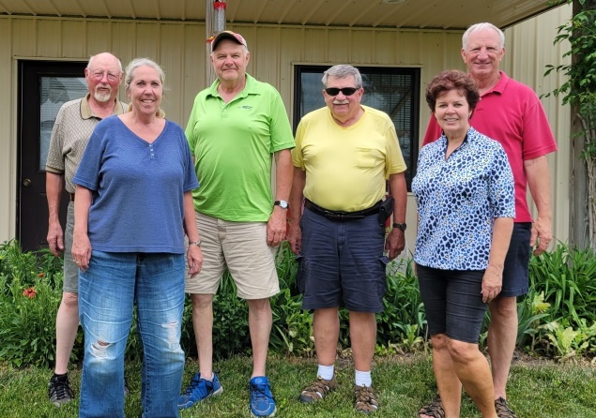
L–R: Lyle Asell, Dora Guffey, Kurt Hoeft, Tom O’Connor, Shirley Stout, and Warren Johnson
Thank you to Art Bryant for updating us on his and Mary Jane’s activities. “I haven't communicated with the retirees for some time. In fact I think the last info you had on me was a feature Mark wrote on me when I was working at the State Fair, and I think that was in 2015.
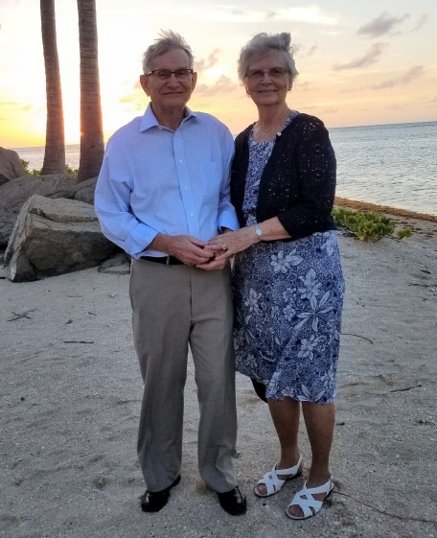
Art and Mary Jane Bryant enjoying sunset on the beach in Puerto Rico
Much has happened since then, and I can't cover it all. But we have survived COVID and are doing well. In August 2017 we left Indianola and moved to Peotone, IL, to be closer to family. We transitioned relatively well and have appreciated being close to our two daughters and their families. We also are involved in church, the Gideons, the Kankakee Valley Audubon Society, and volunteer at a Christian camp where our grandkids attended and worked. We still bike and hike, but we no longer put in the miles we used to.
We froze in the dark on Padre Island at Corpus Christi during the great power failure in Texas in the winter of 2021. But since we survived that, we decided to return for our 24th winter in 2022. This year Mary Jane and I were recognized for our 23rd year of volunteering as tour guides on the USS Lexington Museum on the Bay, a WWII aircraft carrier given the name The Blue Ghost by Tokyo Rose.
Our grandson Nathan was married in Puerto Rico in July of 2021. So we braved COVID, fulfilled all the requirements for entry, and spent a memorable week there.
We made an interesting trip in May to McGee Marsh and Ottawa NWR in Ohio to observe the spring migration of warblers. McGee and Ottawa are prime stops on the south shore of Lake Erie for migrating birds to rest and re-energize before crossing Lake Erie on their trip north to nesting grounds. It attracts thousands of birders for a period of about two weeks every May. Greetings to all, Art Bryant.”
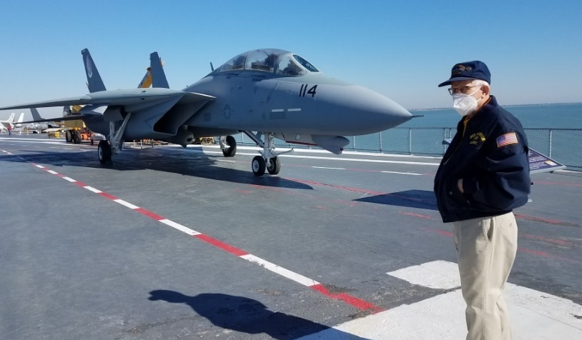
Art Bryant on the flight deck of the USS Lexington with an F-14 Tomcat that was one of the planes used in filming the 1986 Top Gun movie
Thanks to Rick Bednarek for the following: “Beth and I were busy earlier this year helping our youngest daughter, Kelly, finalize her wedding plans. Kelly was married on April 24th. Kelly and her new husband, Alex, went on a two-week honeymoon to Italy. Beth and I got to watch their two dogs those two weeks. Kelly and Alex live in Denver, CO. Beth and l have also been busy going to our grandkids’ softball and T-ball games. We are both enjoying retirement!”
I first met Keith Hunt when we moved back to Iowa in 1988. He was working in contracting in the State Office. He and Rhonda lived in Milo, a small town southeast of Des Moines. After a period of time they moved to Des Moines. After retiring, they moved to Phoenix, Arizona, for several years. Then the lure of coming back home and grandkids pulled them back to Iowa. They've lived in three different locations in the Des Moines area. Now they've come full circle and moved back to Milo. Keith and Rhonda have 10 grandkids, four great grandchildren and one more on the way. That keeps them pretty busy, going to ballgames and soccer games of their grandkids, nieces, and nephews! They just got back from a bus trip with their bank to South Dakota. Some of the highlights they enjoyed were Mt. Rushmore, Crazy Horse, and the Corn Palace. They had fun and did a lot of shopping! They finished remodeling and decorating their house and noted that “It was a lot of work, but we really enjoy it and being back home! Just enjoying the good life of retirement!”
Thank you to Jerry Muff for the following: “The NE Iowa gang of conservationists have been gathering for several years minus the COVID time span. What started as a few retired DCs has grown to a sizable group. We meet at two alternating locations every other month, minus a few winter months. With the recent addition of folks from the western part of our area, we will plan to gather at a third location to accommodate them. Whoever was part of the conservation team – including retired state, district, and federal employees – are all welcome and encouraged to attend. My wish is to encourage other areas of the state to do the same. It's a lot of fun to keep up with old friends over coffee and breakfast.” Jerry also noted that “As you can see, we are still as good looking as ever.” I’ll leave that up to the reader to decide!
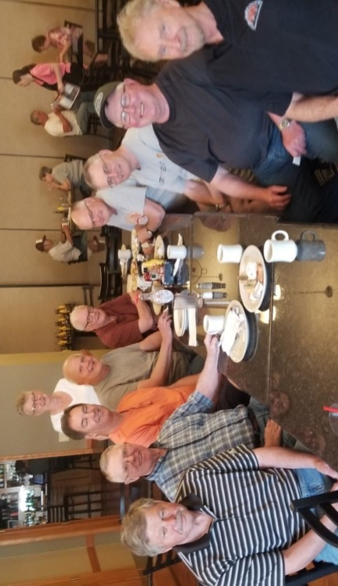
NE Iowa retirees at their May gathering: (L–R) Jim Ranum, Rick Cordes, Brian Rodman, Agnes Kenney (standing), Dennis Sande, Jim Wolfe, Kurt Hoeft, Jerry Muff, Keith Krause, and Dave Gibney.
During the past couple of months, we have been saddened by the loss of two of our retirees. Bill Willis, a long time DC in Atlantic, passed away on April 18th. Rosie Gaudette, who worked in the administrative section in the state office, passed away on June 7th.
KANSAS
Deanne Lull, ARCSE Representative
Email: rlull2@cox.net
Summer has arrived in Salina with a vengeance. Mid-June we were in the park at our River Festival with our son and his wife enjoying the arts and crafts, the fine art, and the music. In the afternoon when the temperature soared and the heat index reached 110, we decided that we old folks needed to be somewhere a whole lot cooler. This made our visit much shorter than usual. This excessive heat has continued, so we are spending most of our time at home in the air conditioning.
During Honoring Public Service Recognition Week, May 1 – 7, John F. Ourada, Salina, Retired NRCS Engineer; and President, Kansas Federation of National Active Retired Federal Employees Association, wrote a Letter to the Editor of the Salina Journal pointing out appreciation of service of our public servants at all levels of government. Many vital services that help all Americans are provided every day. There are about 50,000 Federal and postal employees and retired annuitants living and working in Kansas. John and Linda are both active volunteers in our community. John drives veterans to the VA hospitals for their appointments, and Linda volunteers at the hospital and Food Bank. They both minister to the homebound through their church.
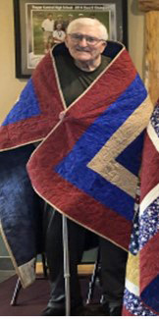
Rodney D. Egbarts was honored alongside five of his classmates from the class of 1961 for their service to our country at the Hebron High School alumni’s Memorial Day weekend in Hebron, Nebraska. Each was presented a handcrafted Quilt of Valor for their service in the U.S. Army. Rod served in the U.S. Army National Guard from 1966 to 1972 as Platoon leader at Fort Leonard Wood, MO, advanced training at Fort Leonard Wood and Fort Carson, CO. He retired December 2004 as a Soil Conservationist on the Water Resources Staff in the Kansas State Office in Salina, KS.
We had two retirements on May 31st, 2022: Edward L. Erickson, Supervisory District Conservationist, in the Westmoreland Management Unit; and Kevin D. Gustafson, State Engineer, in the Kansas State Office in Salina, Kansas.
There are no recent retiree deaths to report; however, while preparing the yearly newsletter for Kansas retirees it was discovered that the death of Phillip W. Flock had not been reported last year. Phillip died on March 3rd, 2021. He retired in 2009 as a Soil Conservation Technician in the Eureka Management Unit. He is survived by his wife, Carol Ann.
One spouse passed away. Pauline F. Hoopes, spouse of Francis S. Hoopes, died on May 8th, 2022. Francis, her husband of 64 years, survives. Francis retired in 1988 as a Civil Engineer (Water Management Specialist) in the Kansas State Office in Salina.
MAINE
John Simon, ARCSE Representative
Email: balnengr@tds.net
Hi Everyone from the great state of Maine!
2022 May 10thTuesday’s breakfast at Dysarts was attended by Bruce and Karen Champeon and John Simon (the three Musketeers). The small crowd was probably caused by my malfunctioning email system. The email I sent apparently never went out!
The three of us had a great time getting to know each other better. That is hard when a big crowd shows up. My hearing is not that good, so I often miss conversations among the talking. Karen showed me a bird that had flown into her window but survived. Karen put the yellow bird on a deck table with water and bird seed. Next time she looked the bird was gone!
I recently went out back of my home and saw a small dove on the ground walking around. I knew that the large cedar bush it was under had a nest, as the doves were constantly around the back yard. I went back later and no baby dove was to be found! Two success stories! That, in spite of the numerous small black birds nesting in some of my other big bushes!
When leaving, Bruce noticed my old 2002 Chevy S-10 and remembered having a 1995 pick-up – 4 wheel drive – V-8 – I think he said it was a Dodge. He sold it a while back and still regrets it to the day. It would definitely be an antique by now!
2022 June 14th noon picnic at cascade park in Bangor had nine retirees in attendance. They included Karen and Bruce Champeon, Ellie and Joe Bertolaccini, Noreen and John Simon, Chris Jones, Dan Baumert, and Art Taylor. It was a beautiful day, and we talked from noon to just past 3pm. We haven’t seen some retirees for a year! We were all in good spirits, but we are all definitely aging! Below are several pictures.
A great time was had by all. Chris and I were commenting on how few bugs there were at the picnic. It was sunny and very pleasant. When I got home, I noticed a heavy itch on my rear end and under my right arm pit. Out came the AFTER BITE! Apparently, the wooden benches I was sitting on had some creepy crawlers on them that had a feast on me! I hope the others did not have a similar experience!
I am attaching a photo by Karen for the three of us for your pleasure! Enjoy.
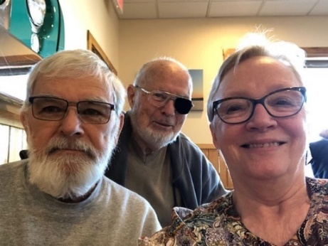
Bruce, John, Karen
Chris was showing us a program on his smart phone called MERLIN by Cornell University. The program is great as it identifies birds by their sound and can even pick out birds in a group of sounds. To an old fogie like me this is absolutely fabulous! I will be putting it on my new smart phone hopefully soon. It does a host of other things concerning birds of North America. Chris uses it when he is out on the lake in his canoe, and it is quiet and he uses MERLIN to identify the birds he hears!
We all got to talking about hydropower in Quebec and I said I had all the dams located on my Google program on my laptop. The dams are not like the ones you see in the U.S., but are much more stunning in their beautiful shapes. Bruce was able to find one of them on his smart phone to show the crew.
Dan indicated that he participated in the first MIllinocket stream race this June. He was impressed at how well it was organized. He said there are miles of wild rapids in the race and the race is probably the hardest of all the spring races in central and northern Maine. Dan hopes to see it as a regular race along with all the rest. Dan did take a spill on the rapids but ended up finishing the race! Good going Dan.
The picnic lasted from noon to 3pm. The ladies commented that they did not know how talkative we guys are! We had not seen Joe or Art for a year, so it was nice to meet up with them again. Many of us are in our 80s, so you do not know if one will see each other again! We all looked healthy, but one never knows.
The ladies enjoyed talking family stuff as usual and had a great time. When it gets down to it, all of us are looking to the future and how to accommodate our getting older and frailer. Nice being retired but not so good getting older and frailer!
Till next time take care and God bless you all.
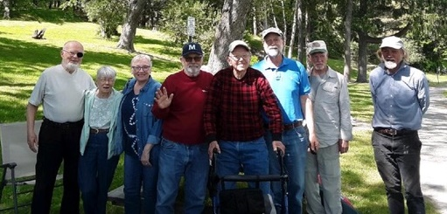
Maniacs L–R: John Simon and Noreen, Karen and Bruce Champeon, Joe Bertolaccini, Chris Jones, Art Taylor, and Dan Baumert.
MICHIGAN
William J. Fude, ARCSE Representative
Email: nigel482@aol.com
On June 15th, 2022, a group of NRCS retirees in Michigan’s Upper Peninsula gathered at the Up North Lodge in Gwinn, Michigan. Enjoying the lunch and conversation were Loren and Erika Berndt; Dave Burgdorf; Larry and Sharon Carey; Selden Collins; Bobbie Hartman; Bernie and Dianne Huetter; Dwight and Connie Jerome; Mike Lapointe; Bruce Petersen; Denny and Sue Robinson; and Walt and Phyllis Summers. Thanks to Bobbie Hartman for organizing this event.
MID-ATLANTIC STATES
Delaware, Maryland, Virginia, and Washington, DC
Ken Carter, ARCSE Representative
Email: duckheadone@gmail.com
This was this morning's Northern VA ARCSE breakfast gathering, which is meeting once again and has been since about January. Ron Marlow organizes the group. We meet at a Bob Evans Restaurant in Woodbridge. In this picture L– R are: Bill Irwin, Jon Vrana, John Peterson, Ron Marlow, Paul Benedict and Dave Thackery. Ron Page has also attended again, and many more are on the attendee list. We hope to see them again soon. Good chance for reminiscing, telling tall tales, and remembering old SCS/NRCS friends. Anyone wishing to attend should contact Ron Marlow for the details.
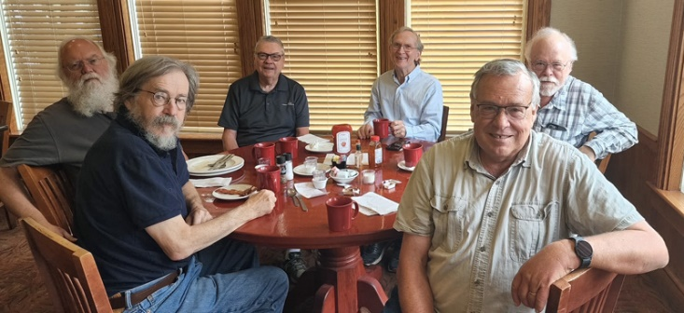

P.S. Attendees over last few months
April – John Peterson, Ron Marlow, Bill Irwin, Dave Thackeray, Ron Page, and Paul Benedict
March – Jon Vrana, John Peterson, Ron Marlow, Bill Irwin, and Dave Thackeray
February – John Peterson, Paul Benedict, Ron Page, Ron Marlow
January – Ron Page and Ron Marlow (Bob Evans was closed; met across street at Silver Diner)
December – Ron Page, Bill Irwin, Paul Benedict, Ron Marlow and Dave Thackeray-- largest gathering in nearly two years.
November – Dave Thackeray, Ron Page, and Ron Marlow
October – Jon Vrana and Ron Marlow
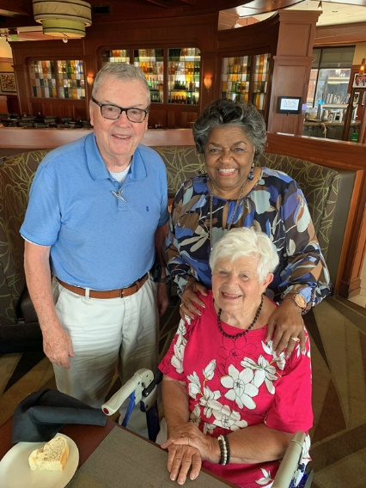
John Peterson, Maxine Barron standing, and Blanche Peterson seated, at International Harbor, MD.
In 1980 Maxine Barron, Doug Helms, and John Peterson found themselves working together in what was then the SCS Program Integration Division in the Planning and Evaluation Deputy Chief area headed by Kenneth L Williams. They became good friends and after they all retired, they continued to meet annually at a restaurant at International Harbor in MD for lunch. Doug is now gone, and the virus interrupted those meetings the past two years, but on June 8th Maxine, John, and Blanche Peterson met again renewing their friendship. The attached picture shows John and Maxine standing, and Blanche seated.
MISSOURI
Dave Rastorfer, ARCSE Representative
Email: daverastorfer@aol.com, moarscse@aol.com
A few of the Columbia area retirees met for breakfast on May 12th. Those in attendance were: John McCarthy, Jean Herman, Gail Sallee, Larry and Bonnie Pollard, Frank and Kay Miller, Robert Hummel, Dennis Hoffman, John Turner, Dwaine Gelnar, Hugh Curry, Jerry Edwards and Dave Rastorfer. The next breakfast will be Wednesday August 10th.
Craig King: Hello everyone from balmy northeast MO. Seems like we missed spring which it looked like that’s what would happen. Most of the crops are in but various sizes. South of us got every rain so behind some. Don’t know what fall will bring, hopefully a bountiful harvest, and that may not be enough with input cost. It was nice to see the ones that came to Shelbina back a couple months ago. Hopefully we can do it again. Weston is staying in Warrensburg this summer since they work out for football. He works at Lowes and umpires baseball/softball for the Rec Center, so he stays busy. He lettered this year so very proud of that.
Candra is playing basketball this summer. Between the AAU and school, she stays busy but still works at the local pizza place when she can. She tweaked her ankle this past Monday – nothing broke after having an MRI, but resting it for a while. Slight ligament strain in the instep. She got 7th place in the shot-put and 2nd throwing the discus at Class 3 State track, while maintaining straight-As on her grade card.
Andrea is always busy with work it seems. She, along with other ACs, SO personnel toured Whiteman Air Force Base. She got to sit in a B2, and she was amazed. They were very adamant about not touching anything. Weston got to eat supper with them and met some of our staff. He would like to do an internship next summer.
I still haul some grain when they need me, but they have been in the field. So, I’ve been working at Nutrien Ag Solutions pulling Anhydrous Tanks and driving nurse trucks. Really don’t want to work every day, but with the price of things... But kind of keeping my Ag brain going.
We bought a house in Warrensburg. Weston and three others stay there. This summer they have six since you have to get out of the dorms. So, I’ve been down there a couple of times turning a storage room into a bedroom and doing some outside maintenance on the soffit.
Anyway, hope everything is going well for everyone. God Bless!
Alton Taylor is heading for the Texas beach east of Galveston on the 23rd. Was on the High Plains last week. Very little rain since September, generally two inches or less. Even where irrigation was available the high dry winds took its toll. I have never seen it in worst condition in my life, and that covers a lot of time. Hope they get Yellowstone’s flood damages repaired by September as we plan a week there.
Bill Pauls said they were in St. Louis for Father’s Day, very much enjoying watching all of our grandkids play basketball, softball, baseball, tennis, and track. We are headed to Gulf Shores, AL in a week and a half, so the whole family can enjoy seven days on the ocean front. Kris and I are celebrating our 51st year of marriage. We're all looking forward to it! Everything at the Lake of the Ozarks is GREAT. The temps are always much nicer around and “in” the lake. Fishing has been good. We've been busy with church activities, and this ol' retired soil scientist has found a near full-time gig being the Sexton of the new church cemetery I created from scratch about four years ago..."They are dying to get in"...nothing like a little cemetery humor! (Soil scientist/gravedigger...match made in heaven). Come to the lake anytime and visit...we're open 24/7, 365. Still running marathons, although my times are getting ridiculously slow, and I've cut back from every other month to three per year. Next up the IMT Marathon in Des Moines, Iowa in October – #115.
Later Gator, Menfro/Marathon/Manuscript Man and currently (Very Happily Retired Man). God Bless!
Steve Black reported that John Deere is set to end production of moldboard plow. 2022 reportedly will be the last model year for the traditional drawn John Deere moldboard plow. Deere famously developed the steel plow in 1837 in Illinois after working for years as a blacksmith. Moline-based Deere and Co. has produced some variation of the moldboard plow for 185 years. While many farmers stopped using moldboard plows in recent decades in favor of minimum and no-till practices, the last call for the Deere 3710 plow this year is historic, according to Sam Paulson, product sales manager for Kibble Equipment.
“We’re living through a very significant moment in John Deere history right now in 2022,” Paulson said in a video posted to social media. “That is the end, or the twilight, of the traditional moldboard plow.”
Jim Rickman: Jere and I just got back from a trip to Norway and Finland. We were pleased that we didn't have to wear masks on the airplane and that we could return to the U.S. without being tested for COVID. Finland completed a bucket list item, as it was the 100th country to visit. It was very different from the 115 degrees in Texas. Attached is a picture taken in Norway on a pleasant day.
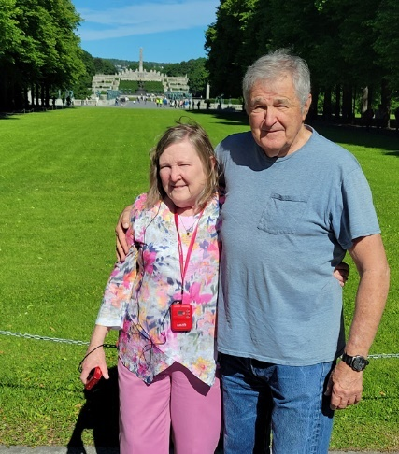
Jere and Jim Rickman in Finland, their 100th country visited
In August we are hoping to visit Mongolia, but we have to get our passports renewed and so we are nervous about being able to make the trip. We are still enjoying good health.
Mike Blaine: Hello to all. It's already shaped up to be a busy summer, and summer only started yesterday! I love to see and smell the hay as it is cut and baled. We are heavily into that now. I've been clearing fence rows of brush that the birds have so thoughtfully started as they deposit seed when they fly off the fences. It's a never-ending job, but I love to work at it. I just wish I could keep the grass from regrowing in our driveway! Looking forward to family visits and a little travel this summer. We hope to make time to take the camper out on some short trips too. Have a great summer, my friends.
MONTANA
Dick Gooby, ARCSE Representative
Email: inca@3rivers.net
Montana Big Sky Report
Scott Hoag Report: After a winter of short snowfall, snow picked up in May, and we've had a wet June. Wet enough to cause historic flooding on the Yellowstone River which shut down roads leading to and from Yellowstone Park. Floodwater took out a section of road in the Park and a bridge north of the Park, leaving folks in Mammoth and Gardiner isolated. Google Yellowstone flooding to see all the devastation.
In June Scott and Nancy travelled to Bainbridge Is, WA to visit their daughter. Then down to Enumclaw, WA to visit Nancy's sister in her new home. Scott still drives a diesel PU, with most fuel prices around $6. Some places on the island are $7. Now that puts a hole in your wallet. Time to trade it in for a more fuel-efficient vehicle.
Gooby Ranch Report 1: We have been making plans to visit our relatives we hadn’t seen since before the pandemic started. Mary Ann thought we should take a COVID test to make sure we weren’t going to pass anything around. Mary Ann got the tests you can do at home. She had Jeannie come over and help her read the instructions. I was all in favor of taking the test until Jeannie said you have to shove the swab up your nose and twist it around 5 times. You have to do it to both nostrils. There’s no way that I was going to stick a swab up my nose and twist it. The pain would be horrendous. I declined the test.
Mary Ann had no problem taking the test. After 15 minutes waiting, she got the results, which were negative. Then she said, “My Love, you’re up next.” I said no way is anything going up my nose.
I got up and started heading out of the room. Mary Ann jumped on me like a steer wrestler and tried to twist my head so I would fall down. Since I don’t have any horns, she wasn’t able to twist my head and take me down. Jeannie got her lariat and threw a heel catch, which laid me out flat. Then Mary Ann jumped on me and tied my hands together. The next thing I knew I was stretched out flat on my belly between the dining room table and the leg of the sofa. Both Mary Ann and Jeannie were smiling and giving each other the high five.
When they started to shove the swab up my nose, I twisted and turned and bucked and bawled, but Mary Ann got the swab up my nose anyway. The results were negative, so Jeannie untied me, and Mary Ann got me two beers as my reward for being so brave.
Gooby Ranch Report 2: With the price of gas being so high, living out where we do is really expensive. We are slowly going broke. The only way to cut our costs is when we need to go to town, we ride the horses instead of driving the pickup. To go to Dillon which has two farm stores, it’s 30 miles. To go to Walmart, we have to go to Butte. That’s 55 miles. To go to Costco, we have to go to Bozeman. That’s 100 miles.
When Mary Ann needs salt for the cattle, she has to put pack saddles on two horses, and she can pick up 8 blocks of salt. They weigh 50 lbs. each. When she goes to Dillon, she gets up early, does the chores, and feeds me. Then she saddles the horses and takes off. Normally Mary Ann will get back home before dark. While she’s gone, I spend a lot of time watching TV movies. When I hear Mary Ann coming in, I shut the TV movies off and switch to the news channel. As soon as Mary Ann gets home and gets everything unloaded, then gets my supper ready, she heads out and feeds the horses and bulls and checks the cow pastures.
I went with Mary Ann to Dillon a couple of times, but since my horse isn’t as fast as hers, we had to take our camping gear and camp out on the way home. So, Mary Ann decided she wanted a Girl’s Day Out, so she would go by herself and save a lot of time. One day while Mary Ann was having a Girl’s Day Out, I decided since she was saving a lot of money on gas, I would drive our pickup to my favorite fishing spot which is 45 miles from home. I fished for hours and never caught a fish. The water was so muddy that the fish couldn’t see the lure. I got home before Mary Ann got back from Dillon. As hard as I tried, I couldn’t remember to tell Mary Ann that I took the gas guzzler and went fishing.
NEBRASKA
Norm Kempf, Jim Culver, ARCSE Representatives
Emails: nkempf@neb.rr.com, j4culver@aol.com
The May 18th meeting was called to order by Chairperson Jim Culver. There were 18 attending: Norm Helzer, Dana Synder, Keith Sheets, Jim Culver, Lou Buller, Steve Stover, Robert Engel, Paul Bartlett, Harold Klaege, Dave Camper, Gus Dornbusch, Steve Scheinost, Craig Derickson, JoAnne Thiele, Norman Kempf, Gary Muckel, Tom Reinsch, and Donna Dornbusch.
The June 15th meeting was called to order by Chairperson Jim Culver. There were 15 in attendance: Gus Dornbusch, Doug Christensen, Norm Helzer, Harold Klaege, Steve Stover, Bob Engel, Keith Sheets, Dave Camper, Louie Buller, Jim Culver, Steve Scheinost, Russ Shultz, Thomas Reinsch, Craig Derickson, and Donna Dornbusch.
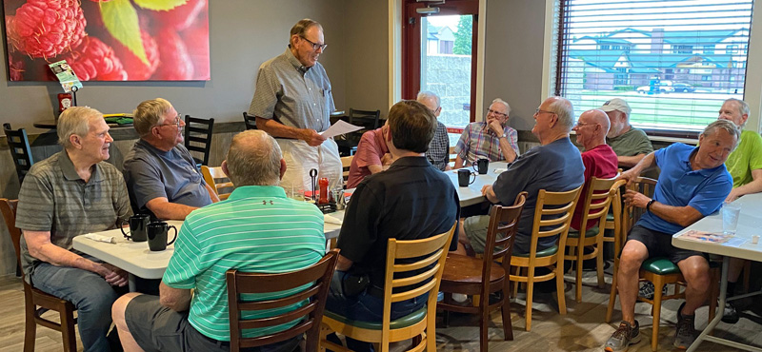
Starting our NE Retirees’ June 15th, 2022 meeting at Greenfield’s Restaurant. Back row, L-R: Russ Schultz, Steve Scheinost, JimCulver (standing), Lou Buller, Dave Camper, Keith Sheets. Second row, Gus Dornbusch. Doug Christensen, Harold Klaege, Steve Stover, Bob Engel. Third row, Craig Derickson and Thomas Reinsch.
Gus and Donna Dornbusch just celebrated their 25th wedding anniversary. Steve Stover and wife will celebrate their 59th next week. Louie Buller and wife celebrated their 67th last Sunday. Norman and Sylvia Kempf celebrated their 59th in June.
Dave Camper lives across the street from Pat McGrane and reported that Pat has had a series of health issues lately. Louie Buller and his wife recently had COVID.
Jim Culver announced the death of Ron Bauer who was a forester on the Soil Interpretation staff at the National Soil survey Center here in Lincoln. He had moved to Colorado after his retirement.
Jim Culver went to his grandson’s graduation with a degree in agricultural engineering from UNL, held at Memorial Stadium. Jim Culver also attended the Tulip Festival in Wamego, KS. Jim Culver attended the Nebraska NARFE meeting in May and said it was a well-organized meeting and that Harold Klaege, President of the Nebraska Federation of NARFE, was in charge. Harold said one of the issues discussed was the state taxation on Federal annuities. They will be contacting Nebraska state senators to see if this taxation on annuities could be eliminated as it is in Iowa and Kansas and as it was on Social Security benefits in Nebraska this year.
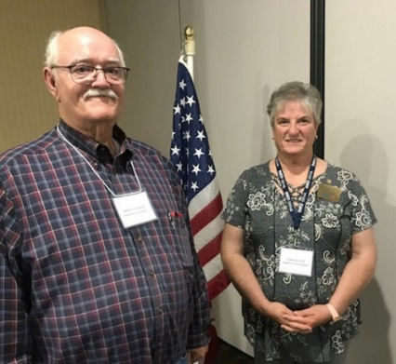
Harold Klaege, one of our retiree club members and President of the Nebraska Federation of NARFE, with Cindy Renée Blythe, Region Vice President providing leadership at the Nebraska May 25–26, 2022 State Meeting in Lincoln.
There are about 990 members in the Nebraska NARFE organization. Also at the meeting was a ceremony for members who had passed away in the last four years.
Jim Culver announced that there will be a Nebraska Soil & Water Conservation Society workshop June 23–25 in Norfolk. He visited Morrill Hall to see the Chris Helzer exhibit which was excellent but said that all the exhibits at the museum were very good.
There will be a biannual Nebraska NARFE meeting May 23–25 in Lincoln. One of the items being reviewed is Nebraska Amendment 864, which allows tax deductions for Social Security to begin in Nebraska next year to see if a similar proposal can be developed for tax deductions for Federal annuities.
Dana Synder and wife were unable to attend the tulip festival in Pella, IA, because of the rain but are planning to travel to the Pacific Northwest next month.
Steve Scheinost and his wife are also planning a trip to the Pacific Northwest. Steve Scheinost and his wife took a trip to Washington and traveled around the state to see various sites. Then last week they went on an annual fishing trip to Lake McConaughy.
Harold Klaege traveled to Arizona for turkey hunting. He also took his grandson to an auction in Pleasant Dale.
Norm and Linda Helzer went on a Sandhills bird watch, and Linda saw 114 different kinds of birds.
Gus Dornbusch announced that he and Donna will be traveling to Oklahoma over Memorial Day weekend. Gus and Donna’s granddaughters, both college juniors, have traveled oversees for summer studies, one to Italy and one to Chile.
Norm Kempf and six others traveled to Canada for a fishing trip on May 28th. They returned home on June 4th with stories of fantastic fishing, but also reported rain, wind, and cold weather. One day they fought 4-to-5-foot waves for 5 miles to return to camp. Norman reported that it was like steering a cork on top of the waves.
Russ Shultz and wife went to Pittsburg to see their granddaughter graduate from Pittsburg medical school. His daughter, who lives in Pittsburg, will be going to Amsterdam to act as a mediator for a Greenpeace conference. Craig Derickson had planned to attend but will not be able to so will give that ticket away to anyone who wishes to attend.
Jim Culver and Craig Derickson will be going to the Nebraska Soil & Water Conservation Society meeting in Norfolk next week. Craig will also be attending the ARCSE national meeting in Denver. The Soil and Water Conservation Society international conference will be held in Denver July 31 through August 3. The annual Association of Retired Conservation Service Employees (ARCSE) meeting will also be held there on August 1st. Craig Derickson has arranged to have the new Nebraska State Conservationist attend and give us an update on NRCS activities.
There is a retiree’s group that meets every Monday at 2pm at the Village Inn at 66th and O Streets, Lincoln.
Bob Engel announced that this is the 42nd anniversary of Mt. St. Helen’s eruption in Washington state. He said he could hear the explosion from where he was working. Bob Engel said he had a new granddaughter born on May 30th in Lincoln.
Tom Reinsch does family history when it is hot or rainy. He discovered that one of his distant relatives, Dr. Martine Emert, was named the most outstanding non-farmer in Texas by SCS in 1953 for her work in conservation. She also co-authored Flat Top Ranch in 1957.
The University of Nebraska women’s softball team won the Big Ten Tournament Title and will be playing in the Stillwater NCAA Regional in Stillwater, OK.
Jim Culver thanked Norm Kempf, Donna Dornbusch, and others in preparing the article for the May/June 2022 issue of The Newsletter for ARCSE. Norm Helzer was active taking photos for this edition.
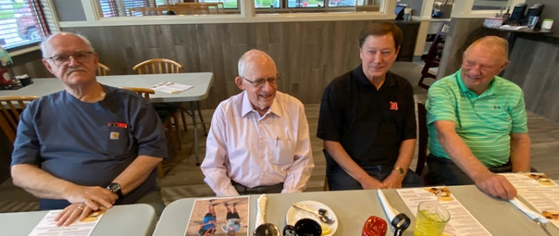
Serious discussion on current events among some of our active members. L-R, Harold Klaege, Norm Helzer, Doug Christensen, and Gus Dornbusch.
Tom Reinsch bicycled to our May meeting, a distance of about 15 miles, which he said took less than an hour.
Jim closed the May meeting with a quote from Theodore Roosevelt: “Believe you can, and you are halfway there.”
Minutes recorded by secretary, Donna Dornbusch
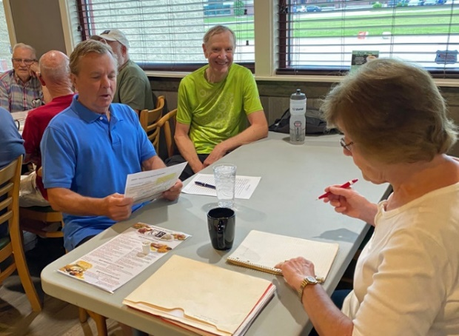
Back table, Donna Dornbusch (Right) taking minutes and attendance at our June 15th meeting, along with Craig Derickson (Left) and Thomas Reinsch, our past Chairperson.
NEW YORK
Nancy Lee, ARCSE Representative
Email: mlee0006@rochester.rr.com
Paul Ray has taken over the reins from Tony Esser for sharing the news from retirees in New York. If you have news, send it to either Paul at oldsurferpar@gmail.com, or Nancy Lee at mlee0006@rochester.rr.com.
Sorry to report two deaths in our retirement community: Dora Newcombe was a Computer Specialist for SCS/NRCS and wrote many manuals for IT training for the three USDA agencies in New York. Lee Sepelak retired with 30 years of service with SCS/NRCS in the Broome County office as a Soil Conservation Technician. Lee was known for his kindness and his smile.
NRCS Retirees' Picnic is set for Wednesday, July 21st from 10am at Chapman Park, Town of Sullivan, Bridgeport 13030, four miles east of Bridgeport on Rt. 31 and 1 mile west of Lakeport Bring a dish to pass, your place setting, condiments, your hamburger/hot dogs, etc., and whatever you would like to drink. Grills will be provided and ready.
NORTH CAROLINA
James Canterberry, ARCSE Representative
Email: jhcanter@bellsouth.net
On May 12th, forty-six SCS/NRCS North Carolina retirees, spouses, and guests gathered for their annual picnic at Lake Crabtree Park near Raleigh. Lake Crabtree is part of the Wake County Park system and is one of the structures in the Crabtree Creek P.L. 566 Watershed Project.

Senior Conservationist John Garrett, who is 94 years old, was recognized as the oldest person in attendance. Senior Conservationist Ed Helmey was also recognized. Ed is also 94 but four months younger than John. It was good to have Ron and Ann Marlow along with their son Ryan visiting with us.
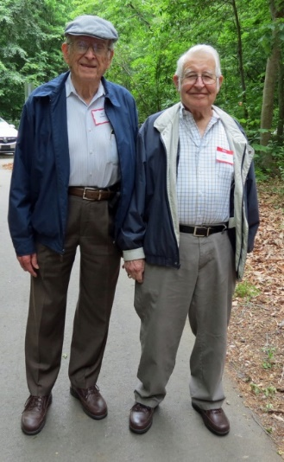
Attending the picnic were State Conservationist Tim Beard, Dewey Botts, Jim and Becki Canterberry, David Clapp, Albert and Susan Coffey, Dr. Maurice Cook, Tommy Cutts, Ray and Debra Dorsett, Frank and Loretta Evans, Dick Fowler, Dick and Carol Gallo, Coy and Barbara Garrett, John Garrett and Tim Garrett. Also attending were Angela and Paul Gragg, Bill Harrell, Boyce Harvey, Ed Helmey, Howard Hobson, Robert Horton, Rodney Johnson, Roger and Rebecca Leab, Claude and Ruby Long, Ron and Ann Marlow and son Ryan, Phyllis Pate, Lane and Merry Price, Clara Raynor, Cecil Settle, Horace Smith, Wilson Spencer, Plummer Vines, A. B. Whitley, and Talmadge and Marjorie Wiggins.

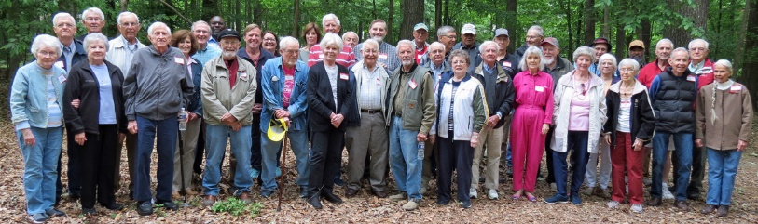
North Carolina Retirees’ May picnic

OKLAHOMA
Randy Freeland, ARCSE Representative
Email: freelandrandy50@gmail.com
The Oklahoma SCS/NRCS Retirees met at the Golden Corral Buffet Restaurant in Oklahoma City, Oklahoma on April 22nd, 2022. Thirty-three people were in attendance: Don Bartolina, Laurie Bogle, Steve Chessmore, Ann Colyer, Larry Coppock, David and Dang Edmonds, Randy and Bonnie Freeland, Harry Fritzler, Chuck Grimes, Sandra and Terry Hough, David Hungerford, Larry and Brenda Jarrell, Bill Johnson, David McKay, George Moreland and guest Betty Gilbert, Kevin Norton, Phil Perryman, John Pewthers and guest Eyvonne Hart, Ben Pollard, Stan Rice, Dan Runnels, Chris Shepherd, Jim and Terry Smith, Ed and Lillie Stinchcomb, and Darol Wilson.
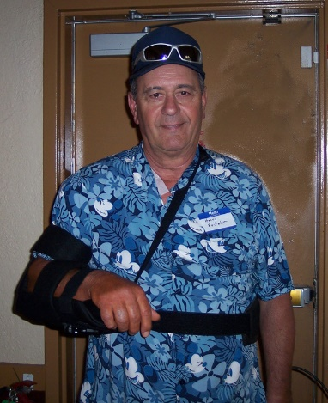
Harry Fritzler
President Harry Fritzler called the meeting to order. He welcomed everyone back after a two-year absence due to the pandemic. Chris Shepherd provided a Blessing, and everyone enjoyed the buffet meal.

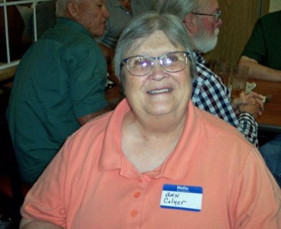 | 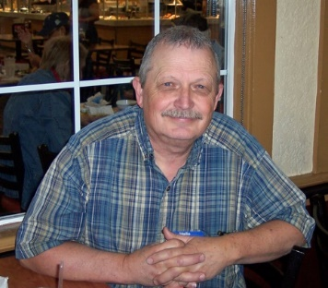
Ann Colver | Larry Coppock
With rotator cuff surgery the day prior to the meeting, our tough-as-nails leader opted to "hurt" at the meeting the same as he could at home. Harry asked all in attendance to introduce themselves and their guests. As we went around the room several “short” stories were told to the delight of all. As a group we could write a book but would probably have to categorize it as humorous, technical, and somewhat "fiction" (due to some of our memories). But I would believe it would be a Best Seller. Definitely written by a group who enjoyed their work and those they worked with.
We were thrilled to have several first-time attendees and are hopeful that trend continues.
Randy Freeland read comments he had received in response to the email announcing the April 22nd, 2022, meeting. Steve Mornhinweg said he was going to attend but his next door neighbor's funeral was the day of our meeting. Fred Fortney was unable to attend due to Gayle being admitted to the hospital for a blood infection. Ron Hilliard said he would attend but has another obligation. Thanks for keeping him on the list. Carolyn Webb said (note: this comes directly from her email) “I'm sorry Bob and I won't be able to attend. Sure will miss seeing everyone. I'm into my 9th week of recovering long haul COVID, but I'm better. So here's your ‘Story’. Posed nude for an art class today. They didn't ask me, think they were doing ceramics!”
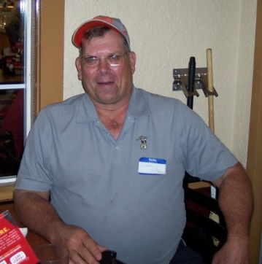 | 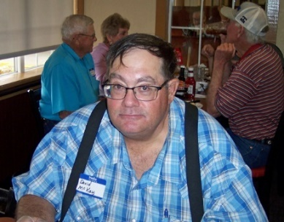
Darol Wilson | David McKay
Andy Tucker said he wouldn't be able to attend due to helping host the 2022 Lt. Governor's Invitational Turkey Hunt in Okemah. Earl Weisner indicated he was helping Minnie McMasters with some health issues and unable to attend. And Gary O'Neill said he wasn't able to attend due to doing a NHQ detail for another month or so. He noted that Jamey Wood is the Acting State Conservationist in Oklahoma.
Forms were passed around for retirees to provide their retirement activities (i.e., volunteer work, travel, part-time work, activities, etc.) This information is used for the National and Oklahoma Retired SCS/NRCS Employees Association newsletters. Here are a few received at this meeting:
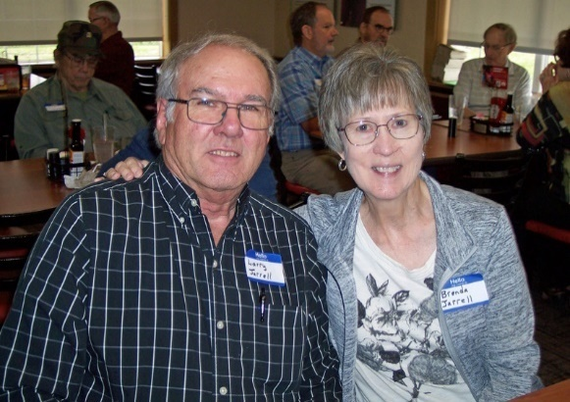
Larry and Brenda Jarrell
Larry Jarrell volunteers for Church work, travels in their RV to several states, enjoying kids and grandkids. He and Brenda will celebrate their 50th Wedding Anniversary in July. Jim Smith continues to volunteer with the Sportsman's Country Club (15 years now). He has also served on the Hunt Club board of directors. He and Terry enjoy traveling. He also belongs to the Oklahoma City Gun Club and participates in rifle and pistol shooting matches. Stan Rice continues to provide consulting work for land application of municipal sludge. He has nine grandkids with two in High School, three in college, and one in Law School. Fredia is dealing with some pretty tough health issues. Please continue prayers for her.
David Edmonds retired 13 years ago but joined us for the first time this year. He worked in Kingfisher, Holdenville, and retired as a Conservation Technician at the Technical Service Office (TSO) in McAlester. He said he had moved a couple of times since retiring and traveled to Viet Nam several times over the past years. David McKay retired in 2017 but also joined us for the first time. He worked in the Marlow and Davis Watershed Offices and as an Engineering Trainee, Ag Engineer, and Area Engineer at the Duncan Area Office. From 2001 to 2017 he served as the Resource Engineer at the Woodward TSO. He now spends his “spare” time farming in Kiowa County.
Laurie Bogle, first time attendee, retired in March 2021as a Range Management Specialist in Cheyenne. Her career was all in Range Conservationist work in Alva, Pawhuska, Taloga, Beaver, then Cheyenne. She has a 20-year-old daughter and spends her time gardening and traveling to National Parks!
Our President for the past two years, Harry Fritzler, passed on the following for those not able to attend our most recent meeting: “I'm still enjoying my retirement. My wife still works. We travel some, although travel has been somewhat restricted because of the pandemic. I spend time on our acreage (small farm/ranch) continually trying to improve the place and tending to the cattle. I've stayed involved with the Oklahoma Prescribed Burn Association and work with landowners on prescribed fire. I still try to set as many fires as I can get by with. Ha Ha! Anyway, I stay busy and out of trouble most of the time. I hope and pray that each of you are enjoying retirement to its fullest. It is a privilege to serve as your president.” Harry
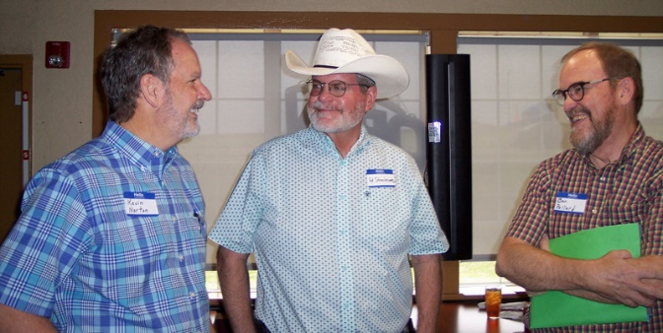
Kevin Norton, Ed Stinchcomb, and Ben Pollard
And last but not least, Kevin Norton. Where do you start? This guy has done it all. I asked him: Where you worked for SCS/NRCS and when: Range Conservationist in the following locations- Lawton Field Office 1981–82, Buffalo Field Office 1982–1984, Clinton Area Office 1984–1987, Woodward Area Office 1987–1991. Area Resource Conservationist, Woodward Area Office, 1991–1993. Resource Conservationist in Oklahoma State Office, 1993–1996. State Resource Conservationist (+1 yr.) and Assistant State Conservationist for Programs, Oklahoma State Office, 1996 to 2007. State Conservationist Louisiana, 2007–2018. Acting Associate Chief, Associate Chief, Acting Chief and acting Deputy Under Secretary for Farm Production and Conservation, 2018–2022.
When did you retire? May 3rd, 2021.
And what are you doing in retirement? I have spent the time since retirement catching up on work around the house. We have traveled to see our children and grandchildren in Oklahoma and Tennessee and Cheri’s parents in Buffalo, OK. As of this writing, we have nine grandchildren from 13 to 5 months. I am teaching my oldest grandson to shoot. He has completed hunter safety and we plan to begin hunting turkey, quail and maybe deer beginning this fall. I have two Brittany pups born in late December that I am hoping to train correctly for quail hunting. I also have a 20 ft Xpress fishing boat and plan to spend time with Cheri and the family fishing in Louisiana and Oklahoma. Cheri will conclude her teaching career in May. Things I would have not done pre-retirement was to spend five weeks babysitting our youngest (3-month-old) grandson while his parents returned to work and trained for the Memorial Marathon Relay, which I ran a 5K leg, with two sons, daughter-in-law and her sister on April 24th. Finally, I started a small consulting business in January doing farm policy and program consulting part-time with clients in Washington, DC, and the lower Mississippi Valley.
As you can see, I got a few very interesting “inputs” from our Retiree Membership. Thank you very much. Others, please feel free to send me something similar, and I promise to keep it until the October 2022 Newsletter. Do it now before you forget! Send it to: randy.freeland@suddenlink.net.
Many retirees have expressed their appreciation for the information presented on the website www.joepad.com. When they are not able to attend the meetings, the website provides pictures, list of attendees, etc. Joe Freeland, retired Construction Engineer, has been very gracious to keep the website updated after each meeting.
President Fritzler read the list of retirees since October 2020. Those included: Dennis Fowler, Soil Conservation Technician, Chandler, 10/22/2021, 35 years of service; Denise Turner, Grazing Land Specialist, Cherokee, 11/19/2021; Dan Smith, Resource Engineer, Perry TSO, 12/31/2021, 38 years of service; and Jim Ellis, Soil Conservation Technician, Stillwater FO, 1/28/2022.
Even though no meetings were held in 2020 or 2021, Randy Freeland composed and sent out newsletters in April 2020, October 2020, April 2021, and October 2021. These newsletters included a list of retirees and a list of those we lost during the previous six months. Secretary/Treasurer Sandra Hough read the list of those who have passed since October 2021: Roland Willis, 89, State Conservationist, 11/15/2021, longest serving State Conservationist from December 21, 1975 until his retirement on August 28, 1987; Rick Schlegel, 55, Irrigation Engineer, Woodward TSO, 12/2/2021, retired August 2009; Bill McVickers, 81, Soil Conservation Technician, Guthrie & Kingfisher FO’s, 12/8/2021; Tony Schreiner, 65, Soil Conservation Technician, Frederick FO, 12/9/2021, retired 3/30/2018 with 17 years of service; Lowell McMasters, 86, Resource Engineer, Pauls Valley & Duncan TSO, 12/16/2021, retired in 1991 with 43 year of service; Earnest (Ernie ) Snook, 88, State Range Conservationist in Stillwater State Office, 1/16/2022, retired in 1987 with 31 years of service; Julia Bookout, 92, Personnel Management Specialist in Stillwater State Office, 1/18/2022, retired in mid 90s; and Marcella Wagner, 11/8/2021, widow of Billy Wagner, Soil Scientist, Stillwater State Office, who passed in 2010. A moment of silence was observed.
Ben Pollard and Stan Rice serve on the nine-person board of the Oklahoma Conservation Historical Society (OCHS). Both presented comments on the activities and importance of this group in preserving Oklahoma’s history in conservation. Tom Lucas initiated the idea of preserving conservation history. This group has been operating as a non-profit organization for five years. Those in attendance were provided with a copy of the 2021 Highlights of OCHS. The purpose of this group is “to collect, preserve, and share Oklahoma’s rich conservation history.” As of 2021, the OSU Library has posted 35 of the oral histories on their website under the Oklahoma Conservation Heritage Oral History Collection. The oral histories can be accessed at: https://library.okstate.edu/oralhistory/digital/. There are an additional 12 oral histories currently in production for completion in 2022. Several conservationists who have provided oral histories are now deceased, emphasizing the need to obtain as many as possible before it is too late. In partnership with the Oklahoma Historical Society, a conservation history photo collection has been established on the Gateway to Oklahoma History website that is managed by the Oklahoma Historical Society. The collection is made up of black and white conservation photos primarily from the 1930s through the 1960s. Photos are being provided by Conservation Districts and NRCS. The photos are digitized and labeled and posted to the website. The original photos are permanently archived at the Oklahoma History Center. To date, over 5,000 photos are in the collection. The photos may be accessed at:
http://gateway.okhistory.org/explore/collections/OKCHS. There are another 10,000 photos being processed with the goal of having 20,000 photos in the collection by 2023.
In an effort to better promote Oklahoma’s conservation history and serve the Society’s membership, a website was established this year. The website can be accessed at: https://www.oklahomaconservationhistory.org.
Ben Pollard made available 2022 Membership forms for those interested in becoming members or renewing their memberships. The SCS/NRCS Retiree group became members in October 2018. The group voted to renew their 2022 membership.
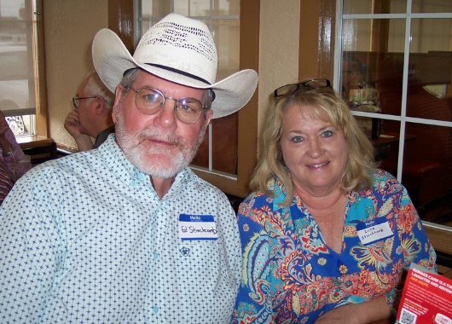
Ed and Lillie Stinchcomb
Officers for the Oklahoma SCS-NRCS Retired Employees serve a period of two years. Harry Fritzler, President; Steve Chessmore, Vice-President, and Sandra Hough, Secretary-Treasurer, were selected in April 2019. However, because of the pandemic, October 2019 was the only meeting held in which these officers served. The officers agreed to continue to serve; however, Steve Chessmore will serve as President, Harry Fritzler will serve as Vice-President and Sandra Hough will continue to serve as Secretary-Treasurer, until April 2023 when officers will be elected.
The next meeting is scheduled for Friday, October 28th, 2022, at the Golden Corral on MacArthur Boulevard in Oklahoma City. The Golden Corral opens at 10:30am so there is extra time for visiting before the meeting starts at 11:30am.
OREGON
Don Stettler, ARCSE Representative
Email: don.stettler@comcast.net
The first post pandemic quarterly lunch was held on April 27th, 2022 at The Old Spaghetti Factory in Clackamas. Attending were Eldena VanderZanden, Louise Davis, Jo Huelshoff, Joe Sahlfeld, Gail Voge, Kay Denfeld, Marcine Richmond, Laurel Grimsted, Ralph Wadleigh, Lamond and Karen Robbins, Pat Straka, Butch Hockett and Beth Zetter, and yours truly, Don Stettler.
Eldena VanderZanden told us about going to the 5th Peter Asher Band cruise, which she enjoyed very much. Jo Huelshoff spent a few days at Sequim, WA, a place she finds very delightful. Gail Voge mentioned that she is staying busy. Besides volunteering for Meals on Wheels, she has done an extensive remodel of her home. Kay Denfeld is planning a trip with former high school classmates. Her ukulele group is active once again. They are making plans to entertain at a senior living residence. Laurel Grimsted, along with family members, toured the Steens Mountain area. It went so well they are planning another excursion. Lamont and Karen Robbins continue to assist Lamont’s brother’s widow in North Carolina. In the past, Karen had made trips to the Ukraine in her work in educating about autism. She grieves what is going on there now and how it may be with acquaintances she has there. Pat Straka stays close to her home in Keizer enjoying her family and church. Butch Hockett and Beth Zetter’s eighteen-year-old cat died, so they got a kitten. For about three days they did not know where she was. Much to their relief they finally found her when they opened a closed closet door, seemingly no worse for wear.
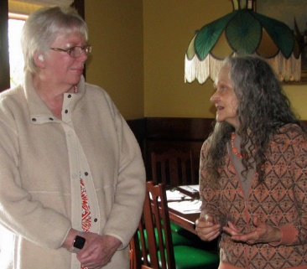 | 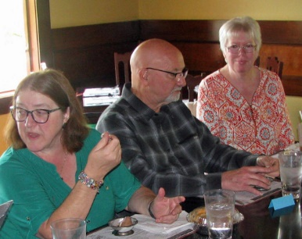
Gail Voge and Laurel Grimsted | Loise Davis, Joe Sahlfeld, and Gail Voge
Sensing that many were more than ready to restart the quarterly lunches, the 15 attendees were far short of the 25 I had anticipated as a minimum. The restaurant manager made it clear to me that I had not upheld my end of the reservation and threated to charge me for lunches not served. Fortunately, she didn’t.
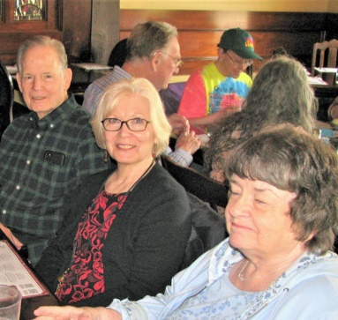 | 
Lamont and Karen Robbins, and Pat Straka | Butch Hockett and Beth Zetter
However, several things seem clear to me. One is that many are still being cautious about venturing out, because COVID-19 is still making many people sick, even those fully vaccinated. The other is that should another lunch be scheduled in the foreseeable future; I must make reservations limited to those who will commit to attending without my optimism that others will show up.
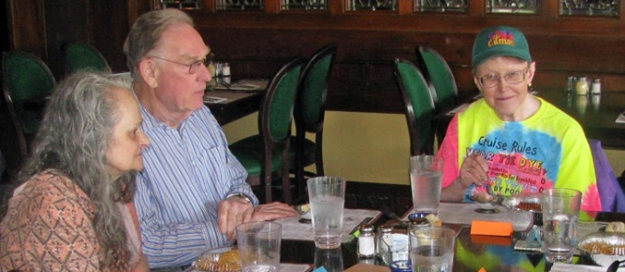
Butch Hockett and Beth Zetter
PENNSYLVANIA
Submitted by Tim Murphy
Email: vindemurph@verizon.net
My wife, Anne and I invite you to participate in our annual meeting on September 18 and 19. Please contact me at the email address above to register. Lodging will be at the Holiday Inn Express in Somerset. This will be a nice opportunity for those of you who live in western PA and those who have relocated to nearby states MD, WV, and Ohio to come and enjoy catching up with friends from working days.
Sunday evening, we will have a picnic setting dinner in a pavilion at Hidden Valley Ski Area. Monday morning, we will meet at the Somerset Kings Family Restaurant where we will have bagels and, if you wish, bring your homemade jelly/jam/honey to be shared as toppings. Following our short business meeting and speaker, we will have lunch at King’s. For the afternoon we will proceed to the Flight 93 Memorial.
Although Tim, Rosie and I have been sharing the organization’s leadership since the passing of Bill Bowers, we are still looking for someone to take the position as President.
The scholarship committee led by Mary Smith and the Keystone Chapter SWCS is currently making the selection of scholarship recipient(s) to be funded by past donations. The SCS 50th Anniversary belt buckle raffle, with proceeds going to the scholarship fund, will once again be a feature of our two-day meeting.
Pat Cecil reports: “I have moved from Texas to Louisiana to be closer to my two sons and their families. Hope all is well with all of you in Pennsylvania, which was one of my most favorite and beautiful states that I worked and lived in.”
Don Lindsey says he and Shirley are getting out more, now that COVID restrictions have been lifted. “We have been well throughout the past three years and feel very blessed, especially as we now are approaching 90. That makes us nonagenarians. Hmmm?”
Alan and Judy Wood celebrated their 50th Anniversary at a party in Maryland with family and friends. This summer they will be taking the family on a Disney cruise!
Don McCandless writes “Shirley and I are celebrating our 69th wedding anniversary this month. We have been blessed with long life, three children, ten grandchildren, seven great grandchildren, and expect another great grandson in August.”
This month marks the 50th anniversary of the Tropical Storm Agnes flood, caused by up to 18 inches of rain. Agnes was the costliest storm to hit the United States at the time, causing an estimated $2.1 billion in damage. The death toll was 128, with tens of thousands of homes and businesses destroyed or severally damaged. Here are some recollections from those who experienced its impact.
Don Lindsey was in his 9th year as D.C. in Wellsboro when Agnes hit. “Every town in Tioga County had extreme flood damage, with one exception. This was Wellsboro, which had three PL-566 dams protecting the town. Wellsboro had a very active and well-equipped Fire and Rescue Company. As the only company that was not damaged, they sent trucks and equipment to towns across the county to give help where it was needed. SCS gained in reputation and respectability overnight. For months after Agnes, I would get calls every time it rained to see if the dams were still okay. An example was one night when my wife and I were in the Wellsboro town theater at a movie, I was called out to check the dams because it was raining hard.”
Don McCandless recalls “I vividly remember the flooding in Harrisburg and how it affected my personal plans. Annual leave was scheduled for first two weeks of July. I had arranged for a contractor to build a one-acre pond on our farm in Butler County. After Agnes hit, the contractor backed out of arrangements because there was more money to be made in flood restoration in eastern PA. It took me two weeks to line up a second contractor, and he started construction after I had returned to work in Broomall. This was a mistake because he was a poor contractor, and while on a visit to check on construction, he was about 90% complete and I paid him in full. He never completed the job.”
“Nevin and Judy Ulery, with our two girls, were living in our mobile home in Millcreek Township, Erie County in June of 1972. And although we experienced a lot of rain, we really had no damage at all. Also, southern Erie Co. experienced relatively minor damage, although ASCS and SCS did assist several farmers with washed out farm lanes, downed fences, and some rather severe gully erosion in crop fields. So, overall we considered ourselves rather fortunate.
However, just a few years earlier we were living in the Bucknell View Mobile Home Park with an excellent view of the West Branch of the Susquehanna River, as well as Bucknell University and Lewisburg, PA. There were fifty-one homes in the park prior to Agnes. After the flood waters receded, there were three homes remaining in the park. One was anchored, and the other two floated against it and remained in the park. The other forty-eight were scattered all over Northumberland and Snyder Counties as far away as Selinsgrove. Some homes floated right down the river channel. Others were captured by large trees or other objects.
Our former next door neighbor’s home was caught in the rows of trees in the former Pennsylvania State Nursery along PA Route 147 and was broken into two sections. We returned to the area a few weeks later and assisted our former neighbors with the retrieval of a few personal items from the remains of their home. Nancy found a set of glasses which they had received as a wedding gift – still in a kitchen cupboard in the original cardboard box.
We really were not very excited about moving our mobile home to Erie County in November 1967. However, just a few short years later we were very grateful to have moved to Cheery Erie!”
Hosea Latshaw recalls “I had just graduated from Phoenixville Area High School in June 1972, and for my summer job I was working as a groundskeeper at the Limerick Golf Course near Pottstown. We lived within a mile of the Schuylkill River, and I had to cross a bridge to get to the golf course.
The heavy rains from Agnes caused our local Chester County creek (with the much smaller drainage area) to rise out of bank early in the week, and then within a day or so the local creek receded to within bank flow. About the time of the local creek receding, the Schuylkill River rose to about 6 – 8 feet out of bank and severely inundated the adjacent small shopping mall and Acme grocery store, where the flood water reached a height of 5 feet on the sales floor. The nearby feed mill and textile mill were also flooded to the same depth. The river bridge crossing between Spring City and Royersford was closed for about 4 days. All of the towns (Reading, Birdsboro, Pottstown, Spring City, Phoenixville, Norristown, etc.) located along the Schuylkill River were severely flooded, and some people were displaced for more than a year. Many buildings were lost.
Just above Pottstown, a business recycled used motor oil by letting the sludge from used oil settle in outdoor storage ponds. Some of the ponds were an acre or more in size. Agnes caused the Schuylkill River to flood over the banks of the oil settling ponds, flushing the oil and sludge out of the ponds and into the raging river currents. Many homes were flooded with oily flood waters. The oil stuck to the houses and trees and remained after the waters receded.
Later that week, I attended a Statewide 4-H event at Penn State. The buses taking us to State College were not able to travel along the flooded banks of the Susquehanna or Juniata Rivers. We had to bypass Harrisburg using the Turnpike bridge and travel from Carlisle to New Bloomfield, and then take back roads to Lewistown to find another high bridge to cross the Juniata River. From the bus, we witnessed flooding and devastation along the entire trip.”
Sam Young was Area Engineer in Bloomsburg in 1972. Central PA took the brunt of the Agnes precipitation, and the flooding lasted about a week in Bloomsburg area. The flood cleanup and recovery took several years to complete.
June 21, 1972: Agnes had been downgraded to a tropical storm and had moved off the coast where it gained strength. Early that day I went to check on preparations for protecting the PA-451, Greene Dreher, and Goose Pond Dam in the Brodhead Watershed, which were all under construction. The Goose Pond Dam was especially critical because previous storms had resulted in sedimentation downstream in Brodhead Creek. After confirming that the contractors had storm protection measures in place, I headed back to the Bloomsburg area Office. All along I-80 there were deer feeding at 4 PM in bright sunlight and 90º+ temperatures, which to me was a sign of impending severe weather. Weather forecasts that evening predicted some rain but no unusually heavy flood producing event.
June 22, 1972: The day started out with heavy rain, and I was scheduled to be in the Bloomsburg Area Office for the day. In late morning we received a phone call from the Middleburg office that the emergency spillway on Walker Dam PL-566 Project on Middle Creek in Snyder County was reported to be flowing, with many area roads impassable due to flooding.
After hearing this, John Zaginaylo, Jr, Bloomsburg WU Technician, and I went to the Briar Creek watershed to check the extent of flooding and document any flooding occurring in Berwick Borough. In early afternoon there was no flooding occurring along Briar Creek. At PA-497 Briar Creek Lake, we drove across the road at the upper end of the lake about 2 PM and observed the lake level was up less than 2 feet and water level was about 3 feet below the low point on the road. We went to check the existing Berwick water supply reservoir which was to be replaced by PL-566 PA-498 multipurpose flood control/water supply dam as part of the protection for Berwick. The road to the existing dam was closed by a mud slide. We decided we would walk the half mile to the dam. We got about 100 yards when a man driving a 4-wheel drive truck came down the road shouting to get out because the dam was failing. I realized if the dam was breaching that John and I had to get up the slope and out of the valley floor. I yelled to John that we needed to climb up the adjacent hill. John was busy talking to one of the home-owners and apparently didn’t hear me.
After a short period of time I realized the man’s warning may be premature, and I returned to the road and told John we needed to get back to our vehicle and approach the dam from upstream at an elevation where we could get to the top of the dam safely. It took 30 minutes to get to the top of the dam from a safe approach. Apparently, what triggered the man’s report of dam failure was that the concrete and rock spillway in the center of the dam was flowing at full capacity. The dam was within inches of overtopping and we could feel the vibrations from the spillway flow as soon as we stepped on the embankment. There was a woman standing in the doorway of a house at the toe of the dam just staring at the spillway. We tried to convince her to go with us because if the dam did overtop or fail, she would not survive. She said she was not leaving until her son came home.
It was now about 5 PM. I took John to his home and tried to return to Bloomsburg. The shortest way back to Bloomsburg was to take the road upstream from Briar Creek Lake. In just 3 hours the road was now impassable and had more than 5 feet of water over it. I decided that the only possible route back to Bloomsburg was to cross the river in Berwick, take Route 239 to Mifflinville and get on I-80 to get back cross the river. Route 239 had numerous mud and rock slides, but I was able to navigate through them and reach the office.
June 23,1972: I was awakened early in the morning by my next-door neighbor to see if I and my house were OK. He informed me that the foundation on his other neighbor’s house had collapsed from the overnight rain. The rain was over, and other than a wet basement, I had no damage, for which I was thankful. I put my hip boots in my car and headed to the office. I could not reach the office by my normal route, due to road flooding, and had to take a five-mile detour.
When I reached the area office, I had to park on the highway and met with Jerry Hytry, AC; and Don Haines, Area Technician. We could see the front door of the office, but the roadway and parking lot were flooded. Both Don and I put on hip boots and waded into the office to try to raise file shelves, other equipment, and desk drawers onto the top of desks, tables, and file cabinets. When we entered the office, flood water was about 6 inches below the floor level. By the time we complete the work, about one-half hour, the water was about an inch deep on the floor. When we waded out to our cars, the water was lapping at the top of my hip boots.
We couldn’t work, so Jerry told us to go home and take care of our families and our properties. My wife Maryellen and four children were spending the week with Bill and MaryAnn Bowers in Greenville in western PA. I called my wife to see if they had any flooding problems. They didn’t have any problems. I told Maryellen that, road flooding permitting, I would be there by noon on Saturday June 24th, and they had to be ready to leave immediately so I could get back to Bloomsburg and prepare for a busy week.
June 26, 1972 and several days after: I went to see if we could get into the office. The water level was still 2 to 3 feet deep on the office floor. For several days the Young household served as the area office, and our only phone was used to manage recovery efforts and status reports on damages from thee area counties. My 10-year-old daughter and wife helped answer and screen the calls. I’m not sure how many days before we were back in the office to determine the damages and start cleanup and replacement of furniture and equipment. Bill Fecke and several others came up from the state office to help with the cleanup and disposal of flood debris. Basically, only the desks and some tables and chairs were salvaged. All photographs and slides were destroyed except for the slides for Sandy Creek PA-475 I needed for my scheduled presentation at the International ASAE Winter meeting scheduled for December in Chicago, Illinois.
Later in the week, I inspected the emergency spillway on the Walker Dam in the Middle Creek PL-566 project, because it was reported to be severely damaged. The emergency spillway outlet channel had a gully that started at the concrete cutoff wall and ended just downstream from the outlet channel. Compacted earth needed to fill the gully was approximately 16,000 cubic yards. On the day I investigate the damage, the reservoir water level was 2 feet below the spillway crest. This was 7 days after the field office notified us that there was flow in the emergency spillway. I estimated that the emergency spillway flowed for more than 72 hours. The other amazing thing was that the principal spillway was flowing at maximum capacity, and the impact basin was calming the flow, as designed, and no erosion of the immediate downstream channel was observed.”
TENNESSEE
Submitted by Dana York and Traci Horne
Email: dyork818@yahoo.com, traci.hornenrcs@gmail.com
Our quarterly meeting was held in Waverly at the Log Cabin Restaurant. In attendance were Allen Crowe, Faye Floyd, Debbie Brasfield, Patty Lane, Traci Horne, Anna Chidester and spouse Jack, James Sims, Billy Headden, Bobby Moore, John Harris and spouse Betty, Odell Poyner and Vic Simpson for a total of 14.
Bob Karger is now home from the hospital and rehab after more than seven months. Tom Beasley's wife will hopefully be transferred from a nursing home in Trenton to one in Jackson that can better serve her needs. Tom asks for prayers for his wife. Lynice Broyles' sister Doris has been diagnosed with bone cancer and has five fractures in her spine. Lynice asks for prayers for her sister and to tell everyone hello.
Larry Goff is still undergoing chemo. Darwin Newton is recovering from a recent surgery. Ray Curl has recovered from his broken hip and returned home. However, he suffered a recent fall, but thankfully nothing was broken.
Billy Headden is enjoying life on his 116 acres. He is growing blueberries with so much produce he is giving them away to neighbors and friends. His grandson just graduated from law school. And a great grandchild had to be taken at 29 weeks weighing only two pounds and six ounces. The baby is already up to three pounds now!
John Harris visits his daughters in Knoxville and the Sevierville area and has another daughter living in Jackson. He is in the Rotary Club, wife Betty plays bridge, and both are active in church. Bobby Moore still has 12 farms in west Tennessee with four in Gibson County. His wife Brenda was not able to attend this meeting due to health issues. James Sims is still working for ACES at age 82 and plans to continue. He is a frequent dog sitter for his daughter Jana and her husband, who are world travelers.
Traci Horne has her two teenage nieces visiting next week for a few days. Has upcoming trips to Montana's Glacier National Park and to New Orleans. Patty Lane had nothing new to report but is enjoying retirement.
Allen Crowe stays home a lot working on their cars and taking care of the yard. His grandson recently graduated from UT Knoxville as a Civil Engineer with a 4.0 GPA. His twin granddaughters have just completed their first year of college, one at UT Knoxville, and one at Tennessee Tech. Both are in the nursing field. Faye Floyd is thoroughly enjoying being retired for the second time. She is active at church, enjoys playing bunco and spending time with her little dog. Odell Poyner is still working and doing a lot of flood recovery from the devastating flood that Waverly had. He stated that the schools are being rebuilt at different locations.
Anna Chidester is glad to be here with husband Jack. They are celebrating 60 years of marriage this August! Vic Simpson has planted a little garden. His mom will be 96 on Saturday and is doing great while still living at home in Maryville. He received a shock at the cost of gas when he filled up and was stunned that a quart of oil was $12.00!
Debbie Brasfield is still working as an ACES employee one day a week. She helps with wetland conservation and also works with the schools. She babysits her two granddaughters about once a week.
We all enjoyed a delicious lunch and catching up with each other. Our next meetings will be on 9/15/22 in Cookeville and then on 12/15/22 in Lebanon. Save those dates and we hope to see you next time!
TEXAS NORTH
Mike Bogard, ARCSE Representative
Email: bogard61@centurylink.net
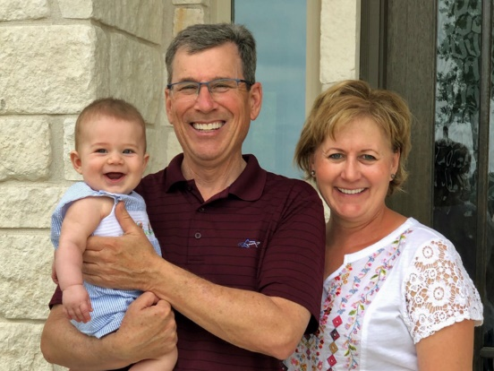
John and Kate Mueller with grandson.
Kate and John Mueller moved to their new home a little west of New Braunfels, TX at the end of last September. 2021 was not the best time to start building but somehow they managed to navigate through the constant delays and changes that were just part of the COVID experience. John has worked for the SCS/NRCS in Texas, West Virginia, Nebraska, and Oklahoma.
They plan to do more traveling in the future but are just now getting most of the items with the new house taken care of. The builder is close to finishing the last punch list items, and they are still working on landscaping in the midst of a severe drought.

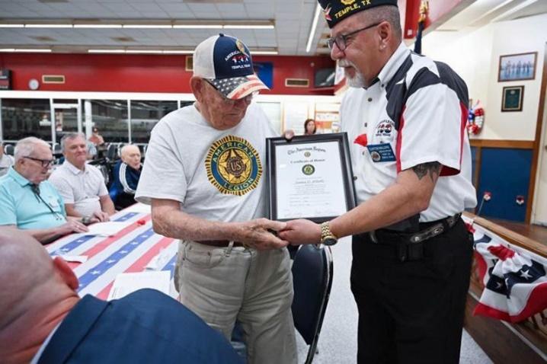
James D. Abbott (left) receives certificate honoring his World War II service from the Temple, Texas American Legion during their Memorial Day Service, May 30, 2022.
James Abbott was a Marine paratrooper during 1942 and 1943. James started working for the SCS in 1948 and retired in 1994. He is also being honored as a Senior Conservationist in this edition.
Charles (retired SCS/NRCS engineer) and Debbie Melton – We celebrated our 50th wedding anniversary with a reception on Saturday, the 21st of May at the Sammons Community Center in Temple, TX. Three of our four boys were there with their wives and children: Charlie and Nina, James and Melissa with Ethan, and John and Amanda with Mark and Hannah. Son John prepared a video of our 50 years with a map of all our moves with the SCS/NRCS and pictures showing family times. Precious memories were a highlight of the reception. We were blessed with many loving SCS/NRCS friends. We thank the Lord for health, safety, and joy. We invite everyone to come to our 65th anniversary in 2037.
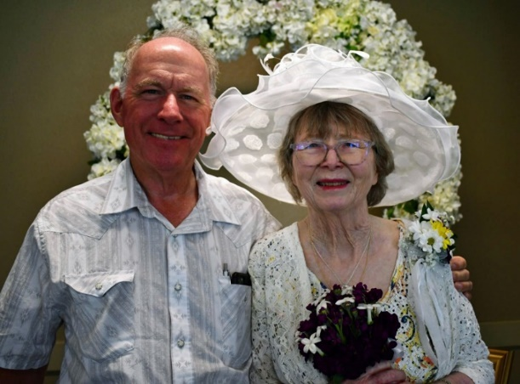
Charles and Debbie Melton
Charles Melton grew up in Sallisaw, OK. His dad was the District Conservationist at Sallisaw. Debbie and he met at Texas A&M and were married in 1972. They both graduated in 1973. Her degree was Elementary Education and mine was Agricultural Engineering.
In 1974 I started working for the SCS at Paris, TX. After working at seven Texas locations, including several years at Ebasco Services in Dallas, he retired in January 2010 from the NRCS Engineering Staff in Temple, TX.
After retiring he joined M&E Consultants working on the repair of flood control dams and various other projects similar to NRCS conservation work. While he still does some work for M&E, he spends more time working with private landowners on the design of lakes and sealing of ponds that leak.
Charles and Debbie are members of 3C Cowboy Fellowship. This year they asked me to be one of their lay pastors. I also lead a worship service at a local assisted living center.
We also have a farm with a few cows where we enjoy spending time with our two sets of twin boys and their families when they come to visit.

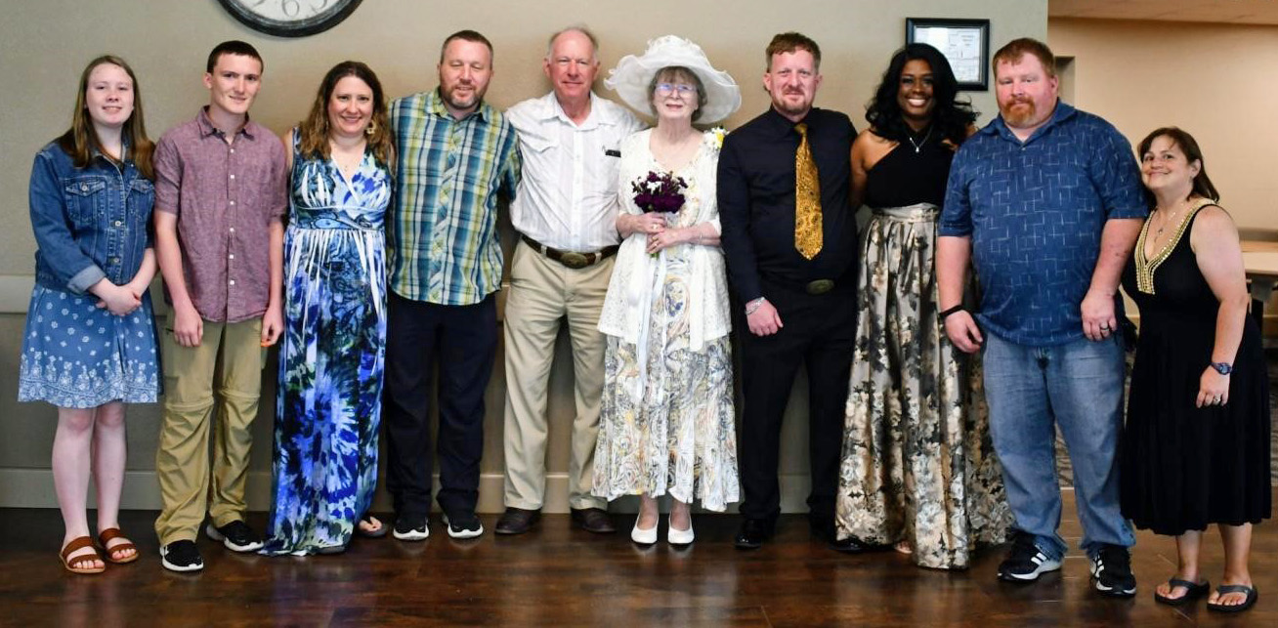
Charles and Debbie Melton and family
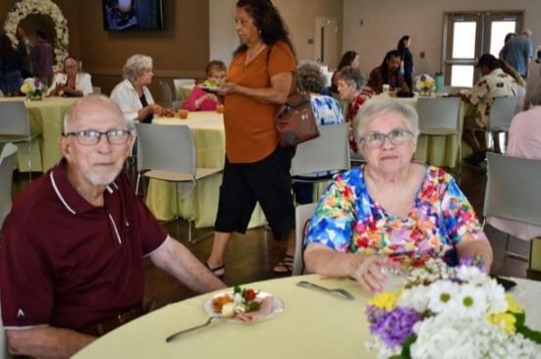
Gene (retired SCS/NRCS engineer) Judy Lindemann
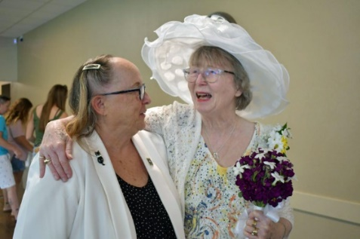
Kat Pinckney (retired NRCS contracting officer) and Debbie Melton

Lee (retired SCS/NRCS engineer) and Arlen Wiederhold
Willeene King reported that her Grandson, Greyson, rode in the Ft. Worth Championship Rodeo recently. He tied for first and split the $1,000 prize
WASHINGTON
Ken Kaul, ARCSE Representative
Email: kenkaul@msn.com
Ken Kaul sent in this article.
Moscow-Pullman Daily News Sixty-five acres of land containing rare Palouse prairie in northern Latah County will be protected under a new conservation agreement with Palouse Land Trust.
Landowner Sarah Metcalf signed the agreement that will prevent future development on her property while keeping it in her private ownership.
According to a news release from Palouse Land Trust, the land contains a remnant of native Palouse prairie "that existed long before colonial settlement converted nearly all the native grasslands to the croplands seen today." That includes the federally threatened flowering plant, Spalding's catchfly. The land is also a travel corridor for wildlife and pollinators. More than 50 species of birds, big game and other wildlife have been seen on the property.
Metcalf bought the property in 1995 and since then has worked with experts from the Natural Resources Conservation Service in Latah County and the Latah Soil and Water Conservation District to learn more about the native plants on her land.
The Palouse Land Trust helped to secure funding for the project through private donations and grants. The land trust received grants for the project from the U.S. Fish and Wildlife Service and The Kendeda Fund through a collaboration with the Heart of the Rockies Initiative's Keep It Connected Campaign.
WEST VIRGINIA
Peg Reese, ARCSE Representative
Email: pegreesewv@gmail.com
JR Wolfe of Preston County is a democratic candidate for the WV House of Delegates to represent district 52. He is an ACES - Farm Bill Specialist - Financial Assistance attached to the NRCS State Office in Morgantown.
John Eddy lost his battle with pulmonary fibrosis on June 8th, 2022. Before his retirement, John was a Civil Engineer at the Morgantown State Office. He also spent many years on the Tri-Ag Credit Union Board. You can learn more about his life in the “In Memoriam” section of this newsletter.
The West Virginia Agriculture and Forestry Hall of Fame (WVAFHF) will honor the 2022 inductees with a banquet on Saturday, July 23rd at Jackson’s Mill. The 2022 banquet and reception will start at 5pm with a dinner to follow at 6pm. Although none of the inductees this year are retired SCS/NRCS employees, many of us will know several of the 2022 inductees:
William P. “Bill” Ingram (Tyler County) – is a third-generation dairy farmer and owner of Ingram Farms in Sistersville. Known for his agriculture wisdom, Ingram is recognized for helping youth learn and grow while providing hands-on farm experience. He was a founding member of the Tyler County 4-H Foundation, received the WV Farm Bureau Distinguished Service Award, and was honored as the 1975 Outstanding Soil Conservation Farmer.
Thomas R. “Tom” McConnell – (Preston County) – received his B.S. and M.S. in agriculture from WVU. He was the WVU Extension Service Preston County Agriculture Agent for 20 years before being promoted to Extension Assistant Dean, and finally as the Program Leader for the WVU Extension Service Small Farm Center. He retired in 2020 and continues to operate a large beef cattle and sheep farm in Terra Alta. He’s a founding member of the Preston Farmers’ Market and the Preston County Chamber of Commerce.
Juergen A. Wildman – (Monongalia County) – was born in Munich, Germany and received his M.S. in Forestry at WVU. He began his career with the WV Division of Forestry in Kanawha, Marion, and Taylor Counties as a service forester. Over his 31-year career with the WVDF, he wrote more than 250 forest management plans for landowners. He retired in 2017 as the Landowner Assistance Specialist. He continues to do consulting forestry work. He is a two-time WVDF Employee of the Year.
Jennifer Ours Williams (Monongalia County) – has dedicated her entire career to being an advocate for agriculture. She joined the WVU Extension Service in 1993 as Upshur County Agriculture Extension Agent and has worked her way up through the organization to her current position as Associate Dean. She is the recipient of the Susan Dew Hoff Award and was instrumental in the creation of the WV Women in Agriculture Conference. She is the co-owner of Ours Valley View Poultry Farm, raising over one million birds a year.
For more information or to secure tickets, contact Jennifer Keaton at 304-558-3200, or jkeaton@wvda.us.

SENIOR CONSERVATIONISTS
Senior Conservationists have reached the minimum age of 83 years and have completed the Senior Conservationist Questionnaire (download at https://arcsecommunications.wordpress.com/senior-conservationists/). See IN-MEMORIAM for the Senior Conservationists who have left us since the last Newsletter. Please help us identify retirees who should be named Senior Conservationists. Please provide their contact information to your ARCSE Representative or Regional Vice-President.
SENIOR CONSERVATIONIST CHRONICLE
Senior Conservationist
James Abbott
James Abbott was born in 1924 on a farm in the Bradshaw community near Abilene, Texas as one of seven children. James has three brothers and three sisters. One of his brothers, Everett, was a long-time SCS/NRCS employee.
James graduated from Bradshaw High School in 1942 and joined the Marines soon after graduation. James was placed in a parachute battery where he served in 1942 and 1943. After James’ military duty he attended Texas Technological College (Texas Tech University) where he graduated with a BS degree in 1947and a MS degree in Soil Science 1948.
Following graduation, James started to work for the USDA Soil Conservation Service (SCS). The SCS sent James to four different universities for more training. James worked as a soil scientist in Lamesa, Texas and Littlefield, Texas prior to becoming the Area Conservationist at Lubbock, Texas.
On December 23, 1945, James married Euna Hart in Lubbock, Texas. James lost Euna November 15, 2015. James and Euna were blessed to have three daughters born to their marriage.
In 1961 James was promoted to Assistant State Conservationist stationed at the state office in Temple, Texas. James served in several positions in the SCS/NRCS Texas State Office until he retired in 1994.
James started playing golf when he was about forty years old and was a very good golfer. James has not played golf recently. Jim will be 98 years old in October, and It may be time to retire his golf clubs.
NOTE: Marc will be retiring from his Chronicler volunteer duties on July 1, 2022. We are looking for another volunteer to assume the Chronicler tasks for the association.

CORRECTION for the May/June edition: Rich Duesterhaus' Master of Arts degree in political science was from Northern Illinois University (Dekalb, IL).

ARCSE.org

OBITUARY INFORMATION  Paul Benedict, Membership Chair | When you receive word of someone passing, with little other information provided to you, obituaries can often be found by doing an advanced search using Google, using the full name of the deceased. If you do not have access to the web, Paul Benedict will be glad to do the search. Please send death notices and obituary information directly to Paul at soilwarden@verizon.net. Always include the position or the spouse’s position with SCS/NRCS.

Surname | Year | In-Memoriam (Note: These are recent notices. For a complete list, please see www.arcse.org)
Flock | 2021 | Phillip Wayne Flock (73) of Madison, Kansas, died peacefully at his home on March 3, 2021, with his wife of 51 years by his side. Phillip was born May 4, 1947, in Eureka, Kansas, the son of Virgil Wayne and Phyllis Orvilla (Totland) Flock. He received an associate degree in Welding from Butler County Community College. In May 1968, Phillip joined the Army National Guard and served on active duty with the 69th Infantry Brigade from May 1968 thru August 1969 at Fort Carson, Colorado. He met his future wife, Carol Ann Storrer through 4-H, and they were united in marriage February 15, 1970. In 1980 they purchased Carol Ann’s family farm, where they continued to live. Early in his career Phillip worked for Hesston Manufacturing, Stephens Dairy, as a ranch hand for his aunt, Gladys Totland, and then for the USDA-National Resources Conservation Service (NRCS) where he worked as a soil conservation technician. He spent his entire life being a wonderful steward of the land and livestock that God blessed him with. Phillip worked tirelessly to improve his home place and planting all the pasture ground back to native grass. Phillip and Carol Ann won the Farm Family of the Year in 2008. He was a Greenwood County Farm Bureau Member and Board member; Kansas Farm Bureau member, serving on several statewide committees; KLA member; past Greenwood County Cattlemen’s President; Eureka Jaycees; Young Farmers and Ranchers; and Greenwood County Fair Board. He supported 4-H activities his entire life. He was a member of the Central Christian Church of Madison, Kansas, where he served as a Deacon. Phillip is survived by his wife, Carol Ann; daughters: Erin (Reece) Laurie of Ottawa, Kansas; and Joanna (Darin) Mason of Hamilton, Kansas; four grandchildren: Wayne Laurie, Ryan Laurie, Lydia Mason, and Elias Mason; and great-granddaughter, Elizabeth Laurie.
Wagner | 2021 | Marcella Irene Wagner (87) of Antlers, Oklahoma, passed away November 8, 2021, in Oklahoma City, Oklahoma. She was the widow of Billy J. Wagner, former State Office Soil Scientist for the USDA-Natural Resources Conservation Service who passed away in 2010. Marcella was born in Tuskahoma, Oklahoma to Robert Dewey Kimberlin and Willie Lee (Barnard) Kimberlin on September 16, 1934. Marcella and Billy were married on March 30, 1956. She was a faithful and devoted member of Antlers First Baptist Church. Marcella enjoyed reading, history, sewing, antiquing, storytelling, baking, cooking, and any time spent with her family was her absolute favorite. She loved feeding people. She is preceded in death by her husband Billy Wagner and son, Eric Wagner. She is survived by her children: Marcia Pitman of Homer, Louisiana; Leah Kyrk of Saginaw, Texas; Eva Willingham of Nashville, Tennessee; and Lana Wagner of Albuquerque, New Mexico; 10 grandchildren and multiple great-grandchildren.
Carpenter | 2022 | Kenneth Elba Carpenter (66) of Fort Collins, Colorado passed away unexpectedly on May 24, 2022, at his residence. He was born January 5, 1956 to Hestel “Corky” Carpenter and Mary Elizabeth Holmes in Charleston, West Virginia. Ken earned a bachelor’s degree in Civil Engineering at West Virginia University before joining the USDA-Soil Conservation Service in the late 1970s as a civil engineer. In 1992, he joined the new Technology Information Systems Division as a software project manager when the agency consolidated its information technology function to Fort Collins, where it became part of the Natural Resources Research Center in Fort Collins, a federal government reinvention initiative with Colorado State University. Ken managed the development, deployment, and maintenance of conservation engineering software used throughout the agency. His influence is reflected in the portfolio of engineering applications available today at https://www.nrcs.usda.gov/wps/portal/nrcs/detail/?cid=nrcs144p2_029573. In the years prior to his retirement, Ken managed the testing and release of software across all technical disciplines for NRCS. He is survived by his lifelong friend and partner Michelle, their three children: Kenny Carpenter (Michelle Grigsby) of Fort Collins, Colorado; Kyle Carpenter (Laura) and grandson expected in the fall of Washington, New Jersey; and Megan Carpenter (Eli Peterson) of Greeley, Colorado; as well as siblings Richard Carpenter of Dunbar, West Virginia and Janet Runion of Sissonville, West Virginia. Several NRCS and USDA co-workers and friends attended a celebration of his life held May 29, 2022. Ken will be missed.
Eddy | 2022 | John Irvin Eddy (74) of Westover, West Virginia, passed away June 8, 2022, at his home after a battle with pulmonary fibrosis. John was born Oct. 7, 1947, in Sistersville, West Virginia, a son of the late Bernard Eddy and Ruth Henderson Eddy. John retired as a civil engineer at the Morgantown State Office for the USDA-Natural Resources Conservation Service with many years of service. He also spent many years on the Tri-Ag Credit Union Board. In his spare time, John also enjoyed being outdoors, fishing, and spending time with his grandchildren. John is survived by his wife, Linda Gorby Eddy; one daughter, Shannon (Kirk) Wissmar, of Westover; three grandchildren, Reese Wissmar, Audrey Wissmar and Waylon Earl Eddy. John was preceded in death by his son, Craig Matthew Eddy. In lieu of flowers, the family requests that donations be made in John’s memory to the Pulmonary Fibrosis Foundation, 230 East Ohio St. Suite 500, Chicago, IL 60611. Graveside services were held at Greenlawn Memorial Park in New Martinsville.
Gaudette | 2022 | Former ARCSE Member Rosemary “Rosie” (Rinehart) Gaudette of Altoona, Iowa, passed away Tuesday June 7, 2022, in Des Moines, Iowa. Rosie was born February 29, 1940, in St. Joseph, Missouri to Cecil and Mary (Chumbly) Rinehart. Rosie moved to Washington, D.C. following her high school graduation, where she worked for the Navy Department. There she met Robert “Bob” O. Gaudette. They were united in marriage on June 2nd, 1962, in Washington, D.C. In 1966 they moved to Columbus, Ohio where they were blessed with two children: Jon and Debra. In 1972 they moved to Iowa where Rosie went to work for the USDA-Soil Conservation Service Iowa State Office as a financial analyst, until she retired in 1994. Rosie’s love of books led her to work and then volunteer at the Altoona Public Library. Rosie is survived by her husband of 60 years, Robert “Bob” Gaudette of Pleasant Hill, Iowa. Additional survivors include her adult children Jon (Tammy) Gaudette of Runnells, Iowa; Debra Mikkelson of Atchison, Kansas; and four grandchildren Devin (Marie) Gaudette, Alex Gaudette, Markelle Mikkelson, and Anna Mikkelson. She was preceded in death by her son-in-law Mark Mikkelson.
Gelhen | 2022 | Former ARCSE Member Carolyn Jane Gelhen (79) of Broomall, Pennsylvania, passed away on April 9, 2022. She had suffered a stroke and a fall in March. Carolyn was born in Philadelphia, Pennsylvania on July 22, 1942, the daughter of the late Norman and Harriette (nee Scott) Van Artsdalen. Carolyn had worked for the USDA-Soil Conservation Service at the Northeast Technical Center in the Soil Survey Unit in Upper Darby, then Broomall, and finally Chester, Pennsylvania. She was the wife of the late Timothy D. Gehlan.
Harney | 2022 | Bill R. Harney (82) of Perry, Oklahoma passed away on June 21, 2022, at his home with his faithful caregiver and wife Jan by his side. He was born November 3, 1939, in Ponca City, Oklahoma to Lee Ross and Grace Jeanette (Miller) Harney. He grew up on the family farm south of Ponca with his three brothers before graduating from Ponca City High school in 1958. He went on to earn his degree in Agricultural Science from Oklahoma State University in January of 1963. Bill and the former Jan Leathers were married on November 17, 1962, in Ponca City. He worked for the USDA-Natural Resources Conservation Service (formerly Soil Conservation Service) for 42 years as a soil conservationist. He began his work in Atoka, Oklahoma and later served the Oklahoma communities of Cherokee, Enid, Alva, Perry, Medford, Newkirk, and Tahlequah. He retired from the Natural Resources Conservation Service in 2004 but continued to work on the family farm growing wheat, cattle, and horses until his health wouldn’t allow. He was a hard worker and enjoyed being outside growing and fixing things. He could fix just about anything, including things around the house, tractors, cars, and gadgets of all kinds. He would always stop along the highway to help anyone who was having car trouble and get them rolling again. They would thank him and offer to pay, but he would always refuse and say, “Just stop and help the next guy when you can.” He was preceded in death by his son Douglas Harney in 2005. Bill is survived by his wife, Jan, who faithfully cared for him through his health challenges. He is also survived by his daughter Jo Ewy (Erron) of Edmond, Oklahoma, and Gina Harney (Steve McFarlane) of McKinney, Texas. He is also survived by grandchildren Brooke Ketch, Bryce Ewy, Oliver Prows, Willow McFarlane, and River McFarlane as well as great grandchildren Keegan Ketch and Kaiden Ketch.
Hodges | 2022 | Luther Pat Hodges (90) of Chickasha, Oklahoma, passed away May 17, 2022. Pat was born March 18, 1932, in Tuttle, Oklahoma, to Gertie Effie Hodges (Hutchison) and Marvin Luther Hodges. On December 2, 1950, he married Nettie Virginia Fleming, a girl he had known since 3rd grade. In the late 1950s, Pat began a long career working for the USDA-Soil Conservation Service as an engineering technician, and he and Nettie moved to Chickasha. For the first 15 years or so, he was an integral part of the survey crew, traveling all over the state of Oklahoma, surveying the creeks and rivers to map out and build flood-control lakes. When an old back injury got the best of him, he finished his career in the Chickasha office drawing intricate maps of the very lakes he had helped create. He loved to fish and quail hunt, and he and Nettie became avid square dancers. Pat retired from the Soil Conservation Service in the mid-eighties and later worked part-time for his son Rick at the gas station, at Motor Service delivering parts, and finally at AutoZone. Pat is survived by his wife Nettie, all four of his children and their spouses, ten grandchildren, eleven great-grandchildren, one great-great-grandchild, numerous nieces and nephews, cousins, and friends, and his dog China.
Hoopes | 2022 | Pauline Frances Hoopes (88) of Anthony, Kansas, passed away May 8, 2022. Pauline was the spouse of retired USDA-Soil Conservation Service employee Francis S. Hoopes, who retired in 1988 as a Civil Engineer (Water Management Specialist) in the Kansas State Office in Salina, Kansas. Pauline was born January 21, 1934, on the family farm. She went on a blind date in 1954, and a few weeks later her date, Francis Hoopes, was called to serve over seas. Pauline awaited his return in 1956, so the two could share a lifetime of happiness together. They married on June 2, 1957. Pauline spent most of her life as a homemaker and farm wife. She was a member of the First Baptist Church in Anthony. She loved gardening and canning. She quilted, making many heirlooms for her family and friends.
Johnson | 2022 | Anita Johnson (83) of Mt. Sterling, Kentucky passed away Friday, May 13, 2022, at her residence. Anita was the widow of the late Ray Johnson, former Area Conservationist for the USDA-Soil Conservation Service, who passed away December 23, 2020. She was born in Sandy Hook, Kentucky on December 16, 1939, to the late Ernest Adkins and Maxine Fannin. She was a member Rolling Hills Church of Christ and a Worthy Matron of Eastern Star. She retired from Commonwealth Urology as Insurance Billing Manager after 10 years. She is survived by a son, James Kevin Johnson of Mt. Sterling; a daughter, Kimberly Barnes (Steve) of Mt. Sterling; and three grandchildren.
Lamarca | 2022 | Chilean Farmer and No-Till Legend Carlos Crovetto Lamarca (89) of Florida passed away June 17, 2022, at his home. According to the Argentine newspaper La Nacion, he was born in the city of Concepción, Chile, taking charge of the family farm called “Chequén” at an early age. As early as the 1950s, he recognized that tillage was the main cause of soil erosion and degradation. He radically changed the management of his soils and production methods, ceasing to till his soils. He planted trees on the most limited soils of his property, or permanent grasslands for cattle ranching on the rest. He freely and generously shared his ideas, knowledge, and experiences with countless producers from around the world. He devoted years of traveling the world to participate in various exchange activities, spreading his ideas and experiences with passion for soil conservation. He wrote many technical articles and published three books, including Stubble Over the Soil: The Vital Role of Plant Residue in Soil Management to Improve Soil Quality, describing his knowledge and documenting his experiences. He visited the United States several times in the 1980s and 1990s, working with Dr. David Schertz, Dr. Jerry Lemunyon, Mike Hubbs, and many others to promote the adoption of no-till.
Latshaw | 2022 | Gerald Jesse Latshaw (87) of Omak, Washington passed away in April of 2022. Jerry was born May 3, 1934, in Okanogan, Washington to Edward and Violet Latshaw. He graduated from Okanogan High School as class president in 1953 going on to Washington State University to earn a degree in agricultural sciences. After serving 1 year in the United States Army, he went to work for the USDA-Soil Conservation Service which began a 30-year career beginning in Okanogan and which took him to Pennsylvania, Texas and finally to Portland Oregon where he retired as State Soil Scientist. Upon retirement he moved back to his beloved valley and settled in Omak, Washington where he enjoyed fishing, gardening, and meeting old friends for coffee. Survivors include his wife, Sharon; children, Becky, Wayne, Matt, Debbie, and Jan; four grandchildren; and five nieces and nephews.
Leab | 2022 | Former ARCSE Member Roger Jay Leab (75) of King, North Carolina, passed away suddenly on May 18, 2022, in a tractor accident on his property. Roger was born in Salisbury, North Carolina on February 19, 1947, to Joseph C. Leab and Mildred Hall Leab. Roger received a Bachelor of Arts degree in Geology from Catawba College in 1969. He continued in this field working for Kerr McGee Corp. in New Mexico and Wyoming in uranium mining. He then furthered his education, obtaining a Bachelor of Science degree in Soil Science from North Carolina Agricultural and Technical State University (A&T State University) in 1975. This began a successful career as a soil scientist, working for the USDA Natural Resources Conservation Service for 37 years. He was the Major Land Resource Area Office Leader when he retired in 2010. Roger was known to be a hard worker in anything he attempted to do. During his entire career he was always a very devoted family man. He coached baseball for his 3 sons in both Elizabethtown and King, North Carolina. He enjoyed life, family, friends, sports, fishing, gardening, and working on his many projects. After retiring, one of his primary projects was working tirelessly to fix up his "happy place" at High Rock Lake, a lifelong dream. Roger is survived by his wife, Rebecca Lindsay Leab; his 3 sons, Keith Fulk (Roxy), Eddie Fulk, Joshua Leab (Whitney); 5 grandchildren, Kenneth Fulk, Hannah Willis, Bridgette, Griffin, and Payne Leab; as well as 2 great grandchildren, River and Atlas Willis.
Lines | 2022 | Ivan Lines Jr. (79) of Spokane, Washington, passed away April 9, 2022. Ivan was born in Stockton, California March 21, 1943, to Ivan and Emma Lines. "Papa," as he was called, was an avid outdoorsman who spent his life working to restore waterfowl habitats. He worked for the USDA-Natural Resource Conservation Service after graduating from Humboldt State University with a degree in Wildlife Management, most of it as State Biologist in the Washington State Office, engaged with on-the-ground stream restoration, upland game habitat development, helping protect sage grouse habitat, and improving diversity in biological “deserts.” He was most proud of his 10 years with Ducks Unlimited restoring wetlands in Eastern Washington and Northern Idaho. Ivan was a founding member of the Ducks Unlimited Shoot at the Spokane Gun Club and a lifetime member. He taught his sons to love the outdoors, despite the different ways they both enjoy it. Ivan would spend days fly-fishing for Steelhead and be thrilled to just get a bite. To him, it was a good day when he was setting duck decoys in the morning darkness and listening to the birds whistling overhead. Sometimes he would get a limit and then spend another hour calling ducks into his set just to watch them land. There was always a hunting dog (or two) by his side. Ivan's family and friends will remember his more memorable quotes: Fly Fishing- "You catch more fish with the fly in the water." ...he was not impressed by fancy casting techniques. Turkey Hunting- "Put some Benelli on 'em." ...his favorite Italian-made shotgun. Duck Hunting- "As long as there's lead in the air, there's hope." He was preceded in death by his brother Greg Lines. Ivan is survived by his wife of 56 years, Mary Dickel; sons John Lines (Becky), Peter Lines, (Christy); and his granddaughters Annaliese and Madelyn.
Maculaitis | 2022 | Teena M. Maculaitis (66) of Mountain Top, Pennsylvania, passed away June 2, 2022, at Geisinger Wyoming Valley Medical Center in Wilkes-Barre, Pennsylvania. Teena was born in Blossburg, Pennsylvania, the daughter of Donald and Faye Llewellyn Lamonski. She was the wife of retired USDA-Natural Conservation Service employee Richard Maculaitis, who worked as a District Conservationist in Plymouth, Pennsylvania. She is survived by her husband.
Minnick | 2022 | Berta Minnick (86) of Walnut Creek, California, passed aways April 23, 2022 after a short bout with cancer. She was the wife of Edwin L. Minnick, retired State Conservation Engineer in Michigan for the USDA-Soil Conservation Service. Edwin retired in 1988. Berta was born on 05/04/1935.
Newcombe | 2022 | Dora Ellen Newcombe (69) of Baldwinsville, New York passed away peacefully on April 19, 2022, at Elderwood of Liverpool in Liverpool, New York. Dora was born January 17, 1953, to James Johnson Newcombe and Lillian Weykman Newcombe. Dora graduated from Bryant and Stratton College. She retired from the USDA-Natural Resources Conservation Service as a Computer Specialist. Dora was predeceased by her parents. She is survived by her cousins.
Philbin | 2022 | Former USDA-Soil Conservation Service employee James “Jim” Woodward Philbin (71) of San Rafael, California passed away unexpectedly February 12, 2022, at his home, of natural causes. Jim was born in Glen Cove, New York. He graduated from California Polytechnic State University in San Luis Obispo, California with a degree in Agricultural Management, and later obtained a Batchelor of Arts degree in Psychology from Cal State University, Northridge. After working for many years with the USDA-Soils Conservation Service throughout California, Jim settled in Sebastopol, California, with his wife Maria, and their two young daughters, and started his own landscape construction business. He was involved in a variety of service work, including work with the Wilderness Youth Project in Santa Barbara, California, and Inner Light Ministries near Santa Cruz, California. He is survived by his daughters, Katie (Blake) and Hanna (Michael); his former wife and lifelong friend, Maria; and his grandchildren, George, Isabel, and Eleanor.
Schwant | 2022 | Eldon William Schwant (78) of Seneca, Kansas, passed away June 12, 2022, at Crestview Nursing and Residential Living in Seneca. He had been a resident of Crestview Manor since 2017. He was born March 11, 1944 in Westmoreland, Kansas, the oldest of four children, to Lester and Louise (Krohn) Schwant. He attended Kansas State University and in 1967 received a bachelor’s degree in Agriculture. Eldon married Betty Mae Schwartz on October 9, 1966, at St. Luke Lutheran Church in Wheaton, Kansas. They celebrated 50 years of marriage in 2016. He and his family spent the early years of his career in soil conservation in the communities of Clay Center, Osborne, and Yates Center, Kansas. In 1976 he accepted a position with the USDA-Soil Conservation Service in Seneca as the District Conservationist. He held that position for the next 28 years, retiring in 2004. After retirement Eldon returned to the NRCS office and worked on a part-time basis until 2017. He took a lot of pride in his career. One of his proudest accomplishments was the development of the Centralia Lake, which was completed in 1990. He was a member of the First Lutheran Church in Sabetha, Kansas. Eldon was proceeded in death by his wife, Betty, in 2017. He is survived by three children: daughters Lori Jones of Camden Point, Missouri; Amy Isaacs (Matthew) of Tonganoxie, Kansas; and son Scott Schwant (Kristina) of Holts Summit, Missouri; nine grandchildren: Nathan, Noah, Sara, and Hanna Hale; Tucker, Adam, and Sage Isaacs; and Gavin and Payten Schwant.
Sepelak | 2022 | Lee Sepelak (71) of Maine, New York, passed away peacefully on May 17, 2022, at his home. He was born September 4, 1950, to Frank and Irene Sepelak. He was a retired Technician for the USDA-Natural Resources Conservation Service where he worked with the Broome County Soil and Water Conservation District in Binghamton, New York for 30 years. Lee was known by all for his kindness and his smile. He is survived by his loving wife of 50 years, Kathy (Surace); his son, Jacob; his daughter, Rebecca; his grandson, Dylan among other family and friends.
Smith | 2022 | Rodrick “Rod” Edgar Smith (79) of Nancy, Kentucky passed away suddenly on May 15, 2022, at his home. Rod was the husband of Peggy Smith, retired Human Resources Specialist in the Kentucky State Office of the USDA-Soil Conservation Service. Peggy retired in 1994. Rod was born on June 27, 1942, in Trimble, Ky, to the late Jacob F. Smith and Adria F. Smith. He worked for Trane Company in Lexington, Kentucky. He was a member of White Oak Baptist Church. He is survived by his wife of nearly 58 years, Peggy; daughter, Kimber (Bobby) Thomas; and three grandchildren.
Sosbe | 2022 | Howard P. Sosbe Jr. (65) of Connersville, Kentucky, passed away June 1, 2022, after a long illness. He was born in Harrison County, Kentucky on February 17, 1956, to the late Howard P. Sosbe, Sr. and Frances Wagoner Sosbe. He was retired from the USDA-Natural Resource Conservation Service where he worked as a Soil Conservation Technician. In years past he and his black and white 1967 Chevrolet water truck, on which he put over 650,000 miles, were a familiar sight all around Harrison County. He was an avid collector of Chevrolet trucks and antique Ford tractors and was a born storyteller. He is survived by his wife of nearly 40 years, Pamela Jean Sosbe; a son, John Sosbe (Whitney); and one granddaughter, Annaleigh Frances Sosbe.
Spencer | 2022 | Alan Charles Spencer (67) of Clarkston. Utah, passed away on March 18, 2022, from a heart attack resulting from congestive heart failure. Alan was born in American Fork, Utah on October 20, 1954, to Ralph H. and Betty G. Spencer. He developed a passion for archaeology early and spent many childhood days by Utah lake looking for fossils and arrowheads. By 15, Alan was a crew chief with the BYU archaeology field school in Southern Utah, and at 17 he graduated from American Fork High School. After spending his summer with the American Archaeological Expedition to Petra, Alan started his scholastic career at BYU as a second semester sophomore. From there, Alan served an LDS Mission to the Dallas/Fort Worth area, and upon his return to BYU completed his bachelor’s degree with honors, and would later go on to earn his Masters’ and PH.D. from the University of Leicester in Leicester, England. Alan married Leesa Gurney in the Salt Lake LDS Temple on June 25,1982 and, having accepted a job with the USDA-Natural Resources Conservation Service in Portland, Oregon, Alan and Leesa embarked on a grand adventure that would take them first to the Pacific Northwest for 24 years, where he worked as a Cultural Resources Officer at the West National Technical Center. Then they moved to Little Rock, Arkansas for 14 years where Alan worked at the National Water Management Center. After retirement in 2014, they moved to the Cache Valley of Utah, settling in the small town of Clarkston. Alan is survived by his wife, Leesa, his three daughters, two sons, 12 grandchildren, and two great-grandchildren. An incredibly brilliant man, his vast treasure trove of knowledge on any subject, his quirky sense of humor, his laugh, and his love will be sorely missed by his family and by all who knew him.
Trayvick | 2022 | Johnny Clarence Trayvick, Sr. (75) of Phenix City, Alabama passed away April 22, 2022. Johnny was born August 29, 1946, in Atmore, Alabama and graduated as Valedictorian for the class of 1964 from Escambia County Training School in Atmore. He earned a Bachelor of Science Degree in Agronomy and Chemistry at Alabama Agricultural & Mechanical University in Normal, Alabama near Huntsville; and he later took courses in auto mechanics and accounting at the University of Alabama. Johnny was drafted into the United States Army in 1969 and served a tour of duty in Vietnam. He was a proud veteran and received the National Defense Service Medal, Vietnam Service Medal, Combat Infantryman Badge, and Air Medal. Johnny worked as a Soil Survey Project Leader with the USDA-Soil Conservation Service (SCS) from June 1968 until his retirement in 2005, except for service in the U.S. Army. During his career with the SCS he worked in the Alabama counties of Bullock, Dallas, Tuscaloosa, Sumter, Russell, Macon, Tallapoosa, and Barbour. Johnny received Certificates of Merit in 1982 and 1997 and spot awards in 1998 and 1999. Johnny was an active member of Franchise Missionary Baptist Church where he was an avid Sunday School teacher, dedicated deacon, trustee, and faithful friend to many. Many people enjoyed Johnny during his role of Jesus for Franchise Missionary Baptist Church’s Resurrection Cantata. As a steward of the land and for the beauty of God’s earth, he provided lawn care to the grounds of his church. Survivors include his wife, Sharon Davison Trayvick; children, Johnny C. Trayvick, Jr., Michael Hatcher, Denise Trayvick, Stephanie (Reginald, Sr.) Williams, LaBronda Riley, Tangia Riley and Sonjia (Rocky) Roberts; grandchildren; and great-grandchildren.
Weeks | 2022 | John Waldo Weeks (72) of Nampa, Idaho, passed away peacefully May 21, 2022, after a long and courageous battle with leiomyosarcoma cancer with family and the family dog Evie at his side. John was born in Caldwell, Idaho, on Dec. 6, 1949, to (Waldo) Ingle and Margaret Weeks. He attended college at University of Idaho and Boise State University. In 1972 he enlisted in the United States Marine Corps. He remained on active duty for 8 years. During those years he attended college at the University of Oklahoma and Arizona Western College. John married his high school sweetheart Gerry (Motichka) on July 10, 1972. John and Gerry would have celebrated their golden 50th anniversary this year. He belonged to Boone Memorial Presbyterian Church. In his professional career, his work involved installing and maintaining water monitoring systems all over the United States, Puerto Rico, Mexico, and Thailand. He worked for Sutron Corp. and Vitel, Inc, as a contractor to the Bureau of Reclamation while living in Caldwell. In 2002 John and Gerry moved to Beaverton, Oregon, when he began working for Stevens Water Monitoring in Beaverton. In 2004 he began his career with the Federal Government working for the USDA-Natural Resources Conservation Service’s National Water and Climate Center in Portland, Oregon, where he became the Lead Technician keeping the Snotel system working. After retiring in 2019, they moved to Nampa, Idaho to be near family. He is survived by his wife Gerry; daughters Shawna Weeks, Marcella (Ryan) Frasier and Janet (Joshua) Orr, grandchildren Zadie Fross, Erica Frasier, Emily Frasier; Eli Orr and Grace Orr.
Willis | 2022 | William Edward “Bill” Willis II (79) of New Virginia, Iowa, passed away April 18, 2022. Bill was born in Estherville, Iowa on March 18, 1943, to William Edward Willis and Mary Marguerite Farnnham Willis. Bill grew up on a small farm on the east edge of St. Joseph, Missouri. He received a Bachelor of Science degree in agriculture from the University of Missouri in 1966 and went to work for the USDA-Soil Conservation Service (SCS). Bill worked for the SCS at locations in Missouri at Clinton, Bethany and Charleston before moving to Decorah, Iowa in 1970. In 1973, Bill moved to Atlantic, Iowa where he was the District Conservationist until 1993 when he retired from the SCS. In 1997, he formed Willis Dirtwork. In 1999, Bill and his wife, Mary, relocated to a farm outside of New Virginia, Iowa. For more than the next two decades, Bill through his dirt working business, literally helped shape the land in the communities surrounding the New Virginia area. Throughout his adult life, Bill was actively engaged in service to his community. He was President of the Atlantic Lions Club and three-term Mayor of the town of Wiota, Iowa. In 2003, Bill became a trustee for Squaw Creek Township, in which capacity he served the residents of the township continuously for nineteen years. Bill was instrumental in the beautification of the township’s three pioneer cemeteries, helping to oversee improvement of the grounds, fence, and flagpoles. In 2008, Bill joined the Board of Directors of Clarke Electric Cooperative, where he served until his death. Bill is survived by his wife, Mary Ann Willis, his sons, Chris Willis of Independence, Missouri and Jeff (Kelly) Willis of Shelby, Nebraska; a step-daughter, Kimberly Dawn (Scott) Thomas; six grandchildren, three step-grandchildren, and a step great-grandson.

Deadline for Sept/Oct 2022 Newsletter Contributions is August 25th, 2022.

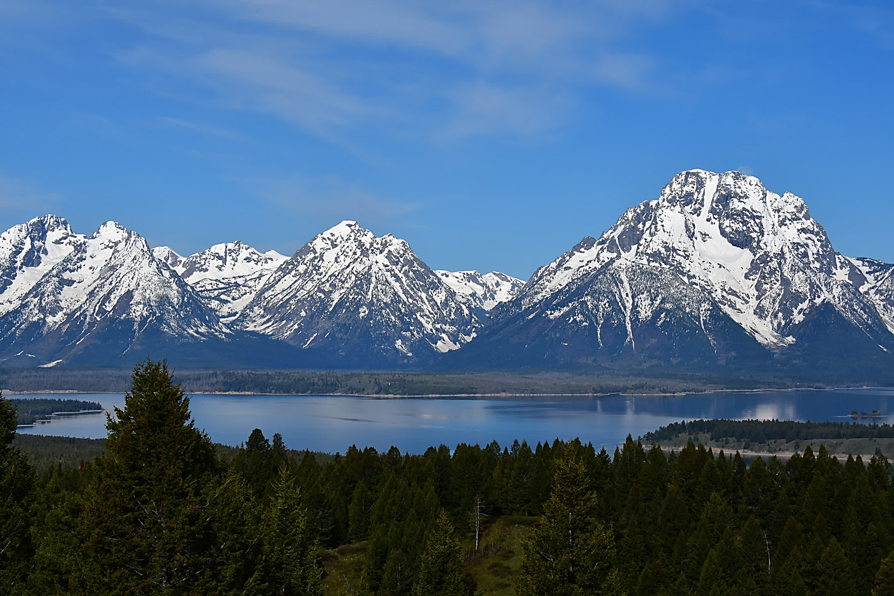
Reflections of the Grand Tetons, Wyoming

