Governing Board  President:  Arnold D. King  1800 Canaveral Ct.  Granbury, TX 76048-4370  (817) 578-8177  arnolddking@hotmail.com  President-Elect:  Julie MacSwain  1024 E Cascade Ave.  River Falls WI 54022  (651) 472-2453  juliemacswain@gmail.com  Immediate Past President:  Cheryl K. Simmons  1055 Hazeltine Rd  Moscow, ID 83843  (817) 542-2725  cksoil@aol.com  Secretary: Jack R. Carlson  2937 Garrett Drive  Fort Collins, CO 80526-6222  (970) 980-7443  pspicata@gmail.com  Treasurer: Donna Beggs  P.O. Box 8965, Moscow, ID  83843  (518) 524-8907  arcse.treas@gmail.com  Regional Vice-Presidents  EAST: Melvin Womack  10307 Scots Landing  Mechanicsville, VA 23116  (804) 803-8940  mwpocket2@comcast.net  WEST: Bill Ward  3029 Nikol Street  Sacramento, CA 95826  (916) 769-0280  bluegrassbillward@gmail.com  SOUTH: William Kuenstler  79 Gulf Winds Way  Santa Rosa Beach, FL 32459  (817) 845-65158  bkuenstler@gmail.com  MIDWEST: Rebecca Fletcher  15 Danridge Drive  Danville, IN 46122-1342  (317) 371-6944  becky_fletcher@sbcglobal.net  Advisory Board Members  Membership Chair:  Paul Benedict  190 Nittany South Way  Stephens City, VA 22655  (202)-578-8226  soilwarden@verizon.net  Historian: Vacant  Editor: Jerry Bernard  15 Apple Blossom Ct.,  Stafford, VA 22554  (540) 720-5644  jbernard.nrcsret@gmail.com  Webmaster: Vacant  Notes From the Potomac:  Vacant  Sr. Conservationist Chronicler:  Marc Safley  11975 William and Mary Circle, Woodbridge, VA 22192  (703) 494-8074  Jsafley1@verizon.net | 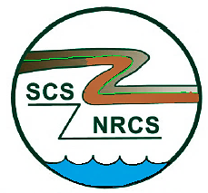 | NEWSLETTER  The Newsletter for Retired Conservation Service Employees  Vol. 49, No. 3 May/June 2022  The ARCSE Newsletter is published bi-monthly by the Association of Retired Conservation Service Employees, 1800 Canaveral Court, Granbury, TX 76048-4370  Website: www.arcse.org
A message from NRCS Chief Terry Cosby on Earth Day:
As retired NRCS employees you can take pride in the fact that your work helped farmers and landowners install conservation practices that promoted healthy soil, clean air and water, abundant wildlife habitat and healthy forests. Regardless of your role with the agency, you played an important part in the future health of our planet. During this Earth Day, I hope you will take time to get outside and enjoy the vital natural resources that you helped to protect and improve during your service to the agency. By “helping people help the land” you left a lasting legacy which we can all enjoy. Thank you for your service and happy Earth Day.
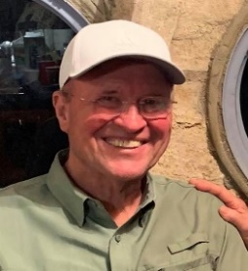
FROM THE PRESIDENT
Arnold King
It seems we are out of the pandemic stage of COVID and firmly into the endemic phase. Medical facilities are still requiring masks, and I suppose that is a good thing. And some of us older folks are being extra careful. People are pouring across the southern border and being distributed across the United States without a requirement for vaccination. Who knows what effect that will have on the COVID situation.
ARCSE is doing fairly well financially, but we need more members to keep our head above water. About half of our members are Life members who obviously aren’t required to pay annual dues. That works out fine as long as we are signing up members. I attended the Texas Retiree reunion at New Braunfels on April 5th and 6th. Attendance continues to drop because of deaths and health problems. So, again, we need to sign up new retirees. During the meeting, I encouraged several to sign up for the 1st year complimentary membership. I was able to get eight applications filled out, and hopefully they will become permanent members. Based on that experience, we probably have a lot of potential ARCSE members who faithfully attend their local meeting but have never been adequately encouraged to sign up as members. Julie McSwain, our President-Elect, informed me that a few of her friends told her they didn’t know a retiree organization existed. So, we need to find ways to inform folks about ARCSE who are planning to retire in the near future. And I encourage local leaders to take blank applications to their local meetings and be sure they know about our complimentary first year membership.
Bob Halstead sent me a newspaper article written by an urban SWCD board member who is rightfully concerned about a newly passed Florida bill requiring district board members to be active farmers. Her concern is that many urban districts may not have eligible candidates for the local boards, and some of the SWCDs could be in jeopardy. Urban areas do, in fact, have serious soil and water issues that can be addressed by urban districts and programs. Hopefully, that situation will be worked out and will not spread to other states.
Our plans for the annual meeting at Denver on August 1st are shaping up nicely, but we need to have good representation from local members and folks planning vacations to Colorado who might make plans to also attend our luncheon. The luncheon will be at John Elway’s Steakhouse in the Ritz-Carlton Hotel near the SWCD headquarters hotel in downtown Denver. Please plan to come.
ARCSE on Facebook
Facebook Engagement by Julie MacSwain
Thank you ARCSE members for “liking” our ARCSE Facebook page. We are nearing 300 likes for our page. If you have any suggestions for content or pictures to share for “Throw Back Thursday,” please reach out to Julie MacSwain at juliemacswain@gmail.com.
Let's keep in touch!
ASSOCIATION OF RETIRED CONSERVATION SERVICE EMPLOYEES

Notes from the Potomac (by way of the Rocky Mountains)
– Jack Carlson, ARCSE Secretary, Fort Collins, Colorado
After five years Patty and Doug Lawrence have passed the reins of “Notes from the Potomac,” and your ARCSE Secretary at the foot of the Rocky Mountains has them in hand, ready to give to someone further east with a closer ear to the ground. With drought, wind, and fire holding our attention in these parts, it can be somewhat difficult keeping up with the goings on back there. Nevertheless, Vicki and I trek to WDC two to three times a year to see our two granddaughters and their parents. Daughter Sara works for USAID on biodiversity projects, and her husband Michele is a research economist for the World Bank, who emailed this link in March on Ukraine and global food security, featuring Joe Glauber, former USDA Chief Economist:
https://tradetalkspodcast.com/podcast/160-how-putins-war-could-disrupt-global-food-supplies/
And FSA Administrator Zach Ducheneaux was in town for the Farm Credit Administration National Forum on Serving Young, Beginning, and Small Farmers and Ranchers at Colorado State University in late March, also asking for a briefing on our erosion modeling service support to the Conservation Reserve Program. Additional information on the recent CRP signup and other program highlights are here:
https://www.youtube.com/watch?v=KQ6-6AVmHWI
In mid-February, NRCS Chief Terry Cosby outlined agency progress and priorities in a keynote address at the NACD annual conference, which convened in person in Orlando, Florida:
https://www.youtube.com/watch?v=64LoSsyJZLc
Also in February, Secretary Vilsack and Deputy Secretary Bronaugh released the USDA Equity Action Plan in support of Executive Order 13985, Advancing Racial Equity and Support for Underserved Communities through the Federal Government. The plan can be accessed and downloaded here:
https://www.usda.gov/equity/action-plan
In April, USDA announced a $420 million investment in rural water infrastructure benefitting underserved communities:
https://www.nrcs.usda.gov/wps/portal/nrcs/detail/national/newsroom/releases/?cid=NRCSEPRD1913231
In March, NRCS produced the latest report from the Conservation Effects Assessment Project (CEAP) entitled Conservation Practices on Cultivated Cropland: A Comparison of CEAP I and CEAP II Survey Data and Modeling. The analysis found conservation tillage systems becoming the dominant form of tillage, increased structural practices in combination with reduced tillage, reduced irrigation water application rates and withdrawals, and increased irrigation in more humid areas. More than 70% of cropland is in conservation crop rotations, and 28% having high biomass rotations, overall increasing soil carbon by 8.8 million tons per year.
https://www.nrcs.usda.gov/wps/portal/nrcs/detail/national/newsroom/releases/?cid=NRCSEPRD1891029
In March, USDA, responding to stakeholder feedback, extended the application deadlines for Partnerships for Climate-Smart Commodities into May and early June. The funding opportunity finances projects creating market opportunities for U.S. agricultural and forestry products using climate-smart production practices and cost-effective methods to measure and verify greenhouse gas benefits. The initiative expects proposals from $250,000 to $100 million in size, to be funded through the USDA Commodity Credit Corporation.
https://www.nrcs.usda.gov/wps/portal/nrcs/detail/national/newsroom/releases/?cid=NRCSEPRD1898239
Finally, the Security and Exchange Commission (SEC) approved a proposed rule in March that would require publicly traded companies having set carbon footprint reduction goals to start reporting progress-cutting emissions in their supply chains. The intent of the rule is to provide more information to investors, as well as to motivate standardization of how progress is tracked and disclosed. Many organizations have and will continue to weigh in with their different perspectives.
https://www.sec.gov/news/press-release/2022-46
That's it for now, less comprehensive than what you've come to expect from the Lawrences, but perhaps a sufficiently informative dose. Headed down to ABQ tomorrow for soccer tournaments and the twins' First Communion this weekend. Red flag day and hopefully no grass fires on the way.
Who would like to take the Potomac reins?
NRCS Hiring Strategy Task Force -Marketing Team
Julie MacSwain
The NRCS Hiring Strategy Task Force Marketing Team continues to work on the mentoring portal, with the goal to have the retirees added to the portal.
In addition, we have established the Student Ambassador program that will be piloted for the college students in the Fall. Fourteen colleges and universities will be piloted during the phase #1 rollout, with an expansion in phase #2 to include the remaining 13, for a total of 27 participating colleges and universities. The objective is to identify, develop, and enhance the college students’ knowledge and skills, while preparing them for critical natural resources careers.
If you have any questions regarding this team, please reach out to Kasey Taylor at Kasey (Taylor@usda.gov).

ARCSE MEMBERSHIP DUES
Due by January 1st
Member $18 per year
Affiliate $18 per year
Life (One–time payment)
Age 64 or younger $250
Age 65 thru 74 $200
Age 75 or older $125
NOTE: Dues payment includes receipt of the bimonthly electronic newsletter only. All members (both life members and those who pay annual dues) who desire a hard copy of the newsletter must pay an additional fee of $12.00 per year.
Please submit Dues to ARCSE at P.O. Box 8965 Moscow, ID 83843
MEMBERSHIP REPORT
Paul Benedict, Membership Chair
New Life Members
James E. Hannawald – Denton, Maryland
Edward Schmit – Davis, California
George H. Comer – Murrells Inlet, South Carolina
Bruce E. Green – Vandalia, Michigan
New Members
Stephen Musser – Auburn, Alabama
Kenneth Howell – Southside, Alabama
Philip Abney – Hokes, Alabama
Conversion from Affiliate Member to Full Member
Rafael Guerrero – Benbrook, Texas
Diane Gelburd – Falls Church, VA
I hope everyone will take time to scan through the 2022 ARCSE Directory that you are receiving with this newsletter. We have many new members, many members have moved, and some have changed their email addresses. You may want to save a copy in a place where you can readily find it. The directory has a section on current NRCS Leadership. There are a lot of new names at National Headquarters and many new State Conservationists.
Please remember that all SCS/NRCS retirees are eligible for Senior Conservationist recognition at age 83. Also, if you have been a member of ARCSE for at least 5 years before turning age 91 you will automatically become an Honorary Member the following year and for the rest of your life and not have to pay annual dues (Honorary Members are still required to pay $12 annually for the hard copy if they choose to have it mailed to them). There are about 140 members that I do not have a birthday for. This is fine, but I will not know if you are eligible for Senior Conservationist recognition or Honorary membership without it. Birthdays are never published, and I never give them out. They are stored in a secure cloud site that only our Secretary Jack Carlson and I have access to. If you are getting close to age 83 or age 91, you may want to let me know.
Our Association is always looking for volunteers. Several states need a state representative to help coordinate information for the newsletter and assist members in your state. Marc Safley, who has been serving as the Senior Conservationist Chronicler for many years, has announced he will be stepping down in July; so if that is something you might want to do, please let us know. We also need a Historian to replace Doug Helms who passed away in 2018. You don’t have to be a historian, just someone with an interest and decent writing skills.
ACES
Jerry Bernard, Editor
Some of you may have heard of the “ACES” program. No, it isn’t a card game. But it could be of significant benefit to you, depending on your retirement needs – and you can be a winner! You probably have heard of it when a colleague retired, and then they went back to work as an “ACES employee.” See the representatives’ reports in this issue that include several NRCS retirees who are now ACES employees (see if you can find the four other ACES employees).
The Agriculture Conservation Experienced Services (ACES) Program employs experienced workers, age 55 and over, and helps NRCS employees provide technical services in support of conservation (also includes retired conservationists from other federal agencies).
I’ll spare you the administrative details, but simply put, the NRCS needs the work, and payment is through nonprofit partners, as shown below. Open positions are shown on these websites, and wages don’t affect retirement pensions.
Senior Service America, Inc - www.seniorserviceamerica.org
National Older Worker Career Center - www.nowcc.org
In my case, I was rooted at home during the pandemic, and an ARCSE Board Member sent me a notice of a job opening with ACES-NOWCC. It looked like a good fit – providing technical editing services for handbooks. So, I thought I would try it. I am working with a large number of NRCS specialists in preparing a new handbook for NRCS publication on eDirectives. For me, this was a perfect fit, and I learned a lot.
So, if you have time on your hands and want to exercise your conservation skills – and have some more income – you might look into the ACES program. More information is available at:
https://www.nrcs.usda.gov/wps/portal/nrcs/detail/?cid=stelprdb1248766.
ARIZONA
Ken Cookson, ARCSE Representative
Email: ckcookson@aol.com
Wade and Joanne Biddix moved to Pebble Creek in Goodyear, AZ in July 2020. They are enjoying the many activities offered in this active adult community. Wade plays in the Senior Softball Association and won season championships in 2021 and 2022. He and his wife also play pickleball and have won two tournaments. They love the outdoors and hike the many trails in the area. Wade also enjoys playing golf on the three courses in the neighborhood and finally won the 2022 Men’s Club Championship after finishing 2nd in 2021. If you’re in the Phoenix area, please look them up and stop in for a visit.
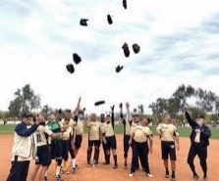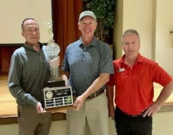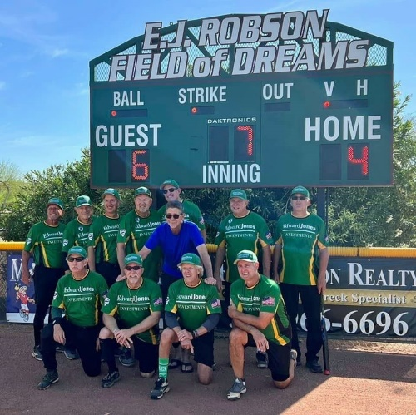
Deadline for July/August 2022 Newsletter Contributions is June 25th, 2022.
ARKANSAS
Ralph Mashburn, ARCSE Representative
Email: ralphmashburn@gmail.com
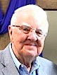
COVID: Arkansas is finally getting some relief from the pandemic that was surging so high last January. COVID hospitalizations have fallen to a two-year low, and no deaths were reported today for the third time in three weeks. Mask mandates are still in effect for some schools where cases are higher.
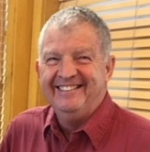

How about them Hogs? We are all still celebrating over the 2021 and 2022 University of Arkansas Razorback sports accomplishments. Football: An unexpected 10-win football season, counting the Bowl win over Penn State. Basketball: Making the NCAA Elite Eight in basketball including a win over Gonzaga. Baseball: In the 2021 College World Series and now having a 2022 successful baseball season, #1 in the SEC and ranked #3 in the national coaches’ poll. It’s been lots of fun for the fans in our small state.
Bob Price, our Arkansas ARCSE president, has arranged our annual meeting for Sept 22nd, 9:45am to 1:45pm at the Thompson Library in Little Rock. Bob will advise about the program and meal later. He is having another back surgery on May 9th. We will pray that this time it is completely successful.
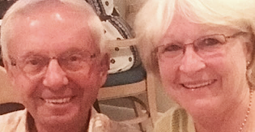
Vacation: Dick and Lori Babeu are having a vacation in April going to a Florida beach and on a Caribbean cruise. Ralph is sorry to lose his fishing partner during this time of great fishing in Lake Maumelle near Little Rock, and Nancy will miss Lori, her shopping partner.
Easter: As seen in the picture, Ralph and Nancy Mashburn were able to have their annual family Easter Egg hunt this year without masks. However, they had the hunt in their barn because of the steady rain throughout the day.
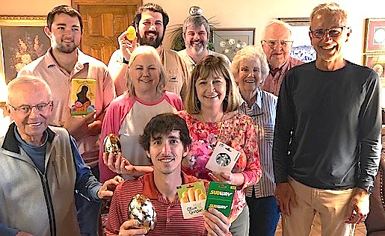
Their grandson, Andrew, found the Golden Egg and earned the best prizes. SCS retirees, Dick (front row left) and Lori Babeu attended as always – they are full-time adopted family members and help Ralph and Nancy with arrangements and supplies at family gatherings. Lori took the picture.
CALIFORNIA
Bill Ward, ARCSE Representative
Email: bluegrassbillward@gmail.com
California Retirees continue to have and enjoy a monthly Zoom meeting for all who wish to participate and stay connected. We had seven of us shown below for our March 2nd meeting.
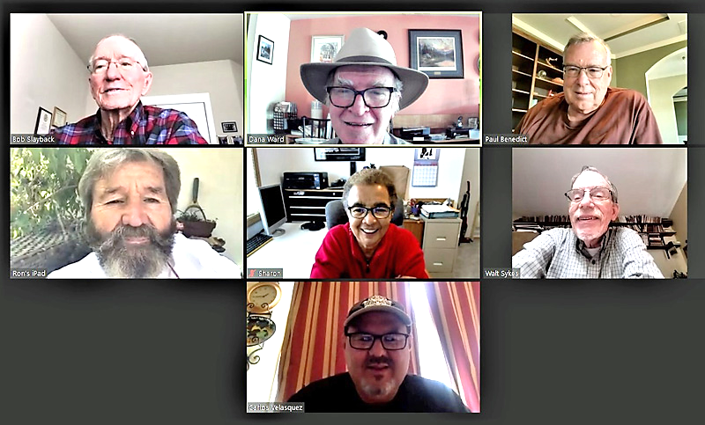
Bob Slayback, Bill Ward, Paul Benedict, Ron Harben, Sharon Nance, Walt Sykes, Carlos Velasquez
It is always nice to see our fellow retirees to share news with each other. First time “Zoomer” Ron Harben shared a very interesting story with us about a unique hobby he enjoys. Ron was in the Navy and still enjoys being out on the open sea. He figured out a way to continue getting out on the sea by taking on the job as a free-lance crew member on boats of all sizes that are sold and need to be sailed to distant ports and new owners. These transfers are done under the direction of different delivery captains who are all certified USCG Captains.
Just prior to our April Zoom meeting, Ron let us know he would be unable to attend as he had just accepted a new crew member job requiring him to fly to Hawaii the next day. From there he would then get on a “49-ft Ketch” and help sail it back to southern California. I could tell he was very excited about this next sailing adventure before him.
On March 20th I (Bill Ward) turned 70, reaching a new “decade milestone” in my life. I was blessed to celebrate it with all my immediate family, kids, and grandkids.
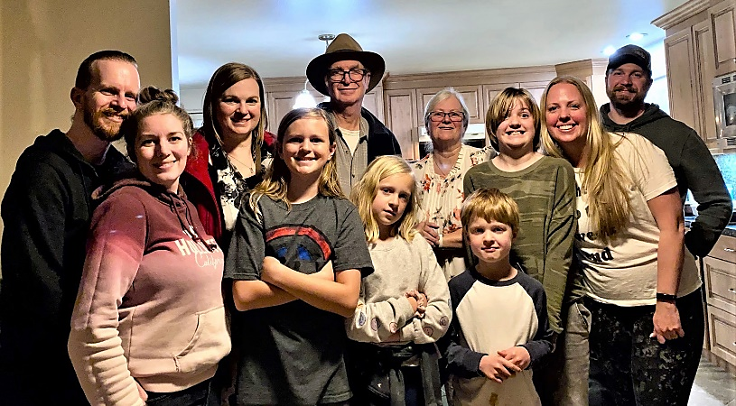
Bill celebrates his 70th Birthday with his family
Playing and sharing music together is always part of our family gatherings and events. My three children inherited my passion for music, and they all took it to a new level. This occasion seemed extra special and one I will never forget. With help from various family members, we captured some video, and I was able to put together the following YouTube video documenting the occasion and wonderful memories we created.
https://youtu.be/Dmu80JwNoy4
I received a nice note and update from Karl Klingelhofer. Karl is 95 years old now and doing well. He spent most/all of his NRCS Career working in New Mexico. He recently moved to a retirement home in the San Diego area where he joined our California NRCS retiree group to stay better connected. Thanks for this update, Karl!
“Karl R Klingelhofer: retired 1981 with 31 years of service with the SCS. Position at retirement: Director of Special Services in DC office. Did two volunteer assignments after retirement; a month in Costa Rica studying dry season irrigation, and a month on the Island of Roatan supervising drilling of wells for water in the boon docks. Then did 15 years working for private engineering firm (full and part-time). After 30 years in Tucson, AZ, now in a retirement home in San Diego area (Silvergate). I am 95 years old and still drive to my doctor appointments.”
Well, that is all for this time around folks, Best Wishes to all, Bill Ward, CA ARCSE State Rep. and ARCSE West Regional Vice President.
COLORADO
Jack Carlson, ARCSE Representative
Email: pspicata@gmail.com
Seven Fort Collins retirees gathered for first Tuesday breakfast club in March and a larger contingent in April. Travel scheduled, fishing spots lined up, tax prep assistance provided, other part-time work and volunteering going on. Family, kids, and grandkids status check completed. Hoping the wind dies down sometime this spring. Check out brandypiebooks.com.
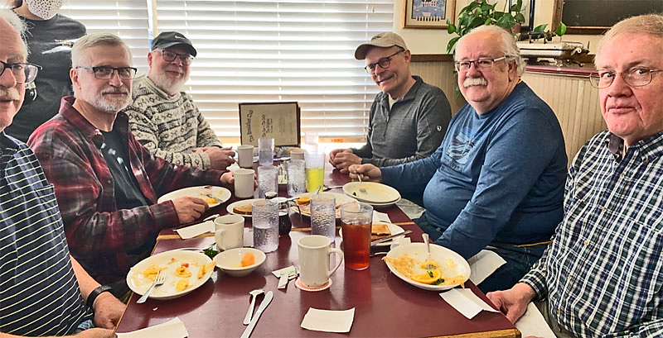
From left: Stu Keil, Frank Geter, Jason Restad, Steve Ekblad, Wendall Oaks, and Dave Butler (photographer: Jack Carlson)
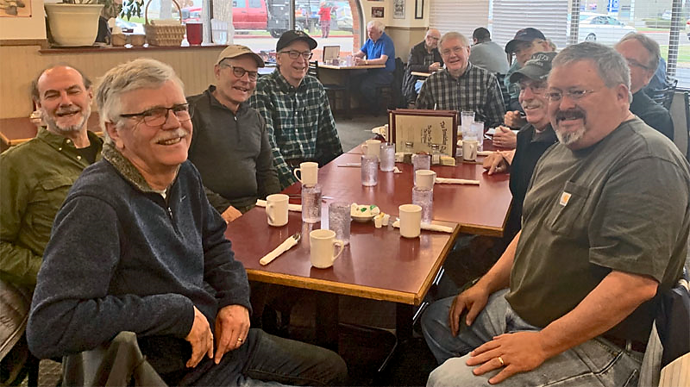
Around the table from front left: Phil Smith, Ken Harward, Steve Ekblad, Jack Carlson, Dave Butler, Bernie Shafer, Terry Buettgenbach, Chuck Hart, and Ken Rojas (photographer Stu Keil)
FLORIDA
Bill Kuenstler, ARCSE Representative
Email: bkuenstler@gmail.com
It’s getting to be late spring/early summer here in the Florida Panhandle. This is the perfect time of year for outdoor activities in our area – the temperatures are still in the upper 70s, and the humidity is only 60–70%.
But in April I hit the jackpot. Not only did I have my regularly scheduled walk, but two days later I led a walk for 35 members of a local garden club (see pictures – I’m the old guy with the ponytail). This was the largest group I’ve had on these walks, and it was a challenge to hold everyone’s attention and make sure everyone could hear me and see the plants I was describing. I had to reach deep into my bag of tricks from my “Effective Presentations and Instruction” training all those many years ago. I really enjoy educating people about our native plants.
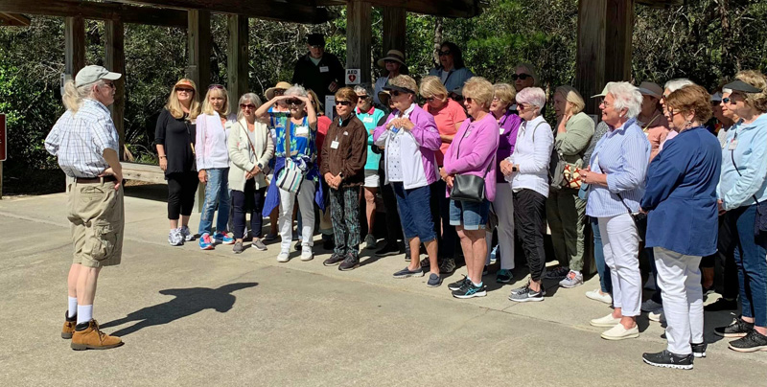 | 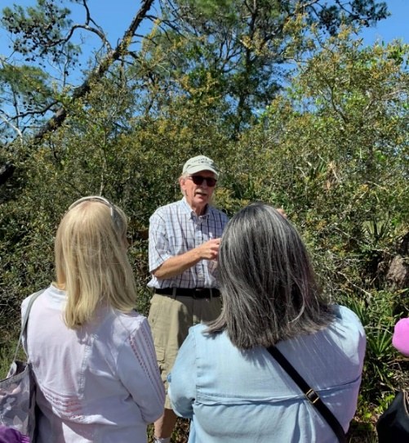
Bill Kuenstler leading a plant identification walk. | Bill leading discussion on native plants.

In January, I resumed hosting monthly plant identification walks in Topsail Hill Preserve State Park, which is only a couple of miles from our house. I get anywhere from 5–12 people attending these, a mix of locals and people camping at the park.
I will be participating in the South Walton Turtle Watch again this year. I will walk a section of beach about 1.6 miles long two days a week, looking for evidence of sea turtle crawls and/or nesting activity. Turtle Watch starts May 1st and goes until Labor Day.
A lasting quality over time. From Bob Halstead, Homosassa, Fl.
I started my career with SCS in the 50s as a Soil Conservation technician in Southern Maryland. Those were the days when we even operated some of the equipment, building terraces and waterways and always enjoying a great lunch prepared by the landowner’s wife. Wonderful memories, but more about that at another time. During that period, we designed and built a number of farm ponds. Cost shared by ASCS ($500). They were planned as irrigation ponds for the Maryland tobacco crop. Over the course of time, I had a hand in probably 50 to 75 structures. Today that part of Maryland has become a suburb of Washington, DC, and houses have replaced crops. But many of those ponds remain, becoming scenic and recreation areas for the homeowners.
On a recent visit to one of our granddaughters, her husband mentioned he was working on a study of the Chesapeake Bay watershed. The study was an inventory of structures built before 1992 and their impact on the sediment, nitrogen, and phosphorus load of the bay. It is a cooperative effort with the counties, State of Maryland, EPA, and his company who had a lead role.
As a part of the project, he was inventorying “My Ponds”. As I remember those days from over 60 years ago, we designed those ponds, that had a structure, with a corrugated riser and barrel (later asphalt coated), 3:1 and 2:1 slopes, and a 10-ft top. The water surface area was limited to one and one third acre in size or less. His study included site visits and examining some of the original designs, as well as the use of drones and other modern technology. The results of the study recommended ways to enhance the ponds and other structures and lower the runoff impact on the Bay.
At last report, most of our structures had stood the test of time and only need a few improvements. Much like the author of this article, our conservation work has aged gracefully.
The young man in the picture is our son (Who is now 67 years old) and the father of our granddaughter whose husband was doing the study I wrote about.
The photo is an official SCS photo, ID # Ma-1638-2, taken over 60 years ago by yours truly (Bob Halstead).
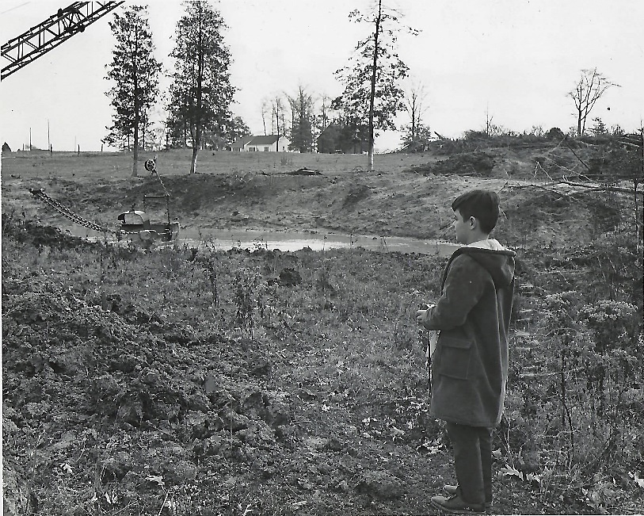
Bob Halstead’s son watching construction of an SCS pond in Maryland over 60 years ago.
IOWA
Mark Jensen, ARCSE Representative
Email: amjens1@gmail.com

The Knoxville Area Community Theater (KACT) performed their spring production of the comedy “Harvey” at the end of April. The play “Harvey” premiered on Broadway in November of 1944 and ran for 1,175 performances. Then in 1950, it was made into a popular film that starred Jimmy Stewart. Over the years, it has been performed by many theater companies. Marty Adkins is the President of the KACT Board, and his wife Carol Adkins is the Board Secretary. Marty was the Director of “Harvey” and also worked on the props. Carol was the producer and worked on the props and costumes. Carol said that she “believes she’s sewn about a zillion show costumes” over the years. In addition to her behind-the-scenes work, Carol also played the part of Mrs. Chumley in the play. The first picture shows the front cover of the program for “Harvey.” The second picture is Mrs. Chumley posing with Harvey and Marty. Harvey is rather tall but seems to take a good picture! | 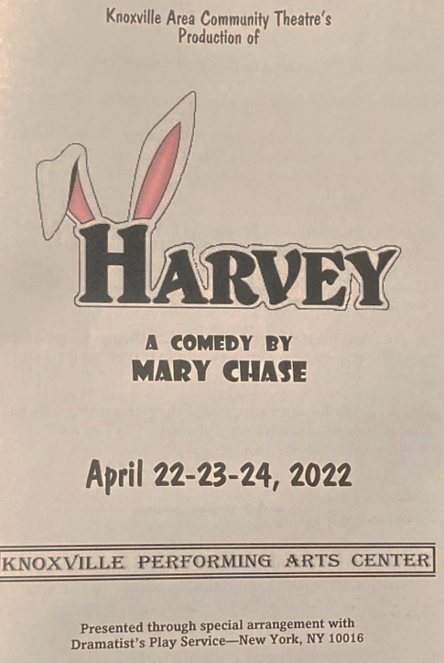 | 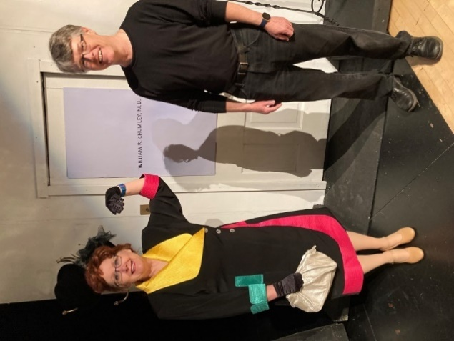  Mrs. Chumley, “Harvey,” and Marty.
For a good-sized group of retirees, current employees, relatives, and friends, the annual ski trip to Colorado was back on this year after taking a year off due to COVID. Jody Christiansen told me they are considering changing the name of the trip from “ski trip” to “Colorado trip.” As the age of the group keeps getting older, the amount of skiing has decreased, but there were several days of snowshoeing. That’s not all bad – the socializing was still great! This was the 36th year for this venture. The group was happy to welcome back NRCS employee Nicky Williams. She joined the group 11 years ago. The group includes retirees Bob Dayton, Jody Christiansen, Rick Knutson, and Duane Miller; current employees Dale and Joanne Bruce and Nicky Williams; and friends Craig and Kim Muehlberg and their niece Emma Muehlberg, Rick Rubenstein, Chris Davis, and Bill Dayton.
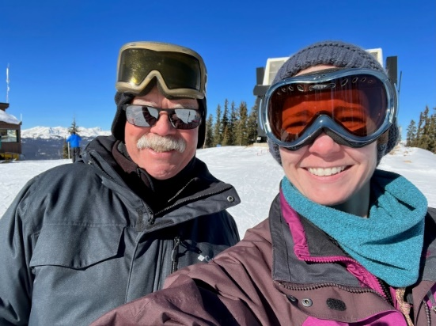 | 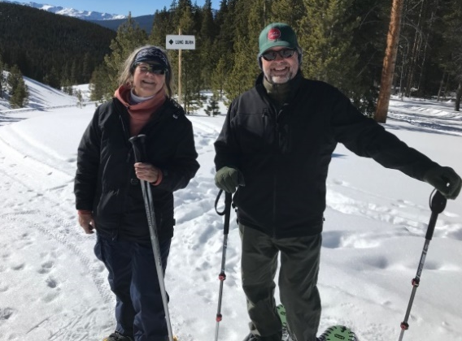
Bob Dayton and Nicky Williams | Jody Christiansen and Rick Knutson

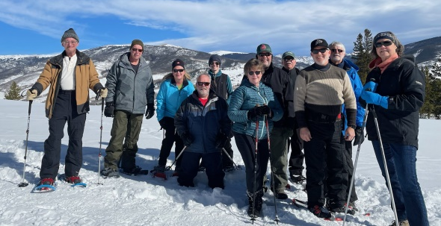
Snowshoe Group: L-R: Rick Rubenstein, Bill Dayton, Kim Muehlberg, Craig Muehlberg, Nicky Williams, Joanne Bruce, Rick Knutson, Bob Dayton, Dale Bruce, Duane Miller, and Jody Christiansen.
After Jeff Godwin retired in July 2017 as the Area Engineer in the Atlantic Area Office, he went to work for the consulting engineering firm Snyder & Associates. During the past several years, Jeff has worked on numerous projects involving stormwater management, erosion control, wastewater treatment systems, and water supply systems. One of his recent projects was with the city of Bedford in southern Iowa. Bedford was experiencing high water losses from their water distribution system. When the city could no longer meet the water supply needs of the community, they hired Snyder & Associates to help them resolve the problem. Jeff was the Project Manager for the project. He and his team studied the issues and presented the city with options on how to solve their water supply issues. The city is currently in the process of installing the recommended improvements to their system. Jeff and his team helped the city and gained statewide recognition in the process. Recently they were notified that the Iowa Rural Water Association has chosen Bedford as their community of the year in Iowa in recognition of all the work that they have completed on their water system. Congratulations, Jeff on a job well done!
Eldon and Jeannie Weber celebrated their 64th wedding anniversary. They were married in El Paso, Texas, in 1958 while Eldon was in Army Officers Basic training. That June, he was assigned as Operation Officer on Selfridge Air Force Base in Michigan. Jeannie worked as a teacher on the airbase. As part of their anniversary celebration, they attended the play “Double Wide in Texas” at the Ames Community Theater. Eldon said it was so humorous and appropriate, since they were married in Texas.
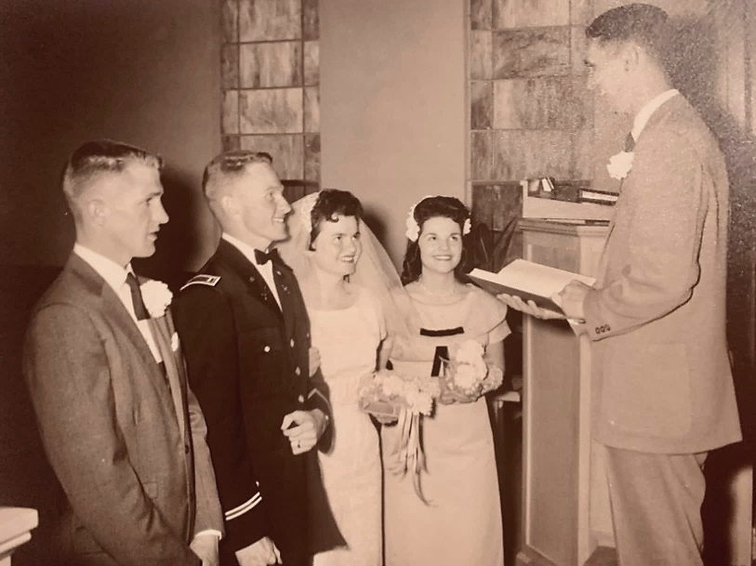 | 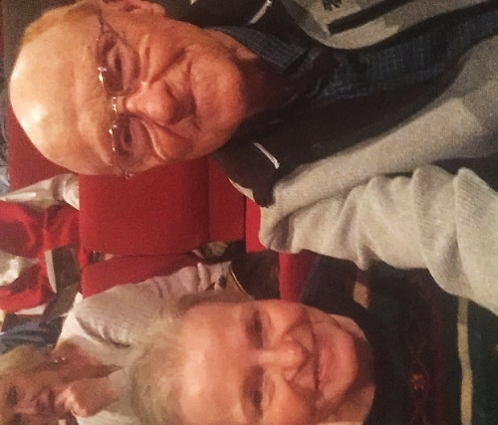
Eldon and Jeannie Weber’s wedding, April 5th, 1958 | The Weber’s at the Ames Community Theater

Since the beginning of the year, we have welcomed a number of folks into our retiree community. They include: Betsy Norland, Wetland Specialist on the Spencer Resource Team; Warren Angus, Soil Conservation Technician on the Creston Resource Team; Roger Heim, Soil Conservation Technician on the Chariton Resource Team; Michael Webster, Wetland Specialist in the West Union Area Office; and Mark Schmidt, Soil Conservation Technician on the Epworth Resource Team.
Recently we have been saddened by the passing of several retirees. Don Redman was a technician in several offices in southern Iowa. Roger Will was a long-time technician in the Emmetsburg Field Office. Wayne Dankert was a soil scientist who worked on soil surveys in several Iowa counties. Ray Dake was a soil conservation technician in Marion and Ottumwa and later a civil engineering technician in Fairfield. From what I’ve heard about all four of these guys, what I’m going to say next would apply to all of them. However, I worked directly with Ray. He was one of the best. He had very good technical abilities, great people skills, and impeccable integrity and character. We’ll miss all four of them.
KANSAS
Deanne Lull, ARCSE Representative
Email: rlull2@cox.net
Spring has sprung! The daffodil beds are beautiful this year, and the flowering trees are bursting – which means that we will have lots of crab apples to pick up from our flowering tree. Ron and I spent a cold Easter weekend with our son and his family in Oklahoma. We had a wonderful weekend celebrating a belated Christmas, Easter, and our son’s birthday.
Retirees Gerald Karnes and Jean Hamilton, spouse of the late Vern Hamilton, exhibited their artwork in the “Art is Ageless Exhibition” sponsored by the Presbyterian Manor, a retirement center in Salina, KS. The exhibition is open to anyone over 55 years of age with an art piece created within the last five years. Gerald received a blue and red ribbon for his exhibit of two photos, a mural on a Salina elevator and a monarch butterfly. Jean, a quilter, exhibited two quilts. A full-size scrappy quilt made from left-over fabric was made during COVID-19. The other piece was a wall hanging of sunflowers. Jean is in her mid-80s and still does beautiful work. She never goes anywhere without her sewing bag. I have watched Jean stitch on her latest project at many, many meetings.
 | 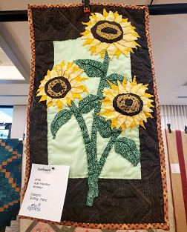
“Hand in Hand” mural on elevator in downtown Salina, Kansas. | Jean Hamilton’s entry in the “Art is Ageless” event at Presbyterian Manor in Salina was a wall hanging in the quilting category.

The Kansas retirees will be having an annual meeting on June 24th, 2022, at Martinelli’s in Salina, KS. Early in May Kansas retirees are asked to submit any news about families, activities, travels, etc. for a newsletter which will have all the meeting details.
We have had only one recent retirement. Joel A. Willhoft retired on February 2nd, 2022, as a Resource Conservationist in the Kansas State Office in Salina, KS.
One spouse has passed away. Ernestine “Ernie” L. Goerend, spouse of Duane Goerend, died on February 22nd, 2022. Duane retired in 1992 as a District Conservationist in the Salina Field Office. He preceded her in death in 2020.
MAINE
John Simon, ARCSE Representative
Email: balnengr@tds.net
Tuesday, the 8th of March, was a cold, windy, but sunny day; but there were nine hearty Mainers who showed up. Included were Karan and Bruce Champeon, Mary Thompson, Patty Wright, Dave Mussulman, Dan Baumert, Judy Boothby, Bob Lagassey, and John Simon.
It was so great to have Judy Boothby bless our breakfast after the recent loss of her husband, Charlie on January 23rd, 2022. She enjoyed her time with us, as we did also having her with us. She is a blessing and inspiration to us all. We do truly miss having Charlie not being with us anymore. Charlie and Judy missed only a few of our breakfast meetings over the years. Colonel Charles L. Boothby had his obituary in the Bangor Daily News in January. Charlie worked for years in Washington with the National Association of Conservation Districts, NACD, after working with SCS in Maine
Bob Lagassey is still getting used to being without his beloved wife Louise who passed away last year. Louise was a wonderful friend to my wife Noreen, and we miss her a lot and hearing her voice. Bob is finally getting used to most of the bells and whistles on his new car!
Bruce told the group that Norm Kalloch has written and published three novels! We pulled out our Iphones and went on the internet looking for Norm Kalloch, and lo and behold up comes Norman R. Kalloch, author of A Long Way to Walk, which had a 4½ star rating! That is a new twist to retirement. However, those who know Norm know of his story telling potential! Just reading about his years at the camp at West Carry Pond with Audrey would make a good read in itself!
Dan Baumert has been doing quite a bit of skiing this winter and really enjoys it. Good for you, Dan. Lots of sunshine (vitamin D) and fresh air to boot. Hopefully next month spring will be arriving, and the weather will be warming up.
Looking at my records of electric energy used by my two mini-splits for January and February show that I use about 1.05 kWh/HDD for my 2,000 ft² house. At an annual use of about 7,000 heating degree days for the Bangor area, this amounts to about 7,350 kWh for the year (heating). This may be of use to someone thinking of installing one or more units in their home. My house has a circuit for the baseboard hot water system in the bedrooms, which uses most of the oil. On average, I save about 75% on oil but on real cold, windy days oil use can amount to about 50%. My home is not super insulated as is Art Taylor’s house with R50 in walls and ceilings and triple pane windows. Art relies totally on mini-splits for his heating needs.
I talked to Art recently, and he is pain free but gets tired very easily. He still does woodwork in his shop AMAP, but it is slow going. I think a few of you retirees are also into woodwork. I know Dana Nelson used to be into woodwork.
Tuesday, April 12th we had seven retirees enjoying each other’s company. Attending were Bob Lagassey, Bruce and Karan Champeon, Tom Smith, Mary Thompson, Dan Baumert. and John Simon. Tom Smith graced our breakfast by driving (for two hours) up from Portland – now that is an act of brotherly love for sure! Thank you, Tom! Tom and I spent many years together in the Lewiston field office! Wow, such memories during the 1980s and 1990s.
Dan Baumert said he is through with skiing for the year but has been practicing on the Kenduskeag stream with his kayak in preparation for the upcoming race. He will be using his kayak to win the race! The race will be on TV I think, viewing it from Six-Mile Falls. Go for it Dan!
Mary Thompson will not be with us again until fall because her blueberry work will be filling up her days. Mary has been scouting local cemeteries for family graves. She notified me that she has located two this week! Mary also brought a bunch of photos for us to look at. I knew a lot of the folks in the photos, but a lot were a mystery to me.
Judy Boothby contacted me with the time of Charlie’s funeral. It will be held on April 29th (Friday) at 2pm at the Unitarian Universalist Church, Park St., Bangor, Maine. The church is just uphill and behind the existing Bangor City Hall. Judy is still looking for someone (who worked with or was close to Charlie) to say a few words about Charlie at the funeral celebration.
We got to talking at the breakfast about Norman R. Kalloch, Jr. – Publisher. Norm has three books published by Maine Authors Publishing, 12 High St., Thomaston, ME 04861, Ph 207-594-0091. Norm’s three books are: A Long Way to Walk (275 pages), 45th Parallel (208 pages) and Life in the Backwoods (269 pages). The publisher had a comment from another writer who had great praise for the ability of Norm to tell a story! Paul Hersey has just finished books 1 and 3. Paul said he could not put the books down once he started reading!
I remember Norm telling me long ago of his Mom’s publishing a book of Poetry, and somewhere in my library is a forgotten copy. It is really neat to have a gifted writer in our midst. I have always believed that each one of our lives is a story! Listening to the things Norm did at his camp at West Kerry Pond was a wonder to me! Congratulations to Norm on using your gift of writing for us to enjoy.
Oh, before I close, I would like to share a book with you. The book is The Immune System Cure, authored by Vanderhaeghe and Bouic, 1999, published by Kensington Books. Although the book is some 23 years old, it is loaded with useful info with only a few items that probably need updating. Many of you will probably pick up the items that need updating. All in all, a wonderful book for your health library. I felt I would be remiss if I did not pass this information along, as it could have a major effect on your health.
Till next month, take care and God bless,
MID-ATLANTIC STATES
Delaware, Maryland, Virginia, and Washington, DC
Ken Carter, ARCSE Representative
Email: duckheadone@gmail.com
Fom John Peterson
For some years Carolyn and Niles Glasgow (Columbia, SC), and Jo and Don Gohmert (Alexandria, LA) have joined Blanche and John Peterson (Burke, VA) at Peterson’s condo on Hilton Head Island (HHI), SC over St. Patrick’s Day week for a small reunion. While there they met Art Holland (Sun City, SC) for lunch at the Crazy Crab Restaurant on HHI. In retirement Art has moved to Sun City which is about 15 miles from HHI on the mainland. Niles, Don, and John all worked together in AZ in the 1970s. Niles and Art also worked together in AL. John and Art worked together when John was in DC and Art directed the NENTC in Philadelphia. John and Niles also worked together in DC.
These old timers have remained friends all these years and enjoy reminiscing about all the places they have been and the people they worked with. The ladies enjoy some of that but find other things to do when bored with the same old stories. They enjoy the HHI seafood and the day trips to places like Charleston, Savannah, Beaufort, and Bluffton. Last year they took a day trip to Daufuskie Island, the southernmost inhabited sea island in South Carolina. Accessible only by ferry or barge, and with a full-time population of just over 400, Daufuskie Island encompasses a rich cultural experience, with environmental preserves, private communities, resorts, Gullah houses, diverse art galleries and history. The island was named a historic district on the National Register of Historic Places due to its Gullah and Civil War history. The island is also the setting of Pat Conroy's memoir The Water Is Wide recounting Conroy's experiences teaching on Daufuskie in the 1960s.
This year they toured Bluffton, across from HHI on the mainland. After the Tariff of 1842, Bluffton became a hotbed of separatist sentiment, which in turn led to a protest against federal taxes called the Bluffton Movement in 1844. Even though the movement quickly died out, it somewhat contributed to the secession movement that led to South Carolina being the first state to leave the Union on 20 DEC 1860. In the Antebellum Period, Bluffton became a popular location for wealthy merchants and plantation owners. During the War Between the States, two thirds of the town was destroyed by fire during the Union's Bluffton Expedition on June 4th, 1863. SCS/NRCS has caused many people like these to become lifelong friends. Our conservation family is unique.
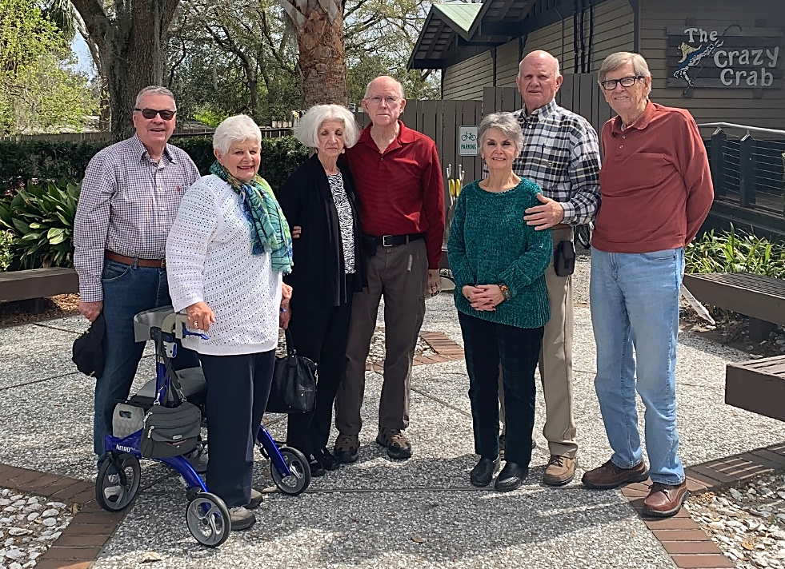
Retirees at Hilton Head Island: John and Blanche Peterson, Carolyn and Niles Glasgow, Jo and Don Gohmert, and Art Holland.
MINNESOTA
John Brach, ARCSE Representative
Email: jcb1153@yahoo.com
Some of the Minnesota retirees got together April 13th for an informal lunch. It was good to get caught up with everyone who could make it.
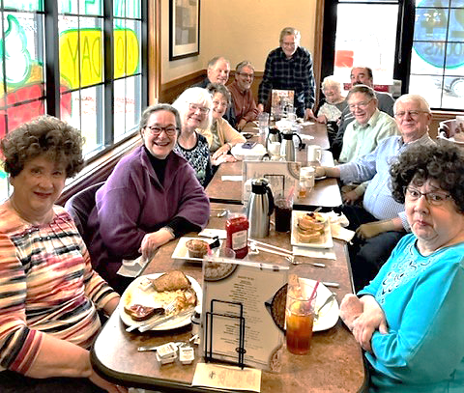
Pictured from left: Margy Gangl, Susan Ploetz, Cathy McCormack Cheri Appel, Scott Sawnberg, Pete Cooper, John Brach, Marlene Mechelke, Paul Flynn, Mike Appel, Harvey Sundmacher, and Micki Gangl.
This was the first MN gathering since COVID started. We are hoping to do an outdoor get-together sometime this summer.
MISSOURI
Dave Rastorfer, ARCSE Representative
Email: daverastorfer@aol.com, moarscse@aol.com
John Turner: 40 former and current employees of conservation agencies, along with spouses and friends, attended the First Northeast Missouri Conservation Employees Get-together in Shelbina on Saturday, March 26th. Keith Jackson came from North Carolina; others came from the Kansas City Area, and some came from “South of the River.” Six hours of great conversation, catching up with old friends, and good food were enjoyed.
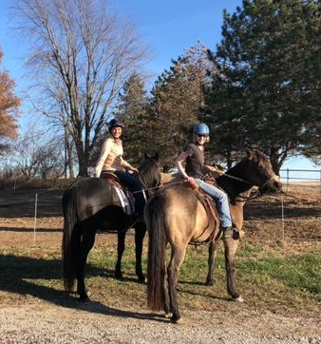 | 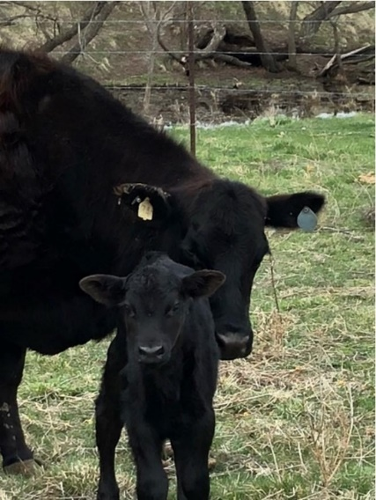 | 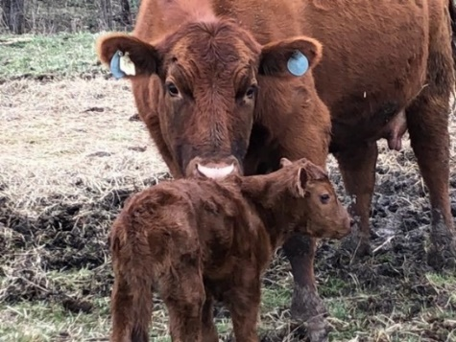
Finding time to ride with friends! | Calving is well under way in NW MO
Bill Pauls: Everything here at the Lake of the Ozarks is PEACHY! Kris is good too. She's up at Jeff City today at the Midwest March-For-Life. Spring is busting out all over as the redbuds are in full bloom and the dogwoods aren't far behind. Ok now for a little family bragging – Just back from watching my grandson pitch a complete game three-hitter for his freshman baseball team – what a complete joy. He's also on the Chess team and plans on being an engineer (smart kid). Of course, I hate to admit that to Rastorfer or any of the other engineers we soil scientists used to party with. Also have three granddaughters who are all doing well in school and are outstanding in their chosen sports; a tennis player, a track runner, two basketball players and two softball players; yup, some of them do double and triple duty. Soooo much fun to watch develop. Life continues to be a HUGE blessing. Come see us if you're in the neighborhood. Boats are just about to be de-winterized, and the fish are almost jumping out of the lake. I heard a joke driving to my g'kids ballgame on Comedy Central yesterday that I thought I'd share. Did you hear about the guy that ate Life cereal for breakfast every day, and he also ate Life cereal for supper every night. He wanted people at his funeral to say, “He was just so full of life.” Gotta go do stuff. PS: marathon #115 in Indy IN is in the book and headed to Des Moines in October for #116. I've been thinking I was getting too old for this sport because my times are really getting slower; but in Indy I finished three minutes ahead of an 85-year-old guy, and he was gaining on me. Guess I'd better keep moving!
Alton Taylor: (from Texas) Just taking it easy after Easter as it was a long day. Had sunrise service at the big hill with a big cross on it. This is on Kay's ranch, and she had breakfast ready at her house as we were leaving. After the 11 o'clock service we were invited to Kay's daughter’s for lunch, and this was in Allen TX. Another of Kay's daughters will be taking us to an Airbnb on the coast above Galveston in June and a wedding in August and Yellowstone in September. We will be on our way for a May wedding in MO and a Farm business trip in June to the West Texas farms. The National Day of Prayer is coming up soon, and Kay is Denton County Treasure for it. When we find time, we take care of the normal things required to live. Example – Income Taxes.
Frank Miller: Just a small note. We have been to Western Kansas for Franks Brother-in-Law’s Celebration of life. Been staying at home trying to keep well. Kay developed dizzy spells with a low heart rate, and Boone Hospital found her upper and lower heart chambers were not in sync. Now has a pacemaker to keep them together. All went well. Just recuperating and preparing for a trip to Kansas to Grandson Cameron's Graduation from McPherson College. Then to Western Kansas the last of June for a Miller Family Reunion
Bob Ball: Orlando was surprisingly very cool during a recent visit to watch our two grandsons while their parents took a brief vacation. After a week of getting the boys to school and little league, plus trips to the grocery to keep them fed, Lenore and I needed a break, too. Retirement is much easier than raising children, and it’s less costly.
We are now lengthening our visits to our farm in SE Ohio. Each year we seem to have an increase in farm projects and activities. The past year we completed a concrete feeding pad for beef cattle to use during the worst days of the winter. The need for water at the pad was motivation to install a pressure water system, drawing water from our farm pond and pushing it into five pastures to improve grazing efficiency. Moving water over the highest elevation on the farm proved to be challenging and more costly than NRCS planned.
Several acres of timber stand improvement were completed in two stands of red and white oak, with mid-story oak management for white oak completed in another stand. Those projects brought attention to the need for woodland management practices in adjoining stands, so we will tackle that soon. To help offset our project costs, we finalized a contract with the Natural Climate Exchange (NCX) for carbon sequestration on our woodland acres that will generate a little income. When we are in Columbia, I try spending more time on woodworking projects, using some of the hardwoods we grow on our tree farm. Working in our home office, I just completed a book about my life through StoryWorth, which will not be a best seller, but it will provide some insight into my life for the grandchildren. Related to those efforts, I have been trying to complete family trees for too many years in Ancestry. And I am still active in Walnut Council, writing newsletters for our Missouri Chapter. With COVID hopefully ending, Lenore and I are scheduling trips to destinations we had hoped to visit two years ago.
Mike Blaine: I'm sure glad to see spring. Now if the garden will only dry out so I can get in it! Not much else happening on Blaine Hill. Cutting grass, fixing fence, designing stream crossings, cutting brush. That's about it! Have a great spring and summer!
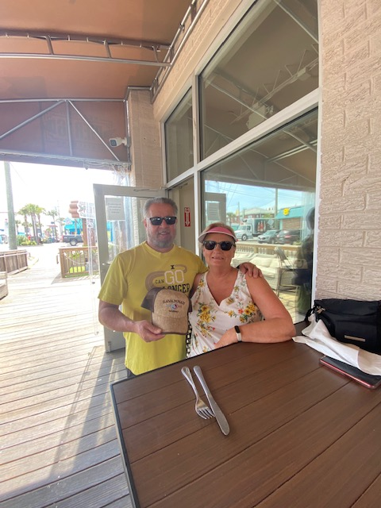 | 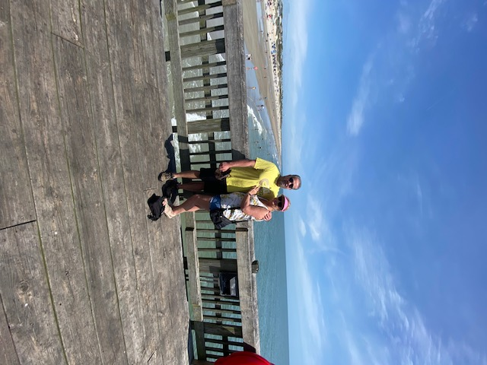 | 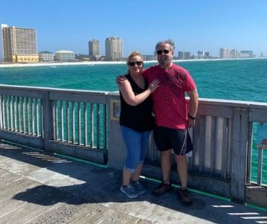
J.R. Flores: J.R. and Nancy Flores in Panama City Beach, Florida and Tybee Island, Georgia.


Sunrise on the Atlantic
MONTANA
Dick Gooby, ARCSE Representative
Email: inca@3rivers.net
Montana Big Sky Report
Joyce Swartzendruber report: Carlos Valdez Rodriques age 69 passed away February 14th, 2022 at his home in Polson, MT. Carlos was a long time NRCS employee in the Polson field office.
Scott Hoag Jr. Report: Things are going pretty well, now that spring is about here. Still having trouble with my hip. I guess I injured the bursa when I fell. Here's our report.
Scott and Nancy made it through the winter. Not a lot of snow, though. We call this time of year "sprinter." Madison, Gallatin, and Jefferson basins are about 75% of normal according to NRCS SNOTEL data. Doesn't bode well for the summer fire season. Scott continues to consult on watershed stuff – a rehab project in Las Cruces, NM and an irrigation project north of St. George, UT. Nancy continues to write. She's recently published in two editions of Chicken Soup for the Soul; in Guidepost compilations; and other Christian publications.
Gooby Ranch Report 1: For the past three weeks the weather has been real nice; and since we are inundated with ground squirrels, I spend most of my time harvesting them. I take the ground squirrels to the house and Mary Ann cleans and freezes them. We have more pounds of squirrel meat in the freezer than we have elk. Mary Ann has developed several recipes for the squirrels. The one I like the best she named it “Squirlew.” It’s a fancy Squirrel stew she makes.
During this time a lot of the cows were supposed to be calving, but they decided since the weather was so nice, they would just lay out in the sun and get a tan. To heck with having a calf.
Yesterday it started getting really cold. They predicted a three-day blizzard. The wind was blowing 45 mph. There is no way a calf could survive being born out in this kind of weather. Mary Ann decided to put all the cows in the barn. Not only would they be out of the wind, it would be much easier for her when she went out every hour to check on them. The cows had other ideas about going in the barn. Mary Ann would just get them up to the open barn door, and they would all come racing back, knocking her end over tea kettle. Not only was it hard on her body, but the landing spots were not always that clean.
I was going to help, but the Golfs Master’s TV program was on, so I wasn’t able to help. After about an hour of working with the cattle, she would come in to warm up. It worked really well, because when Mary Ann would come in, it was time for her to bring me a beer. As the night wore on, she was covered with cow poop and didn’t smell so good.
One first-calf heifer started trying to have her baby, but it just wasn’t working. Mary Ann tried to get the heifer in the stanchion, but the heifer didn’t want any help. After she knocked Mary Ann down a couple more times, she finally got her in the head catch. Mary Ann checked her the best she could and said the calf was turned the wrong way. Since the Masters was over, I called the vet for Mary Ann and went out to watch. The vet spent over an hour turning the calf around and pulling it out. When she finally got the calf out, Mary Ann gave the calf a good rub down. Now the calf decided Mary Ann must be her mama. When Mary Ann tried to push to calf to her real mother, the cow put her head down and sent Mary Ann flying again. Because she was so covered with cow poop, I had her roll around in the garden to fertilize it. Then she took her clothes off outside and headed for the shower. Mary Ann was really happy how everything worked out, and she was proud of me for having her fertilize the garden.
Gooby Ranch Report 2. We have a bull that is totally crazy and wilder than a March Hare. When Mary Ann goes out to feed him, she can’t go in the bull pen to feed him in the tub. She has to throw the hay over the fence. While Mary Ann is throwing the hay over the fence, the bull is bucking, blowing, snorting, and charging toward Mary Ann on the other side of the fence. It’s like he is thinking of jumping the fence and taking her out.
We decided we needed to take the bull to the sale yard and get rid of him before he hurt Mary Ann. Mary Ann got the stock trailer hooked up and put into place so we could load the bull. We got everything ready, but the bull refused to go down the alley to the trailer. We tried everything, but he refused to go.
Finally, we decided that Mary Ann would take some hay, get in front of the bull and draw him down the alley and into the trailer. Our trailer has a small section at the front of the trailer that Mary Ann could jump into, but the bull couldn’t. It worked great. The bull ran full blast after Mary Ann and followed her into the trailer. Mary Ann jumped into the small area, and I closed the door. We spent the next two hours trying to get Mary Ann out of the trailer. But every time I started to open the trailer door, the bull would charge the door.
We finally decided that Mary Ann would stay in the trailer with the bull and feed him some hay as we drove to the sale yard. The weather was really cold, and Mary Ann would probably freeze to death before we got to Butte. It’s over 60 miles.
When I finally got to the sales yard, I got the trailer in place to unload the bull. I looked in the trailer, and Mary Ann was sitting on the bull. What a surprise! Mary said she got so cold she couldn’t stand it anymore, so she hopped on the bull and put her arms around his neck so she could get warm from his heat. The bull looked like he liked Mary Ann’s heat as well. I opened the door, and Mary Ann rode the bull out of the trailer. The bull told her he only wanted a friend to talk to, not hurt her. Mary Ann said they are now friends, and she didn’t want us to sell the bull. She rode the bull back into the trailer, I closed the door, and we headed for home. Mary Ann is now known as a Bull Whisperer.
NEBRASKA
Norm Kempf, Jim Culver, ARCSE Representatives
Emails: nkempf@neb.rr.com, j4culver@aol.com
The March meeting was called to order by Chairperson Jim Culver. There were 15 attending: Paul Bartlett, Steve Stover, Steve Scheinost, Tom Reinsch, Louie Buller, Jim Culver, Dana Snyder, Russ Shultz, Gus Dornbusch, Craig Derickson, Norm Helzer, Dave Camper, Norm Kempf, Gary Muckel, and Donna Dornbusch.
The April meeting was called to order by Chairperson Jim Culver. There were 12 attending: Paul Bartlett, Steve Scheinost, Louie Buller, Jim Culver, Dana Snyder, Gus Dornbusch, Craig Derickson, Norm Helzer, Norm Kempf, Gary Muckel, Keith Sheets, and Donna Dornbusch.
Charlie Greene, an UNL Hall of Fame track and field legend, passed away on March 14th, 2022. He excelled in track for UNL and won many titles throughout his track career. He won gold and bronze medals at the 1966 Olympics in Mexico. He was going to be honored with other USA track stars at the upcoming NCAA Track meet in Oregon. His wife, Linda, worked for the Natural Resources Conservation Service in the Regional Office in Lincoln, NE.
Ruth Armstrong, an employee who edited soil surveys during the 1980-1990’s at the USDA-NRCS National Soil Survey Center, died on March 27.
Ivan Wilkinson’s wife, Ginger, passed away on March 6th, 2022. Ivan worked at the Lincoln, NE National Technical Center until his retirement. They have been living in Estes Park, CO. Gus and Donna Dornbusch attended the funeral in Colorado.
Paul Barlett celebrated his 91st birthday. Norm Helzer and Gary Muckel had birthdays in April. Louie Buller helped his sister celebrate her 100th birthday in Stromsburg, NE.
Dave Camper traveled to Colorado to see the Girls’ State basketball games. His daughter from Connecticut joined him, and then they went skiing. Keith Sheets visited Sue Alby, widow of Gene Alby. She still lives in her home of many years. Tom Reinsch, wife, and daughter, traveled to Ecuador where they also saw the Amazon River. They then traveled to the Galapagos Islands.
Gary Muckel will participate in the annual April cartridge show in St. Louis, MO, and then plans to go to Holland in September for another ammunition show. Norm Kempf will be going to Canada in May for a fishing trip. Norm Helzer and his wife will be going on a Sandhill Safari for bird watching.
Keith Sheets and wife have returned from their winter home in Texas. Dana Synder and wife will travel to Pella, Iowa, in May. Gary Muckel went to St. Louis to attend a cartridge show. Attendees came from a number of countries, such as Germany, the Czech Republic, Argentina, and Holland.
Jim Culver said that Fontenelle Forest was a nice place to visit and was well managed. Paul Bartlett said that Lauritzen Garden was also a good place to go. Gary Muckel and his Kiwanis club will again provide soil samples to second grade teachers (about 150), so they can provide students with soils lessons. Each sample also includes a song about soils, which he then performed. There was some discussion about the added values of the song to the program.
Norm Kempf has done a great job in preparing articles for The Newsletter for Retired Conservation Service Employees. Harold Klaege also has done a good job on doing zoom shots for the newsletter. Donna Dornbusch was also recognized for her efforts in recording the minutes of the breakfast meetings.
Roger Hammer keeps up with our activities via zoom and minutes even though he now lives in Wahoo. Russ Shultz has moved, and his new address is 6201 Normal Blvd., Apt. 207 68506. His phone number remains the same. Going through his papers, he found a letter from Congressman Doug Bereuter, dated January 3rd, 1990, thanking him and Frank Jedlicka for their work on the USDA conservation planning language included in the 1985 Farm Bill. Russ Shultz’s granddaughter is graduating from medical school in March and waiting for an internship.
Craig Derickson will contact the new Nebraska State Conservationist (Robert Lawson) to come and talk to our group about Nebraska NRCS activities. Craig met him last week. Tim Gragert, Nebraska State Senator from District 40, has proposed bill LB925 to create funding for soil health activities. The National Soil and Water Conservation Society meeting will be in Denver this year. The Soil and Water Conservation Society, University Chapter, will be picking up trash today at Branched Oak Lake (west side).
Keith Sheets has written a book of Poems and Stories About Life which is available at Barnes & Noble bookstore or on Amazon. Donna Dornbusch has an extra copy of Hidden Prairie: Photographing Life in One Square Meter to loan out, written by Chris Helzer, son of Norm Helzer. An exhibit based on this book is currently at Morrell Hall at UNL through May, 2022. Chris Helzer also has participated in a “Wonders Under Glass” exhibit at Lauritzen Garden open through May 8th.
Jim Culver announced that the Nebraska Federation of the National Association of Retired Federal Employees will have their meeting at the Holiday Inn Lincoln Southwest May 25-26. They will be reviewing state taxes on Federal employees’ retirement annuities. Jim Culver has scanned all the previous minutes of our meetings. This is a treasure trove of the history of our group. Thanks Jim!
The Nebraska girls’ softball team is on a roll at this time with 18 straight victories. Daylight savings time change proposed by Congress was discussed. If passed, it would affect our starting times. The group voted to change their meeting times to 8am, starting in April. Keith Sheets and Dana Snyder suggested that we have some of our club meetings at Virginia’s café in north Lincoln. A vote will be taken at the next meeting.
The January Zoom meeting was called to order by President Jim Culver. The Zoom meeting was held because of the recent increase of COVID-19 outbreaks and health department guidance on wearing of masks and limited indoor activities. Attending were Jim Culver, Claudia Stevenson, Arlis Plummer, Harold Klaege, Norm Helzer, Bill Hance, Doug Christensen, Norm Kempf, Donna and Gus Dornbusch, Ken Noonan, Arnold Mendenhall, and Keith Sheets.
The February Zoom meeting was called to order by Chairperson Jim Culver. There were 14 attending: Harold Klaege, Jim Culver, Donna Dornbusch, Gus Dornbusch, Doug Christensen, Norm Kempf, Bill Hance, Steve Stover, Arnold Mendenhall, Steve Scheinost, Ken Noonan, Louie Buller, Norm Helzer, and Gary Muckel.
Doug Christensen announced that he had a positive COVID-19 test last week. He was not eligible for COVID treatments because he had had the vaccine and booster. At this time COVID treatments are limited to those not vaccinated because of the scarcity of treatment options. He is recuperating at home and is doing better this week. Doug also had good things to say about the urgent care center at 70th and Van Dorn.
Ken Noonan reported that he had right knee surgery and is scheduled for his second knee surgery in March. Steve Stover said his wife Jan came home from the hospital after eight weeks. They are thankful for all the prayers and support. Steve Stover turned 83 recently. Arnold Mendenhall just turned 79 and is thinking of cutting down on his work.
Claudia Stevenson and husband are planning to go to Hawaii in February. She also invited everyone to the SWCS Nebraska skiing event in Wyoming, March 4–5. Harold Klaege’s son is refurbishing his camper for a turkey hunting trip with Dad in Arizona in April. Keith Sheets and wife will be returning to Lincoln in April. Arlis Plummer and husband are planning to go to Padre Island at the end of February.
Doug Christensen and wife are going on a cruise ship in March, starting at Barcelona, Spain and cruising the Mediterranean, with stops along the way. The trip had been planned for 2021 but was canceled because of the pandemic.
Jim Culver announced and presented the Distinguished Service Award to Norm Kempf from the ARCSE. Gus Dornbusch received a similar award several years ago.
Robert (Rob) Lawson has been selected as the State Conservationist for Nebraska, with a starting date of February 14th. He will move to Lincoln sometime in May. He has been with NRCS for 18 years and is originally from Iowa.
Claudia Stevenson is working on and will be sending out the revised guidelines for the Nebraska SWCS.
Norm Kempf’s wife Sylvia ordered four quick tests for COVID-19 online yesterday. Today’s Lincoln Journal Star had an article about the availability of the tests via online.
Jim Culver reported that our retirees club celebrated its 50th anniversary last year and the history was published in the Nebraska SWCS newsletter. Our retiree’s group is probably the oldest one in the states.
The NARFE conference will be held May 25–26. The postal reform bill was passed last week by the House. The Nebraska legislature is considering repealing taxes on Social Security benefits. There would still be taxes on Federal annuities. Harold Klaege and others are working to have the bill exempt Federal annuities also. Harold Klaege reported that there is proposed Nebraska legislation trying to move from permanent easements to 99 years.
Jim Culver reported that the Nebraska SWCS will have its virtual brown bag meeting today on Climate Smart Ag from 12–1. Information was previously sent out by email to our members. Norm Kempf is going ice fishing as always and reported his catch as mostly minnow size.
Arnold Mendenhall is still working for the Audubon Society and has done so for 21 years. He is currently working on contracts with NRCS and other agencies; and is also working on the Haines Branch corridor from Pioneer Park to Spring Creek Prairie.
Harold Klaege and family attended the Lied “Beautiful – The Carole King Show“ last weekend and really enjoyed it.
Bill Hance is still volunteering at the Lincoln state prison. Engineers have looked at the structural aspects of the prison and said most of the structures need to be rebuilt from ground up. Currently, three different sites are being considered for a new penitentiary.
A Brief Overview of our Long-Term Coffee Group at the Village Inn at “O” Street and 66th Street, Lincoln, NE
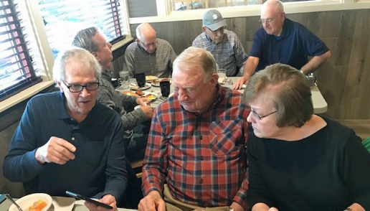 | 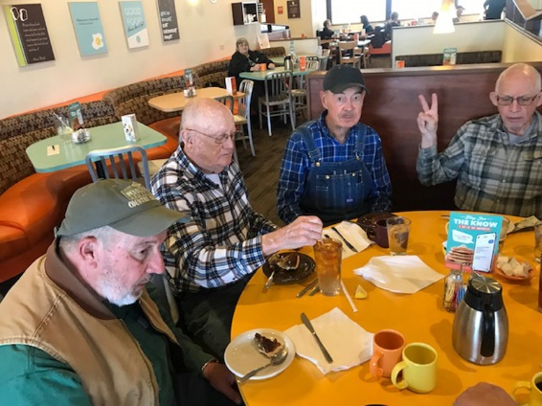 | 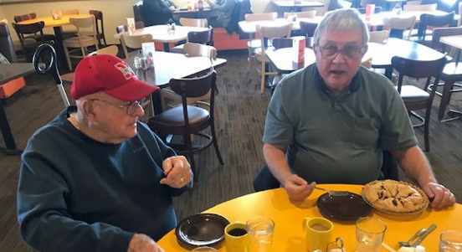
Great conversation during our March 16th, 2022 breakfast meeting. Front, Left to right: Russ Schultz, Gus Dornbusch and Donna Dornbusch. Back, left to right: Craig Derickson. Norm Helzer, Dave Camper and Norm Kempf. | Norm Helzer birthday celebration at Village Inn – April 4, 2022. Left to right – Bruce Evans, Paul Bartlett, Roger Hammer and HORM HELZER. | Lou Buller (left) and the oldest member or our group celebrating his recent birthday with Steve Scheinost, our youngest member.
Our best records indicated that a current coffee group of retired Soil Conservation Service (SCS) – United States Department of Agriculture (USDA) started out in about 1971 in Lincoln, Nebraska. There were several people who retired in the early 1970s. Thus, the coffee group was initiated to keep up with what was going on in the SCS and to share experiences on retirement activities. Currently our review has indicated that over 50 different people have attended this weekly coffee over the years.
The first location for the coffee group was Miller & Payne in downtown Lincoln. Most of the retired coffee drinkers had worked in the old Sears Building in the Nebraska State office, Regional Cartographic office, or the Regional office located in the Sears building.
Some of the early retired SCS coffee group members were Lloyd Mitchell, State Soil Scientists, Ross Greenawalt, Nebraska Soil Correlator, Art Marquardt, Assistant State Conservationist, Jim Bickle, State Administrative Office, Larry Joris, Regional Training Center, Don Broberg, Regional Soil Conservationist, and Allen Fisk, Assistant State Watershed Conservationist.
In later years the meeting location was changed to the location of the current meeting place at the Village Inn on “O” Street and 66th Street. In the 1990s the name of the agency was changed from SCS to NRCS. Most of the older members of the coffee group were quite proud of the SCS, and the new NRCS was thought by several not so great. As some of the people retired from NRCS and joined the coffee group, there was a general acceptance from the older coffee drinkers to accept the NRCS organizational name.
During the past 30 years or so the group has met at each Monday afternoon at 2pm and adjourned at about 3pm. Usually a busy one hour of discussion that was important to the group but probably had little impact on what was going on in the agency or the nation.
By 2pm the noonday crowd has usually cleared out, so some space is available. The group commonly pulls up around a large round table to the right side of the dining area. The number of the group is somewhat variable but there are usually 6 to 12 or more attending now and in early days even more. It is surprising how many more chairs can be pulled up to a round table. Like most people who sit at a table there are some of the senior members of the group who have a traditional certain place at the table to sit – so they usually get their preference. Currently most of our members have birthdays with “BIG NUMBERS.”
No agenda. Most discussion is spontaneous with no real direction or goal of solving anything of value. This is a good session for venting of issues and sometime finding out some good information from others on income tax payments, good fishing places, places on where to go on vacation, and other similar things of value for retired people.
Traditional topics are weather – too cold, too hot, too wet, or too dry – where to go deer hunting, Nebraska football and other Nebraska sports, recalling experiences of many years ago and who did what. No one is spared from some nitty gritty old day things that happened. Many recaps, often with a different viewpoint from one coffee day to another. All in fun. In recent years discussion recaps about the good old Army, Navy, and Marine days has always been interesting. From time to time there is a wager (small amount) on a football game or any other item of difference.
Prior rank or jobs of importance hold no value in this group – everyone is in the same level. So everyone has to take a little ‘heat” from time to time during discussion issues. Surprisingly, everyone handles the difference of opinions on various issues in good style, and there is a valued level of appreciation and respect by each coffee drinker to their colleagues.
All coffee drinkers are expected to honor their birthday. This is to provide treats like pie, cake, brownies, cookies, etc. and share with all other coffee drinkers who are there for the day. Also, the Birthday person is expected to pick up the check for everyone’s coffee and the treats. There is always a lot of discussion and fun surrounding the special birthday events by all.
Current coffee drinkers and also members of our monthly Wednesday Lincoln SCS/NRCS Retirees Club include Paul Bartlett, Lou Buller, Jim Culver, Brue Evens, Roger Hammer, Gary Muckle and Steve Scheniost.
Our coffee group owes a Special “THANKS” to STEVE – “the man”– and a Village Inn manager. Steve has been most helpful and congenial, even though at times he is always giving us some “beef” for one thing or the other. There is always a completive dialog between Steve and some of our coffee drinkers – especially Lou Buller and Bob Pollock. Steve is a real gentleman and thoughtful scholar, as on several occasions when a member of our elite club passes on Steve on his own initiative has provided several (like 6 to 8) excellent Village Inn pies for the luncheon following the memorial service for our past beloved coffee drinkers.
We meet each Monday afternoon at 2pm at the Village Inn on 66th and “O” Street in Lincoln, Nebraska. So, if you are in the area, please feel free to stop by and enjoy some excellent conversation, great coffee and have fun. It will make your day!
NEW YORK
Nancy Lee, ARCSE Representative
Email: mlee0006@rochester.rr.com
James R. Calhoun passed away peacefully on March 10th, 2022. Jim had a 43-year career with SCS and NRCS. Jim ended his career working out of the Albany Area Office in the Federal Building.
Gregory Allan Kist, age 60 of Catlettsburg, Kentucky, passed away on March 16th, 2022 in Columbus, Ohio. Greg was State Conservationist in New York before he retired and moved to Kentucky to be near family while he struggled with his battle of cancer.
NORTH DAKOTA
Robert Bird, ARCSE Representative
Email: rajmbird@aol.com
The good news is that it is April with signs of spring. The bad news is that we just had a couple feet of snow dumped on us in three days. The ranchers were scrambling to find shelter because of calving and lambing season, but the farmers were happy for the moisture, even if it meant a late planting season. North Dakota – at least the west and central parts – has been in a drought for the last few years.
Some snowbirds have returned, but others are probably waiting for the Colorado Lows to settle down before returning. Usually, our storms are Alberta Clippers or Saskatchewan Screamers, but lately are circling in out of Colorado. I hope everyone survived another winter and are looking forward to a safe and healthy year.
Marcell S. Flicek, 93, formerly of Grafton, ND, passed away on March 30th, 2021 in Bismarck, ND. Marcell became known as the "Tree Man" and received an award in 1999 for planting the most trees in the State of North Dakota.
Patricia Mae (Schindele) Johnson, 92, of Bismarck, ND, passed away on April 19th, 2022, at Edgewood Assisted Living. Pat was the wife of the late Everett Johnson, whose last duty station with SCS/NRCS was at the Carson, ND, Field Office.
More information is included in the In Memoriam section.
OREGON
Don Stettler, ARCSE Representative
Email: don.stettler@comcast.net
Oregon retirees met for a quarterly lunch for the first time since the pandemic on April 27th at the Clackamas Old Spaghetti Factory. Plans are underway for a lunch on the westside to be held on July 27th. Watch your email for its announcement.
The St. Helens Chronical recently featured Bill Eagle and his wife Claudia in a story about the community service project they initiated in 2013. Back then Claudia was involved in an evening reading program at the Columbia City School Library. Parents brought their children to the library dressed in pajamas and carrying blankets to listen to bedtime stories. It came to Claudia’s attention that many children, even those from affluent families, did not own a book of their own. Knowing how important book ownership was to her, she and Bill took action to remedy this.
First, they sought funding from the local Kiwanis Club. The club agreed to participate only if books were made available to children in all the schools within the St. Helen’s School District. This endorsement began an effort to obtain funding from other sources. In time funds were obtained from many sources including Powell’s Books, the Elks, senior centers, Safeway, individual donations and proceeds from various projects, like Halloweentown, St. Helens Community Garage Sale, and fair parking.
With the funding, books have been purchased for children from kindergarten through fourth grade. Book chosen are of good quality and preferably hardbound. Staff from Powell's books assist in choosing books that are appropriate.

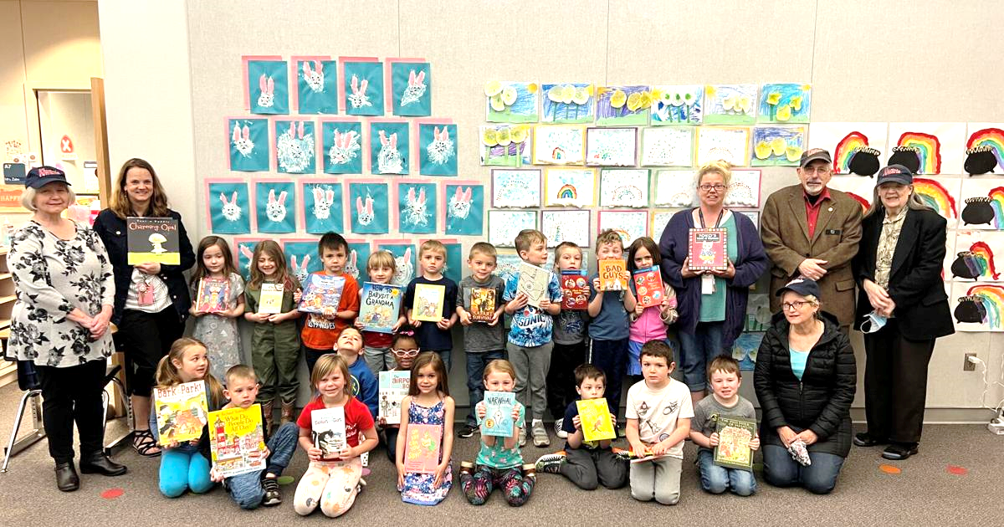
McBride Elementary School children and staff pose for a picture following the book donation with Bill and Claudia Eagle at the far right of the photo.
TENNESSEE
Submitted by Dana York
We met at Shoney's in Lebanon, TN and enjoyed a buffet meal. In attendance were James Sims, Bobby Moore, Patty Lane, Will Nesby and his 10-year-old great granddaughter QuiAria, Laura Lee, Allen Crowe, Billy Headden, Shirley Childs, Donald Dotson, Debbie Brasfield, Larry Hasty and his spouse Connie, Kevin Brown, AnnSue Wattenbarger, Naomi Hamilton-Johnson, Carol Chandler, and Traci Horne.
Larry Goff is still receiving chemo at Vanderbilt and doing pretty well. Best to text him and he can call back. Ray Curl - going to assisted living for more rehab after having broken his hip and having a metal rod inserted but is doing pretty well. Jack Chidester had more surgery for his melanoma this week. Jim Lansford had to go to the hospital for an irregular heartbeat but was sent home this week. Bob Karger fell in late October and had to have back surgery a couple of times, has had some complications and is currently at Life Care at Hickory Woods in room 307 and welcomes visitors. Cards may be sent to his home address at 7000 Buffalo Drive, LaVergne, TN 37086-4198
Kevin Brown attended Titans/Bengals game in the NFL playoffs with four of his high school buddies, is also working with some Franklin area landowners who are planting fruit trees and orchards, recovered after having COVID.
Allen Crowe is watching UT basketball (NCAA tournament game today!), grandson at UT playing rugby and is in civil engineering. Larry Hasty is trying to get his vision taken care of, cataract issues and also some numbness in his foot and is trying to get that diagnosed. He also volunteers on several boards.
Carol Chandler is now working for ACES at National Headquarters with Ralph Smith in Watershed Planning. Very few know how to do watershed planning, so she is trying to train the next generation in this. Her mother turned 100 in December. She also shared that Ray Bryant lives across from her sister in Jackson and that he is very active. James Sims is still working for ACES at home, will be dog sitting for his daughter while she and her husband take a three-week trip. Bobby Moore and Brenda have recovered from COVID. His son has moved in with them. Brenda is still able to do some housework but no longer cooking.
Donald Dotson is still in Franklin and working part time with Williamson County Park on Natchez Trace. Wife Donna is still working mostly at home for a builder, who has some squamous cell cancer on his face to deal with. Naomi Hamilton-Johnson had a heart attack in October and is still undergoing rehab but is greatly improved.
Will Nesby is still coping after losing Ann but is seeing his lady friend from Memphis. He will be travelling with her to the Dallas, TX area for each of them to visit some family members there.
Billy Headden’s wife has macular degeneration and can no longer drive, so he is doing the grocery shopping and other errands that she used to handle. He has now been receiving a retirement check from SCS/NRCS for 35 years. Recently, they celebrated their 61-year wedding anniversary.
Laura Lee’s daughter Amy is now in Lebanon on Old Hickory Lake with her 11-year-old twins. They sometimes take shopping trips to Atlanta and other places. Shirley Childs is very glad to be here and get to meet everyone; feels very blessed. Patty Lane is going to visit Faye Floyd next week and attending a fashion show in Granville this weekend.
AnnSue Wattenbarger is learning to cope with the loss of John. Very grateful for the cards and so many coming to the funeral. Dealing with lots of paperwork from his business, and also John was the sole executor for his mother, and now that has fallen to her as well. Traci Horne is going to Gatlinburg for her 13-year anniversary with Terry and also a trip to Tampa in May for Mother's Day and to visit with her parents and brother.
Debbie Brasfield is still working for ACES, had COVID in January but mostly recovered, attended her first demolition derby recently and really enjoyed it.
SAVE THE DATE! June 16th, 2022, in the West Tennessee Area. The venue is not determined yet but will let everyone know when it is settled. We all had a good visit today, and I hope to see everyone in June!
TEXAS NORTH
Arnold King, ARCSE Representative
Email: arnolddking@hotmail.com
Editor’s Note: Mike Bogard will be serving as the Texas North ARCSE Representative (bogard61@centurylink.net). Thanks, Mike!
As part of his studies at Harvard in the 1970s, David Buhland researched hunger. He worked as a programmer, supporting other people’s projects centered on India’s water resources. He wrote his thesis using income and food consumption data from an Indian village during a time of famine. “The statistics showed that the monied people were getting the calories,” he says.
The experience inspired David to join the Peace Corps, serving the Malaysian Department of Agriculture. “In the center of the country, they were converting jungle to rubber and palm oil estates,” he remembers. “I helped start three hardware stores and also repaired tractors. I learned that Fiat tractors used the same parts as the Allis-Chalmers tractors I’d grown up with!” Malaysia was a fast-growing country at the time. “Still, there was hunger, and I witnessed it,” he says. “The hungry people were the ones without steady jobs.”
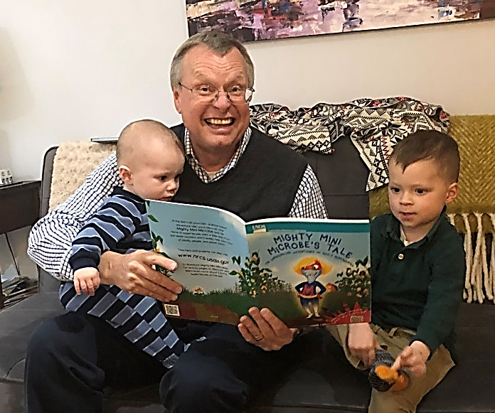
From his childhood on a Minnesota hog farm to studying economics in college to a Peace Corps stint in Malaysia to a long career as an economist, David Buland has explored the connections between food and efficiency for most of his life.
During his third year in Malaysia, Dave married Tiew-Eng. In the mid-1980s, the couple relocated to the United States to start a family. “Our first child was born one week before I entered Wartburg Theological Seminary in Dubuque, Iowa,” David says.
At Wartburg, he joined the Public Witness Committee, where he first heard about Bread for the World—and its founder, Art Simon. “Another student said there was a Bread event happening in Dubuque, and a bunch of us went to learn more.”
With his background in economics, his faith, and having witnessed the effects of hunger on those without means, David immediately recognized the value of Bread’s model.
David realized he would make “a better economist than a pastor.” He returned to school for his master’s degree in economics and worked as an economist for the rest of his career. He retired in 2019, but soon returned to full time work with the USDA, where he helps perform cost analysis on projects like the Farm Bill, the multiyear law that governs an array of agricultural and food programs. [Editor’s note: David is working as an ACES employee.]
“Because I was working for the federal government, I can’t get involved with advocacy activities,” David says. So his involvement with Bread for the World is mainly as a donor. “Then a year ago, I was sending a donation and noticed the monthly giving option.” David began making an automatic monthly gift as a member of the Baker’s Dozen. He calls it “the most effective way I can support an end to hunger.”
Today, David remains active in the ELCA’s North Texas Synod Public Witness. He also serves as webmaster for a USDA economist group. David and Tiew-Eng belong to Grace Lutheran Church in Fort Worth. They have two grown children and five grandkids.
“Being an economist, I see readily how much the church can accomplish – and how much more the government can do to end hunger,” David says. “Voters let Congress know what is needed. From an economist’s view, Bread for the World is the most effective way we can help.”
WASHINGTON
Ken Kaul, ARCSE Representative
Email: kenkaul@msn.com
Washington State's snowpack is “looking good” compared to other states in the PNW. On January 12th, Washington's snowpack level was above average at 133%, but as of March 1st, Washington's snowpack decreased lowering the level to 89%. Eastern Washington was so dry in spring and summer last year, and those areas are still continuing to be dry. In Eastern Washington, the drought continues. With the last several weeks of winter, it's going to be telling on how this fire season is going to be going this summer. We are hoping for the best.
Stefan Fechter Report: Not much new here. We returned from Arizona April 8th. We had good traveling weather all the way, with some wind in northern Nevada. When we arrived in Pendleton, it was almost 70ºF. We enjoyed visiting with other RV-er neighbors. A little rain on the final leg to Spokane. Then the cold weather blew in. The fireplace very comforting this week. Looking forward to spring and summer.
Attending our monthly lunch were Joe Carmack, Larry Edmonds, Ken Kaul and Harry Riehle. Joe Carmack is back in Tennessee working on the farm.
WEST VIRGINIA
Peg Reese, ARCSE Representative
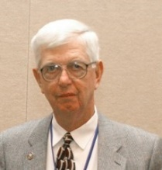
Email: pegreesewv@gmail.com
Like many West Virginians who left the state for a job, Jim Michael returned home when he retired from his position as the Assistant State Conservationist for Water Resources in Virginia in 1991. Prior to moving to Virginia in 1979, he worked in various positions for SCS in Martinsburg, Wellsburg, Moundsville, and Philippi.
Currently, Jim and his wife, Jackie, live on a farm that was designated as a West Virginia Century Farm. A Century Farm must have been in continuous operation by the same family for 100 years or more. James R.S. and Lula Maude Unger founded the farm in 1917 with 301 acres. Their daughter Reba and husband Paul Myers acquired the farm in 1947. In addition to farming, the land Paul contributed to the conservation effort by serving as a supervisor for the Eastern Panhandle Conservation District for 40 years. Upon Paul’s death, stepson Jim inherited 131 acres, while sister Judith and Ernest Baisden acquired 170 acres. If Ernie’s name rings a bell, it is because he also worked for SCS. The Baisden and Michael farms are separated by the main branch of Sleepy Creek.
When Jim and Jackie returned to West Virginia, Paul was still living in the family home, so they purchased a farm nearby. Jim’s son, Brad, is following in his father’s footsteps by graduating from West Virginia University’s Davis College and working to conserve natural resources. While in high school, Brad became an Earth Team Volunteer. Currently he is the Regional Conservationist in Hagerstown, MD.
Brad and his wife Beth live in the old farmhouse and have taken over much of the operation of the two farms owned by Jim and the farm owned by the Baisdens. In addition, the Michaels rent 300 additional acres. Brad and Beth have three children who also help with the chores.
Brad’s help is needed because Jim is very busy giving back to his community. Like Paul, Jim also became an EPCD supervisor and has contributed greatly to conservation. In 2020, he received the Carroll Greene Award for doing “outstanding job promoting wise conservation practices.” One of his many achievements is introducing the Farmland Protection Program to the WV Association of Conservation Districts in 1996. Four years later, the WV Farmland Protection Program legislation was passed. A lot of the protected land lies within the boundary of the EPCD.
Recently, Jim worked with NRCS state engineer Andy Deichert to submit 15 applications for dollars appropriated to NRCS from the Infrastructure Investment and Jobs Act. If West Virginia’s projects are approved, the funds will be spent to restore SCS/NRCS flood control structures. One of the projects submitted was for a Morgan County dam that was built in 1954.
Jim has also been very active on the Cacapon State Park Foundation and WV Association of State Park Foundation. Due to his efforts, Cacapon State Park has a new lodge which added 70 more rooms for visitors to rent, a dog park, and several new trails. Jim still finds time to support the Farm Bureau and other organizations.
Greg Kist lost his battle with cancer and passed away on March 16th, 2022. Prior to his retirement, Greg served as the Assistant State Conservationist for the West Area in Parkersburg. You can learn more about his life in the “In Memorium” section of this newsletter.

SENIOR CONSERVATIONISTS
Prepared by Marc Safley, Senior Conservationist Chronicler
Senior Conservationists have reached the minimum age of 83 years and have completed the Senior Conservationist Questionnaire (download at https://arcsecommunications.wordpress.com/senior-conservationists/). See IN-MEMORIAM for the Senior Conservationists who have left us since the last Newsletter. Please help us identify retirees who should be named Senior Conservationists. Please provide their contact information to your ARCSE Representative or Regional Vice-President.
SENIOR CONSERVATIONIST CHRONICLE
Senior Conservationist
Richard (“Rich”) Duesterhaus
Senior Conservationist Rich Duesterhaus was born March 28, 1939, at Quincy, IL, the oldest of nine children. Rich’s family had a small truck farm. The farm raised tomatoes, sweet corn, and a variety of other vegetables, which were sold to local grocers or on the wholesale market. He attended local schools and after high school attended the University of Illinois where he earned the Bachelor of Science degree in Agricultural Economics (Farm Management) in 1960. During his university years, he worked as a Student Trainee with SCS. Rich served as an officer in the U.S. Army with active duty from 1961-62 (18 months). He served in the Army Reserves and National Guard until 1970.
He began his full-time SCS career as a Soil Conservationist after graduation. In all, between 1959 and 1970 in Illinois, Rich served as Student Trainee in two locations, Soil Conservationist in three locations, Work Unit District Conservationist in two locations, Resource Conservationist for eight Districts, and Acting Area Conservationist. From 1970 to 1973, Rich held the position of Assistant State Conservationist for Operations at Syracuse. During this period, he earned the Master of Arts degree in Political Science from the University of Massachusetts (1970) and the Master of Public Administration degree from Harvard University (1971). In 1973 he was selected State Conservationist for Maine. He held that position until 1975, when he began his career at SCS National Headquarters.
Between 1975 and 1997 when he retired, Rich held the following senior leadership positions with SCS/NRCS and USDA: Assistant to the Administrator for Environmental Development, Assistant Administrator for Planning & Evaluation, Assistant Chief for the Northeast, Assistant Chief for the Midwest, Deputy Chief for Science and Technology, a one-year assignment to the Office of the USDA Secretary as Coordinator for Land, Air, Water, and Solid Waste; six month assignment as Deputy Assistant Secretary; and a shorter detail to the Office of Management and Budget.
Rich has continued to be vitally involved in conservation matters following retirement. His work after retiring included serving as a contractor on projects for SWCS, Partners in Parks, and the National Association of Conservation Districts. Over the last 20-plus years he has been employed by the National Association of Conservation Districts serving in a number of positions, including Director of Government Affairs, Northeast Regional Representative, Director of Projects and Partnerships, and Senior Advisor. He currently holds the latter position. For the past 14 years he served on a part-time basis as the Executive Director of the National Conservation District Employees Association (NCDEA). He ended that position in February of 2022.
Rich and Judie Krapausky married in 1961and were married over 44 years before she passed in 2006. He married Jude Mollenhauer in 2011. Rich has six sons and two daughters, 21 grandchildren, and two great-grandchildren. Family activities are a very important part of his life.
In addition to family activities, Rich has been and remains active in church and community life. Rich is an Eagle Scout and has over 50 years of service as a BSA volunteer leader. He has also been a Girl Scouts of America volunteer leader. He has served on and chaired his Church Parish Council. He has served on the Board and as Vice-President and President of the Soil and Water Conservation Society. He was a founding board member and Chair for 18 years for the Shepherds Center of Northern Virginia (a non-profit organization that provides services and programs for older community citizens). Rich still serves on this Board. And, he has served as Board Member, Vice President, and President of the Association of Retired SCS Employees (now ARCSE).
NOTE: Marc will be retiring from his Chronicler volunteer duties on July 1, 2022. We are looking for another volunteer to assume the Chronicler tasks for the association.

OBITUARY INFORMATION  Paul Benedict, Membership Chair | When you receive word of someone passing, with little other information provided to you, obituaries can often be found by doing an advanced search using Google, using the full name of the deceased. If you do not have access to the web, Paul Benedict will be glad to do the search. Please send death notices and obituary information directly to Paul at soilwarden@verizon.net. Always include the position or the spouse’s position with SCS/NRCS.

Surname | Year | In-Memoriam (Note: These are recent notices. For a complete list, please see www.arcse.org)
Armstrong | 2022 | Ruth Eleanor Armstrong (84) passed away on March 27, 2022. Ruth’s father Robert Burns Armstrong was a Los Angeles Times reporter and photographer. Ruth’s mother, Bess Furman Armstrong, was working in Washington D.C. covering the White House for the Associated Press. But her mom wanted her children to be born in Nebraska, so Ruth and her twin brother Robert were born in McCook, Nebraska on April 4, 1937. She earned a Bachelor of Arts from American University, Washington, D.C., in 1959. She earned a Master of Arts degree from American University, Washington, D.C., in 1969. Ruth was an editor on USDA-Soil Conservation Service Editorial Staff at Hyattsville, Maryland. She edited the technical county soil surveys of states nationally that were published by the United States Government Printing Office. Ruth moved to Lincoln, Nebraska in 1984 when the USDA- SCS editorial staff was consolidated in Lincoln, Nebraska as part of the Midwest Regional Technical Service Center. She is survived by sister-in- law, Diana Armstrong, nieces Susan Ray and Melissa Moore, and nephew John Robert Armstrong. Ruth was preceded in death by her twin brother Robert Furman Armstrong.
Bauer | 2021 | ARCSE Life Member Ronald F. Bauer (87) of Brush, Colorado passed away peacefully on November 8, 2021, at East Morgan County Hospital in Brush. Ron was born to Fredia and Jacob Bauer at Fort Morgan, Colorado on February 9, 1934. He graduated Colorado State University in 1956. After serving two years in the US Army and being honorably discharged he began his work as a soil scientist for the US Forest Service. He later switched over to be a soil scientist with the USDA-Soil Conservation Service. Ron and Patty Hauptmann of Neligh, Nebraska were married on September 1, 1962, in Lakewood, Colorado. Ron’s job took Ron and Patty to Durango, Colorado, Laramie, Wyoming and Lincoln, Nebraska. Following Ron’s retirement after 36 years of service with USDA they moved to the Arbor Apartments at the Eben Ezer Care Facility in Brush where Patty continues to reside. While living in Brush, Ron served on the Tree Board for several years. During this time, he helped plant trees at family homes, at schools, and in Parks on Arbor Day each spring. Survivors include his wife Patty, and his sister Edythe and her husband Harry Watt of Florida.
Bittner | 2018 | Senior Conservationist Elmer M. Bittner (96) of Mesa, Arizona, passed away December 22, 2018, surrounded by family. Elmer was born in Cavalier County, North Dakota, on November 1st, 1922, to John A. Bittner and Mary (Gartner) Bittner. Elmer met the love of his life in 1945, and was married on October 8, 1946, to DeLoris Charbonneau of Langdon, North Dakota. He farmed with his father until 1949, when he went to work for the USDA-Soil Conservations Service (SCS). He spent the next 30 years of his life working as an engineering technician until his retirement in 1979. After retiring from SCS he was employed by the Knights of Columbus as a field insurance agent for ten years. At this time, Elmer & De Loris moved to Mesa, Arizona, where he lived and worked at various activities until his passing. He is survived by De Loris, three sons and one daughter, John Bittner (Barbara) of Round Rock, Texas; Roger Bittner of Apache Junction, Arizona; Doug Bittner (Ellen) of Shakopee, Minnesota, and Lori (Dwight) Baker of Mesa, Arizona; two grandsons, three granddaughters, two great-granddaughters and two great-grandsons. Elmer was preceded in death by son Gregory Bittner.
Bubb | 2018 | Carol (Eakin) Bubb (84) of New Cumberland, Pennsylvania passed away on November 16, 2018, at Harrisburg Hospital. Carol was the wife of ARCSE Member and Senior Conservationist Frederick E. Bubb, retired Information Officer for the Northeast National Technology Center for the USDA-Soil Conservation Service. Carol was born October 17, 1934, in Pittsburgh, Pennsylvania, the daughter of Alvin and Lilly (McCurdy) Eakin. She earned her Bachelors’ degree in Home Economics at Pennsylvania State University in 1956. She devoted her life to raising a family and volunteering for many church and community activities. Carol and Frederick were married 62 years.
Calhoun | 2022 | ARCSE Member James R. Calhoun (77) of Clifton Park, New York, passed away on March 10, 2022. Jim was born in Penn Yan, New York in 1944. He was a graduate of the New York State Ranger School and College of Forestry. He worked as a Forester with the New York Conservation Department and went on to a 43-year career with the USDA Soil Conservation Service/Natural Resources Conservation Service as a Resource Conservationist. He is survived by his wife, Beth, three stepchildren and four grandchildren. He is also survived by his two daughters, five grandchildren and one great-grandchild. Jim’s hobbies included American History and O-gauge electric trains and was a member of the Empire and Eastern Train Club of Schenectady. He stimulated his mind through many classes in Adult Lifelong Learning through Empire State College. Memorial contributions may be made to the NYS Ranger School Alumni Association, 257 Ranger School Rd., Wanakena, NY 13695.
Collins | 2021 | Senior Conservationist and Life ARCSE Member Harlan Gibson Collins (96) of Vancouver, Washington passed away on September 16, 2021. Harlan was born September 19, 1924. While working in Brighton, Colorado, Harlen met a young schoolteacher named Lois Irene Smith. Harlan and Lois were married in Dow City, Iowa in the Methodist Church Aug. 7, 1954. They moved to Rapid City, South Dakota, for the next eight years where Harlan began a career with the USDA-Soil Conservation Service, and Lois taught in the high school for one year before the birth of their first son, Mark, in 1955. Their two other sons, Greg, and Bruce were born in Rapid City in 1957 and 1960. The family transferred to Kailua, Hawaii in 1962 which they both enjoyed tremendously. The next stop for the family was Portland, Oregon, where they moved in 1967. Harlan was an irrigation engineer at the West National Technical Center in Portland, Oregon for the USDA-Soil Conservation Service. He retired in 1980. In 1984 they moved across the river to Vancouver. Harlan was preceded in death by his wife Lois 6 months earlier. He is survived by sons, Mark (Cheryl) Collins, Greg Collins, and Bruce (Maureen) Collins, three grandsons and a great granddaughter.
Creech | 2019 | Senior Conservationist and Honorary ARCSE Member Harold F. Creech (99) of Linton, Indiana, passed away peacefully November 26, 2019, at Hearthstone Health Campus in Bloomington, Indiana. He was born near Danville, Indiana on January 26, 1920, the son of Fred M. and Florence (Hardwick) Creech. Harold was a 1941 graduate of The School of Agriculture at Purdue University with a degree in soil science and a minor in chemistry. Following college, he enlisted in the U.S. Army Air Corp where he served in World War II. Harold retired in 1975 after 34 years of federal service employment as a District Conservationist for the UUSDA- Soil Conservation Service in Bloomfield, Indiana. Harold was a member of Glenburn Methodist Church and the National Association of Retired Federal Employees. He is survived by his daughter, Cheryl (Ron) Stevenson of Peoria, Illinois, a son, Stephen (Peggy) Creech of Bloomington, four grandchildren, Angie and Jeff Stevenson, Wendi (Garth) Goodlett and Christin (Rob) Schippnick, and five great-grandchildren, Baileigh and Sydne Goodlett, and Ashlin, Tyler, and Landon Schippnick. He was preceded in death by his wife, Lenora M. (Wheeler) Creech in 2009.
Dake | 2022 | Raymond Lewis Dake (94) of Fairfield, Iowa, passed away surrounded by his family at Jefferson County Health Center on March 6, 2022. Raymond was born at home December 16, 1927, to John D. and Pauline P. Dake in Benton County, Iowa. Raymond enlisted in the U.S. Army to serve at the conclusion of World War II and Korean War. He celebrated his 18th birthday on the shores of Korea and served until 1947. Raymond returned to the Iowa family farm where he fell in love with the neighbor’s lovely daughter, Rosemary Irene Long, whom he first sighted riding a tractor with her father. They married on August 27, 1950, in Walker, Iowa. Raymond and Rosemary worked on the family farm for many years. In 1971 the family transitioned from the farm to Mt. Vernon, Iowa where Raymond began a second career with the USDA-Soil Conservation Service that would last 24 years. He started as a soil conservation technician and later was an engineering technician in Marion, Ottumwa and Fairfield, Iowa communities. Raymond was instrumental in construction of Lake Sugema in Lacey-Keosauqua State Park. Raymond and Rosemary retired in Fairfield, Iowa in 1994. Raymond was an active member United Methodist Church. In October 2014, Raymond and his son, Brian, participated in a World War II Honor Flight to Washington, D.C. Raymond earned the Lifetime Achievement Award from the Lion’s organization in 2020. Survivors include his wife, Rosemary; daughter, Carolyn (Randy) Bartemeyer; son, Kim (Penny) Dake; son, Brian (Cheryl) Dake; and son, Bruce (Susan) Dake; 10 grandchildren; and 19 great grandchildren.
Dankert | 2022 | Wayne N. Dankert (84) of Ida Grove, Iowa, passed away on January 8, 2022, at the Odebolt Specialty Care of Odebolt, Iowa. Wayne was the son of Albert and Clara (Luebke) Dankert born on March 13, 1937, in rural Palmer in Merrick County, Nebraska. He volunteered for the military draft in Merrick County. After basic and advanced training, he served in northern Italy in a guided missile battalion. After active duty, he attended the University of Nebraska where he graduated with a Master of Science in Agriculture. Wayne went to work for the USDA-Soil Conservation Service in Iowa and worked on soil surveys in Page, Lyon, Dickinson, O’Brien, Muscatine, Ida, and Monona counties. When he moved to Ida Grove he met his future wife, Geraldine Christie. On October 17, 1987, Wayne and Geraldine were united in marriage in the St. Paul Lutheran Church. Following heart problems in 2018, Wayne and Geraldine moved to Golden Horizons Assisted Living in Ida Grove and most recently were residents in the Odebolt Specialty Care of Odebolt, Iowa, until their passing. Survivors include his sister-in-law Julie Christie of Schleswig, Iowa and many nieces and nephews. He was preceded in death by his wife Geraldine Dankert six months earlier.
Dankert | 2021 | Geraldine Rose Dankert (85) of Ida Grove, Iowa, passed away on July 12, 2021, at Odebolt Specialty Care of Odebolt, Iowa. Geraldine was the wife of retired USDA-Soil Conservation Service soil scientist Wayne N. Dankert. Geraldine was an accomplished organist lending her talents playing for weddings, funerals, and church services.
Dingle | 2021 | Beverly T. Dingle (94) of Exeter, New Hampshire, passed away April 9, 2021. Beverly was born July 20, 1926, in Macomb, Illinois, daughter of J. Royal Taylor and Faye (McClintock) Taylor. She held a Bachelor of Arts degree from the University of Iowa. In 1952 she married ARCSE Honorary Member and Senior Conservationist Charles Harlan Dingle. They lived in several Iowa towns. Beverly and Charles moved from Des Moines, Iowa to Durham, New Hampshire in 1961. Charles was an engineer for the USDA-Soil Conservation Service in Iowa and New Hampshire. He served as State Engineer and Assistant State Conservationist. He retired in 1980. Beverly is survived by her beloved husband Charles of 68 years, two loving daughters: Rebecca Brayden (Joe) of South Burlington, Vermont, and Sarah Doyle (Kevin) of Hingham, Massachusetts; four grandchildren Benjamin Brayden, Thomas Brayden, Grace Doyle and George Doyle, as well as four great grandchildren, Callie, Holden and twins Gordon and Everett Brayden.
Flicek | 2021 | Marcell S. Flicek (93) formerly of Grafton, North Dakota, passed away peacefully on March 30, 2021, at the St. Vincent Living Center in Bismarck, North Dakota. Marcell worked for the USDA-Soil Conservation Service (SCS) in Mahnomen, Minnesota, and later as a technician with the SCS in Grafton, North Dakota, developing the Three River Drainage Project. He retired from the SCS on June 3, 1988, then worked another eleven years for the Walsh County Three Rivers Soil Conservation District. Marcell became known as the "Tree Man" and received an award in 1999 for planting the most trees in the State of North Dakota. Marcell is survived by his wife of 61 years, Marlene; children, Joy (Allen) Zidon, of Pisek, North Dakota, Todd (Amy) Flicek, and Becky (Tim) Paul, both of Bismarck, North Dakota, Doug Flicek of Fargo, North Dakota, along with eleven grandchildren and ten great-grandchildren. He was preceded in death by daughter-in-law Cindy (Wegscheid) Flicek and daughter Mitsy Knoll.
Goerend | 2022 | Ernestine “Ernie” L. (Tincher) Goerend, 83, of Salina, passed away, February 22, 2022. She was born December 19, 1938, in Wichita, Kansas. Ernie was the wife retired USDA-Soil Conservation Service employee Duane T. Goerend, who passed away in 2020. She was a homemaker and served as the Kansas State Parent Teacher Association President from 1989 to 1991.
Goerend | 2020 | Duane T. Goerend (84) of Salina, Kansas, passed away November 30, 2020. He was born September 1, 1936, in St. Lucas, Iowa. He served in the United States Air Force then worked for the USDA-Soil Conservation Service. He was preceded in death by his daughter, Pamela Schick and grandson Justin Willingham. Survivors include his wife, Ernestine Goerend, children, Kimberly Willingham, and Linda (David) Rohleder, both of Salina, son-in-law, Bradley Schick, a brother; Frank (Neme) Goerend of Dewey, Oklahoma, 3 grandchildren and 8 great grandchildren.
Greene | 2022 | Charles “Charlie” Edward Greene (77) of Lincoln, Nebraska, passed away March 14, 2022. Charlie was the husband of Linda Greene, Public Affairs/Media Relations Specialist for the USDA-Natural Resources Conservation Service in Lincoln. Charles was born on March 21, 1944, in Pine Bluff, Arkansas to Bertha Johnson. He grew up in Seattle. His athletic ability stood out in high school where he played football and ran track. When in his junior year, he won the Washington state high school championship in the 100- yard dash and captured both the state titles in the 100 and 220 in his senior year. His triumph in the 100 at the Golden West Invitational in Sacramento, California helped him garner the accolade as the number 1 high school sprinter in the nation in 1963. Charlie accepted an athletic scholarship to the University of Nebraska and came to Lincoln in the fall of 1963. He quickly gained the attention of his fellow athletes during an intramural competition and pushed super-star Bob Hayes to a world record performance in the 60- yard dash in New York City at the Madison Square Garden’s indoor meet in January 1964. He missed out qualifying for the Tokyo Olympics at the US Olympic Trials after battling an injury but that served to motivate his competitive drive and determination to another level. Over the next three years, Greene became the nation’s leading collegiate sprinter capturing 3 consecutive NCAA titles in the 60-yard indoors from 1965 to 1967 and 3 consecutive NCAA titles in the 100-yard dash outdoors. He earned his degree in 1967 and after attending ROTC summer camp, returned to Lincoln to begin work on a graduate degree and continue to train for the 1968 Olympic Games with would be held in Mexico City that fall. At the 1968 AAU outdoor national championships, Charlie’s win in the 100- meter final capped off a remarkable evening of competition sports historians have referred to as “The Night of Speed”. Charlie earned two medals at the Mexico City Olympic Games that fall, garnering the bronze in the 100- meter final despite suffering an injury in the last 30 meters of the race. What seemed perhaps somewhat remarkable to some, was that only a couple of days later, Charlie would run the lead “leg” on the US men’s 4 x 100-meter relay. His team won gold and set a new world record. That sprint relay team (Charlie Greene, Mel Pender, Ronnie Ray Smith and Jimmie Hines) were trained and coached by the late great Stan Wright. Three members of that same team had qualified and competed against one another in the 100-meter final only days before. But as Charlie often liked to brag and share, his greatest achievement was in meeting his future wife, Linda Arnone, on a blind date in Mexico City. Linda, a Penn State graduate, was working on assignment for the Philadelphia Inquirer as a journalist. They married in Lincoln on January 18, 1969. Charlie’s career in the US Army would keep him busy over the next 20 years taking him to several different duty assignments and posts including West Berlin, South Korea, West Point, Fort Meade and Fort Lewis. After retiring from the US Army with the rank of Major, Charlie served as an executive for Special Olympics International and traveled around the world. In recent years, even after experiencing some challenging health setbacks, he continued to contribute his talents and expertise in helping to create and teach an OLLI (Osher Lifelong Learning Institute) course of study on the History and Impact of the Olympic Games. Charlie was inducted into the USA Track and Field Hall of Fame in 1992 as well as the US Olympic Hall of Fame and most recently the University of Nebraska Athletic Hall of Fame as part of its inaugural class of 2015.
Grossman | 2017 | Senior Conservationist Raymond Augustus Grossman (97) of Missoula, Montana, passed away peacefully in his sleep on March 5, 2017, surrounded by his loving daughters. He was born December 10 10, 1919, the oldest child of Phillip Augustus Grossman and Maude Lippincott Grossman in Shelbysville, Illinois. He attended the University of Nebraska and graduated in 1942. He had been in ROTC and therefore graduated and was inducted into the Army as a Second Lieutenant. Ray volunteered to join a new command of Airborne Division and was a member of the 82nd Airborne. He was very proud and honored to be in this division and was a bona fide war hero, having been awarded the Silver Star, Purple Heart and the French Croix de Guerre Alec Etoile d'Argent medal earned in Normandy on D-Day. After returning to the states, he was hired by the USDA-Soil Conservation Service and sent to work in Eastern Montana where he met the beautiful and wonderful Myrtle Mae Noblitt and swept her off her feet. They married in 1949 and moved to Forsyth, Montana. Ray continued his military service having joined the National Guard where he retired as a major. The family was transferred to Townsend, Montana in 1967, where the couple lived until 1987. After Ray's retirement from the SCS, he became a realtor specializing in farm and ranch land. Myrt and Ray moved to Missoula in 1987 and he continued as a realtor first with Lambros and then with Rocky Mountain Realty. He didn't fully retire until he was 91 years old. Ray was very active all his life, first with his job out in the fields, then with early morning workouts at the Sports Court and then with Access Fitness. He also enjoyed participating with military funerals and with the retired officer’s organization. Ray loved having coffee with his "boys" three days a week at the Press Box. He had a happy, wonderful life. Ray was preceded in death by his wife of 65 years, Myrtle Mae. He is survived by his three daughters and two grandchildren.
Harrison | 2021 | Senior Conservationist Henry F. Harrison (101) of Demopolis, Alabama passed away January 20, 2021. He was born on January 25, 1919, in Jasper, Arkansas to Austin Harrison and Mauda Phillips Harrison. He worked for the USDA-Soil Conservation Service as a District Conservationist. He was preceded in death by his first wife, Velma Jean Nichols; and his sons Donald Harrison and James Harrison. He is survived by his wife, Helen Lewis Bradford, his daughter Sandra Buck, and his stepson, Henri Bradford. He is also survived by 7 grandchildren and 3 great-grandchildren. Graveside were held at the Demopolis Memorial Gardens Cemetery with Rev. Bill Elwood officiating and Kirk Funeral Homes, Demopolis Chapel directing.
Haynes | 2019 | Senior Conservationist and Honorary ARCSE Member George Thomas Haynes, Jr. (100) of Eaton, Ohio passed away April 28, 2019, at his residence. He was born August 8, 1918, in Dillonvale, Ohio to the late George Thomas and Marjorie (Burriss) Haynes, Sr. He was a U.S. Army Veteran who served during World War II; he retired from the USDA-Soil Conservation Service as a Soil Conservationist and farmed for many years. He participated on three mission trips to Africa; and he attended Grace Lutheran Church in Eaton, Ohio. He was preceded in death by his wife Dorothy “Dottie” H. Haynes. He is survived by his son G.T. Haynes of Eaton, Ohio; daughter Kathy (John) Danner of Prudenville, Michigan; grandchildren: Johnna (Erik) Balk of Farmington, Michigan, Jenifer (Jamie) Sorrell of Evansville, IN and Jeffrey (Melissa) Danner of White Lake, MI; great grandchildren: Jackson, Riley, Sydney, Cameron, Addison, Brody, Paige and Grace. Funeral services were held May 6, 2019, at the Grace Lutheran Church in Eaton, Ohio with Pastor Dwight Hanson officiating. Burial was at Mound Hill Cemetery in Eaton with full military honors provided by the Preble County Honor Guard and U.S. Army.
Hilpmann | 2018 | Senior Conservationist Heinz G Hilpmann (93) of Gering, Nebraska passed away May 7, 2018, at Regional West Medical Center in Scottsbluff, Nebraska. Heinz was born on June 15, 1924, in Seneca, Nebraska to Alfred and Frieda Hilpmann. He attended University of Nebraska Lincoln and University of Wyoming and graduating in 1949 (Agriculture). He entered the U.S. Army on March of 1943 and was honorably discharged in September of 1951. He was united in marriage to Doris Ann Henderson on December 27, 1950, in Cody, Wyoming and made their home in Torrington, Wyoming for twenty-six years, where he was a district Conservationist for the USDA-Soil Conservation Service (SCS). In March of 1981, they moved to Gering upon Heinz retirement from SCS. Heinz was a member of the First Presbyterian Church in Torrington for several years. Survivors include his daughter Jennifer Ann Hilpmann; sister-in-law Leona Grace Welch and numerous nieces and nephews. He was preceded in death by his wife Doris Ann Hilpmann on April 7, 2018. His memorial service was held May 11, 2018, at. at Dugan Kramer Funeral Chapel with Pastor Lyle Hinebauch officiating. Military honors were provided by the Nebraska Army National Guard.
Hodges | 2022 | Senior Conservationist and ARCSE Member Thomas Cranmer Griffith Hodges (90) of Fort Worth, Texas, passed away on February 23, 2022, at a Fort Worth hospital after a brief illness. He was surrounded by his children and his church rector. Tom was born on June 22, 1931, to William Snowden Hodges and Mathilda Ober Griffith Hodges in their Ellicott City, Maryland family home. He married Marcella DeVries Banks on August 2, 1952, at St. Barnabas Episcopal Church in Sykesville, Maryland. He graduated from the University of Maryland with a bachelor’s degree in Agricultural Economics. He ultimately went to work for the UUSDA-Soil Conservation Service. Before his retirement, Mr. Hodges oversaw the financial impact of watershed and flood control programs for the Soil Conservation Service, later known as the Natural Resources Conservation Service, in the southeast United States. The family moved to Broomall, Pennsylvania in 1966, and then to Fort Worth in 1969, all for his work. He was the lead economist at the National Technology Center until his retirement in 1993.Though constantly traveling, he was active in his children’s' activities in sports, school, and church. The family became members of St. Andrew's in the early 1970s. Tom served on the church vestry, including a term as Junior Warden. For decades, he served as an usher on many Sundays and for select funerals and weddings. He was preceded in death by his wife, Marcella, in 2005. Tom is survived by his daughter, Marcella Mayer; son, Charlie Hodges (Lisa); grandchildren, Kyle Mayer and his girlfriend Teri Wilborn; Sarah (Jeremy) Jackson and their children Hodges and Elvie; Laura (Chris) Hall and their children Elizabeth and Addison; “Tommy” F Thomas (Brittany), and their children Paislee and Noah; and Bobby Hodges (Erin), and their children Peyson, Lanham and Orvie. A memorial service was held March 12, 2022, at St. Andrew's Anglican Church at 10th and Lamar St. in Fort Worth.
Holeman | 2018 | Senior Conservationist and Honorary ARCSE Member John Neville Holeman (95) of Pompano Beach, Florida, passed away peacefully in his Heritage Towers apartment on March 23, 2018, with his daughter Laura present. John was born on June 3, 1922, in Dawson Springs, Kentucky, to John and Jesse Hendershot Holeman. John served in the Navy during World War II. After much thought, he decided to become a Geologist, and had a long, distinguished career in the USDA-Soil Conservation Service including serving as the agency’s National Geologist in Washington, DC. John had three loving partners, each for over a decade: Kate Coil, Grace Ruckh, and Jim Burnett. Kate and John met in Kentucky and moved to Clearwater, Florida, where they had an orange grove for many years. Grace and John met through a mutual friend, were married in 1959, and settled in Cheverly, Maryland, outside Washington, D.C. Daughter Laura was born in 1960. Grace passed away in 1975. John retired in the early 1980s and spent winters in Fort Lauderdale and summers in Cheverly. He met Jim in the early 1980s, and they were together happily until Jim’s passing in 2014. John is survived by his daughter Laura Lovell Holeman, and by his two nieces, Lee Clements Tobar and Susan Clements Spratlin. His tactfulness, dry sense of humor, and intelligent conversation will be missed by all who had the good fortune to know him. John’s wish was that the Neptune Society scatter his ashes over the Atlantic Ocean. John retired in the early 1980s and spent winters in Fort Lauderdale and summers in Cheverly.
Hoover | 2022 | Bertha Young Hoover (95) of Lexington, Kentucky, widow of Robert “Bob” L. Hoover, passed away peacefully in her home April 16, 2022. Bob was a contract specialist for the USDA-Soil Conservation Service at the Kentucky state office prior to his retirement in 1989. Bertha was born in Tousey, Kentucky on July 10, 1926, to the late Walter and Olga Young. Bertha was a member of Delta Kappa Gamma Society, International Beta Chapter, and graduated with a master’s degree from Western Kentucky University. She worked as an elementary school teacher and retired after 35 years and was a member of Southland Christian Church. She was preceded in death by her husband of 64 years in 2010.
Johnson | 2022 | Patricia Mae (Schindele) Johnson (92) of Bismarck, North Dakota, passed away on April 19, 2022, at Edgewood Assisted Living. Pat was the wife of the Senior Conservationist Everett Johnson, who passed away in 2013. Everette’s last duty station was as District Conservationist in the Carson, North Dakota Field Office for the USDA-Soil Conservation Service. Pat attended Valley City State Teacher's College earning her teaching certificate. She started her career in Lakota and it was there where she met her best friend, Everett. They were married on June 1, 1951. Pat will be deeply missed by her daughters: Linda Johnson of Wahpeton, North Dakota, and Julie (Jerry) Schock of Redding, California; and two grandchildren.
Kist | 2022 | ARCSE Member Gregory Allan Kist (60) of Catlettsburg, Kentucky, passed away on March 16, 2022, at The James Cancer Hospital and Solove Research Institute in Columbus, Ohio. Greg was born in Cincinnati, Ohio on February 3, 1962, to James and Joyce (Guenther) Kist. He received a Bachelors’ degree in Agronomy from Eastern Kentucky University and an Associates Degree in Agricultural Sciences through the Federal Government Program at Penn State University. He married the love of his life, Lori McBride, on April 20, 1985, and they spent 37 wonderful years together. He worked as an Agronomist and held many leadership roles for the Natural Resources Conservation Service for 34 years including State Conservationist in New York. He was active in every community he lived in. He was a member of the Knights of Columbus, the Elks Lodge, National Rifle Association (NRA), and the National Wild Turkey Federation. He was also deeply involved in Boy Scouts, and even led his two sons and countless other young men on various outdoor adventures. He volunteered for the NRCS in Boyd County, Kentucky as well as the Great Swamp Conservancy of Canastota, New York. Greg and Lori loved gardening, traveling, and spending time with family. Survivors include his loving wife, Lori Kist, and their three children Ellen (Joel) Jones, Thomas (Emma) Kist and Anthony (Graeson) Kist; two grandchildren Daniel and Kennady Kist; and his mother Joyce Kist.
Liggett | 2019 | Senior Conservationist and Honorary ARCSE Member Francis Eugene "Gene" Liggett (99) of Vancouver, Washington, passed away November 27, 2019. He was born February 19, 1920, in Almena, Kansas. He graduated from the University of Nebraska in January 1943. He served in the US Army in World War II, European Theater with the 45th Infantry Division, directing artillery as a Forward Observer. In Italy he was wounded twice. In southern France he was captured by the Germans. He spent 8 months as a German Prisoner of War in Poland. He also served during the Korean War, 1951-1952. Gene was a County Agricultural Extension Agent and later a District Conservationist with the USDA-Soil Conservation Service in Nebraska, where he was responsible for the design and implementation of thousands of acres of contour farming, retiring in March 1975. He moved to Vancouver, Washington in 1979 and was active in the Master Gardening Program. Gene also helped organize and was President of the Ft. Vancouver Chapter of American Ex-POW’s. He was a lifetime member of the Association of Retired Conservation Service Employees, Disabled American Veterans, the American Ex-Prisoners of War, the American Legion, and the Knights of Columbus. Gene is survived by his beloved and devoted wife of almost 74 years, Rosalie (Wiese) Liggett; two sons, James Raymond of Cornish, New Hampshire and Ronald Dale of Littleton, Colorado; and two daughters, Dorothy Jean Tilka of Vancouver, Washington and Marianne Liggett Merriam of Reno, Nevada. He also leaves six grandsons, two granddaughters and ten great-grandchildren. He was preceded in death by his oldest son, Joseph Wayne. He was a member of St. Joseph Catholic Church in Vancouver. He was interred at the Willamette National Cemetery in Portland, Oregon. Donations may be made in his memory to the Oflag 64 “Museum of POWs” being built in Szubin, Poland that will display his WWII/POW artifacts. Donations can be sent through the following link: https://friendsofoflag64.org/.
Mathews | 2020 | Senior Conservationist, Honorary and Life ARCSE Member Richard M Matthews Sr. (101) of Universal City, Texas passed away at home on December 16, 2020. Richard was born in 1919 in Agate, Colorado. In 1947, he married Mildred Reed of Chicago, Illinois. They were married for 67 years at the time of Mrs. Matthews' death in 2015. After high school Richard went to work for the War Department in Washington, D.C. in 1940. In 1943, he enlisted in the United States Army Air Force. He served as a B-17 ball-turret gunner, 15th Air Force, Foggia, Italy from 1944 until the war’s end in May 1945. He flew 23 combat missions, including missions to Berlin, Germany. After World War II, he attended the University of Colorado, Boulder, Colorado, and graduated with a Bachelor of Science degree in Civil Engineering in 1951. After graduation, he went to work for the USDA-Soil Conservation Service (SCS). At the time of his retirement in 1980, he was the Head of the Design Unit in Portland, Oregon for the western U.S. for the SCS. Mr. Matthews is survived by his children - Richard M. Matthews, JR., Roberta J. Edwards, and Elizabeth J. Hobbs; his grandchildren – Richard M. Matthews III, Shannon R. Matthews, David R. Edwards, Michael J. Edwards, Jolene E. Hobbs, and Kaylee A. Hobbs; and great-grandchildren – Caitlin R. Matthews, Kaleah R. Matthews, Evaleigh D. Matthews, and Richard M. Matthews IV. Sadly, Mr. Matthews was proceeded in death by his son, Robert M. Matthews. Richard and his wife Mildred had a dual military funeral service and were interred side by side at the Fort Sam Houston National Cemetery, San Antonio, Texas.
Mernaugh | 2021 | Senior Conservationist LeRoy Joseph Mernaugh (103) of Pierre, South Dakota, passed away on October 2, 2021, at Avera Maryhouse Nursing Home in Pierre. LeRoy was born on July 18,1918 in Mitchell, SD to Sylvester and Margaret (Schladweriler) Mernaugh. He grew up on the family farm outside of Letcher, South Dakota. When he was only three years old, LeRoy and his family attended the South Dakota State Fair. During their visit to the fair, LeRoy was judged to be the healthiest baby in the state. LeRoy attended South Dakota State College (now South Dakota State University) in Brookings, South Dakoita. At the end of his junior year, he left college for one year to help on the family farm but returned the following year to graduate in 1940 with a bachelor’s degree in Agricultural Engineering. With the declaration of World War II, LeRoy enlisted in the Army Air Corp, eventually achieving the rank of Captain. After five years of military service, LeRoy settled in Watertown, South Dakota where he met Isabella “Daisy” Fox. They were married on February 22, 1949, at Immaculate Conception Church and enjoyed a long and happy marriage, raising five sons. They were inseparable for over 70 years until Daisy’s death in 2019. For nearly three decades, LeRoy worked for the USDA-Soil Conservation Service as an agricultural engineer. During that time, the family lived in Watertown, then moved to Winner, and finally to Pierre. After an additional twelve years with the Water Rights Division of the State of South Dakota. LeRoy retired in 1988. His work took him throughout much of South Dakota’s farmlands, and his ability to recall exits, road numbers, and mile markers was legendary. LeRoy was a lifelong member of the Catholic Church and an active member of the Knights of Columbus and the American Legion. LeRoy is survived by his five sons: Raymond (Glenda) of Hoover, Alabama; Kenny of Spearfish, South Dakota; Kelly of Omaha, Nebraska; Kevin (Debbie) of Corpus Christi, Texas; and Paul (Lisa) of Ocala, Florida.
Moore | 2019 | Senior Conservationist Clive Bert Moore (95) passed away on September 23, 2019, at the White Oak Health Campus in Monticello, Indiana. He was born on October 2, 1923, in Norway, Indiana to the late Alonzo and Pauline (Cohee) Moore, On April 13, 1946, at the old Zion Bethel Church in rural Monticello, he married the love of his life, Imogene Bowsher. Clive entered the United States Marine Corps in May of 1942 and saw action in Guadalcanal, hit the beach at Guam and Iwo Jima. Clive received a Bronze Star for action in Iwo Jima. He had worked at the former ALCOA in Lafayette, Indiana and the former Bryan Manufacturing in Monticello, Indiana. Clive then went to work at the USDA-Soil Conservation Service. For over 25 years he worked in White County designing and engineering many tile systems, farm ponds, open ditches and erosion control structures. Clive was a member of the First Baptist Church in Monticello, taught Sunday School for over 35 years, and had also served as a Deacon. Clive was a Director on the Pulaski White Rural Telephone Board and had served two terms on the Board of School Trustees for the North White School Corporation in Monon, Indiana. He also volunteered for ten years at the Habitat for Humanity in Sebring, Florida during retirement. He is survived by his wife Imogene; three children; six grandchildren; ten great-great-grandchildren.
Morehead | 2021 | Stanley “Stan” Thompson Moorhead (87) of Woodland, California passed away peacefully in his Woodland home on September 27, 2021. Stan was born and raised in Kelseyville, California. His military experiences included Navy Seabees and Korea. He was a Civil Engineer by occupation for the USDA-Soil Conservation Service, which took him to various dam construction projects throughout California. Stan served his community extensively, and tirelessly provided for people in need. His contributions included time spent with The Senior Center Inc. Board and The American Legion. Stan's deeply rooted Christian involvement included the Gideons Bible Society, McClelland Air Force Base Chaplain services, and numerous Episcopalian Church committees. Stan was preceded in death by his wife, Imaleta; in 2012. Survivors include two daughters, Dee, of Woodland, and Annette of Oklahoma City, Oklahoma.
Munkittrick | 2022 | Senior Conservationist Graham Telfair Munkittrick “Munk” (93) of Dillsburg, Pennsylvania passed away January 22, 2022, peacefully at his home of forty-six years. Graham was born August 14, 1928, in Orange New Jersey, the son of the Alfred Graham and Pauline Telfair Munkittrick. He was married to the love of his life MaReine Browne on January 27. He received his bachelor’s degree at Arizona State University while working at the university’s farm. He served two years in the United States Army after his education at Arizona State. He received his Masters’ Degree in Public Administration at Harvard University, Magna Cum Laude. Munk worked for the USDA-Soil Conservation Service. Throughout his career there he had many accomplishments retiring as the Assistant Chief of the Northeast Region managing thirteen states based out of Washington DC. After retiring, he started his own company 6M Construction where he and his son, Kevin William, worked together for twenty-five years. He was most proud of the fact he built Willow Mill Veterinary Hospital completed in November 2006. When not working you could find Munk on the golf course. He, along with his sweetheart MaReine, were founding members at Saint Elizabeth Ann Seton Parish in Mechanicsburg, Pennsylvania. Graham was preceded in death by his bride of 68 years MaReine Munkittrick. Surviving are his devoted four children. His three sons Richard Graham Munkittrick and his companion Debbie Waits of Dillsburg, Thomas Wright Munkittrick and his wife Ruth of Dillsburg, Kevin William Munkittrick and his wife Tina of Mechanicsburg, Pennsylvania, and his daughter Elizabeth MaReine Terrel and her husband Richard of Doylestown, Pennsylvania: ten grandchildren and three great grandchildren. Mass of Christian burial was celebrated at Saint Elizabeth Ann Seton Church.
Purvis | 2022 | Johnny Dale Purvis (69) of Burea, Kentucky passed away April 19, 2022, at his residence in Berea. Johnny Dale was born October 21, 1952, in Madison County, Kentucky. He was the son of the late Boyd & Sudie (Seaborn) Purvis. He worked as a soil conservation technician for the USDA-Soil Conservation Service. Previously he farmed near MvKee, Kentucky. Johnny Dale is survived by his loving wife, Phyllis Purvis of Berea; and by two children, Heather (Eddie) Ellis of Richmond, Kentucky, and Richard (Laura) Hibbitts of Cary, North Carolina, and three grandchildren, Caleb Hibbitts, Justin Hibbitts and Reagan Hibbitts.
Redman | 2021 | ARCSE Member Donald Dean Redman (90) of Albia, Iowa passed away on October 25, 2021. Don was born in Decatur, Iowa on January 10, 1931. On September 9, 1951, he married his high school sweetheart, Donna Jean Warren, at the Brethren Church in Leon, Iowa. In November of 1951, he was drafted into the military and served in the United States Marine Corp until November of 1953. He was stationed at Camp Pendleton at San Diego, California, and served a stint in Korea during the Korean Conflict. During that time his bride, Donna, had moved to San Diego to be close to him. After his honorable discharge, they moved back to Iowa where he worked as a farmhand at Huxley, Iowa. In 1959, they moved back to Leon where he worked for Smith Feed, driving a feed mill for a year before beginning his career with the USDA-Soil Conservation Service (SCS) in Leon. He also served the SCS at the Albia office from 1962 until 1966, and in Creston, Iowa from 1966 to 1968, before returning to the Leon office where he remained until retiring from the SCS in 1989. Don worked as a Civil Engineering Technician. Don and Donna were both very involved in Leon Bible Church, Freedom Bible Camp, 4-H, the Iowa State Fair and more. Don was preceded in death by his wife Donna in 2015. He is survived by his children, David Wayne, Deanne Kay, Darrell Lynn, Linda Redman of Leon, Dan Bowers of Fairfield, Iowa, and Teresa Redman of Leon, Iowa; and his grandchildren, Brent Redman, Erica Evans, Scott Mineart, Clint, Reagen Redman, Andy, Ashley Bowers, Angie, Troy Bisgard, Aly, Bruce Dahlhauser, Michael Redman and Zac Cooper.
Rodrigues | 2022 | Carlos Valdez Rodriques (69) of Polson, Montana passed away February 14, 2022, at his home. Carlos worked for the USDA-Natural Resources Conservation Service in the Kalispell Field Office.
Ross | 2019 | Senior Conservationist Robert L. Ross (98) of Bozeman, Montana passed away August 18, 2019, 'at home' at Bozeman Lodge in Bozeman with family by his side. Robert was born July 11, 1921, in Roundup, Montana to Joseph A. Ross and Elsie C. Hogan. Bob was a proud Army Veteran of World War II. He fought and was wounded in France. His many decorations include Purple Heart, 2 Bronze Stars, a Silver Star, and, in 2015, the French Legion of Merit. While living in Hollywood, California, before being discharged from the Army, Bob met Nancy Gene Danielson. They married in Las Vegas, Nevada, June 1, 1946. They had 3 children: Judy, Tim and JoAnn. Nancy was Bob's partner in all his endeavors until her death in 2012 after 66 years of marriage. In 2013 Bob was able to travel with other veterans on a Big Sky Honor Flight to Washington, D.C., to visit the World War II Memorial. Although Bob has missed Nancy terribly, the trip reenergized his life. In 1947 Bob and Nancy left California to return to Montana. Bob graduated from Montana State College (MSC) in 1949 in Range Management. In 1949 he became a member of the Society for Range Management. Following college Bob worked for the USDA-Soil Conservation Service from 1949-1977, starting in Choteau, Montana, moving to Whitehall, Montana in 1951 and to Bozeman in 1965. Bob became Range Conservationist for the western 1/3 of Montana and in 1965, State Range Conservationist. Bob was instrumental in Bluebunch Wheatgrass being designated as Montana's state grass. After Bob's retirement from SCS in 1978 he continued to be active in range management organizations, education, and causes. He worked tirelessly for years to bring attention to severe overgrazing in Yellowstone National Park resulting from overpopulation of bison, elk and big horn sheep. Bob and Nancy enjoyed their horses, especially taking trail rides and pack trips. Bob participated in Cowboy Poetry gatherings across the western US and Canada. He was inducted into the Cowboy Poets Hall of Fame. He is survived by daughters, Judy (Lynn) Rominger of Havre, Montana, Jo Austin of Spokane, Washington, and son, Tim (Karin) Ross of Oakley, Utah; grandchildren Rebecca Ross, Devin Ross, Michael Austin, Elizabeth Williamson, Skylar Tritt, Andrea Fiore, and Alexa Nafisi, and great-grandchildren Austin, Avery, Guss, Gunner, Hunter, and CJ.
Routhier | 2018 | Senior Conservationist Bernard G Routhier (95) of Lemington, Vermont, passed away October13, 2018. Bernard was born February 21, 1923, in Stanhope, Estrie Region, Quebec, Canada. Bernard came to Vermont in the mid-1940s and purchased the family farm in Bloomfield in 1947. It is now known as “Routhier & Sons,” and is presently operated by three of his sons. He also worked for the USDA-Soil Conservation Service as a soil and water technician for 30 years. He was a Fourth-Degree member and Past Grand Knight of the Knight of Columbus, and a member of the Colebrook Kiwanis Club. Bernard was an active communicant at Sacred Heart Parish in North Stratford. He is survived by his wife of 61 years, Angela of Lemington, Vermont; his four sons: Guy of Maricopa, Arizona; Gerard; Rene; Eric and Denault (Dino) all of Bloomfield, Vermont; five daughters: Huguette (Yogi) Poulin of Columbia, New Hampshire; Lori Routhier of Danby, Vermont; Pauline “Poli” Beaudoin of South Burlington, Vermont; Colette Routhier Swain of Monument, Colorado; and Josee Feezor of San Jose, California.; 28 grandchildren, 33 great-grandchildren, and 4 great-great-grandchildren. He is predeceased by his first wife, Simone Couture Routhier in 1954, and a son, Robert Routhier in 2014.
Schuchart | 2021 | Senior Conservationist Millard George Schuchart (95) of Rio Medina (Cliff), passed away April 11, 2021. He was born February 22, 1926, in San Antonio to Raymond Schuchart and Edna Frick Schuchart. Millard earned a 4-year degree from Texas A&M. After graduation, he was commissioned to 1st Lieutenant. of the United States Army. He served in Germany for 2 years where he made Captain. He worked for the USDA-Soil Conservation Service as a soil conservationist and district conservationist for 40 years. On June 15, 1952, Millard married Inell Beck. They were blessed with 68 years of marriage, 2 children, 4 grandchildren and 6 great-grandchildren. Survivors include his wife, Inell Schuchart; daughter, Pam Schuchart Ritch (Don); son, Daryl Schuchart (Kim); grandsons, Greg Sterner (Amy) and Troy Sterner; granddaughters, Tracy Hilbert (Brian), Heidi Tondre (Barrett); and 6 great-grandchildren.
Slusser | 2021 | Steven Eugene Slusser (76) of Reno, Nevada, passed away peacefully June 27, 2021, surrounded by friends and family. Steven was born in Alhambra, California, on March 1, 1945. He was drafted into the United States army while working in the Angeles Forest for the US Forest Service in 1969, Steven proudly served his country for 18 months, 14 of which he was the Gunner on a 105-mm howitzer M102 cannon in Vietnam. Upon his return from military tour, he continued his love of the outdoors as a Soil Scientist for the USDA-Soil Conservation Service (later Natural Resources Conservation Service) for the next 30 years. He worked in Susanville, California and finished his career at the regional soil survey office in Reno. He loved growing gardens, riding horses, dogs on his lap and at his heels, and he was quick and witty with a great sense of humor, still cracking jokes in his final hours. Survivors include his brother, James A. Slusser of Reno, Nevada, ex-wife and friend of 45 years, Sandra McGarva, stepchildren Rayna Harkness (Kindle) and Corey Kindle of Standish, California. Military Funeral Services were held at the Veteran's Cemetery in Fernley, Nevada.
Southern | 2019 | Senior Conservationist Beulah Mae Canter Souther (92) of North Wilkesboro, North Carolina, passed away peacefully on October 17, 2019, at her home. Beulah was born August 11, 1927, in Surry County, North Carolina to Sanford Lee Canter and Cora Mae Peele Canter. She was retired from the Bureau of Alcohol, Tobacco and Firearms and the USDA-Soil Conservation Service where she worked as a Clerk-Typist-Stenographer. She was the oldest active member of Mt. Pisgah Baptist Church where she gave 68 years of faithful service to the Music Ministry. She was preceded in death by her husband Calvin Newton Southern. She is survived by a daughter; Janice Mathis (Perry) of North Wilkesboro, a son; Stephen C. Souther (Sherry) of North Wilkesboro, four grandchildren; Kristin Souther Adams, Derrick W. Howard, Zachary S. Souther and Brian Mathis; and four great grandchildren.
Stettler | 2022 | Linda Ann Stettler (80) of Beaverton, Oregon, passed away peacefully March 2, 2022, in Aloha, Oregon. She was born April 9, 1941, in Salem, Oregon Robert Kellogg and Esther Nightingale Wood. She married Donald Stettler April 11, 1959, in Keizer, Ore. Don is an ARCSE Life Member and the current ARCSE State Representative for Oregon. Linda enjoyed cooking delicious family meals which involved studying many cookbooks and watching cooking shows on TV. In time she used that skill to work in the Ladd Acres Elementary School kitchen. Linda was a member of Village Baptist Church for many years and was involved in children's ministries. She also participated in the Girl Scouts as a troop and neighborhood leader and camp volunteer. She is survived by her husband of nearly 63 years, Donald Stettler; son, Robert (Kelly); daughters, Diane Swanson and Karen (Jason) Christie; eight adoring grandchildren; two great-grandsons, and one great-granddaughter.
Swern | 2017 | Senior Conservationist and Honorary ARCSE Member William E. "Bill" Swern (95) of Rockville, Indiana passed away May 18, 2017, at his home on his cherished family farm. He was born October 2, 1921, in Kokomo, Indiana to the late William E. Swern and Elizabeth Riley Swern. He served in the United States Navy during World War II; later graduating from Purdue University in 1949. He was a District Conservationist for the USDA-Soil Conservation Service (SCS), retiring in 1980. He began his career with the SCS in December of 1950 in Madison County and worked for a short time in Wayne County. He worked for the Soil Water and Conservation District in Hendricks County from 1966 to 1975. From 1975 to 1980 he served as RC&D coordinator with the Arrow Head Country RC&D in Northwest Indiana. He was a member of the Rockville First United Methodist Church and Rockville Rotary Club. During his career he received many awards and citations including, 1988 Hoosier Chapter Soil and Water Conservation Society Service Award, 1988/1992 International SWCS Commendation Awards, 1990 Paul Harris Fellow Award, 1991 Parke County 4H Leader of the Year, 1992 Commendation Award Soil and Water Conservation Society, 1993 Indianapolis Star Jefferson Award, 1999 SCCS Prestigious Honor Award, 2000 Purdue Agriculture Alumni Association Certificate of Distinction Award, 2007 NRCS Earth Team Award, 2009 Parke County SWCD Distinguished Service Award, 2009 Association of Retired Soil Conservation Service Employees Award of Outstanding Community Service. He served 15 years as the administrative secretary/treasurer for Hoosier Chapter Soil and Water Conservation Society, Treasurer of Parke County Ag Day Committee, Parke County Park Board, serving two terms as Trustee of Rockville First United Methodist Church, 10 years as a 4H photography project leader, associate supervisor of Parke County SWCD and Earth Team volunteer, Treasurer of Parke County Historical Society and Sycamore Trails RC&D Forestry committee. Survivors include one sister, Marianne Karpovich of Caro, Michigan and many nieces and nephews.
Thomas | 2019 | Senior Conservationist Delbert D. Thomas (99) of Altoona, Wisconsin, passed away peacefully on September 9th, 2019. Delbert was born on June 28, 1921, on a farm near Baraboo, Wisconsin to Frank and Eva (Davis) Thomas. World War II interrupted his college education and he served in both the European and Asiatic Theaters and was awarded a Bronze Star in combat in Germany. After World War II he completed a Bachelor of Science degree in Soils Science at University of Madison graduating in 1948. He married Evelyn Clark in Baraboo on May 28, 1946. After a distinguished career with the USDA Soil Conservation Service, he retired in 1980 after 31 years of service. He worked many years as an Area Soil Scientist. During his years with the SCS he was instrumental in forming the Wisconsin Society of Professional Soil Scientists. He was an advocate of public service and Senior issues and served on the boards of L.E. Phillips Senior Center, Altoona, Golden Oaks II Housing Authority, Wisconsin Coalition of Aging Groups, and NARFE a federal retiree’s organization. He was preceded in death by his wife Evelyn in 2003. He is survived by daughter Linda (Charles) Mueller, grandsons Matthew (Brandi) Mueller, Brandon (Shannon) Mueller, Andrew (Nikki) Mueller, and great-grandchildren Jaidon, Ethan, Keegan, Grandt, Brayden, Aubrey and Violet Mueller. He is also survived by many nieces and nephews and their extended families.
Wallace | 2021 | Margaret Ann Wallace (95) of West Liberty, Kentucky, passed away December 9, 2021, at the Wolfe County Health Care Center, in Campton, Kentucky. She was born October 12, 1926, at Buffalo Valley, Tennessee, daughter of the late Virgil M. and Cordova Fisher Bartlett. She was the wife of Senior Conservationist H.A. Wallace who passed away in 2012. H.A. worked for the USDA-Soil Conservation Service as a District Conservationist. They were married May 12, 1946, in Rossville, Georgia. She worked at Oak Ridge during the development of the atomic bomb and was also a homemaker, devoting her life to care for her family and her home. She was a devoted member of Grace Baptist Church.
Wheaton | 2022 | Jeffrey C Wheaton (66) of Mongmong, Guam, passed away March 13, 2022, at Guam Memorial Hospital. Jeff was born on April 18, 1955, to Loren D. Wheaton and Joan E. Wheaton of Corning, New York. He served in the United States Army as a Telecommunications Center Specialist. He received a Bachelor of Science Degree in Agricultural Engineering from the University of Tennessee in 1984. Jeff worked as an engineer for the USDA-Natural Resources Conservation Service in Guam. Jeff was a member of the National and Guam Society of Professional Engineers, American Society of Agricultural Engineers, Veterans of Lansingburg, Republican National Committee, and actively participated in the community. He even ran for political office. He was always striving to make life better for those in Guam. He is survived by his wife, Rufina “Fina” Wheaton; children, Reynie (Paiya) Villaflor, Alistina Wheaton, Loren S. Wheaton, and Samuel Wheaton; Funeral services were held at Ada’s Funeral Home in Sinajana, Guam on April 4, 2022, followed by burial at Guam Veteran’s Cemetery.
Wilkinson | 2022 | Virginia “Ginger” F Wilkinson (82) of Estes Park, Colorado, passed away on March 6, 2022. Ginger was the wife Ivan R. Wilkinson who worked at the Lincoln Nebraska National Technical Center for the USDA-Soil Conservation Service as a Water Resources Specialist until his retirement in 1995. born on February 20, 1940, in Arkansas City, KS to her parents, Francis M. Nellis and Laura F. (Smith) Nellis. Ginger and Ivan were married September 2, 1961. She graduated from Kansas University Medical Center in Kansas City and became a nurse. In 1985 Ginger became the HIV/AIDS Program Coordinator for the Nebraska State Health Department. She served in that capacity until retirement in 1995. She is survived and deeply loved by her husband Ivan of 60 years, daughter Bethany Wilkinson (Patrick Klemmer), daughter Cheryl Wetzel (Douglas Wetzel), and grandchildren Nathan and Chloe Wetzel.
Will | 2022 | Lifetime ARCSE Member Roger Allen Will (90) of Emmetsburg, Iowa passed away on January 30, 2022, at Lakeside Nursing Home in Emmetsburg. Roger was born on May 18, 1931, to Martin and Hilda Will in Richards, Iowa. A United States Marine Corps veteran, Roger served his country in Korea and Hawaii from 1952 to 1957, retiring as a staff sergeant and classified expert in rifle and pistol. After his military service, Roger returned to Iowa and met Maxine Grider. They were married in Mapleton, Iowa in 1958. Roger had a long career with the USDA-Soil Conservation Service starting as part-time employee in 1957 before moving into a full-time position as a soil conservation technician. For more than 30 years Roger worked with farmers in and around Palo Alto County, Iowa, helping to implement conservation techniques, conduct soil science research and design drainage and irrigation plans. Following his retirement in December 1991 he drove trucks for the local Co-op well into his 70’s. His interest in firearms propelled him into multiple hobbies and activities that led to life-long friendships with those who enjoyed muzzle-loading, skeet and trap shooting and target shooting. He was a charter member of the Palo Alto Gun Club and the Iowa Black Powder Federation and a member of the National Rifle Association. He was a member of Bethany Lutheran Church in Emmetsburg, where he was past president and member of the board and Sunday school teacher. He was preceded in death by his wife Maxine in 1996. Roger is survived by his 5 children: Pam (Todd), Allen (Beth), Gary, Cindy (KC), and Sherri; 13 grandchildren; Nicole, Amber, CJ, Sam, Sara, Lindsay, Britni, Amanda, Dustin, Zoey, Maddie, Bryan and Kristen; and 4 great-grandchildren.
Woods | 2021 | Senior Conservationist Fred L. Woods (100) of Jasper, Indiana (formerly of Shoals, Indiana), passed away September 2, 2021, at St. Charles Health Campus. Fred was the son of Charles Nelson and Aurelia Wilson Woods, born on February 26, 1921, in Orange County, North Carolina. Fred was a World War II Veteran. He worked in Martin County Indiana as a Soil conservation Technician for the USDA-Soil Conservation Service until his retirement in 1986. He was known statewide as a public speaker and advocate for natural resource conservation and received many awards for his work in service and contribution to natural resources. After retirement, he became a tree planter, planting numerous trees in Martin County. He was of the Christian faith. His first wife Dora passed away in 1978. His daughter Diana passed away in 2013. He is survived by wife Florence Baker Woods and one son, Greg (Joan) and two daughters, Sylvia (Andrew) and Ina (Rick), many grandchildren, great-grandchildren, and great-great-grandchildren.
Yelverton | 2021 | Senior Conservationist Mary Alice Yelverton (nee Bennington) (99) of Boerne, Texas, passed away on August 22, 2021, just three months shy of her 100th birthday. Mary was born in St. Paul, Minnesota, to Ralph R. Bennington and Anna Spilker Bennington on November 1, 1921. When World War II broke out, Mary Alice volunteered at USO and the local Air Force base, serving refreshments to the soldiers traveling through. She once met actor William Holden as a volunteer and got to sit in his convertible to listen to a radio broadcast he had just recorded. She was a fan forever. Often, her family would host homesick soldiers for home-cooked meals and sing-alongs around the family piano. During her single years, she was active in her sorority and helped to stage successful fund-raising shows. Always a fashionista, she modeled for Stanley Marcus of Neiman-Marcus at fashion shows in the Dallas-Fort Worth area. She held jobs as an accounting clerk and secretary for the USDA-Soil Conservation Service and was hired as a secretary for the United States Air Force Project Dallas, where she met her future husband and dashing Air Force officer, Captain Carl Yelverton. She and Carl were married for 47 years. They married in 1954 in San Antonio, while he was still an officer in the Air Force. She was a Girl Scout leader and PTA room mom at the local elementary school. In 1970, she and her family moved to Boerne, to begin life in the country. With four acres, a Shetland pony, an orchard and a large garden, Mary Alice embraced small town life, learning to make preserves and pickles, winning dozens of blue ribbons at the Kendall County Fair over the years and delighting friends and acquaintances with her delicious treats. She was a pet lover and cared for several dogs and cats over the years. A devout Catholic, she had belonged to St. Peter’s Catholic Church since 1970 and served on several church committees over the years. After her children married and moved away, she began writing a weekly column in 1983 for The Boerne Star at the request of its editor, Ann McNair, called Mary Alice’s Potpourri. Her column appeared weekly for more than 30 years. Readers voted her Best Columnist 11 times. She was preceded in death by her husband, Carl Yelverton. She is survived by her daughter, Melissa Landrum (Steve); son, Carl Robert “Bobby” Yelverton, Jr. (Tracy); grandchildren: Grant, Blair and Cole Landrum, Kelsey Yelverton Richter, Mallory Yelverton Griffin; and great-grandchildren, Lyla, L.J. and Luke Richter.

Deadline for July/August 2022 Newsletter Contributions is June 25th, 2022.

